

Mawlana Bhashani Science and Technology University

Lab-Report

Report No: 05
Course code: ICT- 3110
Course title: Operating Systems Lab
Date of Performance: 04/08/2020
Date of Submission: 22/09/2020

Submitted by Submitted To
Name : Amran Hossen Mamun
ID : IT-18018
3rd year 1st semester
Session : 2017 – 2018
Dept. of ICT
MBSTU

Nazrul Islam
Assistant Professor
Dept. of ICT
MBSTU.

Lab Report No - 05

Lab Report Name: Connecting a database (MySQL) with Linux.

Objectives:

I) Install mysql on Ubuntu
ii) login into mysql
iii) Create database table.
iv) Insert data into table.
v) Describe table.
vi) Alter table.
Vii) Modify table.
Viii) Drop data from table.
ix) Update data of table.
x) Where and delete operation.

1.Install mysql on Ubuntu: To install mysql on Ubuntu we need to write the following commands on Linux terminal.

sudo apt-get update
sudo apt-get install mysql-server
mysql_secure_installation

2.Login into mysql: For login into mysql after installation we need to write the following commands in Linux terminal.

Sudo mysql

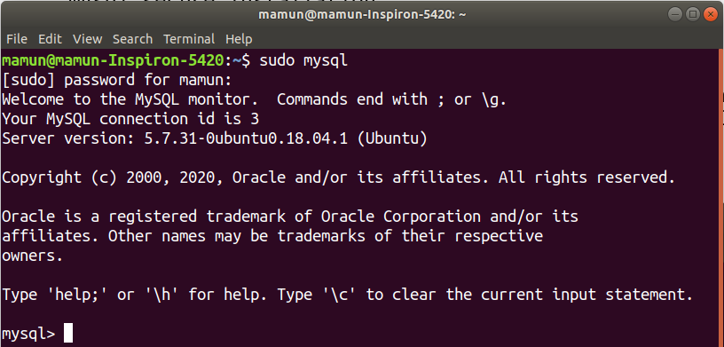

3.Create and show databases:To show databases we need to write a command “show databases”.to create database we need to write “create database databaseName”.
Here, I create ‘mamun’ database.

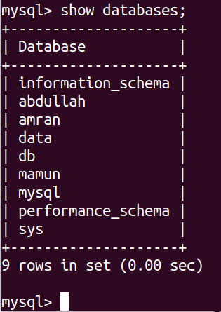

4.Create database table: In mysql database table is created by using below command.
Create table tablename(attributes name type).
Here, I create ‘student’ table.

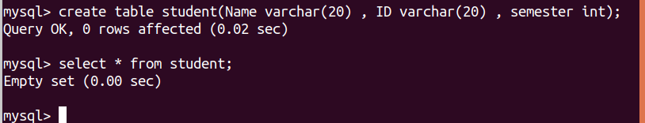

5.Insert Data into table: Data is inserted into table by using following commands:

insert into table_name values(“value1”,”value2...”);
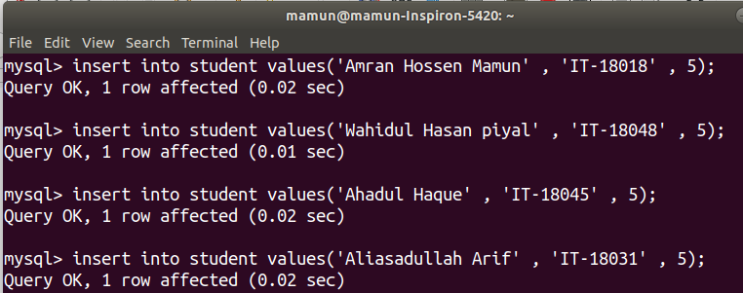
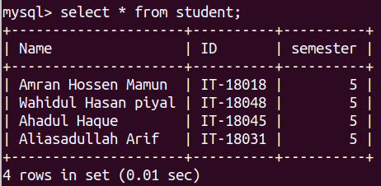

6.Describe table: List the contents of the table, types of attribute.

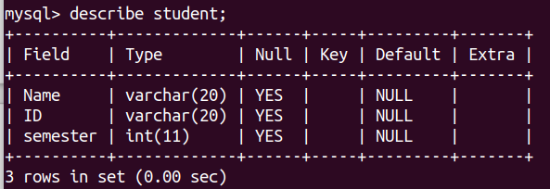

7.Alter table: We can change our table contents by “alter” command .Here i Add an extra column “Age” of integer types.

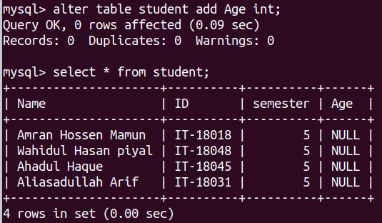

8.Modify table: The existent contents of a table. Here I delete the column Age.

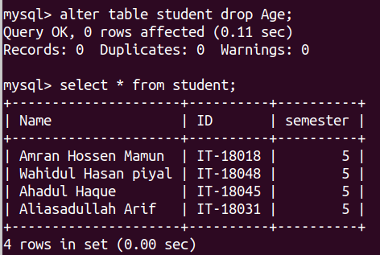

9.Drop data from table:

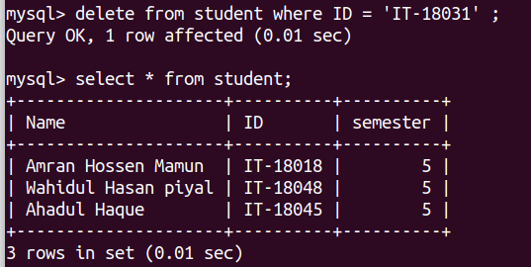

10.Update table: The UPDATE statement is used to modify the existing records in a table.
Update table_name
SET column1 = value1, column2 = value2, …
WHERE condition;

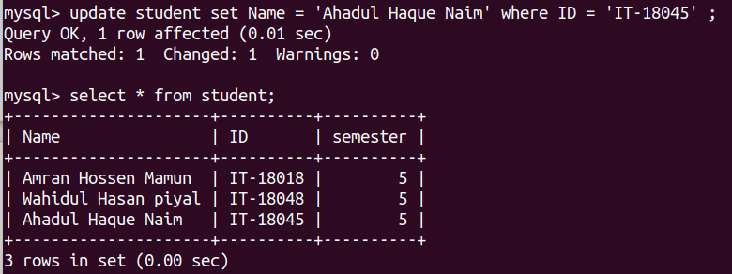

Conclusion: This was an interesting lab. I learned many things from this lab. This lab help me to understand the mysql command such as how to write commands and how to execute the mysql etc. first of all I learn how to Install mysql on Ubuntu: To install mysql on Ubuntu we need to write the following commands on Linux terminal.
“sudo apt-get update
sudo apt-get install mysql-server
mysql_secure_installation”.
And I also learn how to login into mysql, how to create database and how to create database table. A database is a collection of data, A database is typically designed so that it is easy to store and access information.
A good database is crucial to any company or organization. This is because the database stores all the pertinent details about the company such as employee records, transnational records, salary details etc.
when I execute the mysql commands then I will learn to able the database records are update able,delete able and can modify easily. This data are secure and sequential stored.
For this experiment I can learn many things and I can successfully execute all the Linux commands for database(mysql) as screenshot given above.

