

Mawlana Bhashani Science and Technology University

Lab-Report

Report No: 02
Course code: ICT- 3110
Course title: Operating Systems Lab
Date of Performance: 04/08/2020
Date of Submission: 14/09/2020

Submitted by Submitted To
Nazrul Islam
Assistant Professor
Dept. of ICT
MBSTU.

Name : Amran Hossen Mamun
ID : IT-18018
3rd year 1st semester
Session : 2017 – 2018
Dept. of ICT
MBSTU

Lab-report no : 02

Name of the lab report: Basic Command of Linux Operating System.

Objectives:
1.What is Linux command?
2.Write 15 commands in Linux operating system.
3.Describe the operation of Linux basic command.(Screenshot)

Linux command:
Linux is a Unix-Like operating system. All the Linux/Unix commands are run in the
terminal provided by the Linux system. This terminal is just like command prompt of
Windows OS. Linux/Unix commands are case-sensitive.

1. hostname command: the hostname commands shows the system host name.

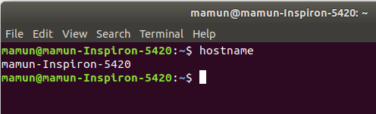

2. pwd command: It shows the directory you’re currently in.

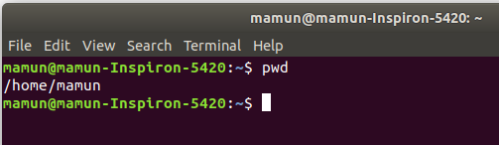

3. ls command: It shows the contents of a particular directory – both files and directories.

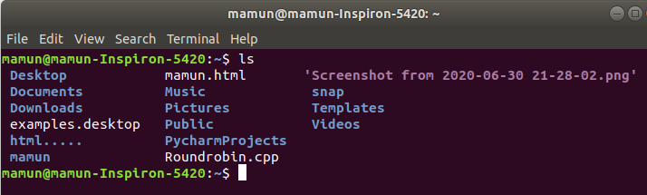

4. whoami command: It is basically the concatenation of the strings “who”,”am”, ”i”.It displays the username of the current user when this command is invoked.

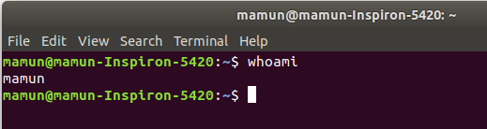

5. cal command: Displays the calendar of the current month.

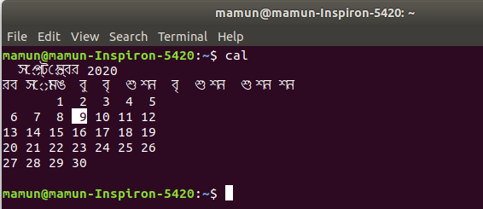
6. date command: Displays current time and date.

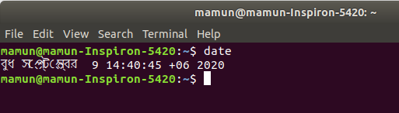

7. clear command: this command clear the screen.
Before press the enter:

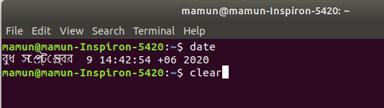
after clear command:
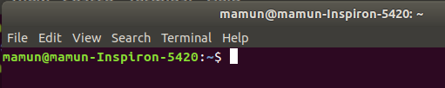

8. cd command: Change to directory . Here after changing directory I go to snap directory.
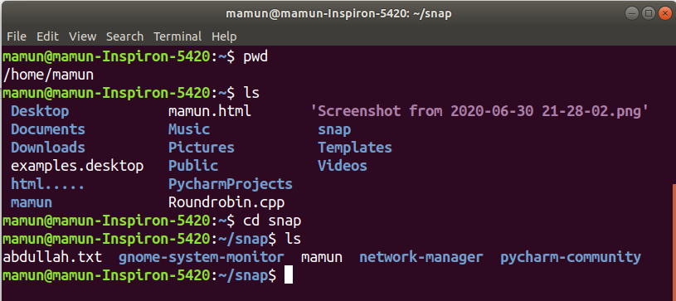

9. mkdir command : mkdir command in Linux allows the user to create directories.
Here I create the Amran directory.

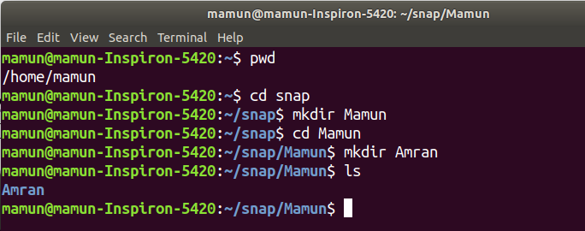

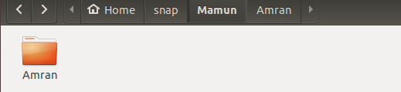

10. rmdir command: rmdir command is used remove empty directories from the
file system in Linux. The rmdir command removes each and every directory specified
in the command line only if these directories are empty . Here I first create a
directory hello and then I remove that file by using rmdir.

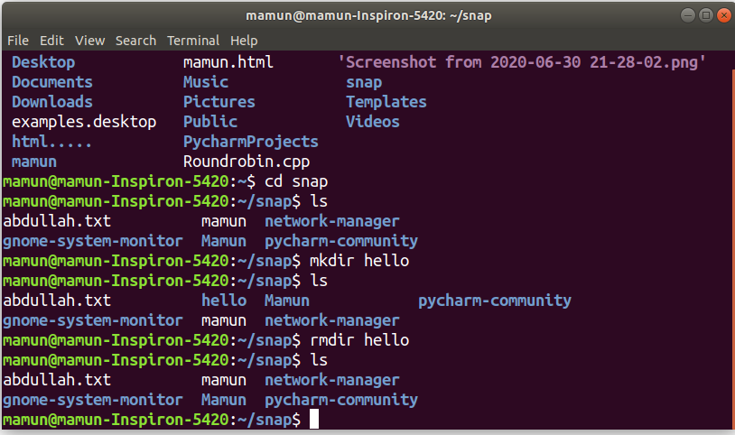

11.touch command: The touch command is used to create a file. It can be anything,
from an empty txt file to an empty zip file. Here I create a new.text file using touch
command.

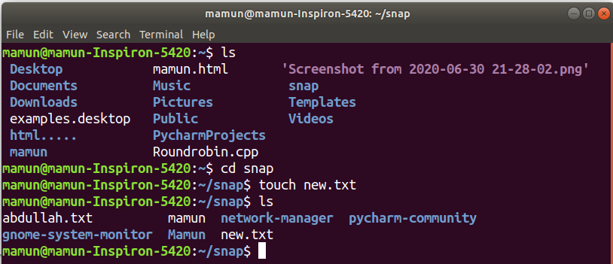

12. uname command:uname is used to show the information about the system
running. Using the command “uname -a” prints most of the information about the
system. This prints the kernel release date, version, processor type, etc.

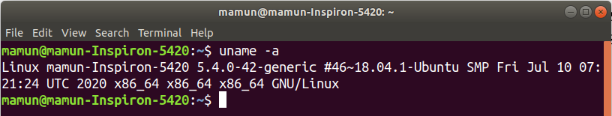
13. mv command: the mv command is used to rename a file. Here i rename the
new.txt file into hello.txt file.

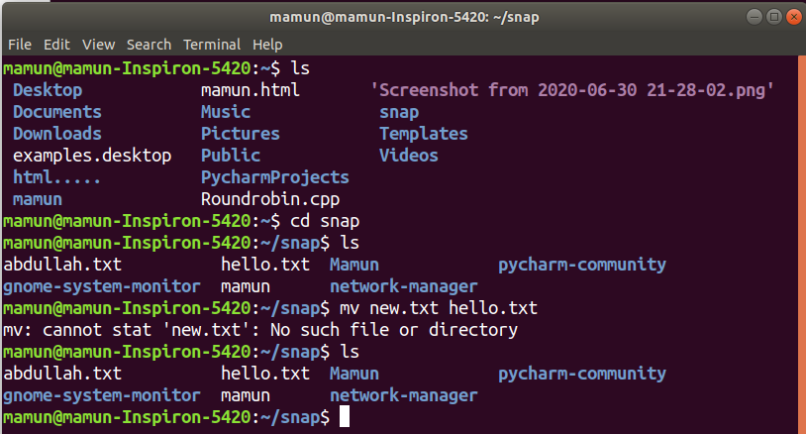

14. locate command:The locate command is used to locate a file in a Linux system, just like the search command in Windows. we can use this command when we don't know where a file is saved or the actual name of the file.

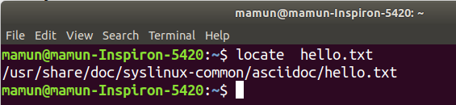

15.df command:

This command is used to check disk space usage on a Linux system. The most common usage is like
below, used along with the -h flag.

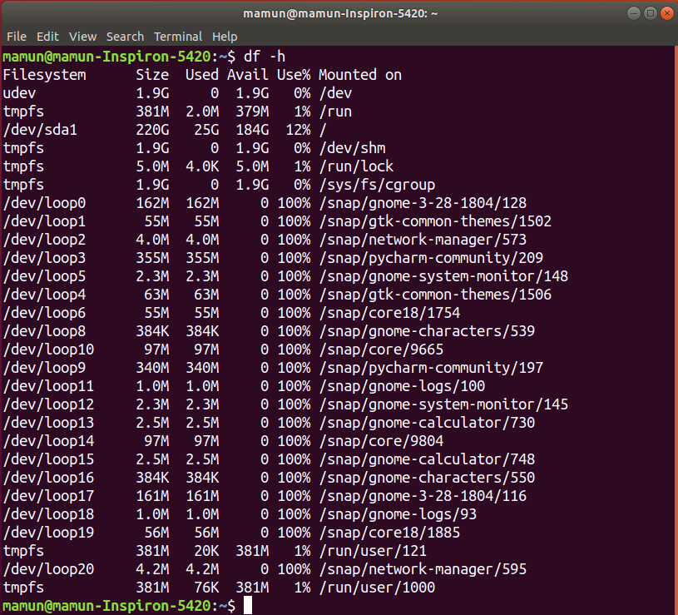

Discussion: This was an interesting lab. I learned many things from this lab. This lab help me to understand the basic of Linux commands such as how to write commands and how to execute the Linux commands etc. I can successfully execute all the Linux commands as screenshot given above.

