

Mawlana Bhashani Science and Technology University

Lab-Report

Report No: 02
Course code: ICT- 3110
Course title: Operating Systems Lab
Date of Performance: 04/08/2020
Date of Submission: 19/09/2020

Submitted by Submitted To
Name : Amran Hossen Mamun
ID : IT-18018
3rd year 1st semester
Session : 2017 – 2018
Dept. of ICT
MBSTU

Nazrul Islam
Assistant Professor
Dept. of ICT
MBSTU.

Lab report no : 06

Name of the lab report: Linux command for process

Objectives:
- How to Manage Processes from the Linux Terminal?
- Run the following process commands in Linux.
Top, htop, Ps, pstree, kill, pgrep, pkill ,killall, renice, xkill.

How to Manage Processes from the Linux Terminal:

The Linux terminal has a number of useful commands that can display running processes, kill them, and change their priority level. Many of the commands here perform a single function and can be combined — that’s the Unix philosophy of designing programs. Other programs, like htop, provide a friendly interface on top of the commands.

Processes can be manage from the Linux terminal using the below commands:

➢ top.
➢ Htop
➢ ps
➢ pstree
➢ kill
➢ pgrep
➢ pkill & killall
➢ renice
➢ xkill.

Top:
The top command is the traditional way to view your system’s resource usage and see the processes that are taking up the most system resources. Top displays a list of processes, with the ones using the most CPU at the top.
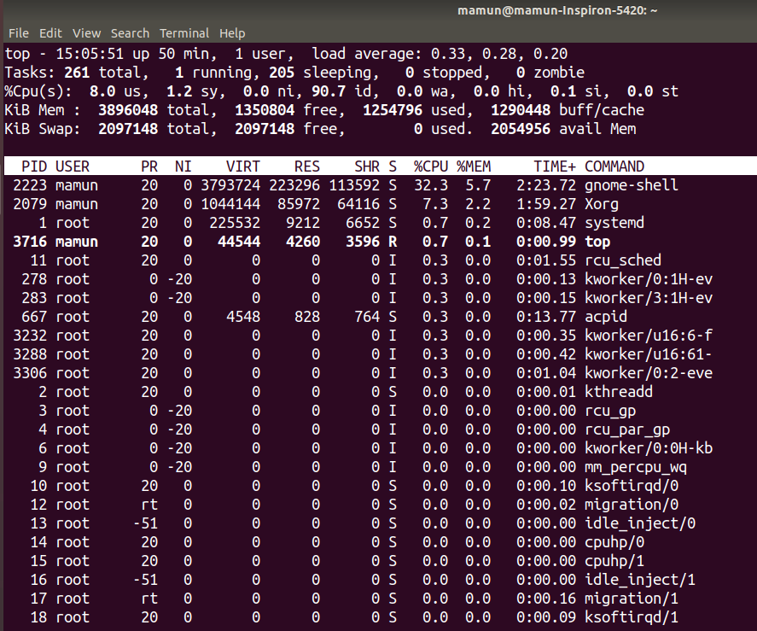

Htop:

The htop command is an improved top. It’s not installed by default on most Linux distributions —here’s the command you’ll need to install it on Ubuntu:
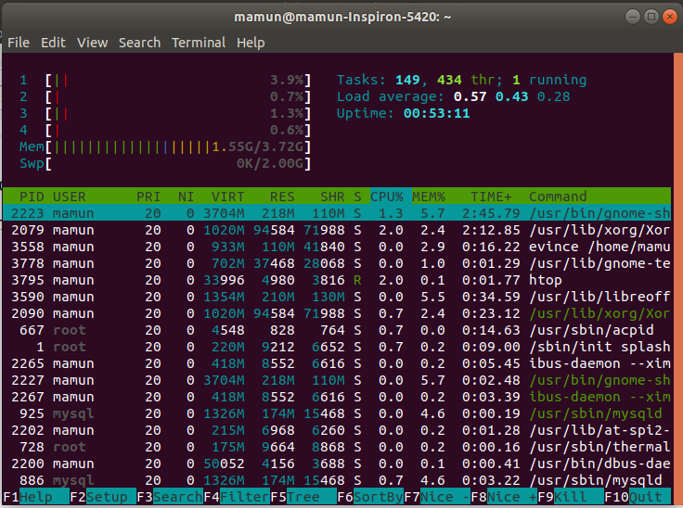

ps
The ps command lists running processes. The following command shows the processes for the current shell –

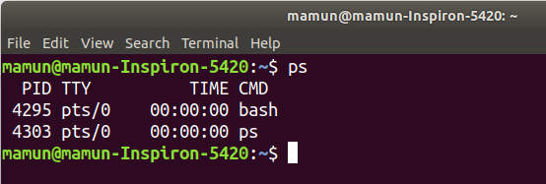

pstree:
The pstree command is another way of visualizing processes. It displays them in tree format. So, for example, your X server and graphical environment would appear under the display manager that spawned them.

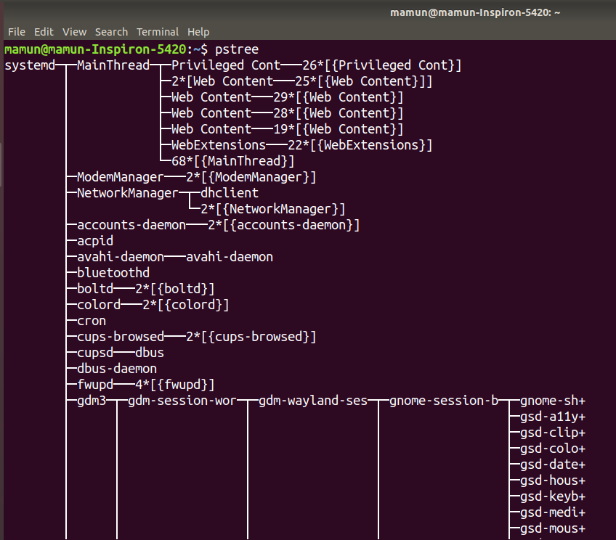

kill:
The kill command can kill a process, given its process ID. You can get this information from the ps -A, top or pgrep commands.

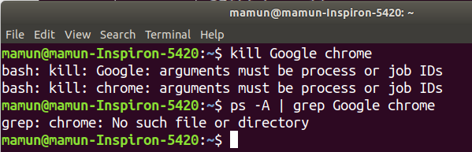

Pgrep:
Given a search term pgrep returns the process IDs that match it. For example, you could use the following command to find bash PID:

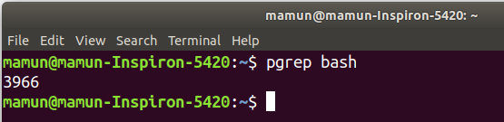
pkill & killall:

The pkill and killall commands can kill a process, given its name.

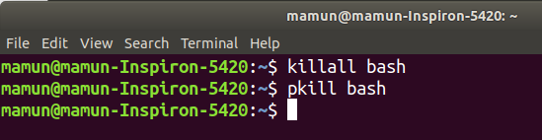

renice:
The renice command changes the nice value of an already running process. The nice value determines what priority the process runs with. A value of -19 is very high priority, while a value of 19 is very low priority. A value of 0 is the default priority.

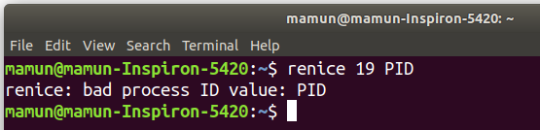

Xkill:
The xkill command is a way of easily killing graphical programs. Run it and your cursor will turn into an x sign. Click a program’s window to kill that program. If you don’t want to kill a program, you can back out of xkill by right-clicking instead.

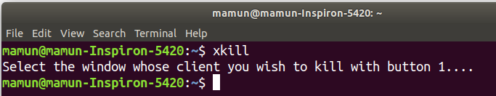

Conclusion:
This was an interesting lab. I learned many things from this lab. This lab help me to understand the Linux command for process such as how to write commands and how to execute the Linux command for process etc. The top program provides a dynamic real-time view of a running systems. By using htop commands I can see the the same information with an easier-to-understand layout. When we want to see the lists all processes running on our system then we can use the ps commands.
The another way of visualizing processes is pstree commands . It displays them in tree format. So, for example, my x server and graphical environment would appear under the display manager that spawned them. If I want to find out the process ID then I can use the kill commands.
In this experiment I also learn the new term “nice value” , the renice command changes the nice value of an already running process and the nice value determines what priority the processes runs with. For example, A value of -19 is very high priority, while a value of 19 is very low priority. A value of 0 is the default priority.
The xkill command is a way of easily killing graphical programs.
For this experiment I can learn many things and I can successfully execute all the Linux commands for processes as screenshot given above.

