**Sample Report – *Accessible Secure Banking System***

**Title Page**

* Project Title: **Accessible Secure Banking System**
* Your Name: MD MAMUN, Ahmed Tanvir
* Date: 29 -09-2025
* Course: CSE5133 UX/UI design

**1. Introduction**

The purpose of this project is to design a **secure and accessible mobile banking application prototype**.  
The system ensures that users can easily log in, check their balance, and make transactions while maintaining **strong security features** such as password, PIN, and fingerprint authentication.

**2. System Type**

We designed a **Banking App** prototype for secure online banking.

**3. Accessibility Requirements**

* Large and readable text for all users
* High colour contrast for better visibility
* Alternative login options: password, fingerprint, and PIN
* Clear and descriptive button labels
* Easy navigation with a logout option

**4. Security Requirements**

* Secure login with username and password
* Biometric authentication (fingerprint login)
* PIN entry for added protection
* Logout confirmation to prevent accidental logout
* (Optional improvement) Transaction confirmation & two-factor authentication (OTP)

**5. Prototype Design (Screenshots)**

1. **Registration Screen** – Shows user account creation with email and password.  
   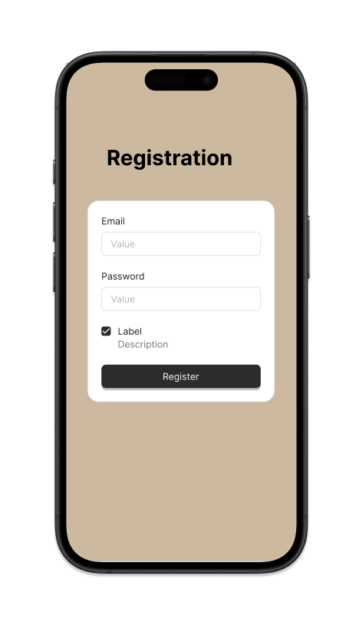
2. **Login Screen** – Username, password, fingerprint login.  
   A screen shot of a phone

   AI-generated content may be incorrect.
3. **Balance & Transaction Screen** – Displays account balance and history, with transfer option.  
   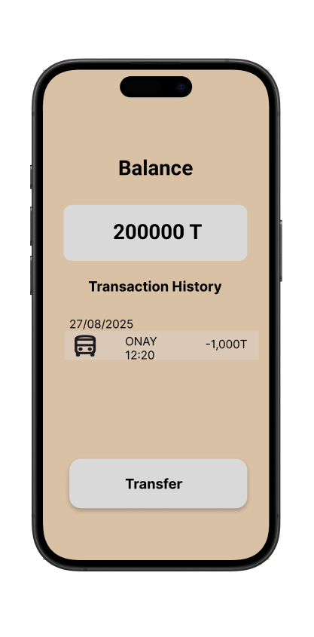
4. **Enter PIN Screen** – Secure PIN entry before accessing sensitive actions.  
   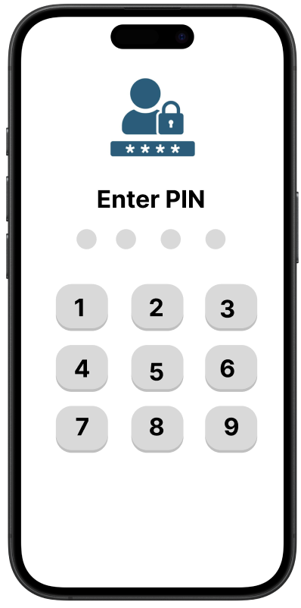
5. **Logout Confirmation Screen** – Asks the user to confirm logout.  
   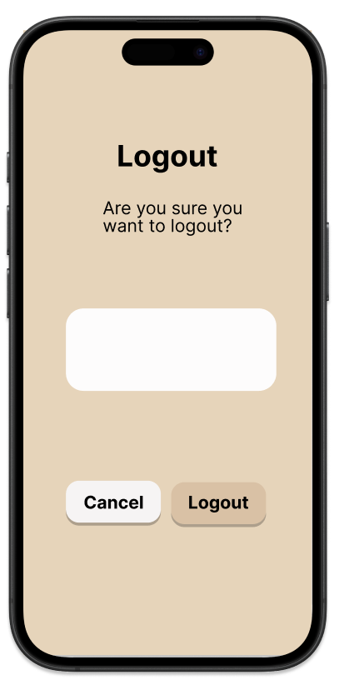

**6. Testing**

* **Automated Tools**: Used the Figma “Contrast Checker” plugin to test accessibility.
* **User Feedback**: Asked 3 classmates to test the prototype.
  + They found the login process simple.
  + Buttons and text were easy to see.
  + Security steps felt trustworthy.

**7. Findings**

**Strengths**

* Multiple secure login methods (password, fingerprint, PIN).
* Clean, simple, and user-friendly interface.
* Accessibility features: clear labels, big buttons, easy logout.

**Areas for Improvement**

* Add a **transaction confirmation pop-up** before sending money.
* Improve **colour contrast** in some screens for better readability.
* Implement **auto-logout after inactivity** for more security.

**8. Conclusion**

This project demonstrated how **security and accessibility** can be combined in a mobile banking system.  
By focusing on **user experience** and **protection**, the prototype ensures safety, trust, and ease of use.  
Further improvements, such as **two-factor authentication** and **transaction confirmation,** will make the system even stronger.