**Dhaka University of Engineering & Technology, Gazipur**

**Department of Computer Science and Engineering**

**Course No.:** CSE-2120

# Course Title: Visual Programming Sessional

**Group No.:** 38

**Porject Name:** Students management system .

**Submitted By:**

|  |  |
| --- | --- |
| Anwar Hossain Sagor | ID – 194102 |
| Khairul Alam | ID – 194107 |
| Anamul Haque | ID – 194110 |

**Experiment Date:** 06-02-2022 **Submission Date:** 09-03-2022

**Submitted To:**

**Dr. Fazlur Rahman Siddiqui**

Professor, Department of CSE, DUET

**Mst. Sumaya Khatun**

Lecturer, Department of CSE, DUET

**Md. Abu Bakkar Siddique**

Lecturer, Department of CSE, DUET

**Project Name:** student management system

**Introduction:**

**Student Management System (SMS) is a solution tool that is designed to track, maintain and manage all the data generated by a School, including the grades of a student, their attendance, their interpersonal activities records. Student Management System** software is created to help manage the student's admissions activities, starting from initial communication to course enrolment.

**Objective:**

design a student management system using python and kivy. In which we can control and management of all students activities of an institution.

**Menu Item:**

1. Login
2. Registration
3. Course
4. Result
5. Academic
6. Attendence

**Login:**

In this part have 2 section. One is admin login and another is students login. After login students are not access of all functions but admin can this. It has two entity.

1. User name
2. Password

**Registration:**

In this part students are completed their registration. These information are stored in database. If any student don’t complete his/her registration then they are not access in this system. This entities are:

1. Student Name
2. Student ID
3. Hall Name
4. Department
5. Year-Semister
6. Session
7. Blood Group

**Course:**

In this part we have shown the individual student result of an individual course. A student can see the specific course details of any semester. This entitties are…..

1. Student ID
2. Department
3. Session
4. Year-Semister

**Result:**

Admin and Studnets both of them are user In this part. users can seen the result of any specific semester and total CGPA . this entities are….

1. Student ID
2. Department
3. Session
4. Year-Semister

**Academic:**

Adimn is the user In this part. User will can see the overall records of a department or a specific semester of any batch or department. As a result admin will can any kind of decision to his present and future plan. This entities are…..

1. Department
2. Session
3. Year-Semister

**Attendence:**

Adimn and students both of them are the user In this part. admin will can see the overall attendance records of a department or a specific semester of any batch or department.on the other hand students can see only their personal attendance details. This entities are…..

1. Student ID
2. Department
3. Year-Semister

**DATA FLOW DIAGRAM (DFD)**

Hall Name

Student ID

Department

Session

Student Name

Password

User Name

Year-Semister

Blood Group

Registration

Login

Department

Session

Student Management

System

Course

Student ID

Session

Year-Semister

Student ID

Result

Department

Attendence

Year-Semister

Student ID

Year-Semister

Academic

Department

Year-Semister

Session

Department

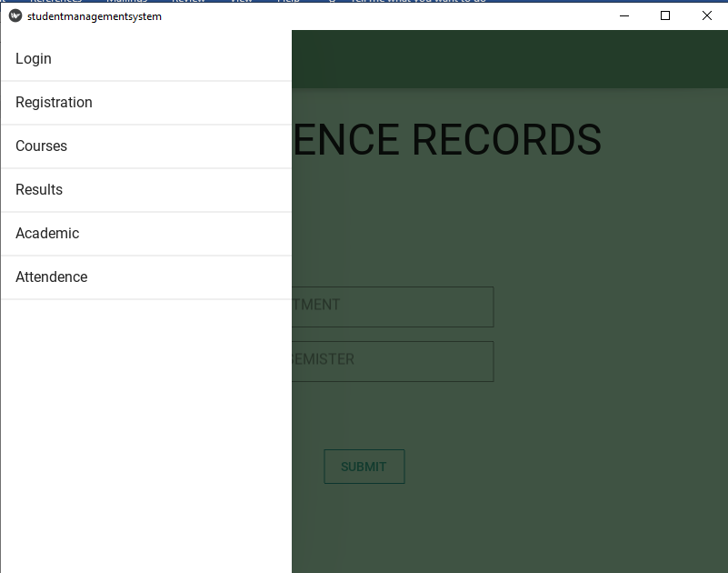

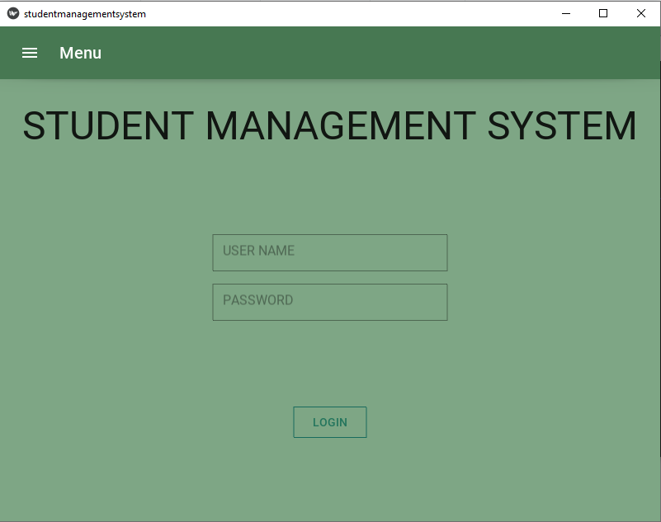

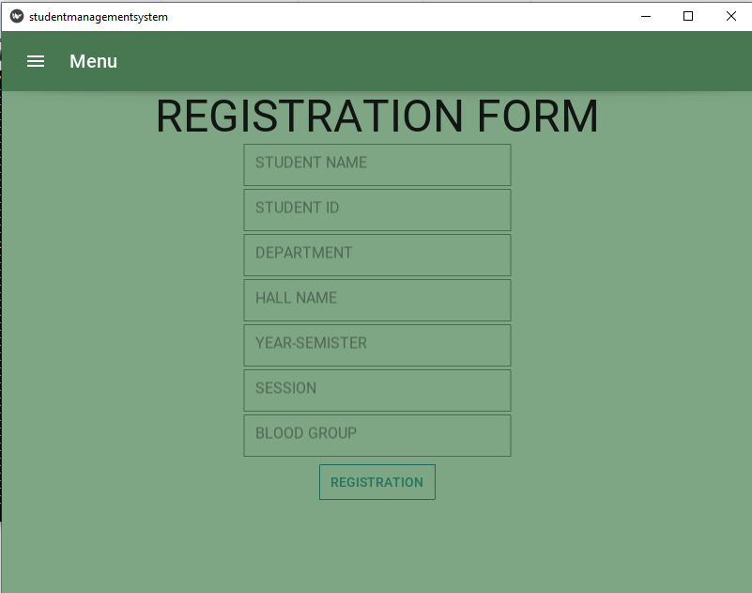

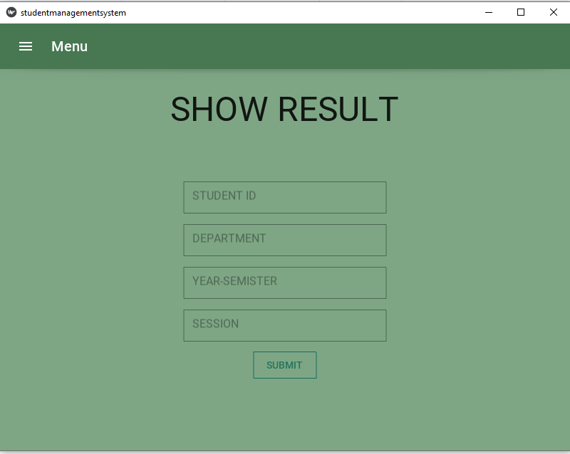

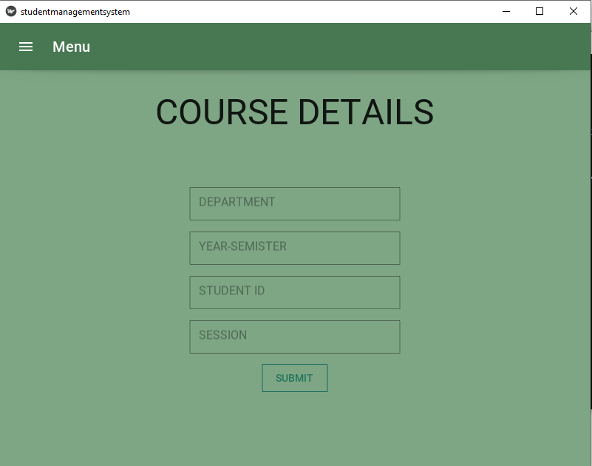

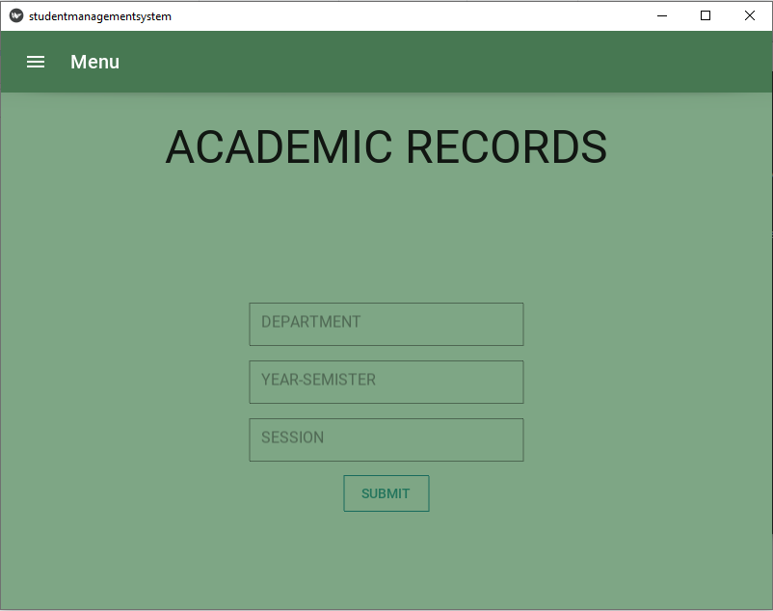

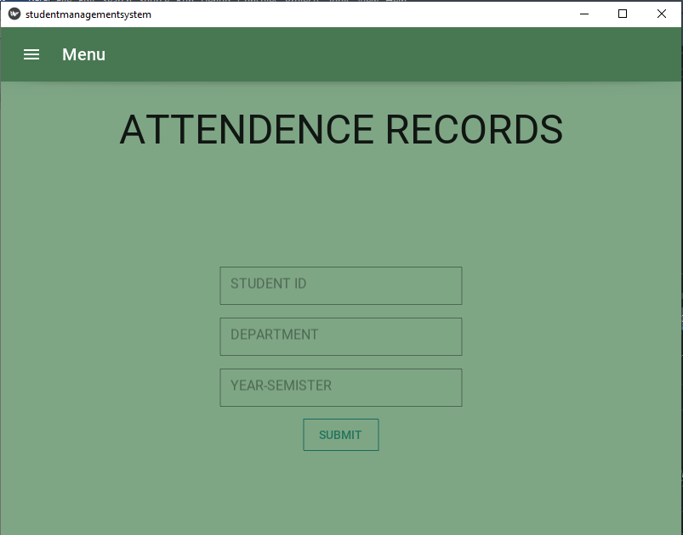

**Conclusion:**

To complete of this long run process we can showing how can design a windows based application using python and kivy. Doig this project we took help of youtube, GUI based kivy and kivymd (kivy framework). During this long time we face many problem and try to solve all this issues. Though this project not complete totally, still we work in this project to develop this. using this project, to control all activities of a school, college, university students. In this way students are free from suffering to offline problem. they are update and seen to their all activities at any time anywhere. We optimistic that in future we can complete this project successfully.