FUNCTIONAL & TECHNICAL OVERVIEW
Check Fraud Detector System
An event-driven microservices platform that scores every check deposit in real time — combining a rules engine, machine learning, computer vision, and privacy-preserving cross-bank intelligence into one explainable decision.
Prepared by Mamun
August 29, 2026

Contents
1. Executive Summary
2. The Problem
3. Solution Overview: One Explainable Score
4. System Architecture
5. Core Services in Detail
6. End-to-End Workflow
7. Data & Privacy Model
8. Web Dashboard
9. Technology Stack & Infrastructure
10. Known Limitations & Roadmap

1. Executive Summary
The Check Fraud Detector System is an event-driven, microservices-based platform that evaluates every check deposit for fraud risk the moment it is created. Rather than relying on a single rule or a single model, the system combines four independent lines of evidence — deterministic rules, machine-learned risk scores, computer-vision analysis of the check image, and privacy-preserving cross-institution intelligence — into a single, explainable decision: HOLD, MANUAL_REVIEW, or PASS.
The system is designed around three ideas that recur throughout the codebase:
- Event-driven by default — services communicate asynchronously over Kafka rather than direct synchronous calls, so the platform scales and degrades gracefully.
- Explainable over black-box — every score returned by the consortium and ML services includes the top reasons and feature contributions behind it, not just a number.
- Privacy-preserving by design — cross-institution matching is done entirely on HMAC tokens and hashes; raw PII never leaves an institution.

2. The Problem
Check fraud rarely announces itself as a single obvious red flag. A single institution often sees only one suspicious deposit in isolation, while the real pattern only becomes visible across a network of banks. The system is built to cover five recurring fraud patterns:
- Duplicate presentment — the same check, or a near-identical image, deposited more than once.
- Altered check suspicion — the amount or payee visible on the image does not match what was submitted.
- Counterfeit / forged checks — fake templates, copied layouts, or forged signatures.
- Cross-institution risk — the same payee, device, account, or image token reappearing across multiple banks.
- Behavioral anomalies — unusual velocity, a new device, an out-of-region deposit, or an unusual amount/channel combination.

3. Solution Overview: One Explainable Score
The moment a deposit event is created, the Fraud Detector service publishes it to the other services in parallel. Their results are combined into a final fraud score, and that score is mapped to one of three actions by the Rules Service:
Action | Trigger Condition | Meaning
HOLD | score ≥ 0.85 OR duplicate presentment | Deposit is blocked pending investigation.
MANUAL_REVIEW | score ≥ 0.60 OR consortium high risk | Routed to a fraud analyst queue for review.
PASS | Below all thresholds | Deposit proceeds normally.
Table 1 — Final decision policy applied to every deposit event.
Because the policy combines a continuous score with hard triggers (duplicate presentment, consortium high risk), a deposit can be held even when its numeric score alone would not cross the HOLD threshold — this is intentional, since some fraud signals are strong enough to act on independently of the blended score.

4. System Architecture
The platform follows a microservices architecture with five core services coordinated by a central orchestrator. Communication between services is entirely asynchronous, over Kafka topics — the orchestrator publishes a command for each downstream service and consumes their response events.
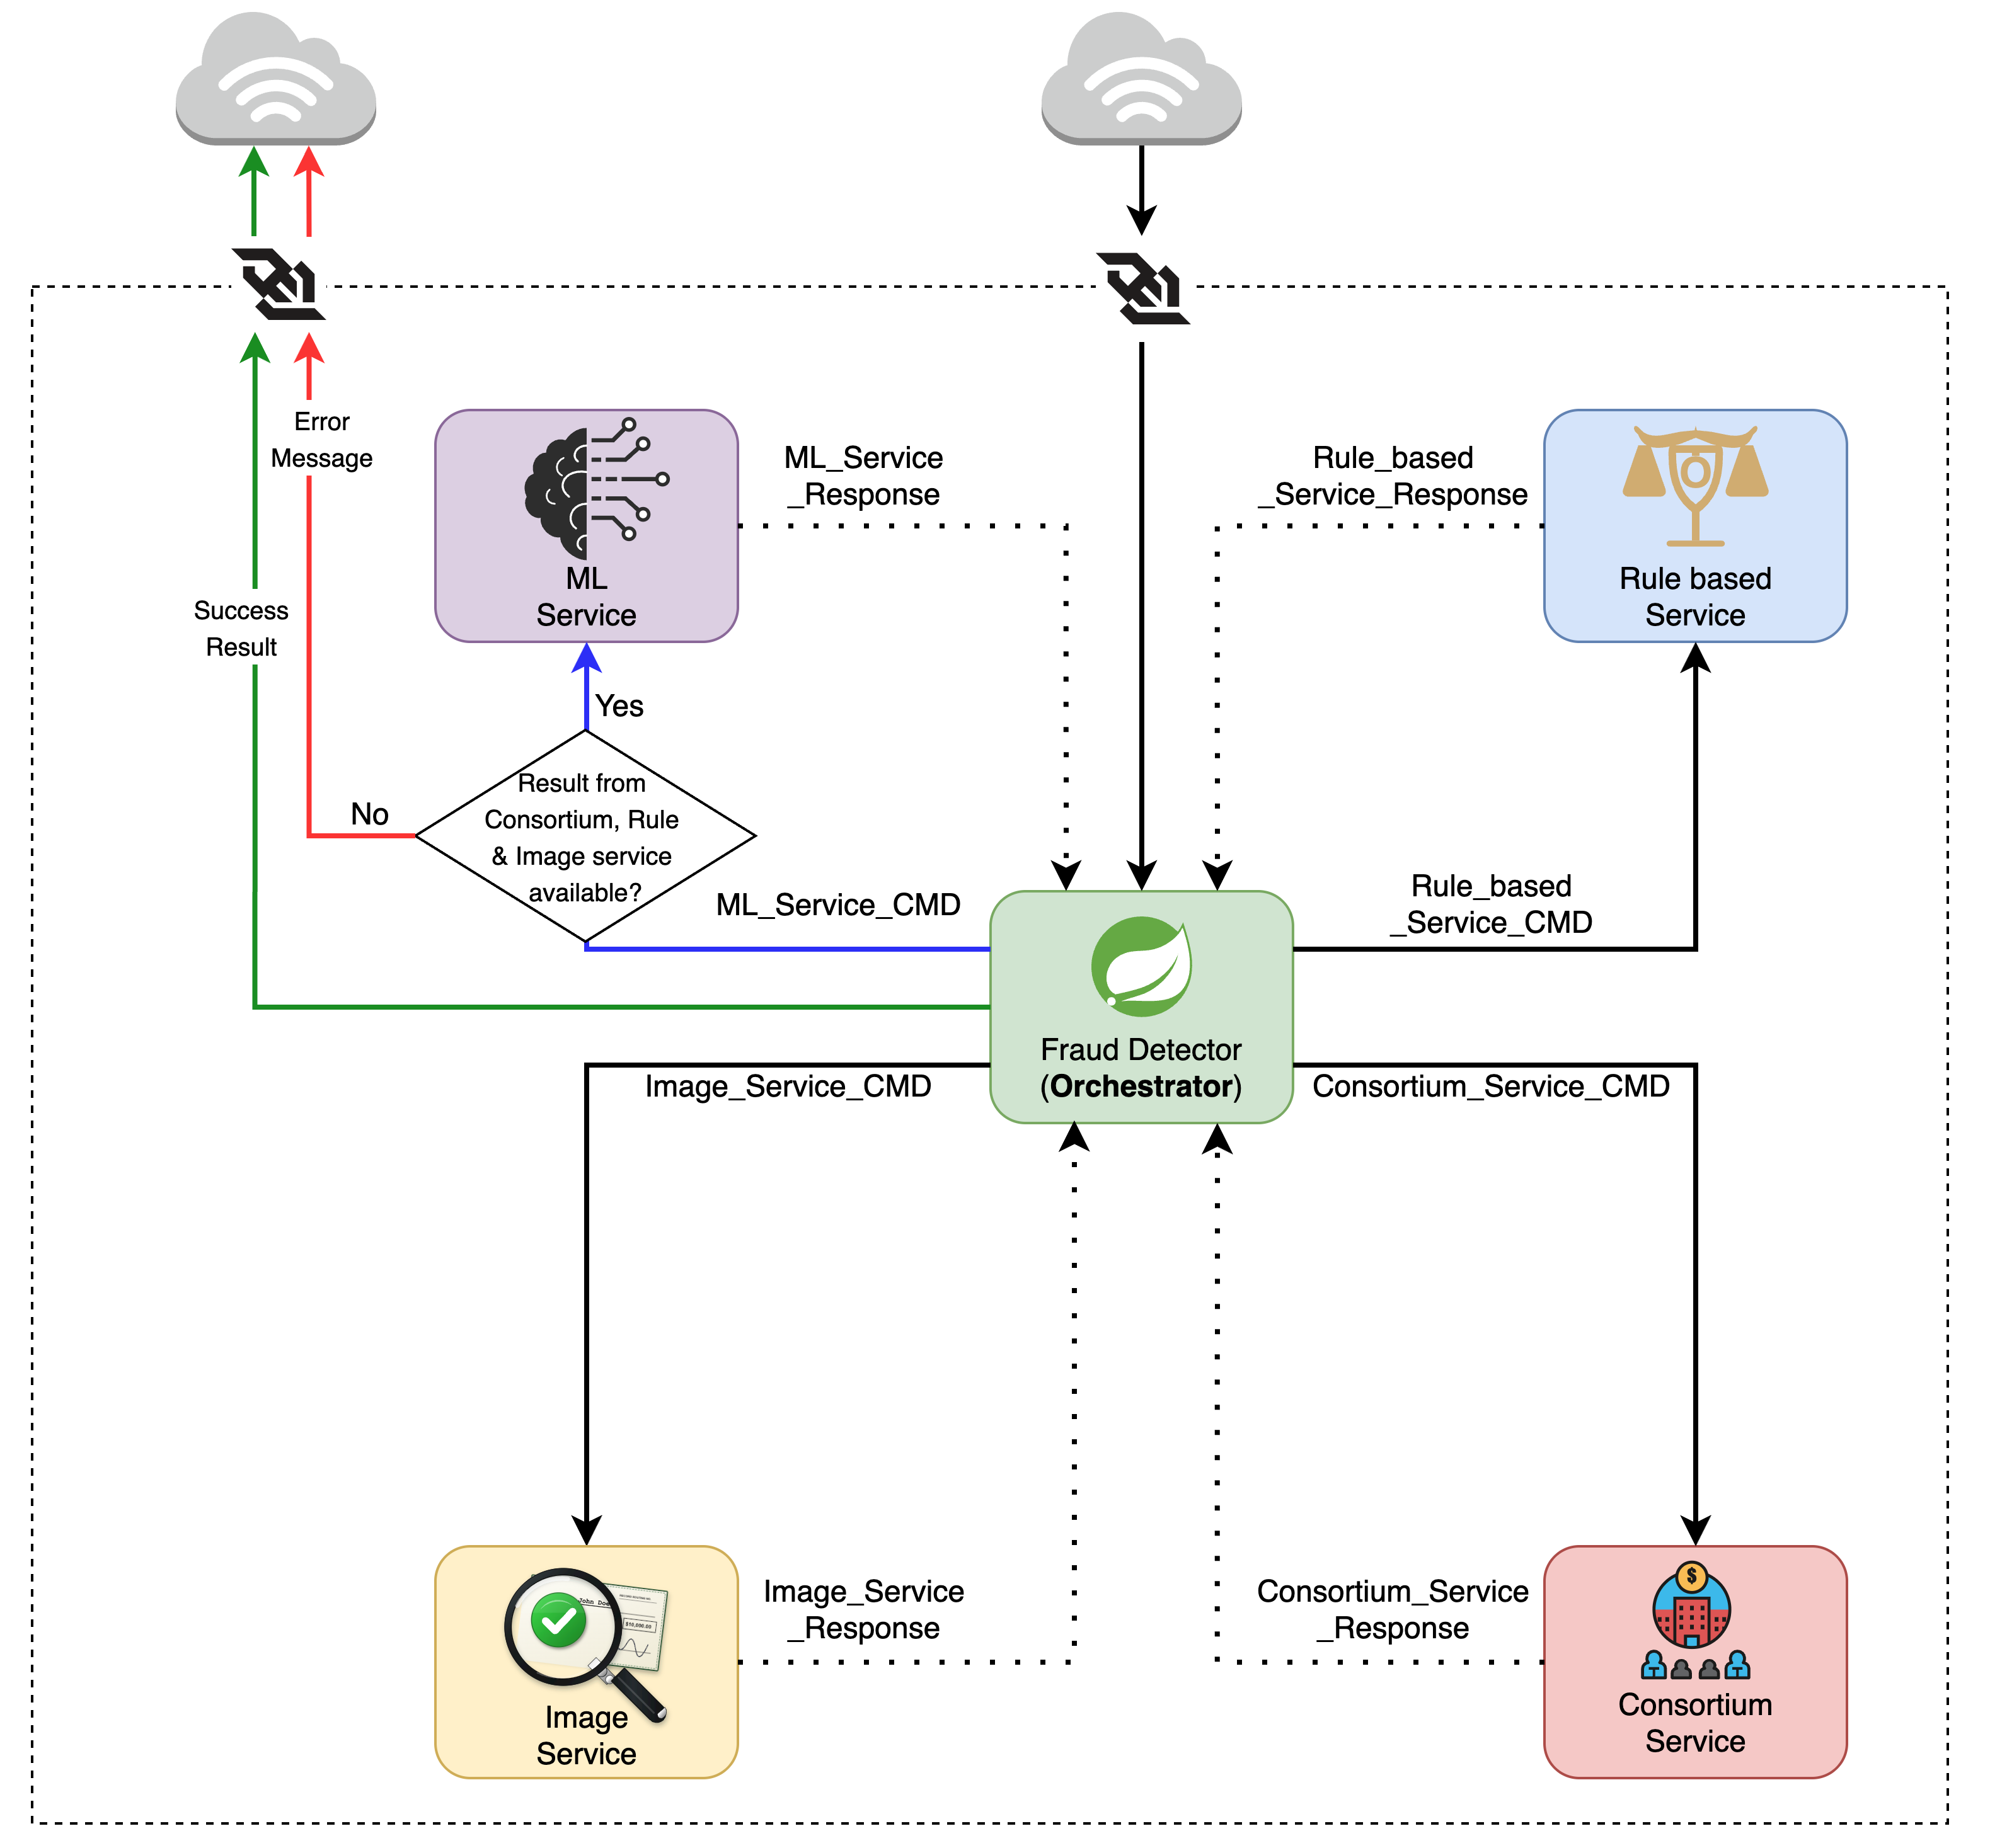
Figure 1 — System architecture: the Fraud Detector orchestrates the Consortium, Image, ML, and Rules services over Kafka.
Service | Role | Purpose
Fraud Detector | ORCHESTRATOR | Spring Boot service that ingests deposit events, fans out Kafka commands to the other services, aggregates their responses, and pushes live status to the web dashboard over WebSocket.
Consortium Service | CROSS-BANK INTEL | Privacy-preserving service that compares tokenized signals against a shared network history to catch fraud that only appears when multiple institutions are viewed together.
Image Service | COMPUTER VISION | Analyzes the front/back check images for duplicates, OCR amount mismatches, layout anomalies, font inconsistencies, and missing signatures/endorsements.
ML Service | RISK SCORING | Two-stage, calibrated XGBoost models that convert event, image, and consortium features into a fraud probability, risk band, and explanation.
Rules Service | POLICY ENGINE | Deterministic rules engine that evaluates rule hits and the final score to produce the HOLD / MANUAL_REVIEW / PASS decision, without redeploying the system.
Table 2 — The five microservices and their responsibilities.

5. Core Services in Detail

5.1 Fraud Detector (Orchestrator)
Built in Spring Boot, the Fraud Detector is the entry point for every deposit event. It:
- Receives the deposit ingest request (e.g. POST /api/deposits) and persists the event.
- Publishes Kafka commands to the Image and Consortium services, and waits for both responses.
- Uses the combined Image + Consortium results to compute ML features, then publishes a command to the ML service.
- Publishes the ML result to the Rules service, which returns the final HOLD / MANUAL_REVIEW / PASS decision.
- Streams success or error results back to the originating client over WebSocket, so the web dashboard updates live.

5.2 Consortium Service — Privacy-Preserving Cross-Bank Intelligence
The Consortium Service answers a question no single bank can answer alone: has this payee, device, account, or check image appeared — suspiciously often, or in a suspicious pattern — across other institutions? It turns "single-bank view" into "network-level fraud view" while never handling raw personal data.

Privacy-preserving tokenization
Callers generate HMAC or salted-hash tokens for account, payee, payor, device, and image identifiers before sending them. The service only ever stores and compares these tokens; when it needs to reference one in an explanation, it returns a short, non-reversible preview hash rather than the token itself.

Three evidence indexes
- Token index — tracks how often a token (payee, device, or image fingerprint) appears across institutions within 7-, 14-, and 30-day windows.
- Relationship index — tracks whether a payor–payee pair is new or has a history of confirmed fraud.
- Bank-flow index — tracks the fraud rate on a specific deposit-bank-to-clearing-bank corridor.

Cross-institution scoring
score = 0.55 × max_token_score + 0.25 × relationship_score + 0.20 × bank_flow_score
Token risk is weighted highest because a reused device, image, or payee is the strongest signal that a network of coordinated activity — rather than an isolated mistake — is involved. The response includes the score, the top contributing reasons, supporting linked counts, and the recency windows used, so the result is explainable rather than a bare number.
Current implementation note: the service stores its indexes in memory for the MVP, so state resets on restart and does not scale across instances. A production deployment would move this to PostgreSQL / Redis / a feature store, per the project’s implementation notes.

5.3 Image Service — Computer Vision on the Check
Given the front and (optionally) back image of a deposited check, this FastAPI service extracts visual and textual evidence and returns fraud-relevant image signals — not a final decision. It performs five checks:
- Duplicate detection — perceptual hashing (pHash) flags a reused or near-duplicate check image, useful for catching duplicate presentment.
- OCR amount verification — Tesseract OCR (after grayscale, resize, blur, and threshold preprocessing) extracts money-like values from the image and flags a mismatch against the submitted amount.
- Layout anomaly detection — edge and Hough line detection estimate whether the check’s structure (lines, boxes, signature area) looks like a normal check.
- Font anomaly detection — the coefficient of variation in text-component heights flags inconsistent font sizes, which can indicate pasted or edited text.
- Signature & endorsement presence — edge/ink density in the expected signature and endorsement regions flags a likely-missing signature or endorsement.
This is explicitly an MVP heuristic system rather than a forensic-grade authentication engine — thresholds are not yet calibrated on real check images, and the in-memory duplicate-hash store is not persistent.

5.4 ML Service — Two-Stage Calibrated Risk Scoring
The ML Service answers: how risky is this check event? It supports deposit scoring, in-clearing scoring, and a combined score, using two XGBoost classifiers trained on tabular features and wrapped with isotonic probability calibration (CalibratedClassifierCV).
- Deposit model — early risk signal using transaction, behavioral, image, and rule-engine features (amount, velocity, new-device indicator, image duplicate/OCR/layout/font/signature scores, rule hit counts, channel, etc.).
- In-clearing model — a downstream refinement using clearing-stage signals (deposit score, days since deposit, amount match, drawee-bank prior fraud, cross-bank risk, return codes, chargebacks, loss amount).
final_prob = max( deposit_prob, 0.45 × deposit_prob + 0.55 × in_clearing_prob )
This combination guarantees the final score never falls below the original deposit-stage risk, while giving the more evidence-rich in-clearing model slightly more influence when it is available. The resulting probability is mapped to an operational risk band:
Risk Band | Probability | Recommended Action | Notes
HIGH | ≥ 0.85 | HOLD | Blocked pending review
MEDIUM | ≥ 0.60 | MANUAL_REVIEW | Analyst queue
LOW | ≥ 0.30 | PASS | Proceeds normally
MINIMAL | < 0.30 | PASS | Proceeds normally
Table 3 — ML risk bands and the actions they map to.
The service also returns approximate, analyst-friendly feature contributions (feature value × explanation weight) — for example image_duplicate_score, critical_rule_hit_count, or payee_fraud_count_30d — so a human reviewer can see why an event scored the way it did.

5.5 Rules Service — The Policy Engine
The Rules Service evaluates deterministic checks (such as MICR routing/account/serial matches for duplicate presentment) alongside the ML risk score and consortium result to produce the system’s final action. Because it is a separate service, rule thresholds and logic can be updated without redeploying the ML or image services.

6. End-to-End Workflow
A single deposit event flows through the system as follows:
- A deposit event arrives at the Fraud Detector (e.g. from the web app or an API call) and is persisted.
- The Fraud Detector publishes commands to the Image Service and the Consortium Service in parallel and waits for both responses.
- Using the Image and Consortium results, the Fraud Detector assembles the feature set for scoring and publishes a command to the ML Service.
- The ML Service returns a calibrated fraud probability, risk band, and explanation.
- The Fraud Detector publishes the combined evidence to the Rules Service, which applies the decision policy (Table 1) and returns the final action.
- The result — HOLD, MANUAL_REVIEW, or PASS — is streamed back to the client over WebSocket and reflected live on the dashboard.
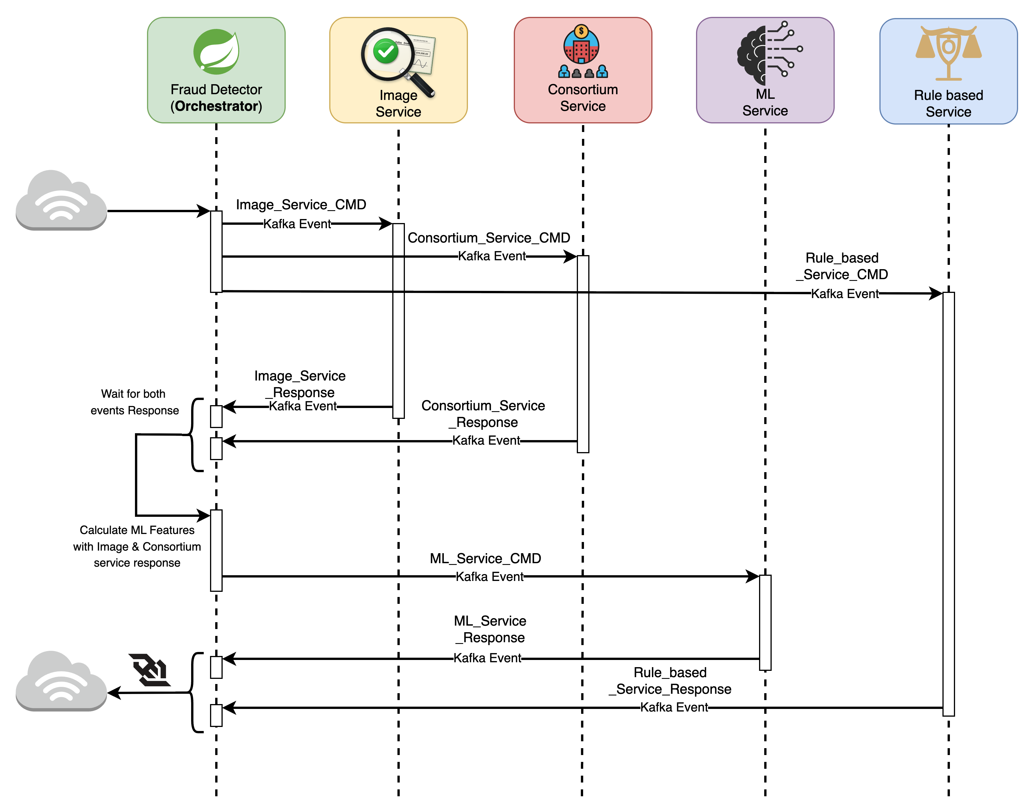
Figure 2 — Sequence diagram of a single deposit event moving through the Fraud Detector, Image, Consortium, ML, and Rules services.

7. Data & Privacy Model
Every deposit event carries identifiers such as accountToken, payeeToken, payorToken, deviceToken, and imageFingerprint — all expected to already be HMAC or salted-hash tokens by the time they reach the consortium layer. The service stores and compares only these tokens, aggregate counts, derived risk scores, and fraud metadata; it does not store raw cross-institution PII.
The PostgreSQL schema (db/schema.sql) persists deposit events, scores, rule hits, alerts, cases, and an audit trail, giving the rules and case-management layers a durable record to work from even though the consortium indexes themselves are currently in-memory.

8. Web Dashboard
A React + TypeScript single-page application (check_fraud_app/) gives analysts a live view of the system:
- Connects to the Fraud Detector over WebSocket, so new deposit events and their scores appear on the dashboard without polling or a manual refresh.
- Lets a user submit a new deposit event from a form and watch it move through consortium, image, ML, and rules scoring in real time.
- Displays events in a color-coded table by decision (HOLD / MANUAL_REVIEW / PASS) with the contributing score, so an analyst can triage a queue quickly.
- State is managed with Redux (fraudEventsSlice) and built with Vite; it is containerized alongside the backend services via nginx.

9. Technology Stack & Infrastructure
- Fraud Detector & Rules Service — Spring Boot (Kotlin/Java, Gradle).
- Consortium, Image, and ML services — Python, FastAPI.
- Messaging — Apache Kafka, for all inter-service communication.
- Storage — PostgreSQL (events, scores, rule hits, alerts, cases, audit).
- Frontend — React + TypeScript + Vite, Redux, WebSocket client.
- ML training — XGBoost with isotonic calibration (train_model_check_fraud.py, train_model_in_clearing.py).
- Synthetic data — a generator script producing realistic multi-bank deposit and fraud scenarios for development and demos.
- Observability — Prometheus metrics with a Grafana-ready setup.
- Local orchestration — Docker Compose (PostgreSQL, Kafka, API, ML, image, consortium, Prometheus, Grafana).
- Cloud infrastructure — Terraform modules for AWS (ALB, ECS, ECR, IAM, MSK, networking, RDS, S3, Secrets Manager).

10. Known Limitations & Roadmap
The codebase is explicit about which pieces are MVP-level placeholders and what replacing them with production-grade components would involve:

Replacing the demo ML with real ML
- Start from an interpretable Logistic Regression or XGBoost model on tabular features (already in place).
- Add real image embeddings — perceptual hash, OCR legal/courtesy amount mismatch, signature/endorsement detection, layout anomaly scoring.
- Add graph/network features — account/payee/device/check-token degree, fraud-neighbor counts, connected-component risk.
- Calibrate scores with Platt scaling or isotonic regression (isotonic calibration is already used).
- Track precision, recall, false-positive rate, alert volume, latency, and explanation coverage in production.

Production hardening
- KMS-backed HMAC keys with per-institution token namespaces and key rotation.
- Row-level security and immutable audit logs.
- Dead-letter Kafka topics and idempotent event ingestion.
- Async score aggregation, a model registry, and champion/challenger deployment.
- Data-drift and feature-drift monitoring.
Together, these items describe the path from the current event-driven MVP — which already demonstrates the full decision loop end to end — to a system that could run in a real fraud-operations environment.

