# **Guided Capstone Project Report**

## **Introduction**

Due to new additions such as chair lift, Big Mountain Resort is spending $1.5 million more this season in operating costs. Now management is faced with a decision to increase the ticket price as well as to reduce the maintenance costs to cover up the extra costs and to increase revenue.

**Work Strategy**

After analyzing the data, we decided to build a predictive machine learning model to understand how each of the amenities and other factors (e.g., location) affect the ticket pricing.

**Results & Discussion**

The most important finding from the model is that the Big Mountain Resort charges less than resorts with similar facilities. We identified 4 factors that are crucial when determining the ticket price, i.e., vertical drop, snowmaking area, total number of chairs, and total number of runs. Even though Big Mountain is near the top in all these factors; however, it’s not charging as much as it could. In fact, our model predicts a fair price for such a resort should be about $96 while Big Mountain is actually charging $81. So, by increasing the price, it can easily generate $2.6M in revenue.

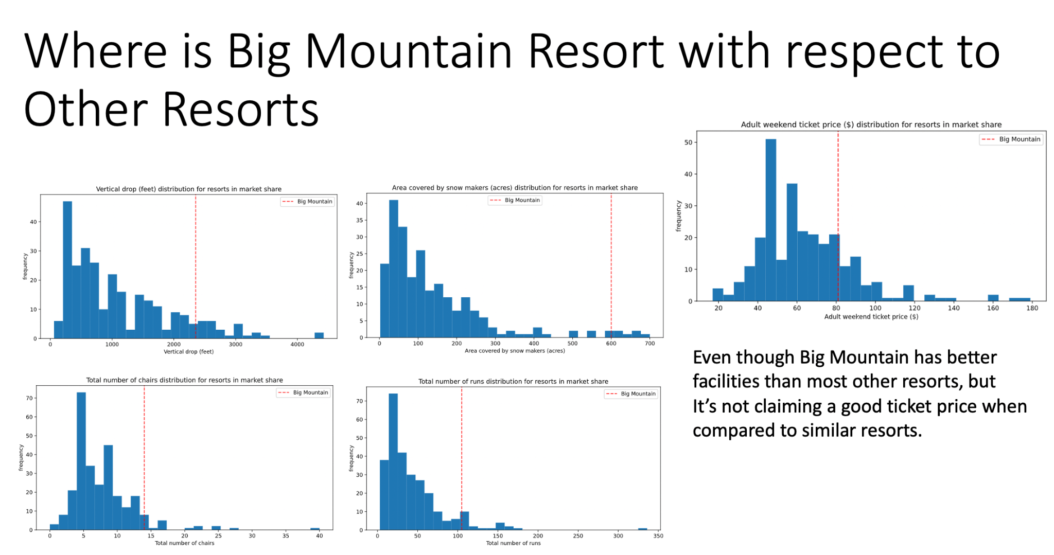

Next, we analyzed the sensitivity of ticket price with respect to the number of runs to justify closing or adding runs to increase the ticket price or decrease the maintenance cost.

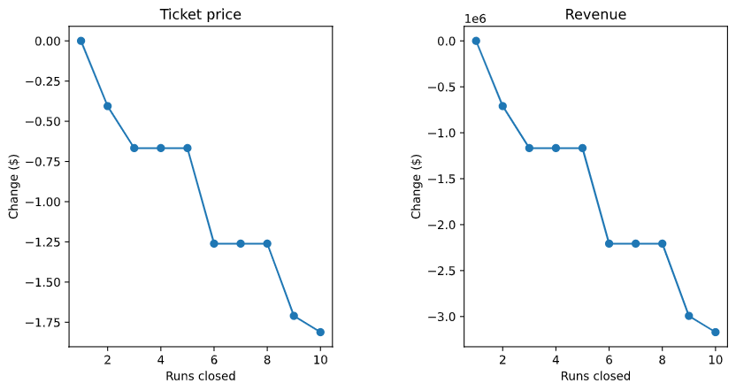

We found that closing 1 run will have no significant impact on the ticket pricing; however, closing 3-5 may lead to a bigger drop. On the other hand, if we add one more run to increase the vertical drop, it can justify a $2 increase in ticket price leading to increased revenue.