7COM1079-0901-2025 - Team Research and Development Project

Final report title: “Understanding Melbourne’s Real Estate Trends: How distance from the Central Business District(CBD) relates to residential property prices.”

Group ID: A 140

Dataset number: ds198

Prepared by: Mohammed Mamun Chowdhury (24158920)
Shah Ahmed (24167559)
Mustehsin Nawaz (24149297)
M Mahmudul Kabir (24133560)
Md. Khalid Abdullah (24154303)

Please make sure the document spelled correctly (including image labels, section headings, and table of contents). Please use correct punctuation.
Make sure your report is grammatically correct.

University of Hertfordshire
Hatfield, 2025

1 Introduction ..........................................................................................................................2
1.1. Problem statement and research motivation ............................................................... 2
1.2. The data set ................................................................................................................. 2
1.3. Research question ................................................................................... …………….3
1.4. Null hypothesis and alternative hypothesis (H0/H1) ................................ …………...3

2 Background research ................................................................................ ………………….4
2.1. Research papers ...................................................................................... ……………..4
2.2. Why RQ is of interest ............................................................................. ………………4

3 Visualisation ........................................................................................................................... 5
3.1. Appropriate plot for the RQ .................................................................... ……………..5
3.2. Additional information ............................................................................ ……………..6
3.3. Useful information .................................................................................. ……………..6

4 Analysis ................................................................................................... ………………….7
4.1. Statistical test used ....................................................................................................... 7
4.2. The null hypothesis is rejected/not rejected .......................................... ………………7

5 Evaluation – group's experience at 7COM1079 ...................................... …………………8
5.1. What went well ....................................................................................... ……………8
5.2. Points for improvement .......................................................................... ……………8
5.3. Group's time management ..................................................................... …………….8
5.4. Project's overall judgement ................................................................... …………….9
5.5. Comment on GitHub log output ............................................................ …………….9

6 Conclusions ............................................................................................. ………………….10
6.1. Results explained ................................................................................... …………….10
6.2. Interpretation of the results ................................................................... ……………..10
6.3. Future work and limitations ......................................................................................... 11

7 Reference list .......................................................................................... ……………………12

8 Appendices ............................................................................................. …………………….13
A. R code used for analysis and visualisation ............................................. ……………………13
B. GitHub log output ................................................................................... …………………….14

Table of Contents add page numbers from here

- Introduction
  - Problem statement and research motivation
Melbourne's real estate market continues to expand but prices remain closely related to location (Smith, 2023). Being near to Melbourne's Central Business District (CBD), the city's business and transportation hub, is often thought to boost house prices, however scientific evidence is scarce. This study uses the Melbourne Housing dataset to evaluate whether distance from Melbourne's central business district is connected with residential property values. The findings could assist homebuyers, investors, and urban planners to better understand Melbourne's geographical pricing trends.
  - The data set
The Melbourne Housing Survey dataset provides a detailed analysis of residential property sales in Melbourne, Australia. It is based on publicly available data and contains important information such as property price, number of rooms, kind of housing, sale method, suburb, real estate agent, date of sale, and distance from the Central Business District (CBD). Additional variables like land size, building area, council area, and regional classification make it useful for analyzing housing trends, market behavior, and factors impacting property values. For our analysis, we have used data for the first three months of 2017.
Here is the top 5 rows and 6 most important columns in our dataset

Table 1: A Subset of the Melbourne Housing Dataset Used for Analysis
Suburb | Address | Price_in_million | Distance | Date | Landsize
Abbotsford | 5 Charles St | 1.4650 | 2.5 | 2017-03-04 | 202
Abbotsford | 40 Federation La | 0.8500 | 2.5 | 2017-03-04 | 156
Abbotsford | 3/72 Charles St | 1.3300 | 2.5 | 2017-03-18 | 134
Abbotsford | 13/11 Nicholson St | 0.9000 | 2.5 | 2017-03-18 | 94
Abbotsford | 138/56 Nicholson St | 1.0900 | 2.5 | 2017-03-18 | 120

  - Research question
Our proposed research question is:
“Is there a correlation between Price and Distance of residential properties from the Melbourne Central Business District (CBD) in Melbourne, Australia?”
This study intends to measure the connection between the choosen variables and discover major regional trends within the metropolitan housing market.

  - Null hypothesis and alternative hypothesis (H0/H1)
Null hypothesis(H0): “There is no correlation between Price and Distance of residential properties from the Melbourne Central Business District (CBD) in Melbourne, Australia.”
Alternative hypothesis(H1): “There is a correlation between Price and Distance of residential properties from the Melbourne Central Business District (CBD) in Melbourne, Australia.”

- Background research
  - Research papers (at least 3 relevant to your topic / DS)
Several studies highlight the influence of location on residential housing prices. Rahman (2023) examined the impact of major transport developments in Dhaka and found that improvements in accessibility significantly increase property values. Similarly, Khan (2024) showed that transport accessibility and distance to urban centres are key predictors of property prices, particularly relevant to cities such as Melbourne.
Australian-focused research also supports location-price relationships. Bourassa (2003) analysed geographical housing patterns in Australia and demonstrated that distance from the CBD is a strong driver of price differences across suburbs. Complementing this, Kauko (2003) identified distance to the city centre as a consistent determinant of residential price variation across metropolitan housing markets.

  - Why RQ is of interest (research gap and future directions according to the literature)
The majority of Melbourne-specific research use pre-2020 or aggregated data, which may not reflect post-pandemic market behaviour, suburban expansion, or transportation changes. This presents a major research gap that requires updated analysis using current datasets. Our research subject is interesting because it analyzes whether the traditional urban economics principle—properties closer to the CBD are priced higher—is still applicable in Melbourne's current property market. The findings will benefit buyers ,planners and many more. Future research could include real-time accessibility measurements, transportation improvements, and neighborhood-level geographical features.

- Visualisation
  - Appropriate plot for the RQ output of an R script (NOT a screenshot) and required supplementary graph/table (include histogram for
correlation/comparison of means RQs, include contingency table for comparison of proportions RQ)
To understand the relationship between house price and distance from Melbourne CBD, a scatter plot is used as it visualizes correlation between two continuous variables. A histogram with Bell curve is included for each variable to assess distribution shape, skewness, and normality
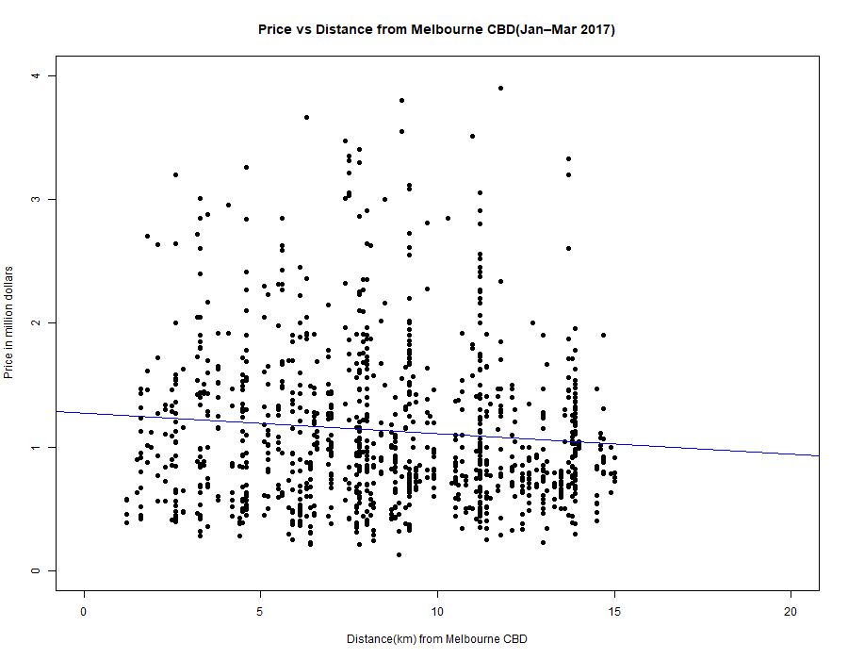
Figure 1: Scatter plot of Price (millions) vs Distance from Melbourne CBD (km), Q1 2017.

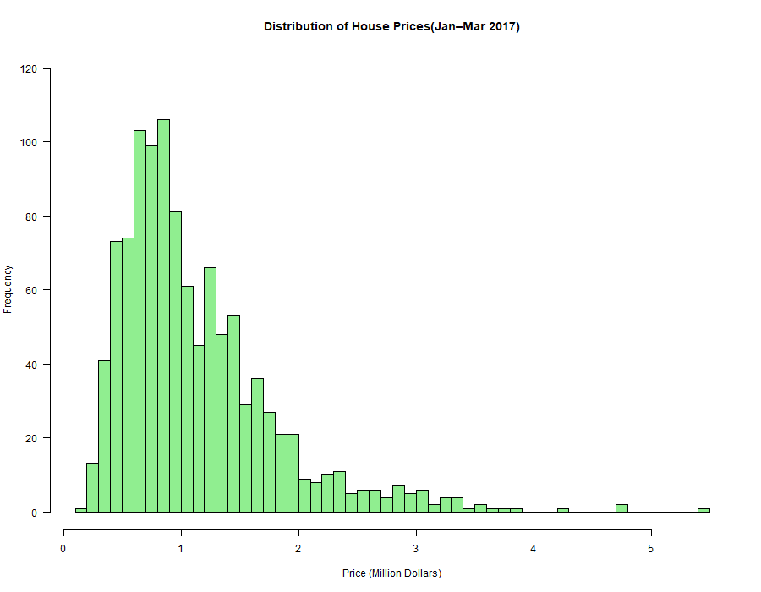
Figure 2: Distribution of House Prices
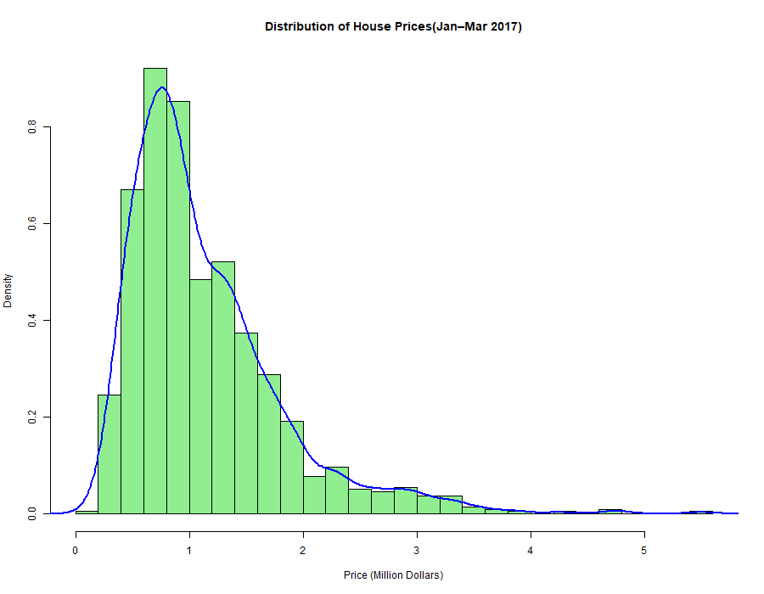
Figure 3: Distribution of House Prices with Bell Curve
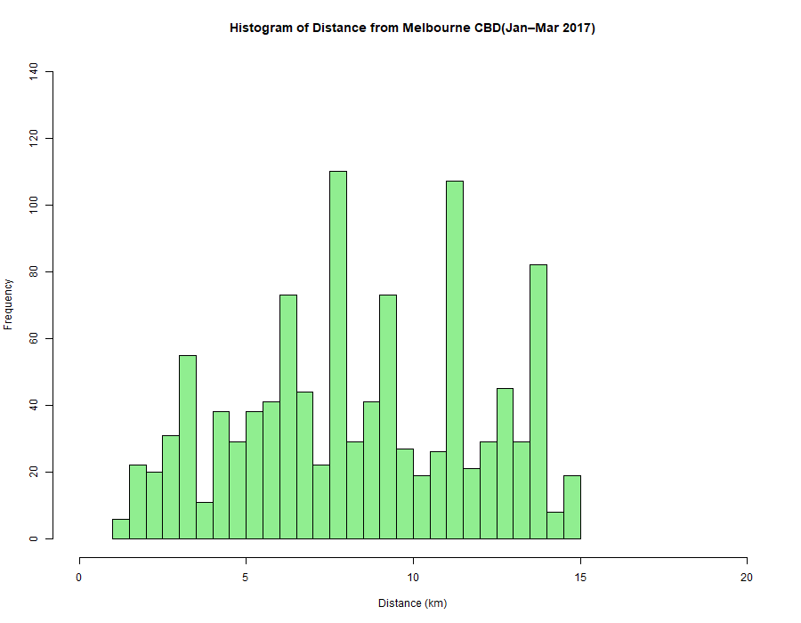
Figure 4: Distribution of Distance from Melbourne CBD

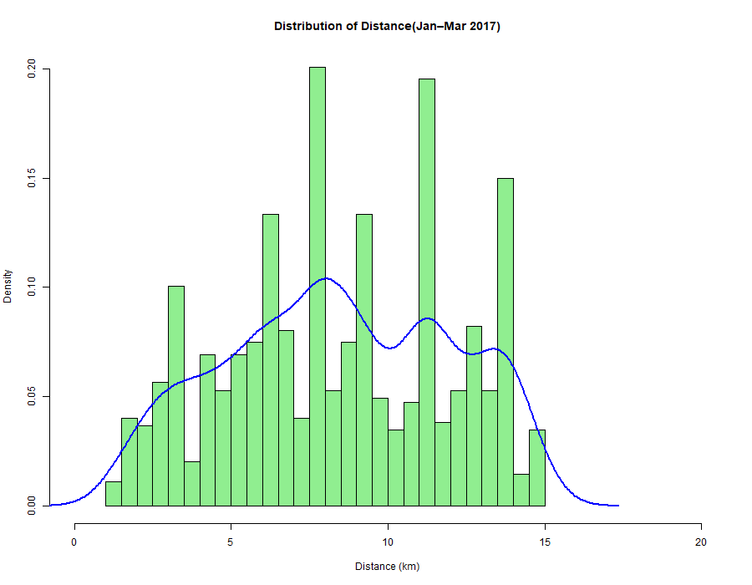
Figure 5: Distribution of Distance from Melbourne CBD with Bell curve
  - Additional information relating to understanding the data (optional)
The scatter plot shows a negative correlation: prices decrease as distance from the CBD increases. The histograms indicate non-normal distributions: distance is right-skewed, and price is considerably right-skewed, showing that the majority of residences are within 10 kilometers and cost less than $2 million, with fewer high-end outliers.
  - Useful information for the data understanding
Key insights:
- Price and distance are inversely correlated.
- The majority of properties are less than $2 million and located within 15 kilometers of the CBD.
- Both variables are right-skewed.
- Location has a considerable impact on price, with closeness attracting a premium.

- Analysis
  - Statistical test used to test the hypotheses and output
Output:
To test the correlation between Price and Distance from Melbourne CBD, three correlation tests were conducted:

Pearson's correlation:
r = -0.0876, t = -2.9083, df = 1093, p = 0.003707
The 95% confidence interval is [-0.146, -0.029].

Spearman's rank correlation:
rho = -0.0679, p = 0.0246

Kendall's tau:
tau = -0.0461

All three tests show a weak negative correlation between price and distance.

  - The null hypothesis is rejected /not rejected (select one) based on the p-value
The null hypothesis is rejected based on the Pearson’s correlation p-value (p=0.0037<0.05). This indicates a statistically significant though negative correlation between price and distance from the CBD (r=−0.088). The relationship suggests that as distance increases, price tends to decrease slightly. The 95% confidence interval [−0.146,−0.029] does not include zero, supporting a true negative association.

- Evaluation – group’s experience at 7COM1079
  - What went well
Our group worked well together throughout the assignment. At first, we had experienced little hardship due to lack of communication as members of the group are from different countries. Communication was consistent later on through frequent meetings and shared materials. We divided work based on individual strengths, which lead to rapid progress in data cleaning, analysis, and visualization. R Studio and GitHub made it easier to perform repeatable analysis and version control. We stayed focused on the research issue, which kept the project organized and goal-oriented.

  - Points for improvement
We experienced difficulties in aligning our initial visualizations which required multiple changes. Some team members had little prior experience using GitHub, which delayed initial communication. Furthermore, more frequent evaluations of R outputs would have helped detect formatting errors sooner.
  - Group’s time management
Time management was mostly good. We set weekly milestones and followed a shared timeline. However, the final week was rushed due to other deadlines. Starting the write-up earlier, while the analysis was still underway, would have minimized last-minute pressure and provided more time for refinement.
  - Project’s overall judgement
Overall, the project was successful. The project gained momentum when we reserved a slot for our research question demo and received valuable feedback from our module leaders. We addressed the research question using proper statistical tests and clear visuals. The analysis is well-documented and rationally organized.
  - Comment on GitHub log output
The GitHub log output shows our progress throughout the project. The commit history represents a planned development process, beginning with data import and progressing through cleaning, analysis, visualization, and reporting. The three most major commits are shown below, each representing a critical stage in the project's evolution. The top three important commits for our project are:
- Commit Message: “Completed background research”
This commit established the project’s theoretical foundation by summarizing relevant literature and clarifying the motivation behind the research question.
- Commit Message: “Completed visualization by using correlation between distance and price”
This update added key plots that helped interpret data patterns and visually assess the relationship between distance and housing prices.
- Commit Message: “Analysis done using Pearson, Kendall and Spearman correlation”
This commit strengthened the project by applying multiple correlation methods, improving statistical reliability and validating the findings.

- Conclusions
  - Results explained.
The correlation analysis of home prices and distance from the Melbourne CBD revealed a weak negative correlation, implying that prices are slightly higher closer to the city centre. The scatterplots indicated significant variability, indicating that distance alone does not strongly predict property prices. Histograms revealed non-normal distributions, particularly the right-skewed price distribution. Overall, the findings suggest that, while distance has an impact on price, it is not the primary predictive factor in this dataset.
  - Interpretation of the results
In response to the research question, the findings indicate that distance to the CBD has minimal predictive power for Melbourne property prices. Although there is a small negative pattern, a negative correlation suggests that many other factors—such as property type, land size, suburb characteristics, and market conditions—play a larger impact. For the population and the larger housing market, this indicates that purchasers and lawmakers should not assume that distance alone affects home value, and a more thorough evaluation is required.

  - Reasons and/or implications for future work, limitations
This study's limitations include missing values, a three-month duration, and reliance on a single dataset. Future research should incorporate more factors, longer time periods, and location-based accessibility measurements. Advanced modelling may show deeper trends and provide more precise insights into Melbourne's complicated housing market environment.

- Reference list

al, B. e., 2003. Do housing submarkets really matter?. Journal of Housing Economics, Volume 12(1), p. pp. 12–28.
Kauko, 2003. On current neural network applications involving spatial modelling of property prices. Journal of Housing and the Built Environment, Volume 18(2), p. pp. 159–181.
Khan, 2024. Urban Property Valuation and Transport Accessibility. Melbourne: University of Melbourne Press.
Rahman, 2023. Metro rail impact on housing prices in Dhaka. Dhaka: Bangladesh Institute of Development Studies (BIDS).
Smith, J., 2023. Real Estate Location and Pricing in Australian Cities. In: Melbourne: Urban Studies Press, p. pp. 45–78.

- Appendices
- R code used for analysis and visualisation.
View(melb_data)
class(melb_data$Date)
mean(melb_data$Price)
summary(melb_data)
class(melb_data$Price)
class(melb_data$Distance)
melb_data$Date_formatted<-melb_data$Date
class(melb_data$Date_formatted)
melb_data$Date_formatted <- format(melb_data$Date_formatted, "%d-%m-%Y")

#Converting the Date column into proper Date format (required for subsetting by year/month)
melb_data$Date_formatted <- as.Date(melb_data$Date_formatted, format="%d/%m/%Y")

class(melb_data$Date_formatted)
melb_data_subset<- subset(melb_data,format(Date, "%Y") == "2017" & format(Date, "%m") %in% c("01", "02", "03"))
melb_data$Date<- as.Date(melb_data$Date, format="%d/%m/%Y")
class(melb_data$Date)
#Creating a subset containing only Jan–Mar 2017 data
melb_data_subset<- subset(melb_data,format(Date, "%Y") == "2017" & format(Date, "%m") %in% c("01", "02", "03"))
#Converting price into millions for easier interpretation and cleaner plots
melb_data_subset$Price_in_million<-melb_data_subset$Price/1000000

png("price_histogram.png", width = 900, height = 700)
#Creating histogram of house prices for early 2017
hist(melb_data_subset$Price_in_million,
breaks =40,
col = "lightgreen",
main="Distribution of House Prices(Jan–Mar 2017)",
xlab="Price (Million Dollars)",
ylab = "Frequency",
ylim = c(0,120),
las=1)
dev.off()

png("price_histogram-with_bellcurve.png", width = 900, height = 700)
#Creating histogram of distance from Melbourne CBD for early 2017
hist(melb_data_subset$Price_in_million,
breaks = 20,
col = "lightgreen",
main="Distribution of House Prices(Jan–Mar 2017)",
xlab="Price (Million Dollars)",
freq = FALSE)
#Adding a density curve to show the smoothed shape of the price distribution
lines(density(melb_data_subset$Price_in_million),
col = "blue",
lwd = 2)
dev.off()

png("distance_histogram.png", width = 900, height = 700)
hist(melb_data_subset$Distance,
main = "Histogram of Distance from Melbourne CBD(Jan–Mar 2017)",
xlab = "Distance (km)",
breaks =40,
col = "lightgreen",
xlim = c(0,20),
ylim = c(0,140)
)
dev.off()

png("distance_histogram_with_bellcurve.png", width = 900, height = 700)
hist(melb_data_subset$Distance,
breaks =40,
main = "Distribution of Distance(Jan–Mar 2017)",
xlab = "Distance (km)",
xlim = c(0,20),
col = "lightgreen",
freq = FALSE)

lines(density(melb_data_subset$Distance),
col = "blue",
lwd = 2)
dev.off()

x<-melb_data_subset$Distance
y<-melb_data_subset$Price_in_million
png("Price_distance_correlation.png", width = 900, height = 700)
#Plotting Price vs Distance to visually inspect whether a correlation exists
plot(x,y,main = "Price vs Distance from Melbourne CBD(Jan–Mar 2017)",
xlab="Distance(km) from Melbourne CBD",
ylab = "Price in million dollars",
pch=19,
xlim = c(0,20),
ylim = c(0,4),
frame=T)
#Using a linear regression model to test the strength of the correltaion
model<-lm(y~x,data = melb_data_subset)
#Adding regression line to scatterplot to show trend between Price and Distance
abline(model,col="blue")
dev.off()

#Performing Pearson correlation test to check statistical significance of the relationship
cor(melb_data_subset$Distance, melb_data_subset$Price_in_million,
method = "pearson")
cor.test(melb_data_subset$Distance, melb_data_subset$Price_in_million)
#Performing Kendall correlation test to check statistical significance of the relationship
cor(melb_data_subset$Distance, melb_data_subset$Price_in_million,
method = "kendall")

cor.test(x, y, method="pearson")
cor.test(x, y, method="spearman")
- GitHub log output.

commit 2dacbd7365c607c34236b28f7fd5dbfa116cec12 (HEAD -> main, origin/main, origin/HEAD)
Author: MOHAMMED MAMUN CHOWDHURY <mc25abo@herts.ac.uk>
Date: Mon Dec 8 11:06:58 2025 +0000

Section 5 is completed

commit 2d1ef4c249513968cebcb9e3a1770cd2ec026c1e
Author: MOHAMMED MAMUN CHOWDHURY <mc25abo@herts.ac.uk>
Date: Sun Dec 7 13:42:58 2025 +0000

Analysis done using Pearson,kendall and spearman correlation

commit d0a33103d601e1594c233d0ed7ef1afd494507f5
Author: MOHAMMED MAMUN CHOWDHURY <mc25abo@herts.ac.uk>
Date: Sun Dec 7 13:19:07 2025 +0000

completed visualization by using correlation between distance and price

commit 510186d19f9d60083f9920b1884bd1dfe1a99e5b
Merge: bf5da06 72428ef
Author: MOHAMMED MAMUN CHOWDHURY <mc25abo@herts.ac.uk>
Date: Sun Dec 7 13:17:27 2025 +0000

Merge branch 'main' of https://github.com/mamuntasin333/Group-A-140

commit bf5da06e42835f25206a869342c40fc01ae54b06
Author: MOHAMMED MAMUN CHOWDHURY <mc25abo@herts.ac.uk>
Date: Sun Dec 7 13:17:13 2025 +0000

The list below outlines the chapter/subchapter numbers, names, word count limits, and explanations of what to write in each section.

1. Introduction

  - Problem statement and research motivation (100 words)
- What is the problem in the area we want to learn more about (motivation for study).
- Use at least one citation from related literature for top marks.
  - The data set (75 words)
  - Research question (50 words). State your RQ (50 words)
  - Null hypothesis and alternative hypothesis (H0/H1) (100 words)

- Background research
  - Research papers (at least 3 relevant to your topic / DS) (200 words)
- Was the data set used for some research papers? Summarise and reference at least 3 relevant research papers to your topic / DS. See https://herts.instructure.com/courses/61421/modules for writing.

  - Why RQ is of interest (research gap and future directions according to the literature) (100 words)

- Visualisation
  - Appropriate graphs for the RQ output of an R script (NOT a screenshot) (50 words)
- Explain the choice of the plot.
- Include your main plot relevant to the RQ type.
- Include histogram or contingency table (think what is suitable) in addition to the main plot.
- Anything on the plot from R is not counted towards word count limit (e.g. legend, axes titles, name).
- Make sure that the plot is from output of an R script (NOT a screenshot).
- Make sure that the plot has a caption or title, X and Y-axis labels with units where appropriate, and legend.
- Make sure the title or caption and axis labels are informative and written in English.

  - Additional information relating to understanding the data (optional) (50 words)
- Per plot: explain the purpose and insights.

  - Useful information for the data understanding (50 words)
- Summarise key observations from the plot.

- Analysis
  - Statistical test used to test the hypotheses and output (75 words)
- Explain the choice of the statistical test.
- Make sure the test is appropriate for the RQ and data.

  - The null hypothesis is rejected /not rejected based on the p-value (100 words) (interpret the results)

- Evaluation – group’s experience at 7COM1079
  - What went well (75 words)
  - Points for improvement (75 words)
  - Group’s time management (50 words)
  - Project’s overall judgement (50 words)
  - Note any changes to group since original allocation if applicable. Add new or amended GitHub Ids for new members (75 words, write only if applies to your group arrangements)
  - Comment on the GitHub log output (50 words)
Please comment on the GitHub log output, and refer to it as being placed into Appendix B.
From your Git log, select three most significant commits during this project and include the following for each:
- Commit Message: [Insert Commit Message] Brief explanation of the broader impact of the change
- Commit Message: [Insert Commit Message] Brief explanation of the broader impact of the change
- Commit Message: [Insert Commit Message] Brief explanation of the broader impact of the change

- Conclusions
  - Results explained (75 words)
  - Interpretation of the results (75 words)
- Interpretation of what the results mean in terms of your RQ and the effect this may have on your population and the wider context of your topic.
  - Reasons and/or implications for future work, limitations of your study (50 words)

- Reference list (not included in the word count)
Harvard (author, date) format.

- Appendices
- R code used for analysis and visualisation (not included in the word count)
Analysis.R code with the appropriate statistics to test the hypotheses.
- No word count, but ensure the code is without redundant lines, well-commented and produces the correct output.
- Make sure it runs (look in Rscript.log for output from a statistical test)
- It should compute appropriate statistics to test the hypotheses
- GitHub log output.

