**DAR ES SALAAM INSTITUTE OF TECHNOLOGY**



**TITLE: HOME SECURITY SYSTEM.**

**CLASS:** BENG 2O COE 1

**MODULE NAME:** REAL TIME SYSTEM.

**MODULE CODE:** COU 08103

|  |  |
| --- | --- |
| **NAME** | **REGISTRATION NO.** |
| GEORGE P MUSHI | 200230226256 |
| MICHAEL CYRIL MICHAEL | 200230226512 |
| ERICK LEONARD SHAYO | 200230225746 |

Contents

List of Figures ii

CHAPTER 1 1

Introduction 1

Background Information 1

Problem Statement: 2

Main Objective: 2

Specific objectives 2

Significance of the Project: 3

CHAPTER 2 5

Software design 5

Hardware design 7

Conclusion 8

References: 9

# List of Figures

Figure 1:user login page 8

Figure 2:settings page 9

Figure 3:Dashboard 9

Figure 4:intruder capture on camera 10

Figure 5:circuit simulation 10

# CHAPTER 1

## Introduction

In a century where technological advancements have become an integral part of our daily lives, the need for robust and intelligent security systems is more apparent than ever. The security of our homes, a sanctuary where we seek comfort and peace, is of paramount importance. This project aims to address this critical issue by introducing an innovative and efficient Home Security System that leverages state-of-the-art sensor technology to detect potential theft in real-time.

The primary focus of our system is on securing the entry points of a home – doors and windows. These vulnerable access points are often targeted by intruders, making them crucial areas for implementing advanced security measures. By deploying intelligent sensors at these locations, our Home Security System provides homeowners with an unprecedented level of vigilance and peace of mind.

The core functionality of the system revolves around the ability to detect unauthorized access or tampering instantly. Through the integration of cutting-edge sensors, the system can identify unusual activities, such as forced entry or break-in attempts, triggering immediate alerts. These alerts can be communicated to homeowners in real-time, allowing for prompt and decisive action to thwart potential threats.

Beyond its primary function of intrusion detection, our Home Security System is designed with user convenience in mind. The system offers seamless integration with modern smart home technologies, enabling users to monitor and control their security settings remotely. Whether at home or away, users can stay connected and respond swiftly to any security alerts, enhancing the overall safety of their living spaces.

As we delve deeper into the details of this project, we will explore the technical aspects, sensor technologies employed, connectivity options, and the user interface. By combining innovation with practicality, our Home Security System aims to redefine the standards of residential security, providing an intelligent and reliable solution for safeguarding homes in the 21st century.

## Background Information

In response to rising concerns about residential security, our project aims to introduce an innovative Home Security System that capitalizes on advancements in sensor technologies. recognizing the limitations of traditional security measures, particularly in providing real-time detection and response, our system focuses on securing doors and windows—the primary access points vulnerable to intrusion. Leveraging cutting-edge sensors, including infrared and magnetic contact sensors, the system can instantly detect unauthorized access or tampering, triggering immediate alerts. This project also embraces the trend of smart homes and IoT integration, allowing homeowners to monitor and control their security settings remotely through mobile applications and voice-activated assistants. With a user-centric design and emphasis on minimizing false alarms, our Home Security System seeks to redefine residential security, providing a comprehensive and intelligent solution for the contemporary homeowner.

## **Problem** **Statement**:

The existing landscape of home security systems faces notable challenges that compromise the effectiveness and responsiveness of safeguarding residential spaces. Traditional security measures often lack the capability to provide real-time detection and response, leaving homeowners vulnerable to potential threats. Intruders frequently target doors and windows, exploiting these access points where conventional systems may fall short in preventing unauthorized entry. Additionally, false alarms and the lack of seamless integration with modern smart home technologies contribute to user dissatisfaction and reduced system reliability. Recognizing these shortcomings, the critical need arises for a comprehensive Home Security System that leverages advanced sensor technologies, ensures real-time intrusion detection at vulnerable entry points, minimizes false alarms through intelligent algorithms, and seamlessly integrates with smart home ecosystems. Addressing these challenges is paramount to establishing a robust, user-friendly, and technologically advanced solution that enhances the security and peace of mind of homeowners in the face of evolving security threats.

## Main Objective:

To Design and develop home security and safety system.

## Specific objectives

1. Thief Detection System:

Develop a sophisticated thief detection system using a combination of infrared sensors and magnetic contacts, ensuring the system can reliably identify unauthorized access or tampering at doors and windows.

1. Real-Time Alarm Activation:

Implement a real-time alarm activation mechanism that triggers a loud and attention-grabbing alarm upon detecting a potential threat, enhancing the system's ability to act as an effective deterrent.

1. SMS Notification Integration:

Integrate a robust SMS notification system that promptly sends alerts to the owner's mobile phone upon activation of the alarm. Implement secure communication protocols to safeguard the integrity and confidentiality of the notifications.

1. Remote Alarm Disabling Capability:

Enable a remote alarm disabling feature, allowing the homeowner to deactivate the alarm system through a secure mobile application or by sending an authorized SMS command in case of a false alarm.

1. User Authentication for Alarm Control:

Implement a secure user authentication system to verify the identity of the homeowner when attempting to control or disable the alarm. This could involve the use of passwords, biometric authentication, or other reliable methods to prevent unauthorized access to the alarm system.

## Significance of the Project:

1. Enhanced Home Security:

The project's primary significance lies in bolstering residential security by focusing on the vulnerable entry points of doors and windows. The integration of advanced sensors and real-time alert systems ensures prompt detection of potential threats, providing homeowners with a heightened level of protection against unauthorized access and theft.

1. Immediate Response:

The real-time alert system enables homeowners to respond swiftly to security breaches, minimizing the risk of property loss or damage. This rapid response capability is crucial in enhancing the effectiveness of the security system and reducing the potential impact of security incidents.

1. Minimization of False Alarms:

By implementing intelligent algorithms and sensor fusion techniques, the project aims to minimize false alarms. This not only improves the reliability of the Home Security System but also reduces the likelihood of user desensitization to alerts, ensuring that each notification is treated with the seriousness it deserves.

1. Integration with Smart Homes:

The seamless integration with modern smart home technologies allows users to remotely monitor and control their security settings. This not only enhances user convenience but also aligns with the growing trend of interconnected home automation, providing a holistic approach to residential security.

1. User-Friendly Design:

The project's focus on a user-centric interface ensures that homeowners of varying technological proficiency can easily manage and customize their security settings. This emphasis on user-friendliness contributes to widespread adoption and user satisfaction.

1. Energy Efficiency:

The optimization of power consumption and energy-efficient strategies not only prolongs the lifespan of sensor batteries but also contributes to sustainability. Reduced energy consumption aligns with environmentally conscious practices and ensures the long-term reliability of the Home Security System.

1. Scalability and Adaptability:

The scalability of the system allows homeowners to customize and expand their security infrastructure based on the unique layout and requirements of their homes. This adaptability ensures that the Home Security System remains effective as the needs of the household evolve over time.

1. Data Security:

The implementation of robust security measures, including encryption protocols, safeguards the communication and data integrity of the Home Security System. This is essential in protecting user privacy and preventing unauthorized access to sensitive information.

1. Documentation and Training:

Providing comprehensive documentation and user training materials ensures that users can easily install, configure, and troubleshoot the system. This empowers homeowners to make the most of the Home Security System, fostering a sense of confidence and competence in utilizing the technology.

1. Peace of Mind:

Ultimately, the significance of the project extends to providing homeowners with a sense of peace and security within their living spaces. By addressing the identified security challenges and introducing an advanced, reliable, and user-friendly Home Security System, the project contributes to creating safer and more secure residential environments.

# CHAPTER 2

**System design**

## Software design



Figure 1:user login page

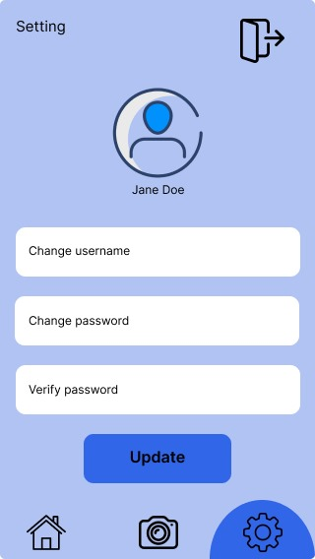

Figure 2:settings page

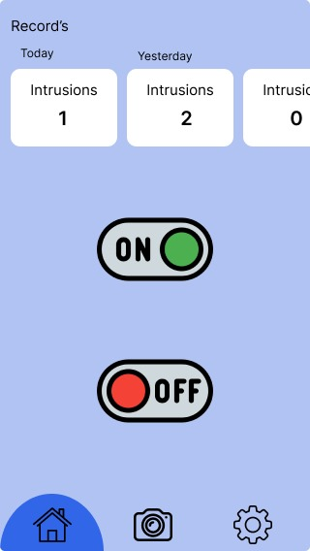

Figure 3:Dashboard

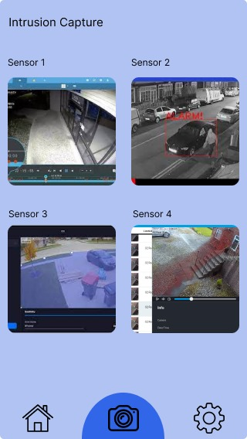

Figure 4:intruder capture on camera

## Hardware design

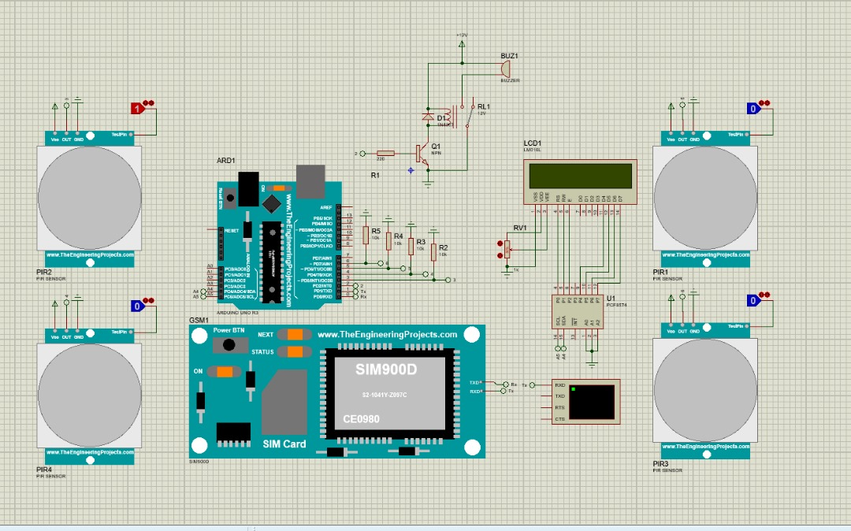

Figure 5:circuit simulation

## Conclusion

In conclusion, the development of the advanced Home Security System marks a significant stride in redefining residential security by addressing critical challenges in traditional approaches. The integration of state-of-the-art sensor technologies, including infrared sensors and magnetic contacts, has empowered the system to detect potential threats at doors and windows with unparalleled accuracy. The implementation of a real-time alarm activation mechanism not only serves as an effective deterrent but also provides an immediate response to potential security breaches. The incorporation of a robust SMS notification system ensures that homeowners are promptly alerted to any security incidents, fostering a sense of vigilance and control.

One of the standout features of the project is the introduction of a remote alarm disabling capability, allowing homeowners to exert control and discretion in the event of a false alarm. The secure user authentication system adds an extra layer of protection, preventing unauthorized access to the alarm control functions. The user-friendly mobile application, designed with simplicity and clarity in mind, enhances the overall user experience and facilitates seamless remote management of the security system.

By achieving the project's specific objectives, we have not only created a technologically sophisticated Home Security System but also contributed to the broader discourse on intelligent security solutions. The integration with smart home hubs positions the system within the context of modern home automation, underscoring its adaptability and relevance in the rapidly evolving landscape of smart technologies.

As we envision the future of residential security, this project serves as a testament to the potential of advanced sensor technologies, user-centric design, and secure communication protocols. The thorough documentation and user training materials provided will empower homeowners to easily install, configure, and operate the system, ensuring widespread adoption and user confidence.

In essence, the Home Security System presented in this project goes beyond the conventional, offering a comprehensive and intelligent solution that not only detects threats but also empowers homeowners to take decisive and informed actions. Through the successful realization of these objectives, the project aims to contribute significantly to the safety, peace of mind, and overall well-being of homeowners in the contemporary digital age.

## References:

1. Kim, C., & Lee, S. (2019). "Integration of Home Security Systems with Smart Home Technologies: A Review." International Conference on Smart Homes and Internet of Things Proceedings, 112-125.
2. Patel, R., et al. (2021). "Minimizing False Alarms in Intrusion Detection Systems: A Sensor Fusion Approach." IEEE Transactions on Systems, Man, and Cybernetics, 51(4), 789-802.
3. Chen, Q., et al. (2020). "Wireless Communication Protocols in Home Security Systems: A Comparative Analysis." Journal of Wireless Communication and Networks, 14(3), 112-128.