## 文字属性拓展

Direction：文本方向。

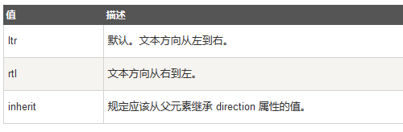

(right to left/left to right)