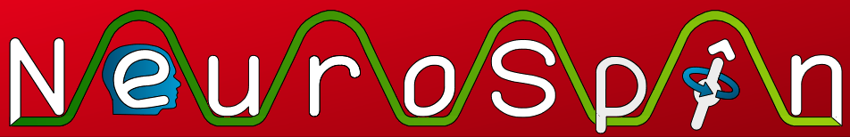


Authors: Courtois Neuromod,
Himanshu Aggarwal, Bertrand Thirion
Date: 21st March 2023
IBC Project: Mario

During this session, you will play SuperMarioBros. Your goal is to reach the end of the level before the timer hits 0, while avoiding and/or interacting with the obstacles and rewards. Please try to keep your head still while playing the game.

You will start at the extreme left of the level, and will need to reach the extreme right. You have unlimited lives to finish each level, but the level will restart from the beginning each time you use 3 lives. Each run is 10 minutes long and you can progress through or repeat as many levels during this time. The next run would start exactly wherever you were at the end of the previous run. You will do 8 such runs.

The controls for the game are as shown below:

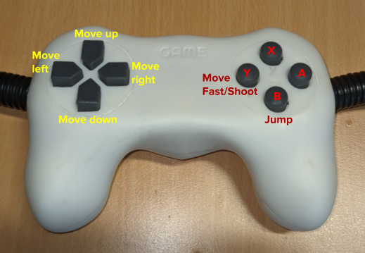

After each run, you will answer a short questionnaire. To navigate through the questions use the up/down arrows, and select a value on the scale with the left/right arrows. Positioning the white dot on the far Left means that you “Completely disagree” with the statement, while the far Right means you “Completely agree”. You can then validate your responses with the A button. Please familiarize yourself with the questions below in order to save time in the scanner.

I feel just the right amount of challenge.
My thoughts/activities run fluidly and smoothly.
I don’t notice time passing.
I have no difficulty concentrating.
My mind is completely clear.
I am totally absorbed in what I am doing.
The right thoughts/movements occur of their own accord.
I know what I have to do each step of the way.
I feel that I have everything under control.
I am completely lost in thought.

