- Making POST resquest for user registration
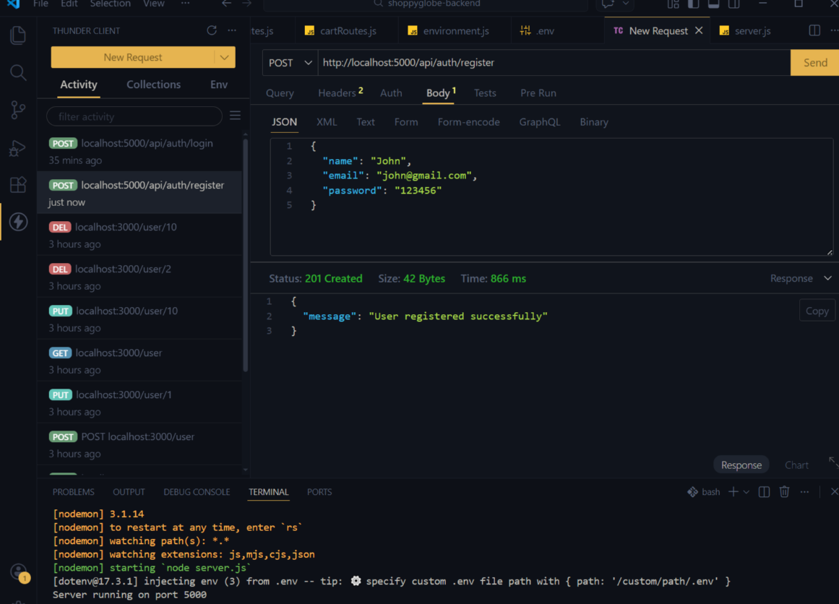

- Auth login with token using POST

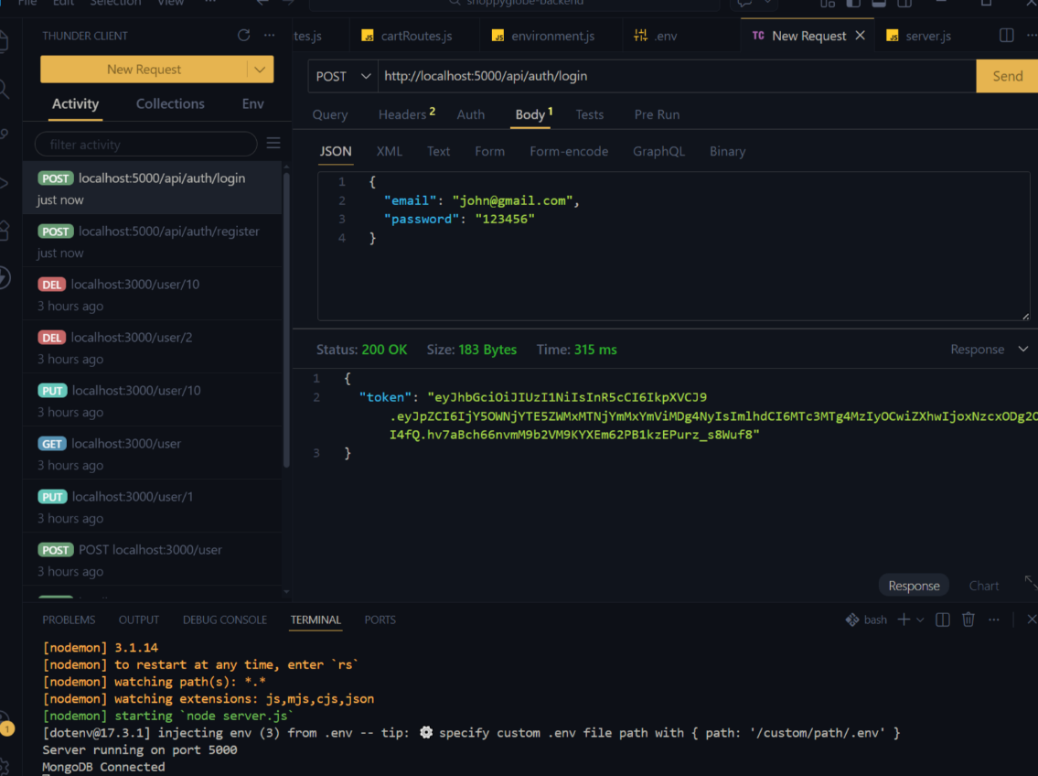

- Making POST request to push product data and generating unique id
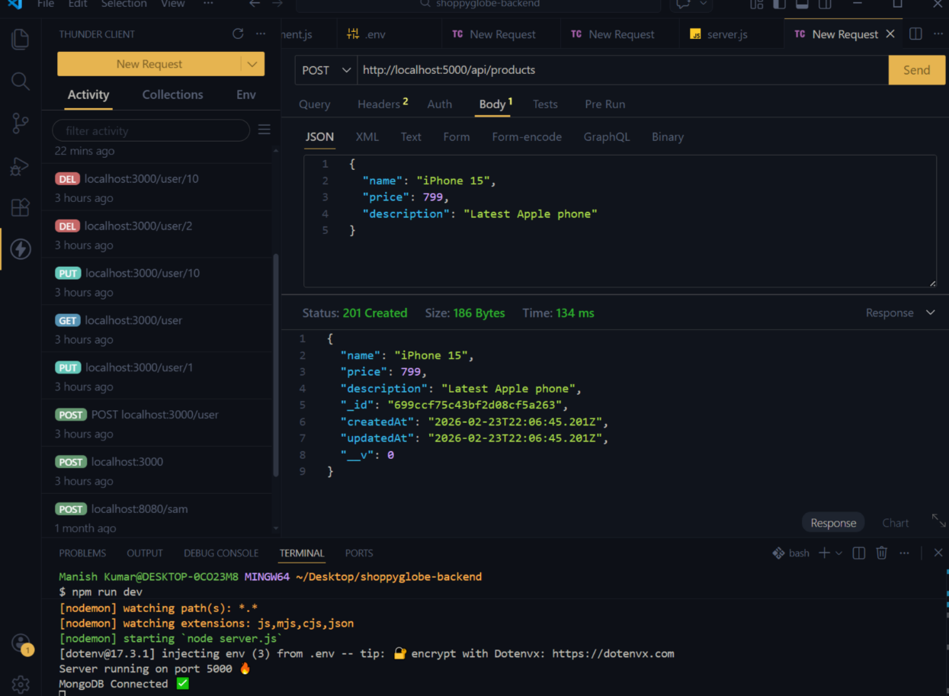

- Using GET to get product details with generated id
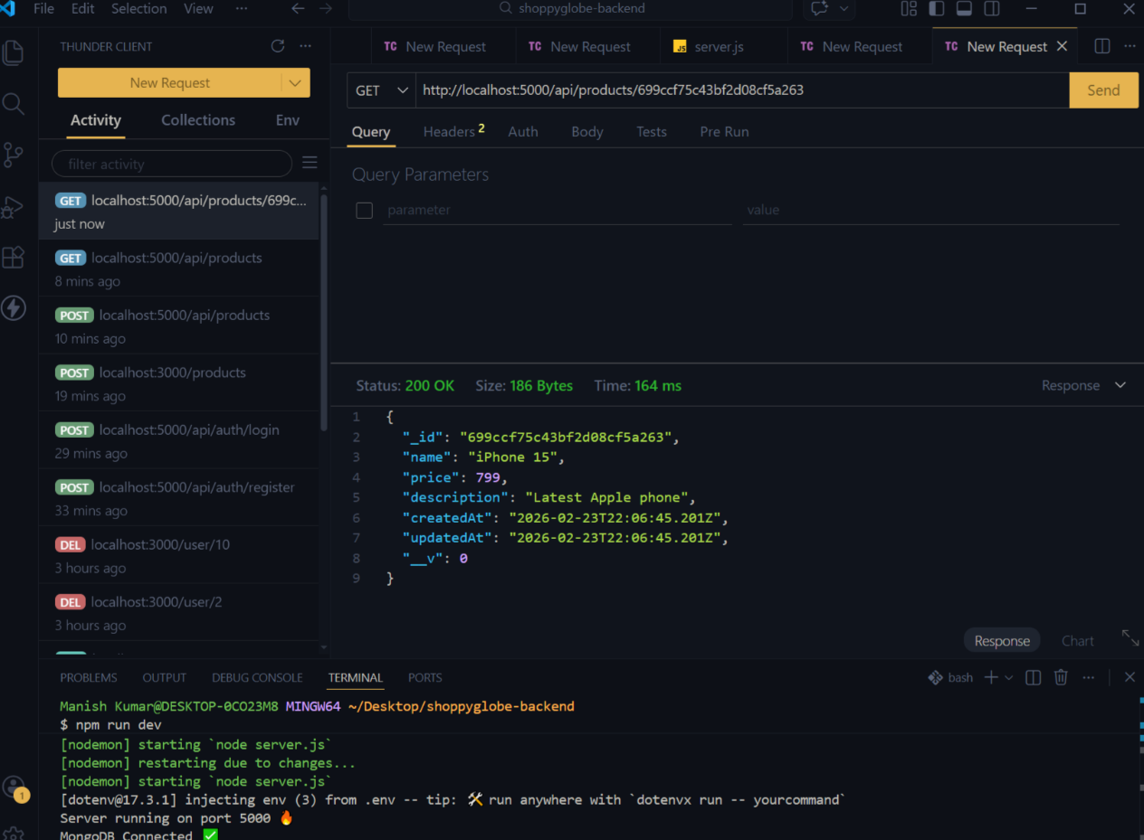
- Updating product details with PUT and id
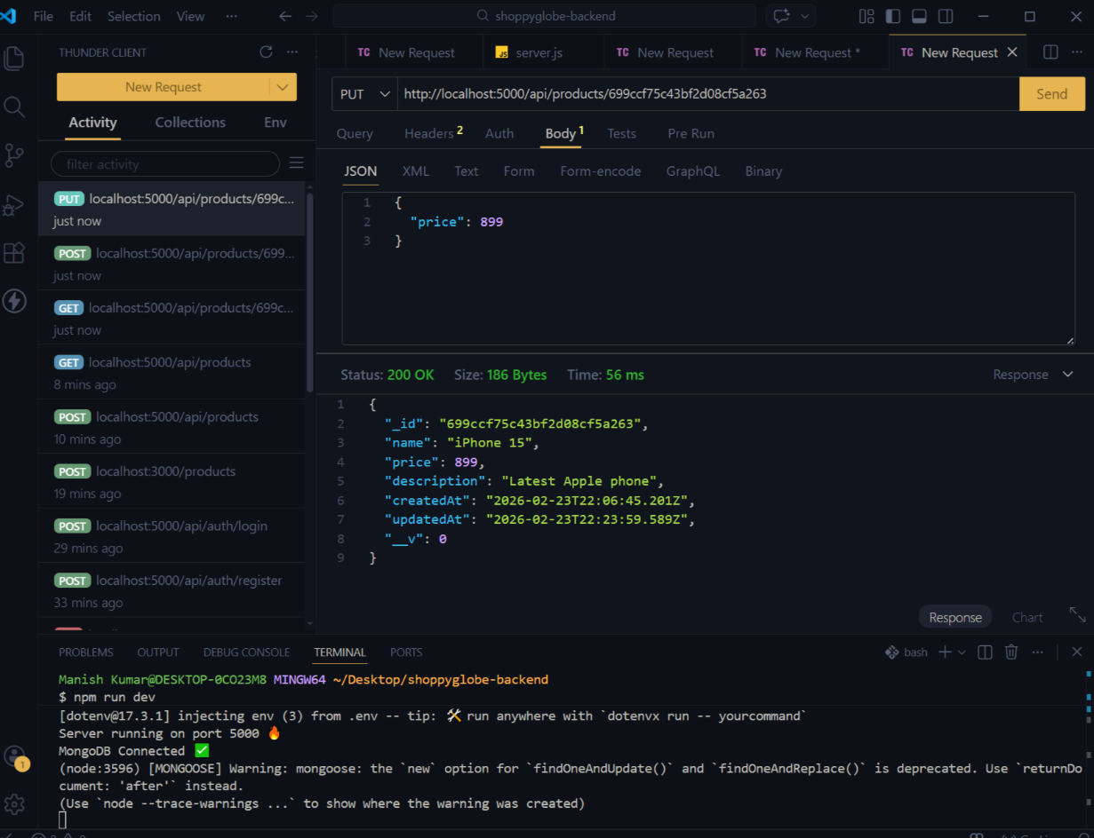

- Deleting product detail with DELETE and id
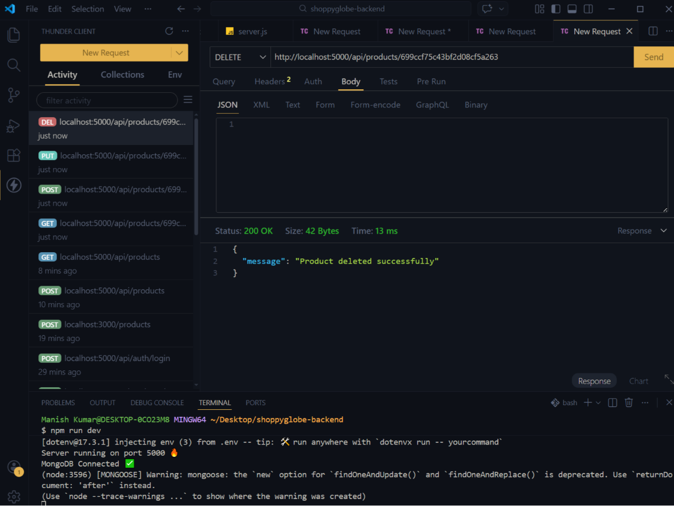

- Product detail of shoppyglobe inside mongodb compass after pushing data
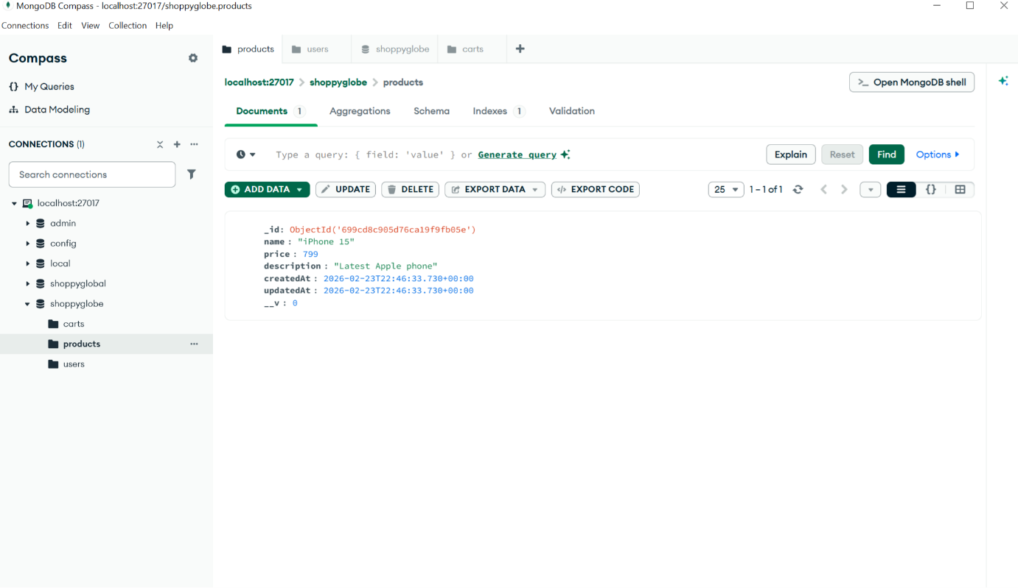

- User deatil of shoppyglobe inside mongodb compass after pushing data
