Assignment-4

Manan Solanki

**Troubleshooting and Helpdesk**

**Section 1:**

1. What is the first step in the troubleshooting process?

🡪 b) **Identifying the problem**

2) Which of the following tools is commonly used to diagnose hardware issues by testing electrical connections?

🡪 c**) Multi meter**

3) Which of the following best describes the purpose of a VPN (Virtual Private Network)?

🡪 a**) Encrypting network traffic to prevent eavesdropping**

4) Which Windows utility can be used to view system logs, monitor performance, and diagnose hardware and software issues?

🡪**Event Viewer**

Section-2

5) Safe Mode is a diagnostic mode in Windows that loads only essential system services and drivers, allowing users to troubleshoot and fix problems with the operating system.

🡪**True**

6) A system restore point is a snapshot of the computer's system files, registry, and configuration settings at a specific point in time, which can be used to revert the system to a previous state if problems occur.

🡪**True**

7) Ping is a command-line utility used to test network connectivity by sending ICMP echo requests to a target device and waiting for ICMP echo replies.

🡪**True**

Section-3

8) Describe the steps involved in troubleshooting a computer that fails to boot into the operating system.

🡪Here are few steps:

1) **Check Power and Connections:**  
Make sure the computer turns on, cables are plugged in, and the monitor works.

2) **Look for Error Messages:**  
Pay attention to any messages or beeping sounds during startup.

3) **Open BIOS/UEFI Settings:**  
Press a key like F2 or DEL when starting up to check that the computer detects the hard drive and the boot order is correct.

4)**Try Safe Mode:**  
Restart and press F8 (or follow steps for your system) to boot into Safe Mode to see if the computer works with basic settings.

5) **Use Repair Tools:**  
Use Startup Repair or System Restore if available to fix boot issues.

6)**Check Hardware:**  
Run tools to test your RAM, hard drive, and other hardware, or try replacing faulty parts.

7)**Reinstall Windows:**

reinstall the operating system, but back up your files first if possible.

Section 4

9. Demonstrate how to troubleshoot network connectivity issues on a Windows computer using the ipconfig command

🡪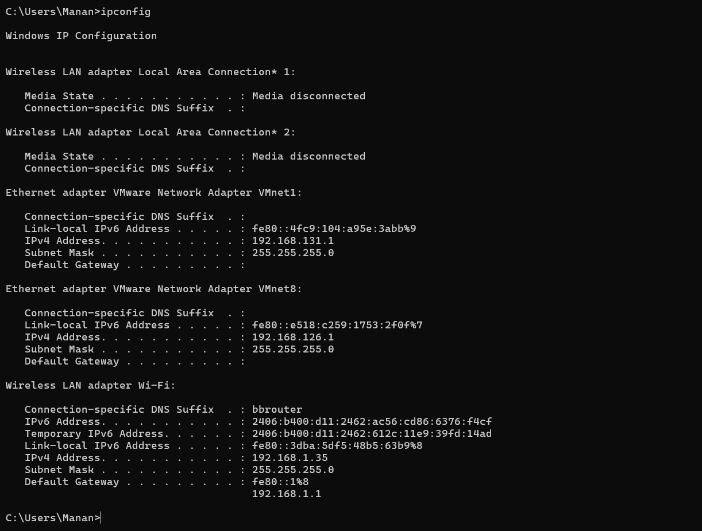

Section 5:

10. Discuss the importance of effective communication skills in a helpdesk or technical support role

🡪**1. Clear Problem Understanding**

* Effective communication helps technicians gather accurate information about the problem. Asking the right questions ensures clarity and avoids misunderstandings.

**2. Simplifying Technical Concepts**

* Many customers lack technical knowledge, so it's essential to explain complex issues in simple, relatable terms without jargon.

**3. Building Trust and Rapport**

* Polite, empathetic, and professional communication helps customers feel heard and valued, even in frustrating situations.

**4. Efficient Problem Resolution**

* Precise instructions and active listening ensure quicker resolution by minimizing back-and-forth.

**5. Documentation and Team Collaboration**

* Clear communication helps document issues for future reference and enables effective collaboration with other team members.

**6. Managing Customer Expectations**

* Setting realistic expectations avoids frustration and keeps customers informed about timelines or limitations.

**7. Handling Difficult Situations**

* Calm and composed communication helps defuse angry or upset customers, maintaining professionalism while resolving their issues.

**8. Encouraging Feedback**

* Good communication encourages customers to share feedback, which can help improve service quality.

--------------%------------%-------------------%----------------