Name- Manan Solanki

Assignment-6

Section-6

1) What is the primary purpose of a firewall in a network security infrastructure?

**🡪 Filtering and controlling network traffic**

2) What type of attack involves flooding a network with excessive traffic to disrupt normal operation?

🡪**Denial of Service (DoS)**

3) Which encryption protocol is commonly used to secure wireless network communications?

🡪 **WPA (Wi-Fi Protected Access**

4) What is the purpose of a VPN (Virtual Private Network) in a network security context?

**🡪 Encrypting network traffic to prevent eavesdropping**

Section-2

5) Patch management is the process of regularly updating software and firmware to address security vulnerabilities and improve system performance.

🡪**True**

6) A network administrator should perform regular backups of critical data to prevent data loss in the event of hardware failures, disasters, or security breaches.

🡪**True**

7) Traceroute is a network diagnostic tool used to identify the route and measure the latency of data packets between a source and destination device.

🡪**True**

Section-3

8) Describe the steps involved in conducting a network vulnerability Assignment

🡪

Section-4

9) Demonstrate how to troubleshoot network connectivity issues using the ping command.

🡪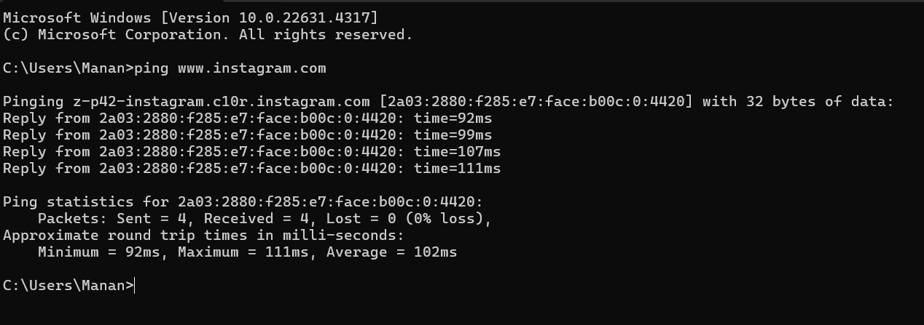

Section-5

10) Discuss the importance of regular network maintenance and the key tasks involved in maintaining network infrastructure

🡪 IMPORTANCE:

1) **Improving Network Performance:**

* Over time, network components can become outdated, misconfigured, or suffer from performance degradation. Regular maintenance ensures that the network operates efficiently, minimizing slowdowns and optimizing performance.

2) **Enhancing Security:**

* Cyber threats evolve constantly. Regular maintenance includes patching vulnerabilities, updating firewalls, and applying security protocols to protect the network from attacks like malware, ransomware, and unauthorized access.

3) **Reducing the Risk of Data Loss:**

* Maintenance includes tasks like backing up critical data, which reduces the risk of data loss in the event of hardware failure or security breaches.

4)**Compliance and Reporting:**

* For businesses in regulated industries, network maintenance is essential for compliance with industry standards (such as GDPR or HIPAA). Maintenance tasks ensure the network adheres to necessary regulatory requirements.

5)**Optimizing Resource Utilization:**

* Regular maintenance helps identify underused resources and optimize the network design to reduce unnecessary costs, increase resource allocation, and improve overall network efficiency.

🡪KEY FEATURES:

1. **Hardware and Software Updates:**
   * **Updating Firmware and Software**: Keeping routers, switches, firewalls, and other devices updated with the latest firmware and software ensures that bugs are fixed, and new features are added.
2. **Backup and Recovery:**
   * **Regular Backups**: Periodically backing up configurations, critical data, and network settings ensures quick recovery in case of hardware failure, data corruption, or cyberattacks.
3. **Monitoring and Performance Tuning:**
   * **Network Monitoring**: Continuously monitoring network traffic, device health, and performance metrics (like bandwidth utilization) helps detect issues such as congestion, latency, or security incidents.
4. **Security Management:**
   * **Firewall Configuration and Management**: Regularly reviewing firewall rules and logs ensures the network is protected from unauthorized access and attacks.
   * **Access Control**: Reviewing and updating access control lists (ACLs), user permissions, and authentication methods ensures only authorized personnel can access sensitive network resources.
5. **Network Documentation:**
   * **Documenting Changes and Configurations**: Keeping an updated record of network configurations, device settings, IP addressing, and layout helps in troubleshooting and network upgrades.
6. **Testing and Troubleshooting:**
   * **Routine Testing**: Performing regular tests like pinging devices, running traceroutes, and checking for network performance issues ensures that all systems are functioning correctly.
   * **Troubleshooting and Issue Resolution**: Quickly diagnosing and resolving network issues (such as device failures, misconfigurations, or connection problems) helps maintain optimal operation.
7. **Network Configuration Management:**
   * **Configuration Backups**: Storing and regularly updating configuration files from network devices (routers, switches, firewalls) ensures quick recovery and consistency.
8. **Network Scalability Planning:**
   * **Capacity Planning**: Analyzing the current network load and planning for future growth helps ensure that the network infrastructure can handle increasing demand.
   * **Hardware Upgrades**: Proactively upgrading hardware components ensures the network can scale efficiently as the organization grows.
9. **User Support and Training:**
   * **User Education**: Regularly training employees on security best practices (e.g., avoiding phishing, password management) helps minimize the risk of human error or security breaches.
   * **Support for End Users**: Providing regular technical support for users helps in resolving connectivity issues, misconfigurations, and other network-related problems quickly.

--------------%-----------------%-----------------%----------------