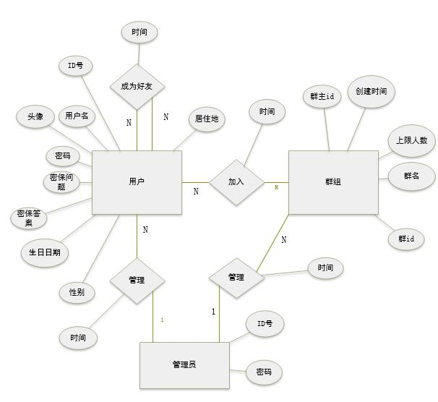

1. 创建user表

|  |  |  |  |
| --- | --- | --- | --- |
| **字段说明** | 字段名称 | **类型** | **约束** |
| **用户id** | **u_id** | **char(8)** | **主键** |
| **用户名** | **u_name** | **char(20)** | **非空** |
| **密码** | **u_password** | **Char(20)** | **非空** |
| **密保问题** | **u_secQuestions** | **Char(100)** |  |
| **密保答案** | **u_secAnswer** | **Char(100)** |  |
| **生日日期** | **u_birthday** | **Smalldatetime** |  |
| **居住地** | **u_address** | **Char(50)** |  |
| **性别** | **u_sex** | **char(2)** |  |
| **头像** | **u_picture** | **image** |  |
| **封禁时间** | **u_time** | **Smalldatetime** |  |

1. **创建好友关系（friend-relation）表**

|  |  |  |  |
| --- | --- | --- | --- |
| **字段说明** | **字段名称** | **类型** | **约束** |
| **用户id** | **u_id** | **char(8)** | **主键** |
| **好友id** | **f_id** | **char(8)** | **主键** |
| **成为好友时间** | **Time** | **Smalldatetime** | **非空** |
| **解除好友时间** | **unfriend_time** | **Smalldatetime** |  |

1. **创建群组（group）表**

|  |  |  |  |
| --- | --- | --- | --- |
| **字段说明** | **字段名称** | **类型** | **约束** |
| **群id** | **g_id** | **char(8)** | **主键** |
| **群名** | **g_name** | **char(20)** | **非空** |
| **群主id** | **u_id** | **char(8)** |  |
| **创建时间** | **start_time** | **Smalldatetime** |  |
| **上限人数** | **Max** | **char(8)** |  |
| **封禁时间** | **time** | **Smalldatetime** |  |

1. **创建群成员（group-member）表**

|  |  |  |  |
| --- | --- | --- | --- |
| **字段说明** | **字段名称** | **类型** | **约束** |
| **群id** | **g_id** | **char(8)** | **主键** |
| **群成员id** | **u_id** | **char(8)** | **主键** |
| **入群时间** | **time** | **Smalldatetime** |  |
| **退出群时间** | **ungroup_time** | **Smalldatetime** |  |

1. **管理员表（admin）**

|  |  |  |  |
| --- | --- | --- | --- |
| **字段说明** | **字段名称** | **类型** | **约束** |
| **管理员id** | **adm_id** | **char(8)** | **主键** |
| **密码** | **adm_password** | **Char(20)** | **非空** |