**CSC-462 ARTIFICIAL INTELLIGENCE**

**LAB 01**

**Manaal Waseem**

**FA18-BCE-074**

**BCE-7B**

**Home Activities:**

**Activity 1:**

Student grading system

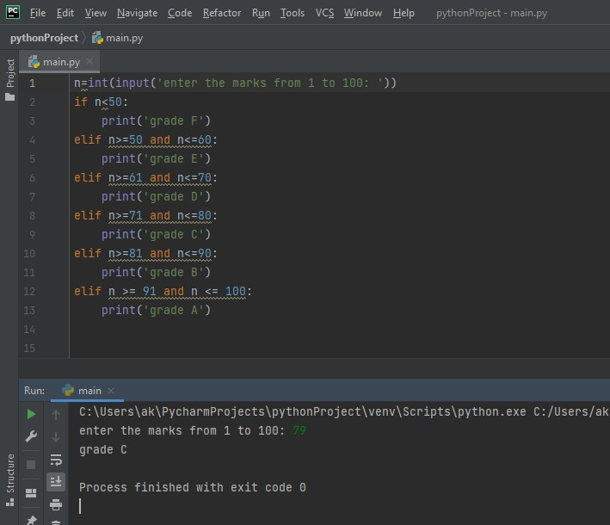

**Activity 2:**

Factorial of a number

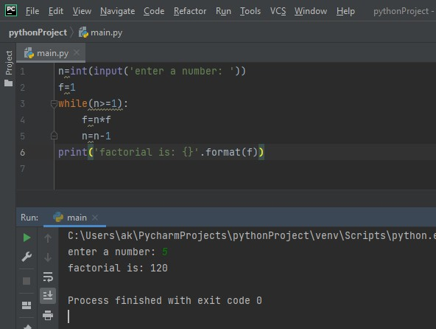

**Assignment:**

Fibonacci series printing the previous number and the sum of last 2 numbers

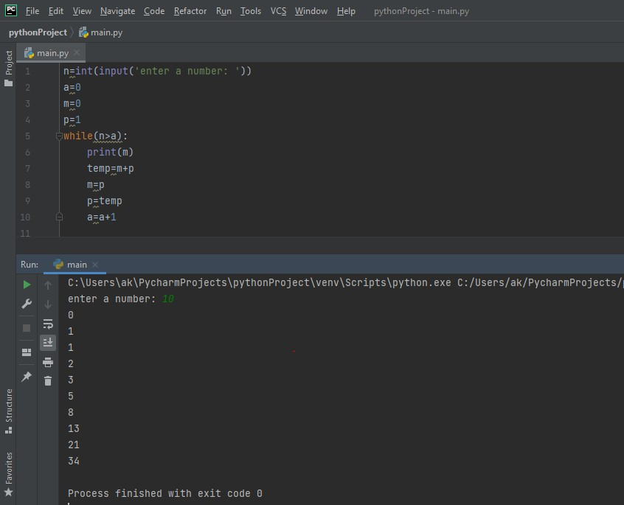

**Critical Analysis:**

This lab was to get an introduction to python language. In this lab we learned the basic commands in python. We learned the commands for strings, variables, the print function, the if else conditions and while loop.