**CSC-462 ARTIFICIAL INTELLIGENCE**

**LAB 05**

**Graph Theory and Path Searches in Python**

**Manaal Waseem**

**FA18-BCE-074**

**BCE-7B**

**Activities:**

**Post Activities:**

Imagine going from Arad to Bucharest in the following map. Implement a UCS to find the corresponding path.

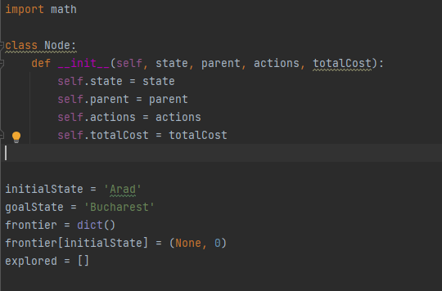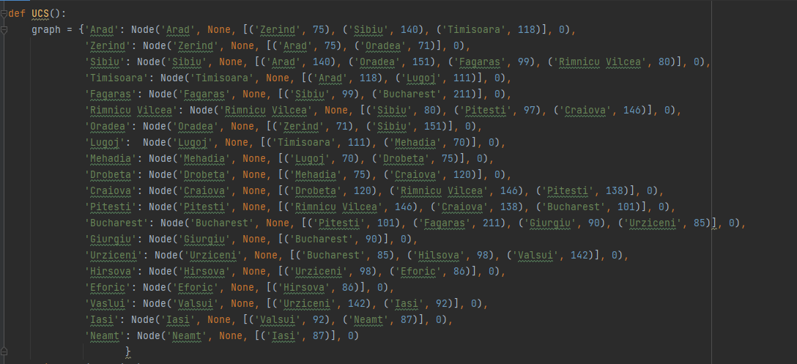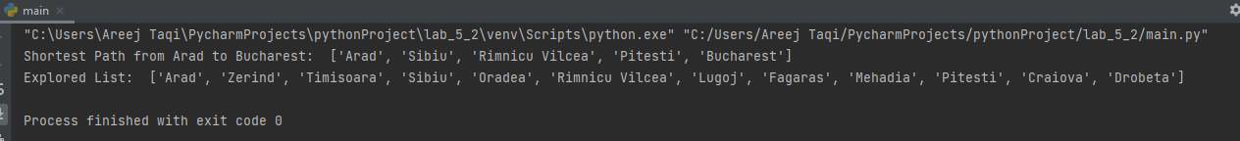

In this post lab task, we are to go from Arad to Bucharest. The program is providing the optimal least costly solution. It uses UCS to reach Bucharest.

**Critical Analysis:**

This lab was to get an introduction on python language. In this lab we implemented depth first analysis and uniform cost search analysis on graphs. In Depth first breadth first search the nodes are searched in form of depth of the node to its first child and then to the child’s first child till either goal state or no more child is there. If there is no more child it would check the recent child’s parents second child node. In uniform cost search the nodes are evaluated by their costs the node with minimum cost is first searched and then from that node as parent node next node is checked for minimum cost or goal state.