**CSC-462 ARTIFICIAL INTELLIGENCE**

**LAB 09**

**Linear and Multiple Linear Regression**

**Manaal Waseem**

**FA18-BCE-074**

**BCE-7B**

**Activities:**

**Activity 1:**

**Code:**

load accidents

x = hwydata(:,14); %Population of states

y = hwydata(:,4); %Accidents per state

format long

b1 = x\y;

yCalc1 = b1*x;

scatter(x,y)

hold on

plot(x,yCalc1)

xlabel('Population of state')

ylabel('Fatal traffic accidents per state')

title('Linear Regression Relation Between Accidents & Population')

grid on

X = [ones(length(x),1) x];

b = X\y;

yCalc2 = X*b;

plot(x,yCalc2,'--')

legend('Data','Slope','Slope & Intercept','Location','best');

**Plot:**

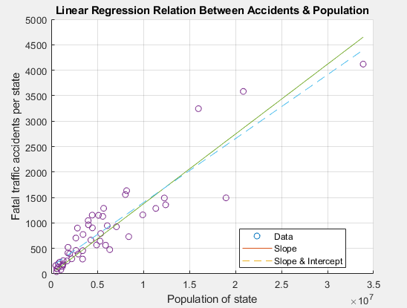

**Activity 2:**

**Code:**

load carsmall

x1 = Weight;

x2 = Horsepower; % Contains NaN data

y = MPG;

X = [ones(size(x1)) x1 x2 x1.*x2];

b = regress(y,X); % Removes NaN data

scatter3(x1,x2,y,'filled')

hold on

x1fit = min(x1):100:max(x1);

x2fit = min(x2):10:max(x2);

[X1FIT,X2FIT] = meshgrid(x1fit,x2fit);

YFIT = b(1) + b(2)*X1FIT + b(3)*X2FIT + b(4)*X1FIT.*X2FIT;

mesh(X1FIT,X2FIT,YFIT)

xlabel('Weight')

ylabel('Horsepower')

zlabel('MPG')

view(50,10)

hold off

**Plot:**

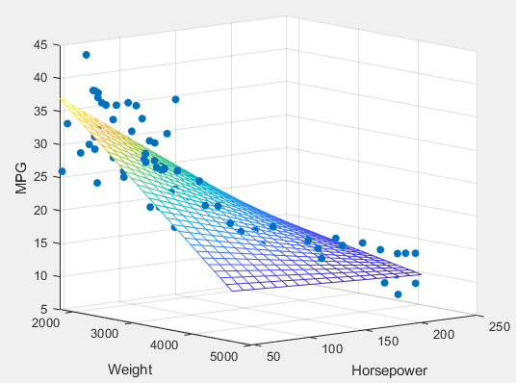

**Critical Analysis:**

This lab introduces us to linear regression in Matlab. We also performed linear and multiple linear regression using different approaches. Further we also got into different data visualization techniques built into Matlab.