**CSC-462 ARTIFICIAL INTELLIGENCE**

**LAB 10**

**Nimra Naeem**

**FA19-BEE-167**

**BCE-7B**

**Activities:**

**Activity 1:**

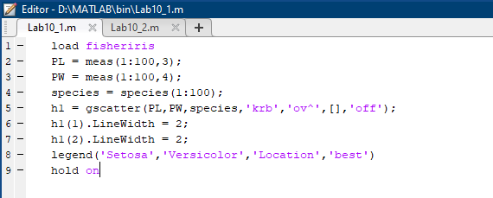

**Output:**

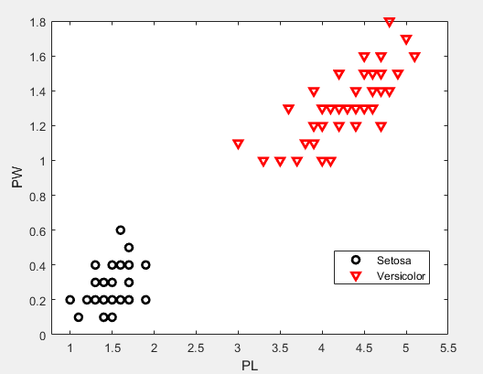

**Activity 2:**

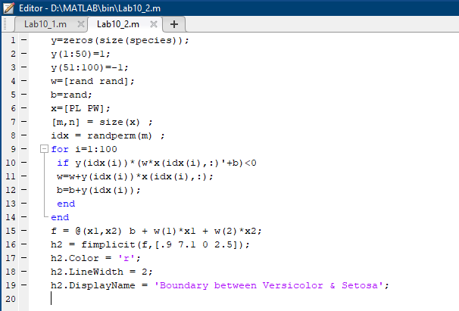

**Output:**

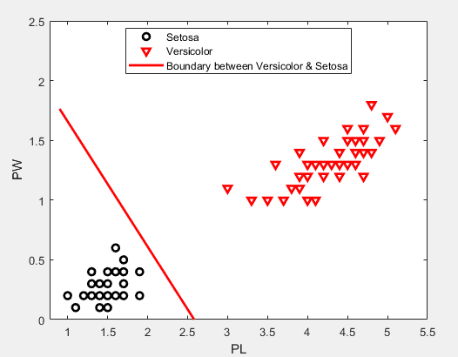

**Activity 3:**

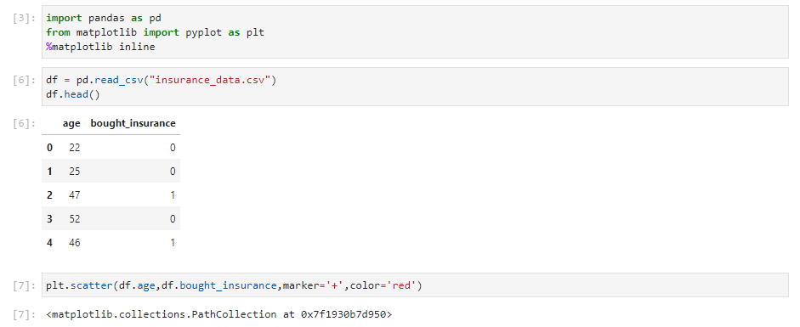

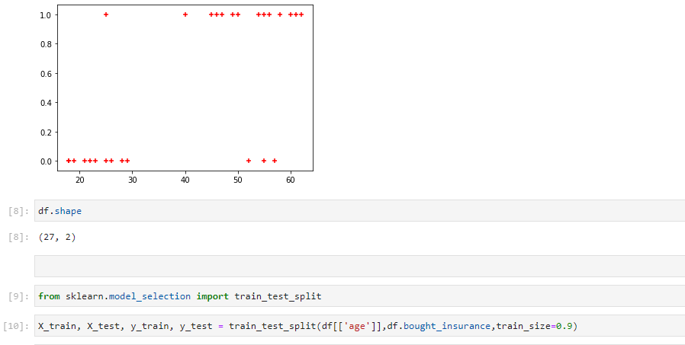

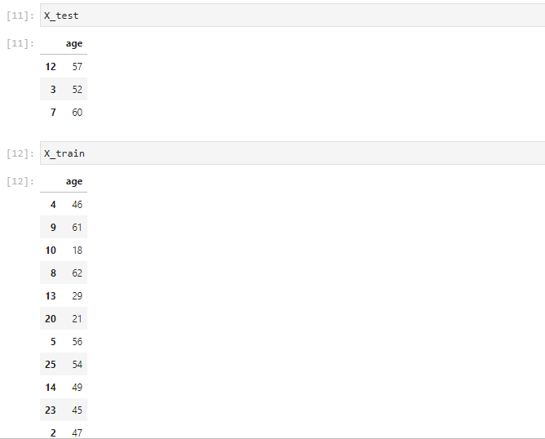

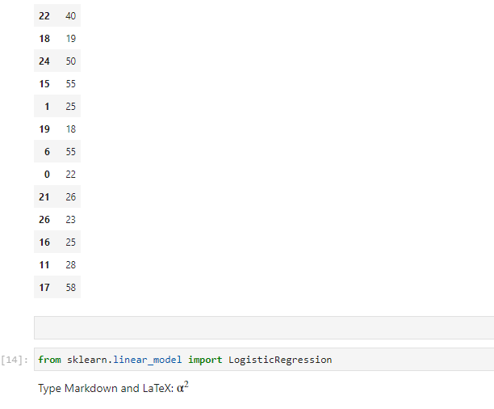

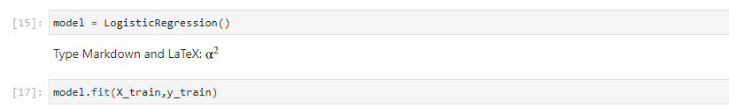

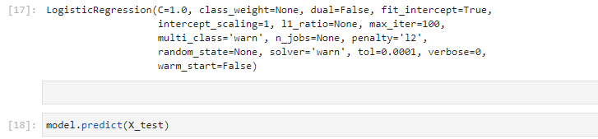

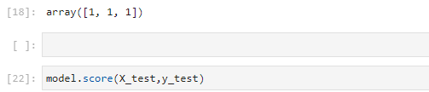

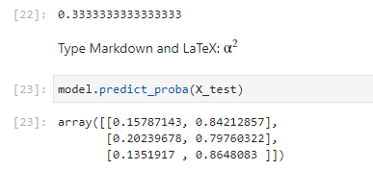

**Critical Analysis:**

This lab helped us develop a deep understanding of Mathematical Analysis involved in Logistics Regression and first we implemented in MATLAB using built in function, later we implemented in Python which let us appreciate the nitty gritty of this algorithm.