**CSC-462 ARTIFICIAL INTELLIGENCE**

**LAB 08**

**Manaal Waseem**

**FA18-BCE-074**

**BCE-7B**

**Activities:**

**Activity 1:**

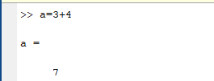

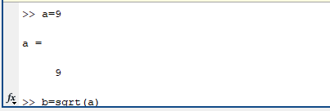

**ACTIVITY 2:-**

**ACTIVITY 3:-**



**ACTIVITY 4:**

**’**

**ACTIVITY 5:**

**ACTIVITY 6:**

**ACTIVITY 7:**

**ACTIVITY 8:**

**ACTIVITY 9:**

