**Data Structures and Algorithms**

**Lab 1**

**Submitted To:**

Mr. Dilshad Sabir

**Submitted By:**

Manaal Waseem

FA18-BCE-074

**In Lab:**

**Task 1:**

**Build and run the program given in Code Listing 1.** **Build and run the program given in Code Listing 1.**

#include <stdio.h>

#include <stdlib.h>

/// Define a structure 'emp' to hold data about an employee

struct emp

{

char name[48]; // Name of the employee

int age;

float bs; // Basic Salary as a floating point number.

};

void flush(void);

int write_records_to_file (struct emp * sptr, int num_records, FILE * fptr);

int read_records_from_file(struct emp * sptr, int num_records, FILE * fptr);

void print_records(struct emp * sptr, int num_records);

int main(void)

{

FILE *fp ;

char another = 'Y' ;

struct emp employee;

int i = 0;

int num_rec = 0;

// Open the file for writing in the Binary Mode

fp = fopen ( "employees_records.dat", "wb" ) ;

if ( fp == NULL ){

printf ( "Cannot open file\n" ) ;

exit(0) ;

}

while ( another == 'Y' )

{

printf ( "\nEnter the name of the Employee: " ) ;

fgets (employee.name, 48, stdin);

printf ( "\nEnter the age of the Employee: " ) ;

scanf("%d", &employee.age);

printf ( "\nEnter the Basic Salary of the Employee: " ) ;

scanf("%f", &employee.bs ) ;

// Writing to file

fwrite ( &employee, sizeof ( struct emp ), 1, fp );

flush();

printf ( "Add another record (Y/N) " );

another = getchar() ;

flush();

i++;

}

fclose(fp);

return(0);

}

**Code Listing 1**

**Program:** In this program, already provided code has been compiled and its working has been analyzed.

1 #include <stdio.h>

2 #include <stdlib.h>

3 **/// Define a structure 'emp' to hold data about an employee**

4 **struct** emp

5 {

6 **char** name[48]; // Name of the employee

7 **int** age;

8 **float** bs; // Basic Salary as a floating point number.

9 };

10 **void** flush(**void**);

11 **int** write_records_to_file (**struct** emp * sptr, **int** num_records, FILE * fptr);

12 **int** read_records_from_file(**struct** emp * sptr, **int** num_records, FILE * fptr);

13 **void** print_records(**struct** emp * sptr, **int** num_records);

14 **int** main(**void**)

15 {

16 FILE *fp ;

17 **char** another = 'Y' ;

18 **struct** emp employee;

19 **int** i = 0;

20 **int** num_rec = 0; // Open the file for writing in the Binary Mode

21 fp = fopen ( "employees_records.dat", "wb" ) ;

22 **if** ( fp == NULL )

23 {

24 printf ( "Cannot open file\n" ) ;

25 exit(0) ;

26 }

27 **while** ( another == 'Y' )

28 {

29 printf ( "\nEnter the name of the Employee: " ) ;

30 fgets (employee.name, 48, stdin);

31 printf ( "\nEnter the age of the Employee: " ) ;

32 scanf("%d", &employee.age);

33 printf ( "\nEnter the Basic Salary of the Employee: " ) ;

34 scanf("%f", &employee.bs ) ; // Writing to file

35 fwrite ( &employee, **sizeof** ( **struct** emp ), 1, fp );

36 flush();

37 printf ( "Add another record (Y/N) " );

38 another = getchar() ;

39 flush();

40 i++;

41 }

42 fclose(fp);

43 **return**(0);

44 }

45

46 **void** flush(**void**)

47 {

48 **int** c;

49 **while**((c=getchar())!='\n'&&c!=EOF);

50 }

**Output:**

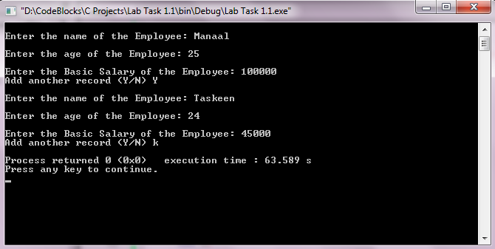

**Task 2:**

**The program in Code Listing 1 writes a single record to the file. Modify it, to use a function**

***‘****write_records_to_file****’* with following prototype:**

***int write_records_to_file (struct emp * sptr, int num_***records***, FILE * fptr)***

**This function should write ‘***num_records***’ number of structures from a dynamically allocated memory pointed to by ‘***sptr***’ to a file pointed to by ‘***fptr***’. It should return the number of structures successfully written to the file.**

**Program:** In this program, first a function; ***‘write_records_to_file’*** has been declared. A file **“person .dat”** has been opened in *‘write mode’*. Now the user is prompted to enter the number of employees, referred by variable **‘n’**, whose record user whishes to save. Then program prompts the user to enter name and age of **‘n’** employees. The data is written to a dynamically allocated memory pointed to by **‘*sptr*’** to a file pointed to by **‘*fptr*’**. Finally, the message **“contents to file written successfully!”** is printedon the console.

1 #include <stdio.h>

2 #include <stdlib.h>

3

4 **struct** emp {

5 **int** age;

6 **float** weight;

7 **char** name[30];

8 };

9

10 **int** write_records_to_file (**struct** emp * sptr, **int** num_records, FILE * fptr);

11

12 **int** main()

13 {

14 **struct** emp *ptr;

15 **int** i, n;

16

17 FILE *outfile;

18

19 // open file for writing

20 outfile = fopen ("person.dat", "w");

21 **if** (outfile == NULL)

22 {

23 fprintf(stderr, "\nError opend file\n");

24 exit (1);

25 }

26

27 printf("Enter the number of emps: ");

28 scanf("%d", &n);

29

30 // allocating memory for n numbers of struct emp

31 ptr = (**struct** emp*) malloc(n * **sizeof**(**struct** emp));

32

33 **for**(i = 0; i < n; ++i)

34 {

35 printf("Enter first name and age respectively: ");

36 scanf("%s %d", (ptr+i)->name, &(ptr+i)->age);

37 }

38

39 write_records_to_file (ptr, n, outfile);

40 **return** 0;

41 }

42

43 **int** write_records_to_file (**struct** emp * sptr, **int** num_records, FILE * fptr)

44 {

45 **for**(**int** i = 0; i < num_records; i++)

46 {

47 fwrite ((sptr+i), **sizeof**(**struct** emp), 1, fptr);

48 }

49

50 **if**(fwrite != 0)

51 printf("contents to file written successfully !\n");

52 **else**

53 printf("error writing file !\n");

54

55 // close file

56 fclose (fptr);

57

58 **return** 0;

59 }

**Output:**

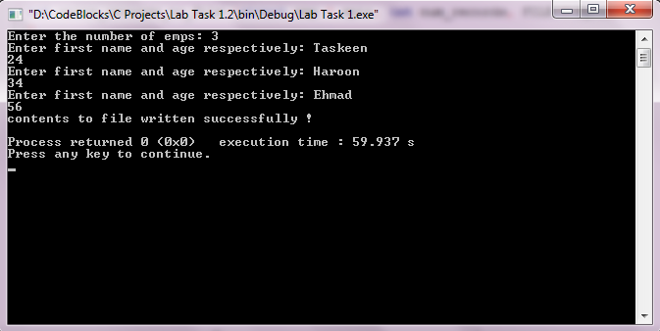

**Task 3:**

**Write functions ‘***read_records_from_file***’, and ‘***print_records***’ with following prototypes**

***int read_records_from_file(struct emp * sptr, int num_records, FILE * fptr)***

***void print_records(struct emp * sptr, int num_records);***

**Use these functions to read a previously written file (employees_records2.dat) and display the contents on screen.**

**Program:** In this program, first functions; ***‘read_records_from_file’*** and ***‘print_records’*** have been declared. The file **“employees_records2.dat”** has been opened in *‘read mode’*. Contents of the file are written to dynamically allocated memory pointed to by **‘*sptr*’**. Now the function ***‘read_records_from_file’*** reads the contents of file and function ***‘print_records’*** prints the contents on the console.

1 #include <stdio.h>

2 #include <stdlib.h>

3

4 **struct** emp {

5 **int** age;

6 **float** weight;

7 **char** name[30];

8 };

9

10 **int** read_records_from_file(**struct** emp * sptr, **int** num_records, FILE * fptr);

11 **void** print_records(**struct** emp * sptr, **int** num_records);

12

13 **int** main()

14 {

15 **struct** emp *ptrin;

16 **int** i, n=10;

17 FILE *infile;

19 // Open employees_records2 for reading

20 infile = fopen ("employees_records2.dat", "r");

21 **if** (infile == NULL)

22 {

23 fprintf(stderr, "\nError opening file\n");

24 exit (1);

25 }

26

27 ptrin = (**struct** emp*) malloc(n * **sizeof**(**struct** emp));

28

29 read_records_from_file(ptrin, n, infile);

30

31 printf("\nDisplaying Information:\n");

32 print_records(ptrin, n);

33

34 **return** 0;

35 }

36

37 **int** read_records_from_file(**struct** emp * sptr, **int** num_records, FILE * fptr)

38 {

39 **for**(**int** i = 0; i < num_records; i++)

40 {

41 fread((sptr+i), **sizeof**(**struct** emp), 1, fptr);

42 }

43 // close file

44 fclose (fptr);

45

46 **return** 0;

47 }

49 **void** print_records(**struct** emp * sptr, **int** num_records)

50 {

51 **for**(**int** i = 0; i < num_records; i++)

52 printf("Name: %s\tAge: %d\n", (sptr+i)->name, (sptr+i)->age);

53 }

**Output:**



**Post Lab:**

**The structures that you write in a file using ‘fwrite()’ are written in the binary format and cannot be viewed in a text editor properly. Your task is to write the contents of these structures in the text format so that the contents may be viewed in a text editor.**

**Program:** In this program, all working is similar to in-lab task 2, except after opening the file **“records .txt”** in *‘write mode’*; function ***‘write_records_to_file’*** writes the contents to file using **‘fprintf’** instead of **‘fwrite’**; such that contents of file can be viewed in text editor properly .

1 #include <stdio.h>

2 #include <stdlib.h>

3

4 **struct** emp {

5 **int** age;

6 **float** weight;

7 **char** name[30];

8 };

9

10 **int** write_records_to_file (**struct** emp * sptr, **int** num_records, FILE * fptr);

11

12 **int** main()

13 {

14 **struct** emp *ptr;

15 **int** i, n;

16

17 FILE *outfile;

18

19 // open file for writing

20 outfile = fopen ("records.txt", "w");

21 **if** (outfile == NULL)

22 {

23 fprintf(stderr, "\nError opend file\n");

24 exit (1);

25 }

26

27 printf("Enter the number of emps: ");

28 scanf("%d", &n);

29

30 // allocating memory for n numbers of struct emp

31 ptr = (**struct** emp*) malloc(n * **sizeof**(**struct** emp));

32

33 **for**(i = 0; i < n; ++i)

34 {

35 printf("Enter first name and age respectively: ");

36 scanf("%s %d", (ptr+i)->name, &(ptr+i)->age);

37 }

38

39 write_records_to_file (ptr, n, outfile);

40 **return** 0;

41 }

42

43 **int** write_records_to_file (**struct** emp * sptr, **int** num_records, FILE * fptr)

44 {

45 **for**(**int** i = 0; i < num_records; i++)

46 {

47 fprintf (fptr, "%s %d\n",(sptr+i)->name, (sptr+i)->age);

48 }

49

50 **if**(fprintf != 0)

51 printf("contents to file written successfully !\n");

52 **else**

53 printf("error writing file !\n");

54

55 // close file

56 fclose (fptr);

57

58 **return** 0;

59 }

**Output:**



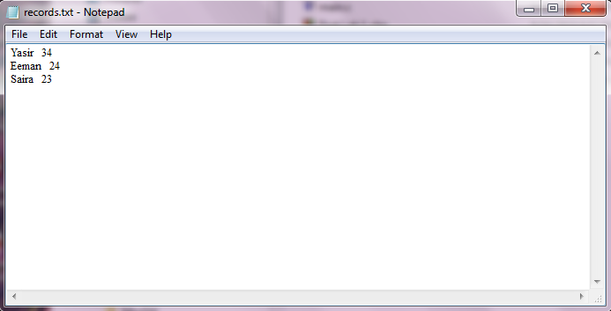

**_______________________**

**THE END**