**Data Structures and Algorithms**

**Lab 10**

**Submitted To:**

Mr. Dilshad Sabir

**Submitted By:**

Manaal Waseem

FA18-BCE-074

**In Lab:**

**Task 1:**

***Your task is to complete the following functions.***

***1. Node deletion***

***2. Node search***

***3. Pre-Order and Post-Order printing***

**Program:** Code for above stated functions is as follows:



***Node deletion***



***Node search***



***Pre-Order and Post-Order printing***

**Output:**



***Node deletion***



***Node search***

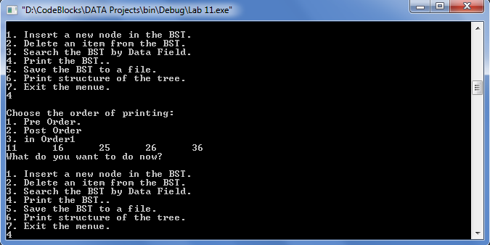

***Pre-Order***

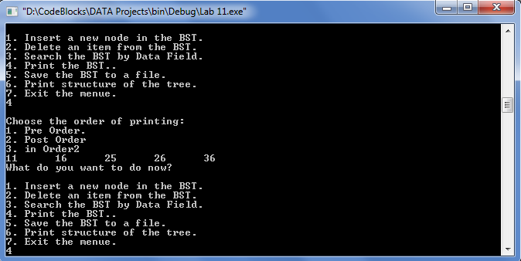

***Post-Order***

**Post Lab:**

**Task 1:**

***Save the Tree data to a file (In-Order, Pre-Order and Post-Order).***

**Program:** Code is as follows:

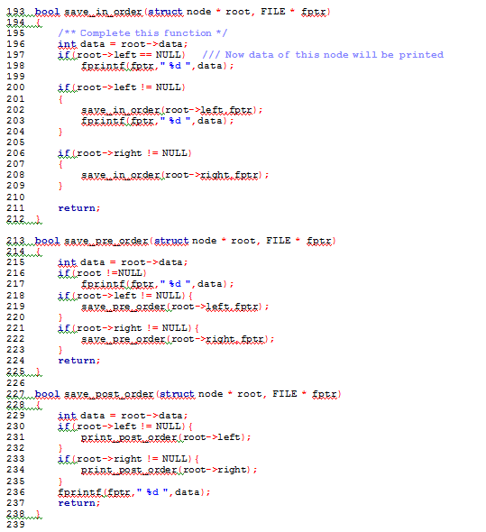

**Output:**



***Pre-Order***



***Post-Order***

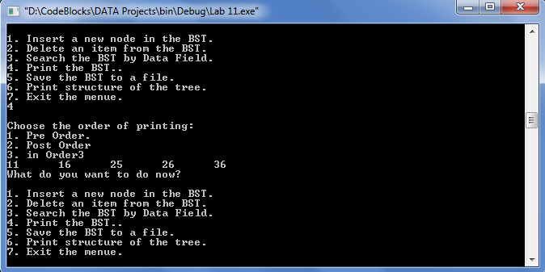

***In-Order***

**Task 2:**

***Load tree from a file containing numbers.***

**Program:** Code is as follows:

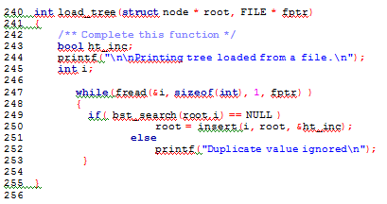

**Output:**

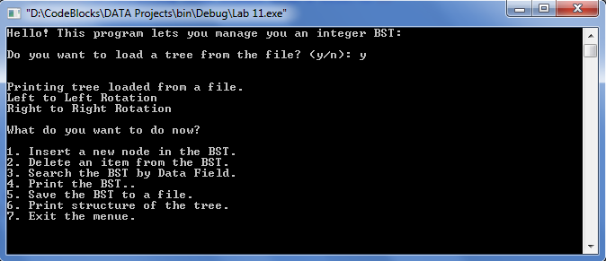

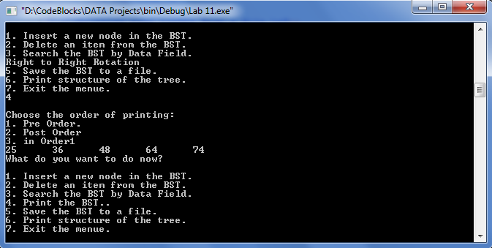

**_______________________**

**THE END**