**Data Structures and Algorithms**

**Lab 11**

**Submitted To:**

Mr. Dilshad Sabir

**Submitted By:**

Manaal Waseem

FA18-BCE-074

**In Lab:**

**Task 1:**

***Modify the insert function to incorporate AVL insertion.***

**Program:** In this program, function ***“insert”*** inserts nodes into the BST through AVL approach i.e. maintaining balance of BST.

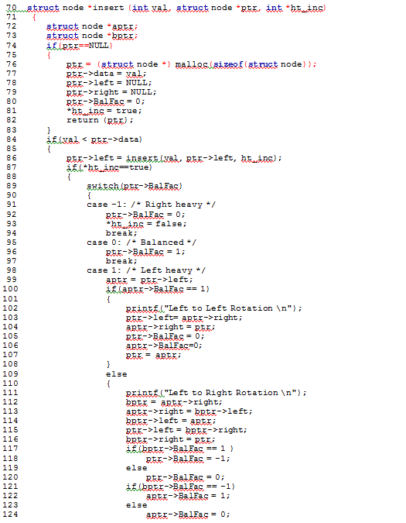

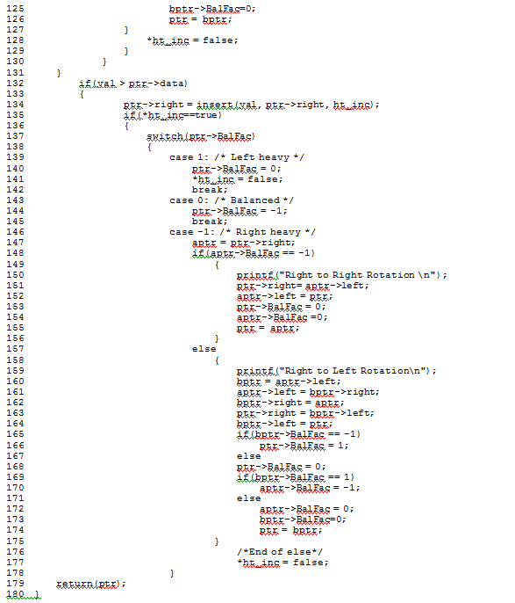

**Output:**

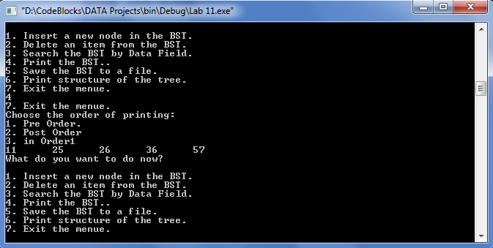

**Post Lab:**

**Task 1:**

***Save the Tree data to a file (In-Order, Pre-Order and Post-Order).***

**Program:** Code is as follows:

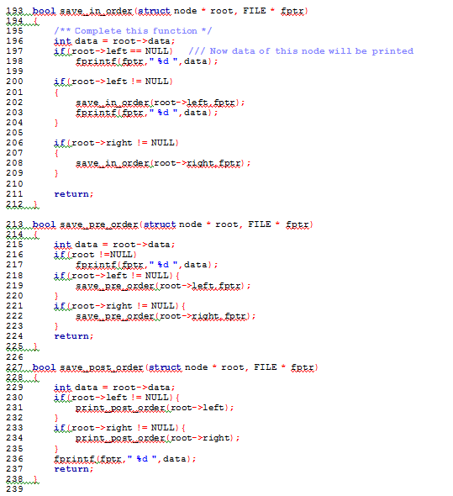

**Output:**

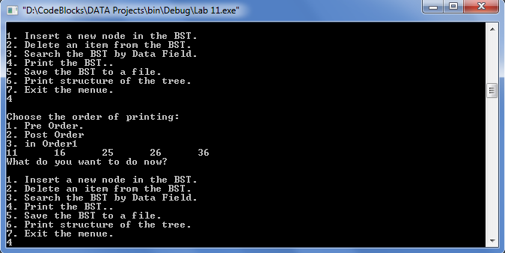

***Pre-Order***

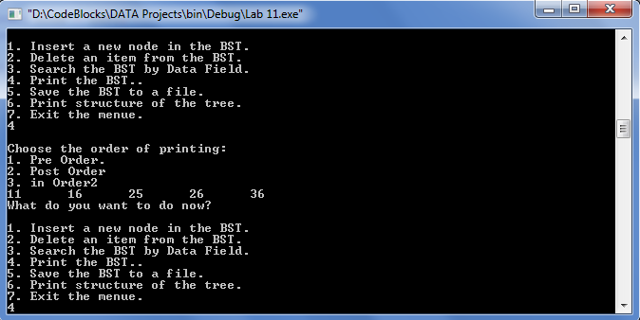

***Post-Order***

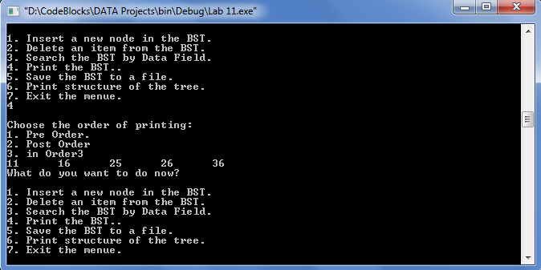

***In-Order***

**Task 2:**

***Load tree from a file containing numbers.***

**Program:** Code is as follows:

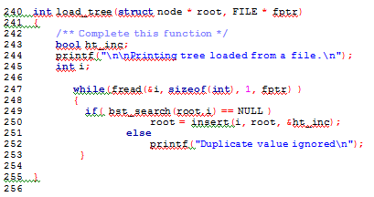

**Output:**

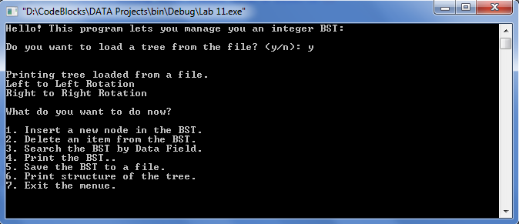

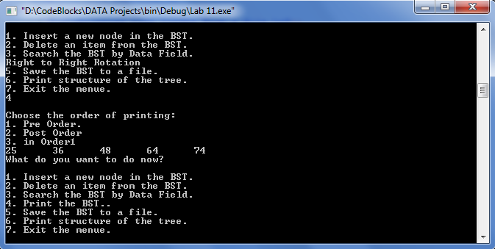

**_______________________**

**THE END**