**Data Structures and Algorithms**

**Lab 8**

**Submitted To:**

Mr. Dilshad Sabir

**Submitted By:**

Manaal Waseem

FA18-BCE-074

**In Lab:**

**Task 1:**

***Complete the functions for Selection Sort and Insertion Sort.***

**The program computes the time taken by the sorting function and displays this after sorting has finished. Your task is to complete the *Selection Sort* and *Insertion Sort* parts of the code.**

**Program:** In this program, randomly generated array is sorted via. techniques of selection and insertion sort depending upon user choice. The sorted array is then printed on the console.

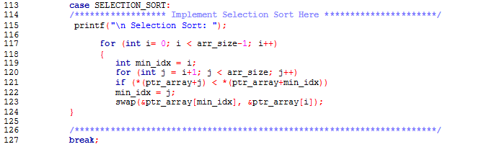

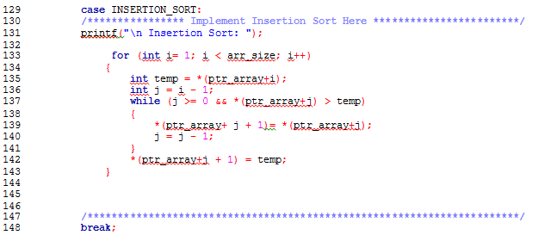

**Output:**

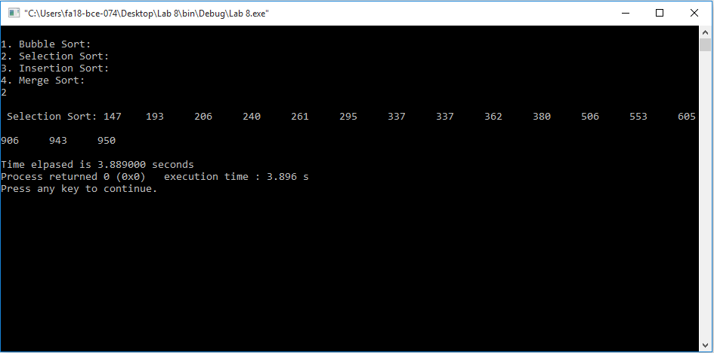

***Selection Sort***

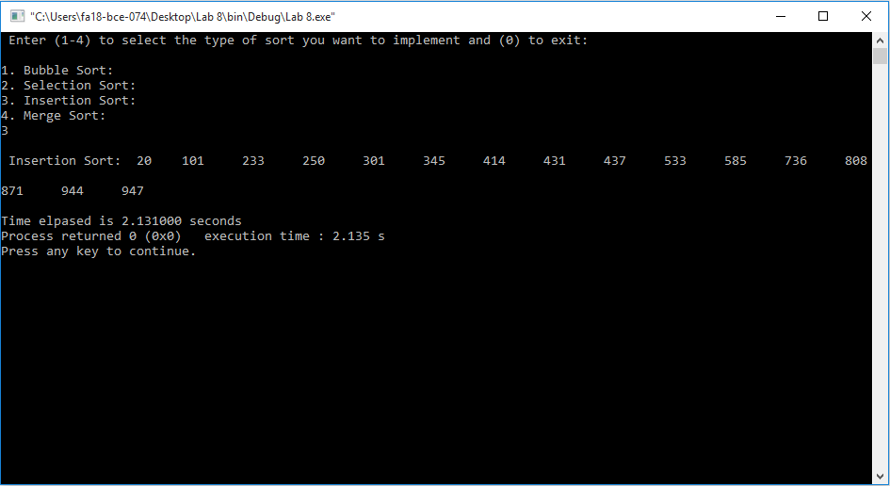

***Insertion Sort***

**Task 2:**

***Compute the execution times for the three sorting methods.***

**Table:**

|  |  |  |  |  |  |
| --- | --- | --- | --- | --- | --- |
|  | **Data Size** | **Bubble Sort** | **Selection Sort** | **Insertion Sort** | **Merge Sort** |
| 1 | 16 | 3.035000 | 4.646000 | 1.954000 | 1.542000 |
| 2 | 128 | 1.767000 | 1.483000 | 1.980000 | 1.939000 |
| 3 | 1024 | 2.028000 | 2.683000 | 1.818000 | 2.584000 |
| 4 | 16384 | 2.778000 | 1.928000 | 1.769000 | 2.154000 |

**Post Lab:**

***Complete the Merge Sort Function and empirically determine its time complexity*.**

**Program:** This program sorts the randomly generated array via. technique of merge sort and prints the sorted array on the console.

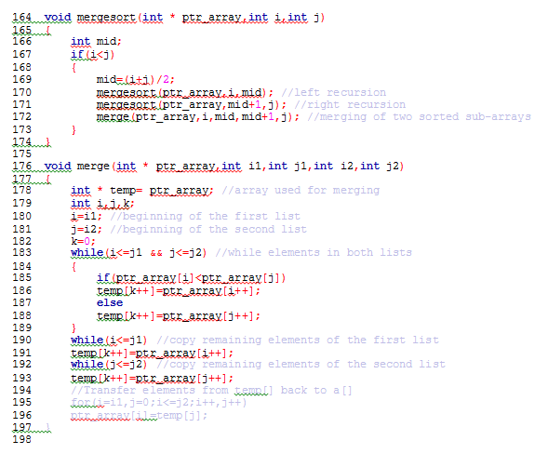

**Output:**

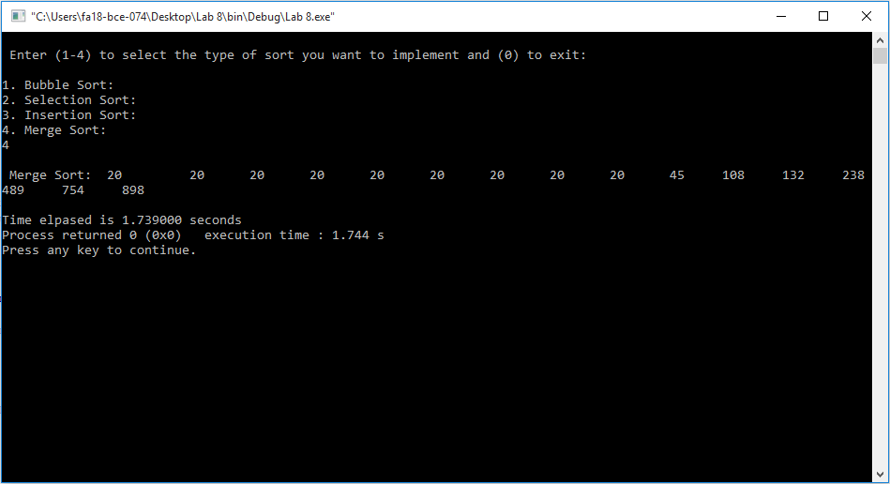

**_______________________**

**THE END**