**Programming Fundamentals**

**Lab 5**

**Submitted To:**

Mr. Dilshad Sabir

**Submitted By:**

Manaal Waseem

FA18-BCE-074

**Task01:**

**Write a C function 'int test_prime(int);' that takes in a positive number as input and returns true (1) if the input number is prime or false (0) if the input is not prime. Then using this function, write a C program that takes a number (N) as input from the user and prints out the first N prime numbers.**

**Program:** In this program, first the variables are declared. Variable **‘N’** stores the value inputted by the user. Variables **‘counter_prime’(**counts the number of prime numbers printed**)** and **‘counter_num’ (**countsthe numbers to be checked if they are prime or not?**)** are initialized as 0 and 2, respectively.A statement is printed to input values on command prompt. A while loop runs until ‘counter_prime’ is less than N. The function **‘test_prime’** is then called and variable ‘counter_num’ is passed to this function. The function **‘test_prime’** determines if a number is prime. Hence, the first numbers till ‘N’ are displayed as output on the console.

1 #include <stdio.h>

2 #include <stdlib.h>

3

4 **int** test_prime(**int** num);

5 **int** main()

6 {

7 **int** N;

8 **int** counter_prime=0;

9 **int** counter_num=2;

10

11 printf("Enter a number: ");

12 scanf("%d",&N);

13

14 printf("\nFirst %d prime numbers are: \n",N);

15 **while**(counter_prime<N)

16 {

17 **if**(test_prime(counter_num))

18 {

19 printf("%d \n",counter_num);

20 counter_prime++ ;

21 }

22 counter_num++ ;

23 }

24 **return** 0;

25 }

26 **int** test_prime(**int** num)

27 {

28 **for**(**int** i=2; i<=num/2; i++)

29 {

30 **if**(num%i==0)

31 **return** 0;

32 }

33 **return** 1;

34 }

**Output:**

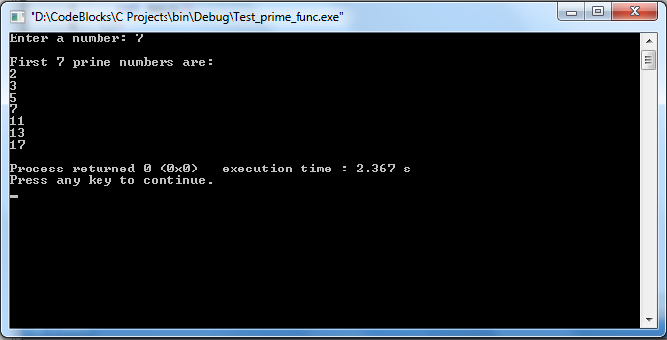

**Task 02:**

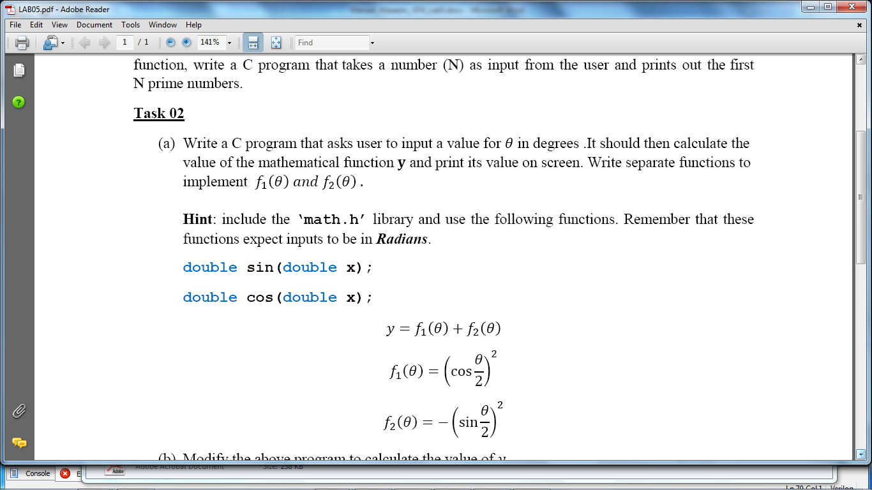

**Program:** In this program, first the variables are declared. The user is asked to input an angle in degrees which is stored in **‘angle’**. This angle in degrees is converted into radians via **‘convert’** function. The **‘cos’**, **‘sin’** and **‘Power’** functions are called from **‘math.h’** header file. The outputs of these functions are added in the main function.

1 #include <stdio.h>

2 #include <stdlib.h>

3 #include <math.h>

4

5 **double** convert(**double** theta);

6 **double** f1(**double** theta);

7 **double** f2(**double** theta);

8

9 **int** main()

10 {

11 **double** y, angle;

12

13 printf("\n Enter an angle in degrees: ");

14 scanf("%lf",&angle);

15

16 y= f1(angle)+f2(angle);

17

18 printf("\ny= f1(%lf)+f2(%lf)=%lf\n",angle,angle,y);

19 **return** 0;

20 }

21

22 **double** convert(**double** theta)

23 {

24 **double** x;

25

26 x=(theta*3.1415)/180.0;

27 **return** x;

28 }

29

30 **double** f1(**double** theta)

31 {

32 **double** x_rad;

**33**

34 x_rad = convert(theta);

35

36 **return** pow(cos(x_rad/2),2);

37 }

38

39 **double** f2(**double** theta)

40 {

41 **double** x_rad;

42

43 x_rad = convert(theta);

44

45 **return** -pow(sin(x_rad/2),2);

46 }

**Output:**

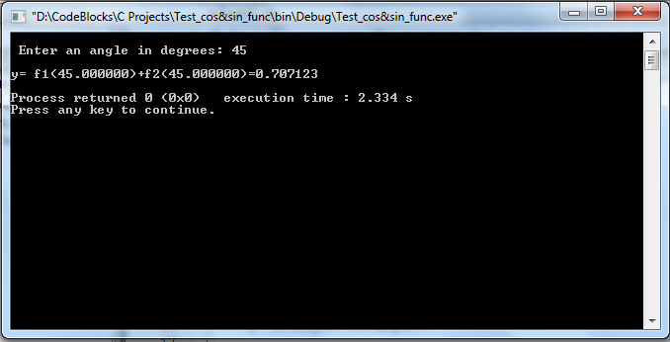

**Task 2b**

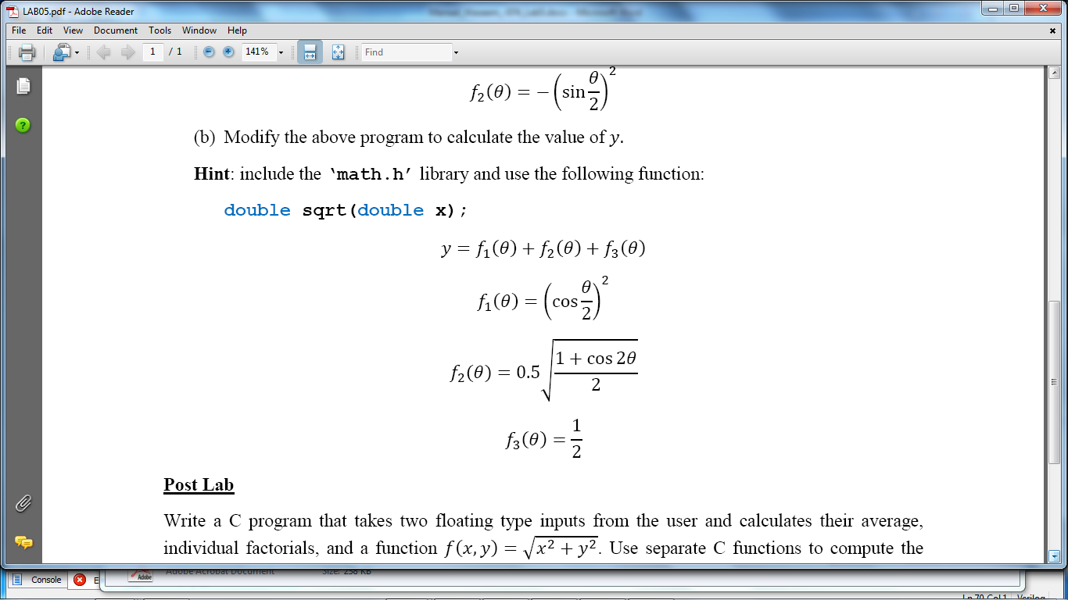

**Program:** In this program, first the variables are declared. The user is asked to input an angle in degrees which is stored in **‘angle’**. This angle in degrees is converted into radians via **‘convert’** function. The **‘cos’**, **‘sin’, ‘sqrt’** and **‘power’** functions are called from **‘math.h’** header file. The outputs of these functions are added in the main function.

1 #include <stdio.h>

2 #include <stdlib.h>

3 #include <math.h>

4

5 **double** convert(**double** theta);

6 **double** f1(**double** theta);

7 **double** f2(**double** theta);

8 **double** f3(**double** theta);

9

10 **int** main()

11 {

12 **double** y, angle;

13

14 printf("\n Enter an angle in degrees: ");

15 scanf("%lf",&angle);

16

17 y= f1(angle)+f2(angle);

18

19 printf("\ny= f1(%lf)+f2(%lf)=%lf\n",angle,angle,y);

20 **return** 0;

21 }

22

23 **double** convert(**double** theta)

24 {

25 **double** x;

26

27 x=(theta*3.1415)/180.0;

28 **return** x;

29 }

30

31 **double** f1(**double** theta)

32 {

33 **double** x_rad;

34

35 x_rad = convert(theta);

36

37 **return** pow(cos(x_rad/2),2);

38 }

39

40 **double** f2(**double** theta)

41 {

42 **double** x_rad;

43

44 x_rad = convert(theta);

45

46 **return** 0.5*(sqrt((1+cos(2*x_rad))/2));

47 }

48

49 **double** f3(**double** theta)

50 {

51 **return** (1.0/2.0);

52 }

**Output:**

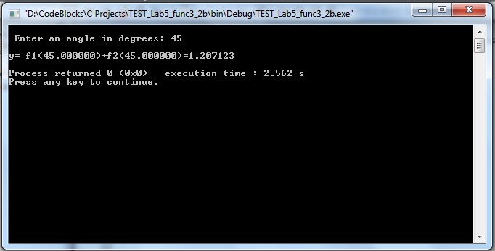

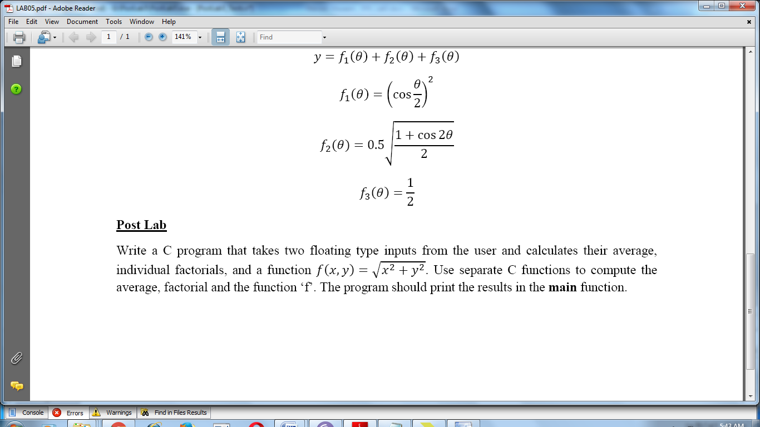

**Program:** In this program, first the variables are declared. The user is asked to input two numbers which are stored in **‘num_1’** and **‘num_2’**. **‘sqrt’** and **‘pow’** functions are called from **‘math.h’** header file. The functions **‘average’** , **‘factorial’** and **‘f’** finds the average, factorial of individual numbers and calculates output as per demanded, respectively. The outputs of these functions are printed in the main function when they are called.

1 #include <stdio.h>

2 #include <stdlib.h>

3 #include <math.h>

4

5 **float** average (**float** num_1, **float** num_2);

6 **float** factorial (**float** num);

7 **float** f (**float** num_1, **float** num_2);

8

9 **int** main()

10 {

11 **float** x,y;

12

13 printf("Enter two numbers: ");

14 scanf("%f %f",&x,&y);

15

16 printf("\n The average of both numbers is: %f\n",average(x,y));

17 printf("\n Factorial of first number is: %f\n",factorial(x));

18 printf("\n Factorial of second number is: %f\n",factorial(y));

19 printf("\n f(x,y)= %f\n",f(x,y));

20

21 **return** 0;

22 }

23

24 **float** average (**float** num_1, **float** num_2)

25 {

26 **return** ((num_1+num_2)/2);

27 }

28

29 **float** factorial (**float** num)

30 {

31 **float** fact=1 ,c;

32

33 **for**(c=1;c<=num;c++)

34 {

35 fact=fact*c;

36 }

37 **return** fact;

38 }

39

40 **float** f (**float** num_1, **float** num_2)

41 {

42 **return** sqrt(pow(num_1,2)+pow(num_2,2));

43 }

**Output:**

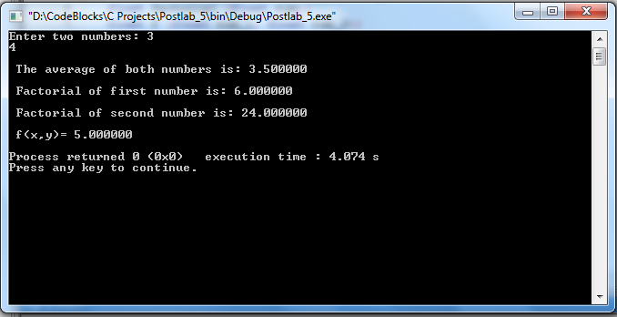

**THE END**