**Programming Fundamentals**

**Lab 6**

**Submitted To:**

Mr. Dilshad Sabir

**Submitted By:**

Manaal Waseem

FA18-BCE-074

**Task01:**

**Write a C program that takes three inputs (floating type) from user and find the minimum number and print it on screen. (Do not use min or max c function)**

**Program:** In this program, first the variables are declared. Variables **‘num_1’, ‘num_2’** and

**‘num_3’** stores the three values inputted by the user. Variable **‘num_small’** is to store the smallest of the three numbers. The numbers are compared with each other via if-else statements. The smallest one of them is stored in **‘num_small’** and is displayed as output on the console.

1 #include <stdio.h>

2 #include <stdlib.h>

3

4 **int** main()

5 {

6 **int** num_1, num_2, num_3, num_small;

7

8 printf("Enter three numbers: \n");

9 scanf ("%d %d %d", &num_1,&num_2,&num_3);

10

11 **if**((num_1<num_2)&&(num_1<num_3))

12 {

13 num_small=num_1;

14 printf("The smallest number is %d.",num_small);

15 }

16 **else**

17 **if**((num_2<num_1)&&(num_2<num_3))

18 {

19 num_small=num_2;

20 printf("The smallest number is %d.",num_small);

21 }

22 **else**

23 **if**((num_3<num_1)&&(num_3<num_2))

24 {

25 num_small=num_3;

26 printf("The smallest number is %d.",num_small);

27 }

28

29

30 **return** 0;

31 }

**Output:**

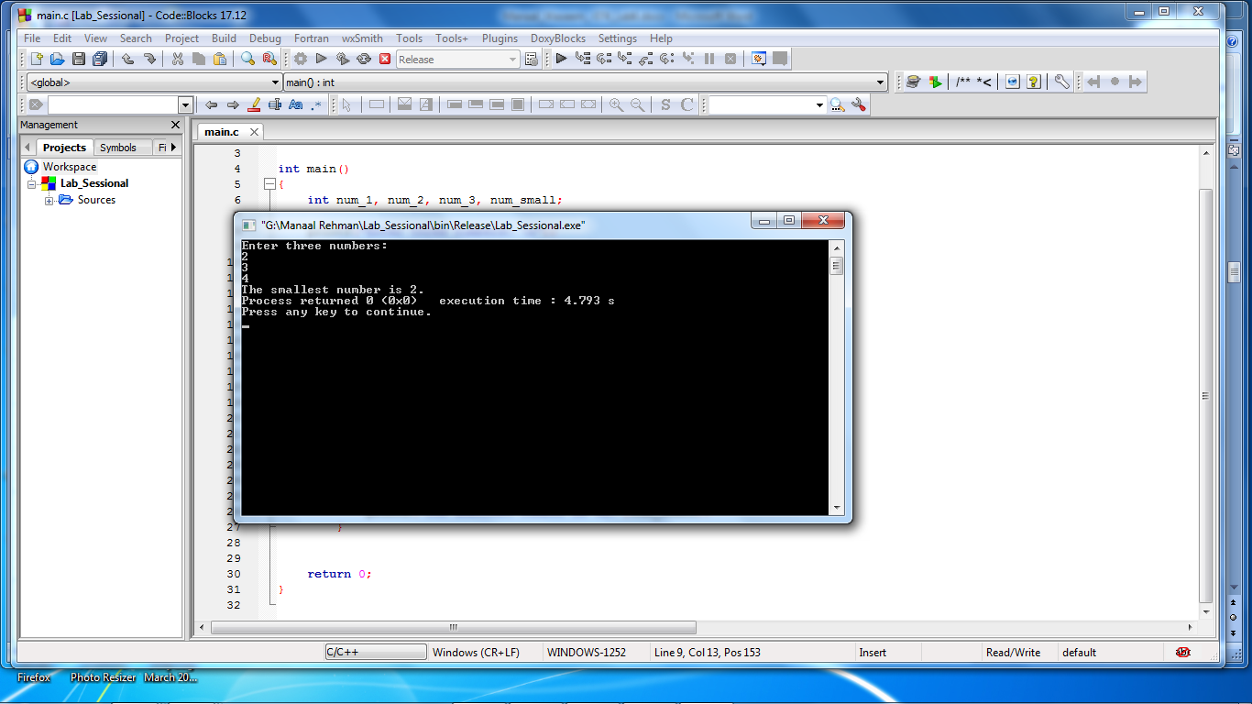

**Task 02a:**

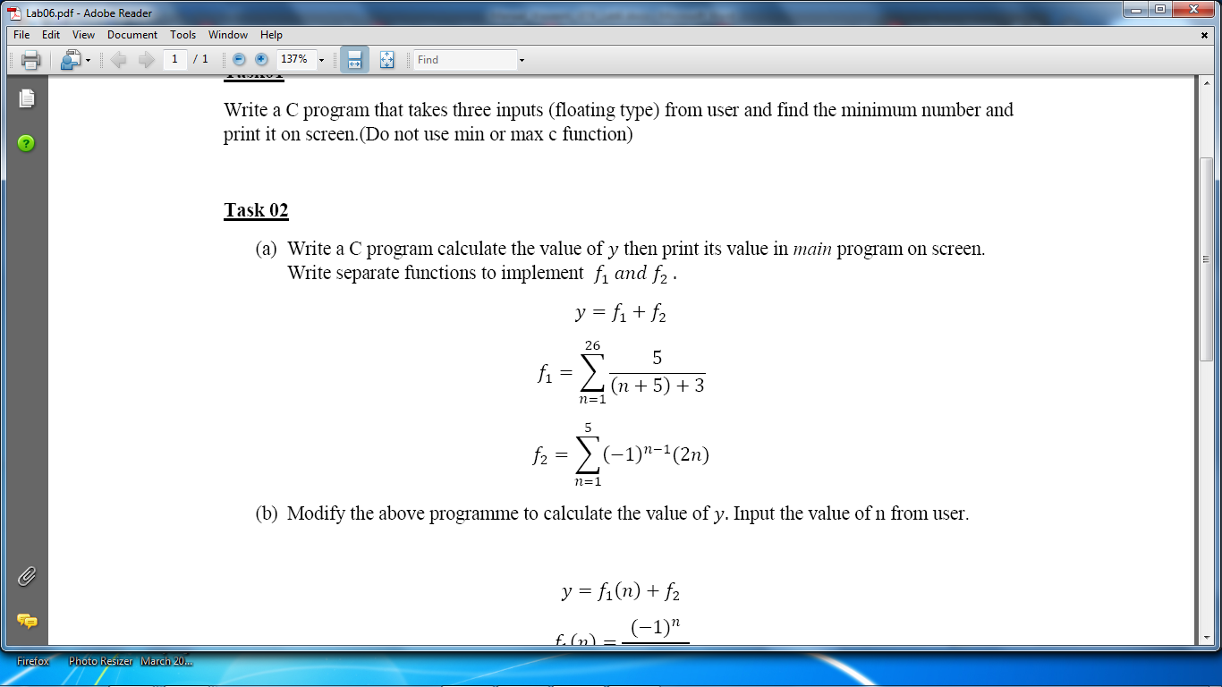

**Program:** In this program, first the functions are declared. First function calculates the value of function for **‘n’** from 1 to 26. Similarly, second function calculates value of function for **‘n’** from 1 to 5. **‘Power’** function is called from **‘math.h’** header file. The outputs of these functions are added in the main function.

1 #include <stdio.h>

2 #include <stdlib.h>

3 #include <math.h>

4

5 **float** f1();

6 **float** f2();

7 **float** main()

8 {

9 **float** y;

10

11 y= f1()+f2();

12

13 printf("\n y=%.4f \n",y);

14

15 **return** 0;

16 }

17

18 **float** f1()

19 {

20 **float** d;

21

22 **for**(**int** n=1; n<=26; n++)

23 {

24 d= 5/((n+5)+3);

25 }

26 **return** d;

27 }

28

29 **float** f2()

30 {

31 **float** z;

32

33 **for**(**int** n=1; n<=5; n++)

34 {

35 z= (pow((-1),n-1)*(2*n));

36 }

37 **return** z;

38 }

**Output:**

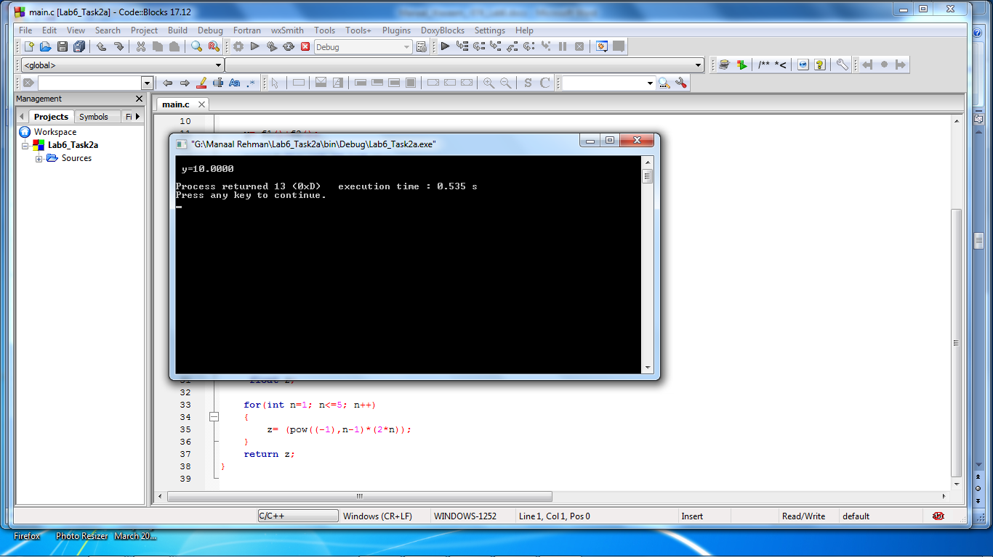

**Task 2b:**

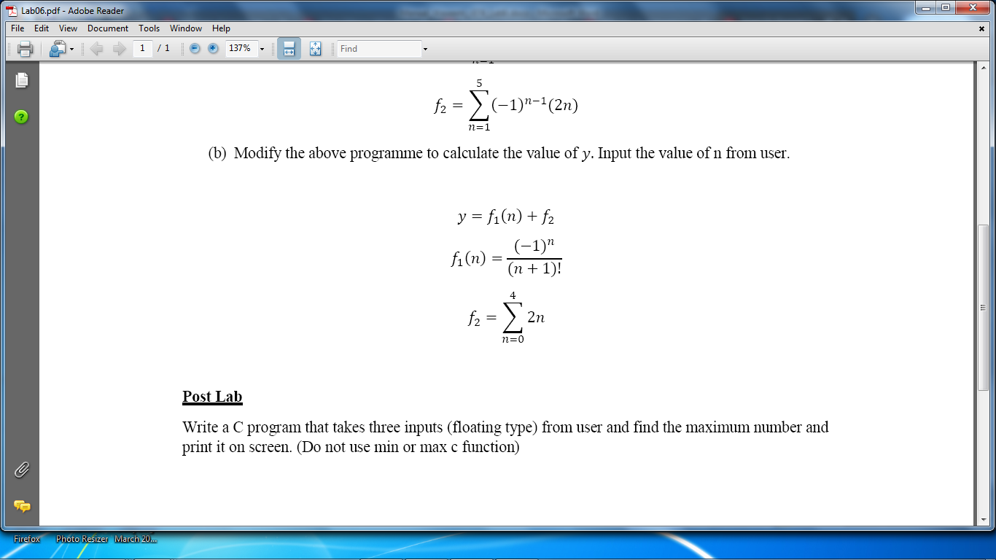

**Program:** In this program, first the functions are declared. First function calculates the value of function for **‘n’** inputted by the user. Similarly, second function calculates value of function for **‘n’** from 0 to 4. **‘Power’** function is called from **‘math.h’** header file. The outputs of these functions are added in the main function.

1 #include <stdio.h>

2 #include <stdlib.h>

3 #include <math.h>

4

5 **float** factorial(**float** value);

6 **float** f1(**float** a);

7 **float** f2();

8 **float** main()

9 {

10 **float** y,num;

11

12 printf("Enter a number: \n");

13 scanf("%f",&num);

14

15 y= f1(num)+f2();

16

17 printf("\n y=%.4f \n",y);

18

19 **return** 0;

20 }

21

22 **float** f1(**float** a)

23 {

24 **float** d;

25

26 d=(pow((-1),a))/factorial(a+1);

27

28 **return** d;

29 }

30

31 **float** f2()

32 {

33 **float** z;

34

35 **for**(**int** n=0; n<=4; n++)

36 {

37 z= (2*n);

38 }

39 **return** z;

40 }

41

42 **float** factorial(**float** value)

43 {

44 **float** c;

45 **float** fact=1;

46

47 **for**(c=1;c<=value;c++)

48 {

49 fact=fact*c;

50 }

51 **return** fact;

52 }

**Output:**

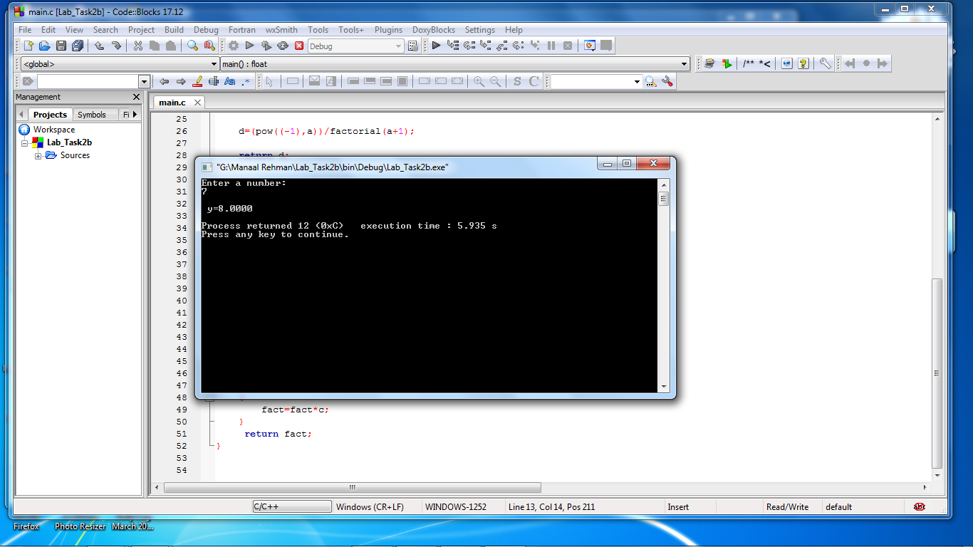

**Post Lab:**

**Write a C program that takes three inputs (floating type) from user and find the maximum number and print it on screen. (Do not use min or max c function)**

**Program:** In this program, first the variables are declared. Variables **‘num_1’, ‘num_2’** and

**‘num_3’** stores the three values inputted by the user. Variable **‘num_big’** is to store the largest of the three numbers. The numbers are compared with each other via if-else statements. The largest one of them is stored in **‘num_big’** and is displayed as output on the console.

1 #include <stdio.h>

2 #include <stdlib.h>

3

4 **int** main()

5 {

6 **int** num_1, num_2, num_3, num_big;

7

8 printf("Enter three numbers: \n");

9 scanf ("%d %d %d", &num_1,&num_2,&num_3);

10

11 **if**((num_1>num_2)&&(num_1>num_3))

12 {

13 num_big=num_1;

14 printf("The biggest number is %d.",num_big);

15 }

16 **else**

17 **if**((num_2>num_1)&&(num_2>num_3))

18 {

19 num_big=num_2;

20 printf("The biggest number is %d.",num_big);

21 }

22 **else**

23 **if**((num_3>num_1)&&(num_3>num_2))

24 {

25 num_big=num_3;

26 printf("The biggest number is %d.",num_big);

27 }

28

29

30 **return** 0;

31 }

**Output:**

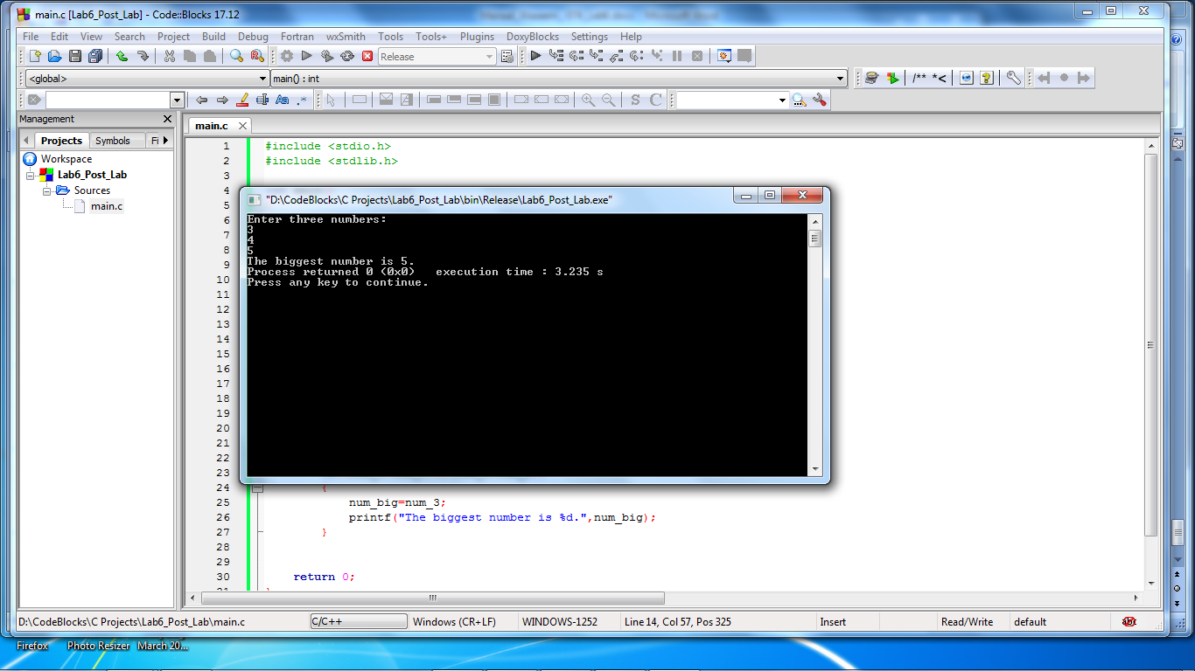

**_________________**

**THE END**

**_________________**