**Programming Fundamentals**

**Lab 11**

**Submitted To:**

Mr. Dilshad Sabir

**Submitted By:**

Manaal Waseem

FA18-BCE-074

**In Lab:**

**Task 1:**

**Write a C Program that does the following:**

1. **Declares a C-String called ‘m1’ and initializes it with text “Programming is great fun!”.**
2. **Uses C-function puts() to print this string.**
3. **Asks the user to enter a String named ‘m2’ (Hint: Use gets() function for this.)**
4. **Concatenates the two strings and stores the result in ‘m3’.**
5. **For example if the user enters m2 as “Not Really!”, m3 should be “Programming is great**
6. **fun! Not really!”**
7. **Inserts the user entered array (m2) into m1 after “Programming is ...”**
8. **For the above example, the resultant String would become “Programming is Not really! great fun!”**

**Program:** In this program, four character arrays are declared, **‘m1’**, **‘m2’**, **‘m3’** and **‘m4’**. **‘m1’** is initialized as **“Programming is great fun!”**, now user is prompted to enter another string in **‘m2’**. Now both **‘m1’** & **‘m2’** are concatenated and stored in **‘m3’**. Then lengths of both **‘m1’** & **‘m2’** are calculated. User is prompted to enter a position stored in integer type variable **‘n’**, string 2 would be inserted in string 1 at this position. **‘m1’** is copied to **‘m4’**. A space is added and a for loop uptill the length of **‘m2’** runs and copies character by character **‘m2’** in **‘m4’** after **‘n’**. In second for loop, characters of **‘m1’** ahead of sum of characters of **‘m1’** till **‘n’** and characters of **‘m2’** are copied to **‘m4’**. Then **‘m4’** is printed as output on the console.

1 #include<stdio.h>

2 #include<conio.h>

3 #include<string.h>

4

5 **void** main()

6 {

7 **char** m1[]="Programming is great fun!";

8 **char** m2[50], m3[100];

9 puts(m1);

10 printf("Enter a string\n");

11 gets(m2);

12 strcat(m3,m1);

13 strcat(m3,m2);

14

15 puts(m3);

16

17 **char** m4[100];

18 **int** l1, l2, n, i;

19 l1 = strlen(m1);

20 l2 = strlen(m2);

21 printf("\ntask5\n");

22 printf("Enter the position where the string is to be inserted\n");

23 scanf("%d", &n);

24 strcpy(m4,m1);

25

26 m4[n] = ' ';

27 **for**(i = 0; i < l2; i++)

28 {

29 m4[n + i+1] = m2[i];

30 }

31

32 **for**(i = n; i < l1; i++)

33 {

34 m4[i + l2] = m1[i];

35 }

36

37 m4[l1+l2] = '\0';

38 printf("After inserting the string is \n%s", m4);

39 getch();

40 }

**Output:**

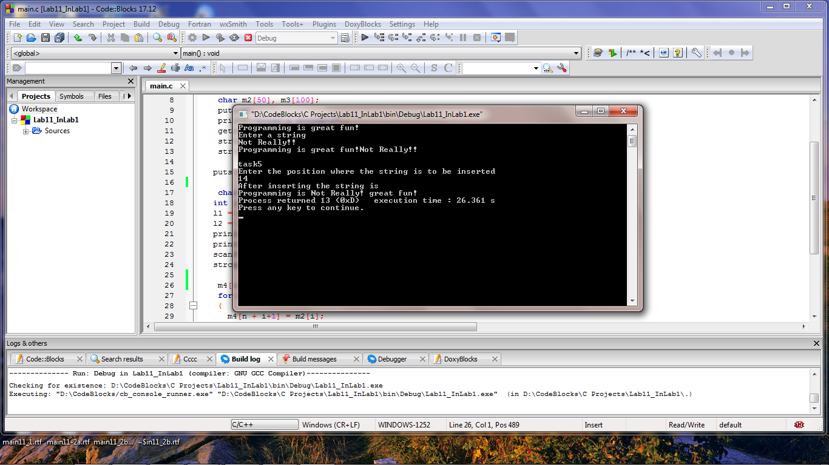

**Task 2a:**

**Write a program that converts a string like "124" to an integer 124.**

**Program:** In this program, user is prompted to enter a numeric string. Length of string is calculated. A for loop is executed uptill the length of the string, ASCII value of deducted from character in string in each iteration and multiplied by variable **‘dec’** initialized as ‘0’(derives the place value of each digit). Henceforth, numeric string is converted into an integer.

1 #include <stdio.h>

2 #include <string.h>

3

4 **int** main()

5 {

6 **char** num[100];

7 **int** dec = 0, i, j, len;

8 printf("Enter a number: ");

9 gets(num);

10 len = strlen(num);

11 **for**(i=0; i<len; i++){

12 dec = dec * 10 + ( num[i] - '0' );

13 }

14 printf("%d", dec);

15 **return** 0;

16 }

**Output:**

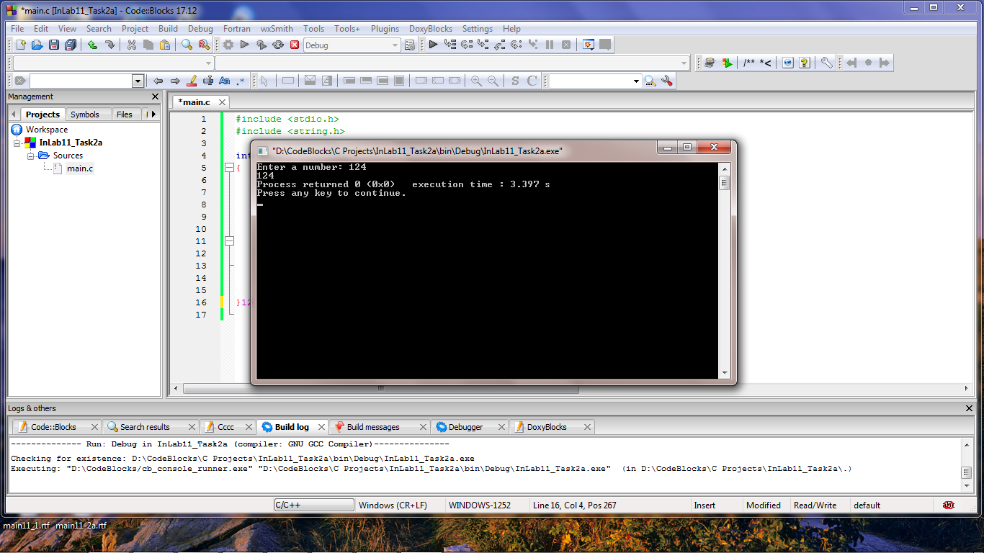

**Task 2b:**

**Write a program that replaces two or more consecutive blanks in a string by a single blank.**

**For example, if the input is**

**“Grim return to the planet of apes!!”**

**the output should be**

**“Grim return to the planet of apes!!”**

**Program:** In this program, two strings are declared. User is prompted to enter a string and is stored in first string. While loop is executed till **‘\0’** is encountered. First string is copied character by character to the second string, if a space is encountered, first one is copied to second string and rest of them are omitted. Second string is then terminated by **‘\0’** and printed as output on the console.

1 **/// C program to remove extra blank spaces from a given string**

2

3 #include <stdio.h>

4 #include <stdlib.h>

5

6 **int** main()

7 {

8 **char** str[100], newString[100];

9 **int** i=0, j=0;

10

11 printf("Enter any string: ");

12 gets(str);

13

14 printf("\nString before removing blanks: \n'%s'", str);

15

16 **while**(str[i] != '\0')

17 {

18 **///If blank space is found**

19 **if**(str[i] == ' ')

20 {

21 newString[j] = ' ';

22 j++;

23

24 **///Skip all consecutive spaces**

25 **while**(str[i] == ' ')

26 i++;

27 }

28

29 newString[j] = str[i];

30

31 i++;

32 j++;

33 }

34 **/// NULL terminate the new string**

35 newString[j] = '\0';

36

37 printf("\n\nString after removing blanks: \n\n'%s'\n", newString);

38

39 **return** 0;

40 }

**Output:**

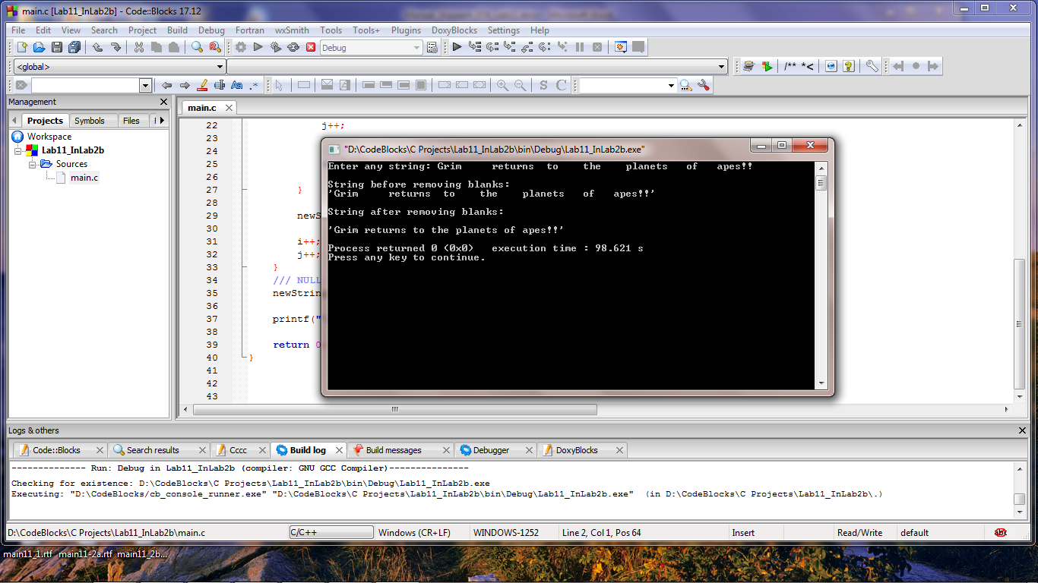

**_______________________**

**THE END**