**Programming Fundamentals**

**Lab 12**

**Submitted To:**

Mr. Dilshad Sabir

**Submitted By:**

Manaal Waseem

FA18-BCE-074

**In Lab:**

**Task 1:**

**Write a C Program that does the following:**

**1. Declares a C-Structure called ‘car’.**

**2. It should contain the following elements:**

**a) A char array of size 20 to hold the make of the car e.g. Suzuki.**

**b) A char array of size 20 to hold the model of the car e.g. Alto**

**c) An integer capacity to store the seating capacity.**

**d) A floating point number to hold the weight of the empty vehicle.**

**3. Then declare 3 variables of this type of structure.**

**4. Let the user populate the elements of these variables.**

**5. Print these structures.**

**Program:** In this program, user is prompted to enter data i.e. **‘make’**, **‘model’**, **‘capacity’** and **‘weight’** for three cars. This data is stored in structure **‘struct car’** and for each car its specifications are referred to as **‘c1.make’** (an example). The details for all three cars are printed as output on the console.

1 #include <stdio.h>

2 #include <stdlib.h>

3

4 **int** main()

5 {

6 **char** ch[1];

7

8 **struct** car

9 {

10 **char** make [20];

11 **char** model [20];

12 **int** capacity;

13 **float** weight;

14 };

15 **struct** car c1, c2, c3;

16

17 printf("Enter make, model, capacity, weight for 3 cars: \n");

18

19 printf("\nEnter details for c1: \n");

20

21 printf("\nEnter make:");

22 gets(c1.make);

23 printf("\nEnter model:");

24 gets(c1.model);

25 printf("\nEnter capacity and weight:");

26 scanf("%d %f", &c1.capacity, &c1.weight);

27 printf("\n");

28 puts(c1.make);

29 puts(c1.model);

30 printf("%d %f\n", c1.capacity, c1.weight);

31

32 printf("Enter details for c2: \n");

33

34 gets(ch);

35 printf("\nEnter make:");

36 gets(c2.make);

37 printf("\nEnter model:");

38 gets(c2.model);

39 printf("\nEnter capacity and weight:");

40 scanf("%d %f", &c2.capacity, &c2.weight);

41 printf("\n");

42 puts(c2.make);

43 puts(c2.model);

44 printf("%d %f\n", c2.capacity, c2.weight);

45

46 printf("\nEnter details for c3: \n");

47

48 gets(ch);

49 printf("\nEnter make:");

50 gets(c3.make);

51 printf("\nEnter model:");

52 gets(c3.model);

53 printf("\nEnter capacity and weight:");

54 scanf("%d %f", &c3.capacity, &c3.weight);

55 printf("\n");

56 puts(c3.make);

57 puts(c3.model);

58 printf("%d %f\n", c3.capacity, c3.weight);

59

60 **return** 0;

61 }

**Output:**

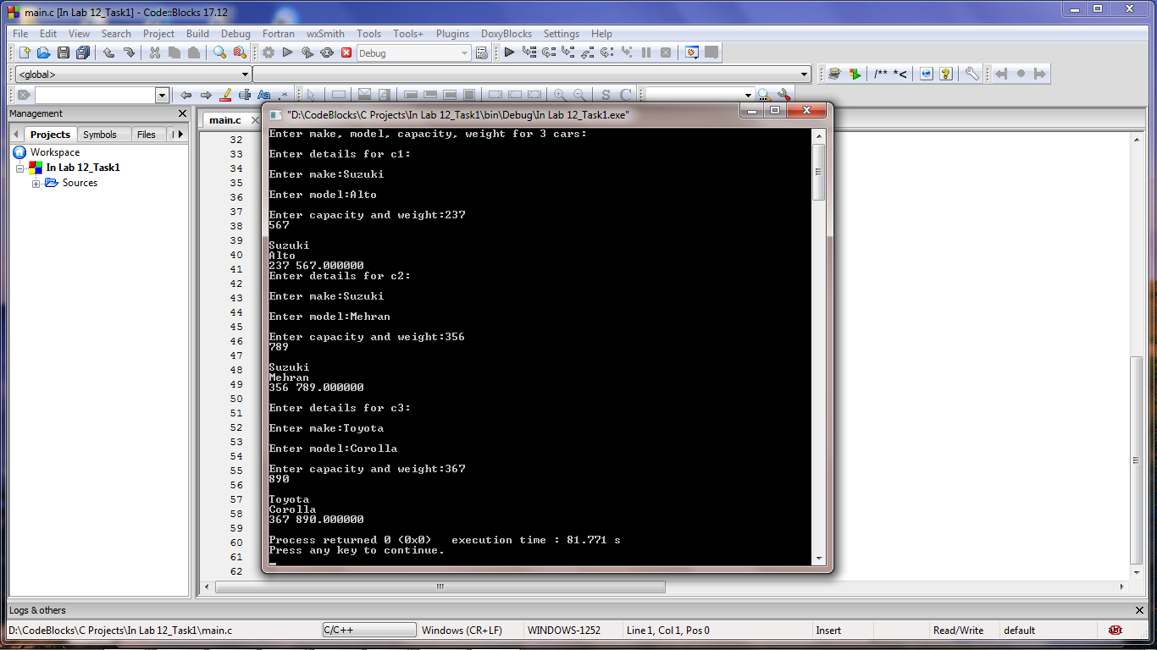

**Task 2a:**

**Write a C program that declares an array of structures of type ‘car’ from previous example, and asks the user to fill in the elements. Once all the structures have been initialized, the program should present a menu to the user so that he can print a certain structure, or modify its elements.**

**Program:** In this program, the main functionality is the same as above. But instead of printing this stored informed it presents the user with a menu, if user wants to print detail of a car or modify the stored information regarding a car. Then user is prompted to enter a choice that which car’s details should be printed or modified. And accordingly, the output is displayed on console.

1 #include <stdio.h>

2 #include <stdlib.h>

3

4 **int** main()

5 {

6 **char** ch[1];

7 **int** choice;

8

9 **struct** car

10 {

11 **char** make [20];

12 **char** model [20];

13 **int** capacity;

14 **float** weight;

15 };

16 **struct** car c[3];

17

18 **int** i;

19 **for**(i=0; i<3; i++)

20 {

21 printf("Enter make, model, capacity, weight for a car: \n");

22

23 printf("\nEnter details for c%d: \n",i);

24

25 printf("\nEnter make:");

26 gets(c[i].make);

27 printf("\nEnter model:");

28 gets(c[i].model);

29 printf("\nEnter capacity and weight:");

30 scanf("%d %f", &c[i].capacity, &c[i].weight);

31 gets(ch);

32 }

33

34 printf("\n\t*********************************");

35 printf("\n\t* *");

36 printf("\n\t* Choose an option *");

37 printf("\n\t* *");

38 printf("\n\t* 1. Print an element *");

39 printf("\n\t* *");

40 printf("\n\t* 2. Modify an element *");

41 printf("\n\t* *");

42 printf("\n\t*********************************\n");

43 scanf("%d",&choice);

44

45 printf("\n");

46

47 **if**(choice==1)

48 {

49 int option;

50

51 printf("\nWhich element you wanna print?\n");

52 scanf("%d",&option);

53 printf("\nPrinting details for c%d: \n",option);

54

55 gets(ch);

56 puts(c[option].make);

57 puts(c[option].model);

58 printf("%d %f\n", c[option].capacity, c[option].weight);

59

60 printf("\n");

61

62 }

63 else

64 {

65 int opt;

66 scanf("%d",&opt);

67

68 printf("\nEnter details for c%d: \n",opt);

69

70 printf("\nEnter make:");

71 gets(c[opt].make);

72 printf("\nEnter model:");

73 gets(c[opt].model);

74 printf("\nEnter capacity and weight:");

75 scanf("%d %f", &c[opt].capacity, &c[opt].weight);

76

77 }

78

79 return 0;

80 }

**Output:**

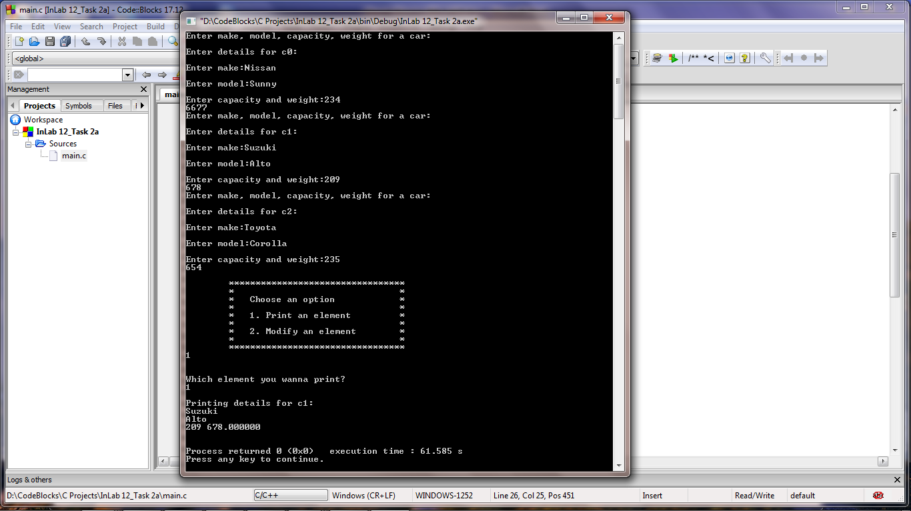

**Task 2b:**

**There is a structure called employee that holds information like employee code, name, date of joining. Write a program to create an array of the structure and enter some data into it. Then ask the user to enter current date. Display the names of those employees whose tenure is 3 or more than 3 years according to the given current date.**

**Program:** In this program, user is prompted to enter data i.e. **‘employee code’**, **‘name’** and **‘date of joining’** in (dd/mm/yyyy) format for two employees. This data is stored in structure **‘struct employee’** and for each employee its specifications are referred to as **‘e1.employee_name’** (an example). Then it is evaluated that which employee’s tenure is three years or greater and based on this evaluation, their names are printed as output on console.

1 #include <stdio.h>

2 #include <stdlib.h>

3

4 **int** main()

5 {

6 **int** ch[1];

7 **int** date;

8 **int** month;

9 **int** year;

10 **int** dif;

11

12 **struct** employee

13 {

14 **int** employee_code;

15 **char** name[20];

16 **int** date;

17 **int** month;

18 **int** year;

19 };

20 **struct** employee e[2];

21

22 printf("Enter employee code, name, date of joining of a employee: \n");

23

24 **for**(**int** i=0; i<2; i++)

25 {

26 printf("\nEnter details for employee%d: \n",i);

27

28 printf("\nEnter employee code:");

29 scanf("%d", &e[i].employee_code);

30 gets(ch);

31 printf("\nEnter name:");

32 gets(e[i].name);

33 printf("\nEnter date of joining (dd/mm/yyyy):");

34 scanf("%d %d %d", &e[i].date, &e[i].month, &e[i].year);

35 gets(ch);

36 }

37

38 printf("\nEnter current date (dd/mm/yyyy):");

39 scanf("%d %d %d", &date, &month, &year);

40

41 printf("\nNames of employees whose tenure is 3 or more than 3 yrs:\n");

42

43 **for**(**int** j=0; j<2; j++)

44 {

45 **if**((year-e[j].year)>3)

46 puts(e[j].name);

47 **else**

48 **if**((year-e[j].year)==3)

49 {

50 **if**((month-e[j].month)>=0)

51 puts(e[j].name);

52 **else**

53 **if**((date-e[j].date)>=0)

54 puts(e[j].name);

55 }

56

57 }

58 **return** 0;

59 }

**Output:**

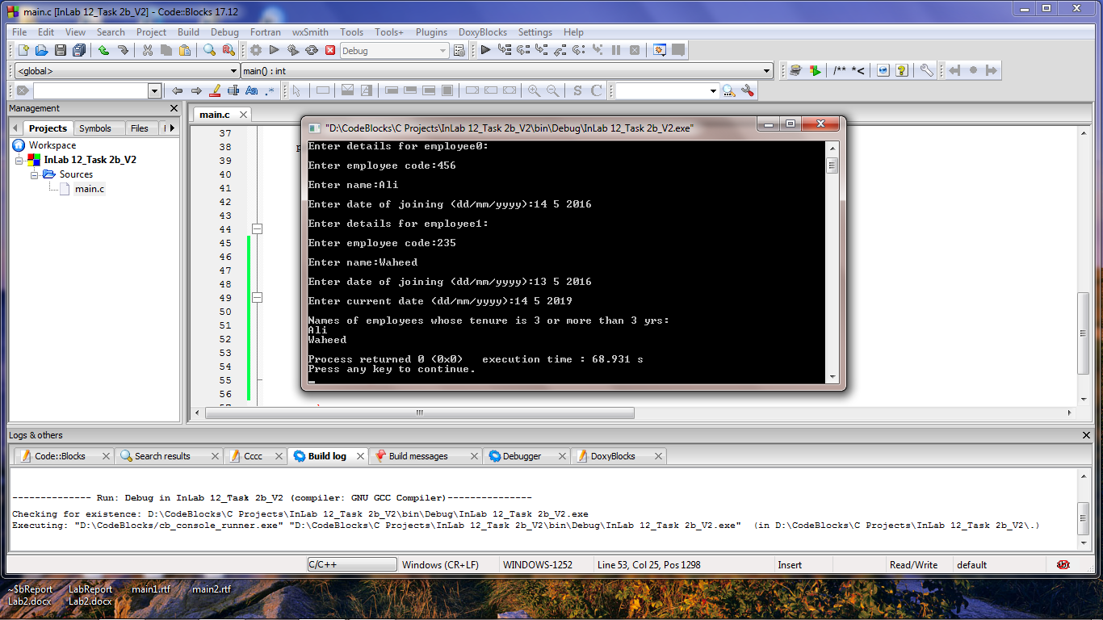

**_______________________**

**THE END**