**Programming Fundamentals**

**Lab 2**

**Submitted To:**

Mr. Dilshad Sabir

**Submitted By:**

Manaal Waseem

FA18-BCE-074

**In Lab:**

**Task 1:**

**Following figure shows a pattern of squares generated for different input values of N (for N=0 to N=5). Develop a general algorithm to fill in the grid for any input N. Use the 4 step process that was discussed in the class (and is given below for reference)**

**The four – step algorithm development process:**

**1. Work an example yourself.**

**2. Write down what you just did.**

**3. Generalize your steps.**

**4. Test your algorithm.**

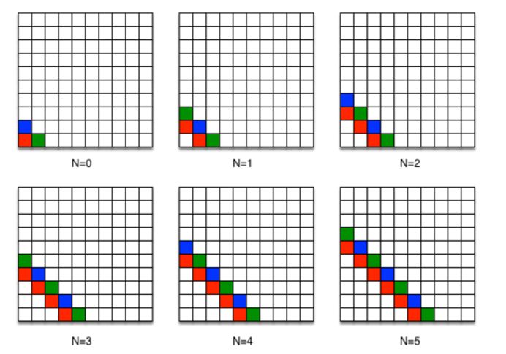

Figure A pattern of squares problem

**Algorithim:**

1. Take a variable N.
2. Take two variables x and y for values of x-axis and y-axis respectively.
3. Assign x=N+1.
4. Assign y=0.
5. If x+y is equal to N then

place a red square at (x,y).

1. Otherwise if (N is even and x+y is equal to N+1) then

place a green square at (x,y) if x is odd

or

place a blue square at (x,y) if x is even.

1. Otherwise if (N is odd and x+y is equal to N+1) then

place a green square at (x,y) if x is even

or

place a blue square at (x,y) if x is odd.

1. Increment y by one.
2. If y is less than or equal to N+1 then repeat from step 5.
3. Decrement x by one.
4. If x is greater than or equal to 0 then repeat from step 4.

**Testing**

Case 1:

**N=4**

|  |  |  |  |  |  |  |
| --- | --- | --- | --- | --- | --- | --- |
| **x** | **y** | **Color** |  | **x** | **y** | **Color** |
| 5 | 0 | G |  | 2 | 0 | - |
| 5 | 1 | - |  | 2 | 1 | - |
| 5 | 2 | - |  | 2 | 2 | R |
| 5 | 3 | - |  | 2 | 3 | B |
| 5 | 4 | - |  | 2 | 4 | - |
| 5 | 5 | - |  | 2 | 5 | - |
| 4 | 0 | R |  | 1 | 0 | - |
| 4 | 1 | B |  | 1 | 1 | - |
| 4 | 2 | - |  | 1 | 2 | - |
| 4 | 3 | - |  | 1 | 3 | R |
| 4 | 4 | - |  | 1 | 4 | G |
| 4 | 5 | - |  | 1 | 5 | - |
| 3 | 0 | - |  | 0 | 0 | - |
| 3 | 1 | R |  | 0 | 1 | - |
| 3 | 2 | G |  | 0 | 2 | - |
| 3 | 3 | - |  | 0 | 3 | - |
| 3 | 4 | - |  | 0 | 4 | R |
| 3 | 5 | - |  | 0 | 5 | B |

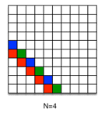

Case 1 Output

**Testing**

Case 2:

**N=3**

|  |  |  |
| --- | --- | --- |
| **x** | **y** | **Colour** |
| 4 | 0 | G |
| 4 | 1 | - |
| 4 | 2 | - |
| 4 | 3 | - |
| 4 | 4 | - |
| 3 | 0 | R |
| 3 | 1 | B |
| 3 | 2 | - |
| 3 | 3 | - |
| 3 | 4 | - |
| 2 | 0 | - |
| 2 | 1 | R |
| 2 | 2 | G |
| 2 | 3 | - |
| 2 | 4 | - |
| 1 | 0 | - |
| 1 | 1 | - |
| 1 | 2 | R |
| 1 | 3 | B |
| 1 | 4 | - |
| 0 | 0 | - |
| 0 | 1 | - |
| 0 | 2 | - |
| 0 | 3 | R |
| 0 | 4 | G |

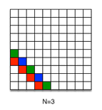

Case 2 Output

**Task 2**:

**Write a C program for following piecewise function. Program must take input from user and calculate and print the function result on screen.**

$$f[n]=\left\{\begin{aligned}-n-4, & n<3 \\ n^{2}-7, & 3≤n≤10 \\ \frac{120}{n} +n, n>10 \\ \\ where n is an integer variable\end{aligned}\right.$$

**Program:** In this program, first the variables are declared. Then a statement is printed to input values on command prompt. Next instruction gets input on the Command Prompt. Thereafter the main logic of the program comes. In the if clause first it is checked that whether the input value is less than 3 else if the values are greater than or equal to 3 and less than or equal to 10 or if it is any number greater than 10. As per the input values the numbers will be printed.

#include <stdio.h>

#include <stdlib.h>

int main( ) // main function

{

int n, output; //Variable declaration

printf("Enter a value: "); //Input message for the user

scanf("%d",&n); // Taking input from the user

if (n<3)

{

printf("Output= %d \n",-n-4); //Output message

}

else if ((n>=3)&&(n<=10))

{

printf("Output= %d \n",(n*n)-7); //Output message

}

else

{

printf("Output= %d \n",(120/n)+n); //Output message

}

return 0;

}//End of Program

**Outputs:**

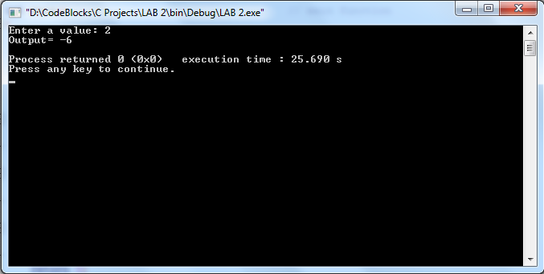

Output 1 when n < 3

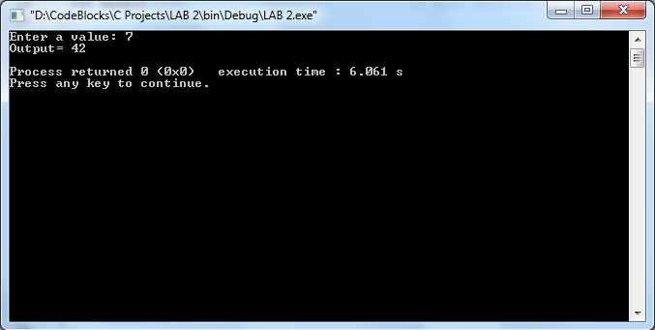

Output 2 when 3 <= n <= 10

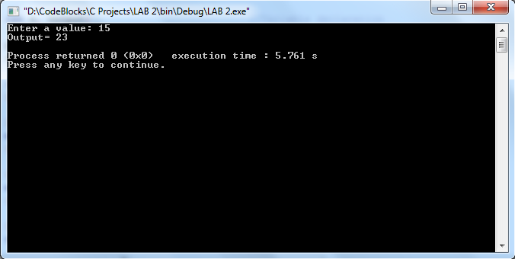

Output 3 when n > 10

**Post Lab:**

**Write a program that takes integer input from user and tells (displays on the output console screen) whether it is even or odd.**

**Program:** In this program, first a variable is declared. Then a statement is printed to input a value on command prompt. Next command gets input on the Command Prompt. Thereafter the main logic of the program comes. In the if statement the input number is divided by 2. If the remainder of this division is “0” than the number is even otherwise the number is odd. The statements are printed accordingly.

#include <stdio.h>

#include <stdlib.h>

int main( ) // main function

{

int n; //Variable declaration

printf("Enter a number: "); //Input message for the user

scanf("%d",&n); // Taking input from the user

if(n%2==0) //Condition for checking whether n is even or not

{

printf("\n\n %d is an even number. \n",n); // display message on the screen

}

else

{

printf("\n\n%d is an odd number. \n",n); // display message on the screen

}

return 0;

}//End of Program

**Output:**

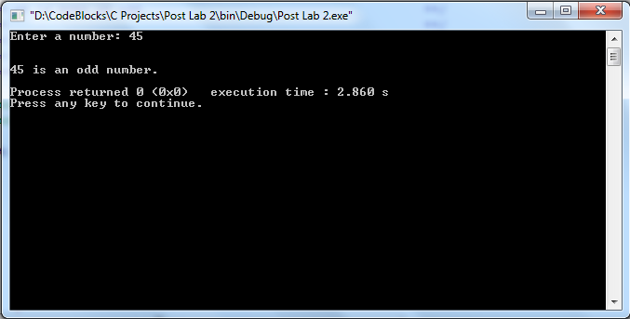

Output