**Programming Fundamentals**

**Lab 3**

**Submitted To:**

Mr. Dilshad Sabir

**Submitted By:**

Manaal Waseem

FA18-BCE-074

**In Lab:**

**Task 1:**

**Write a program that prints all even numbers from N to M, where N and M are user**

**input integers.**

**Program:** In this program, first the variables are declared. Then a statement is printed to input values on command prompt. Next instruction gets input on the Command Prompt. Thereafter the main logic of the program comes. First a for loop start such that it starts from the first number “N” that was obtained as an input and the loop goes till the next number i.e. “M”. In between this loop the main logic of the program runs which filters even numbers by dividing numbers in the range from “N” to “M” by 2 and by selecting those numbers whose remainder come out to be “0”. Finally the even numbers are displayed on the screen.

#include <stdio.h>

#include <stdlib.h>

int main( ) //Main Function

{

int N,M; //Declaring Variables

int i; //Declaring Varibles

printf("Enter two numbers: \n"); //Input message for the user

scanf("%d %d",&N,&M); // Taking input from the user

printf("\n"); //Print cursor to the next line

for(i=N; i<=M ;i++) //Checks the validity of condition across all numbers within the

range defined by user

{

if(i%2==0) //Condition to check if the number is even

printf("%d \n",i); //Display Message

}

return 0;

} // End of Program

**Output:**

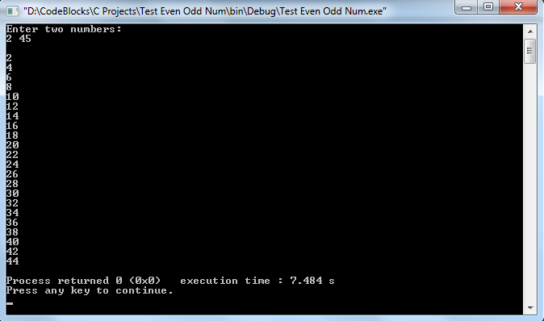

**Task 2+Post Lab**:

Write C programs that output the following patterns exactly. Use a*s* ***few lines of codeas possible***. You are free to use **integers**, **loops**, and **conditional statements** (e.gif/else)**.** No functions or arrays are allowed.

**a. \*\*\*\*\*\*\*\*\*\*\*\*\*\*\*\*\*\*\***

**\*\*\*\*\*\*\*\*\*\*\*\*\*\*\*\*\***

**\*\*\*\*\*\*\*\*\*\*\*\*\*\*\***

**\*\*\*\*\*\*\*\*\*\*\*\*\***

**\*\*\*\*\*\*\*\*\*\*\***

**\*\*\*\*\*\*\*\*\***

**\*\*\*\*\*\*\*\*\***

**\*\*\*\*\*\*\*\*\*\*\***

**\*\*\*\*\*\*\*\*\*\*\*\*\***

**\*\*\*\*\*\*\*\*\*\*\*\*\*\*\***

**\*\*\*\*\*\*\*\*\*\*\*\*\*\*\*\*\***

**\*\*\*\*\*\*\*\*\*\*\*\*\*\*\*\*\*\*\***

**Program:** In this program, first the variables are declared. These input variables serve as a counter and 3 different For loop values. Thereafter the main logic of the program comes. In the main logic there are three nested For loops. In the first For loop a new line is entered. The second For loop prints spaces in the beginning of line. The third For loop prints * in a line and the counter decrements by 2. Thereafter, the For loops repeats 5 more times. In the second half first the counter is incremented by 2 and the logic for printing the rest of the lines executes opposite to the first half.

#include <stdio.h>

#include <stdlib.h>

int main()

{

int counter, i, k, j;

counter = 19; // Initializing counter

// Logic for printing first six lines of pattern

for(i=0; i<6; i++)

{

printf("\n"); //Print the cursor in new line

for(k=0; k<i; k++) //Print spaces in the beginning of line

printf(" ");

for(j=counter; j>0; j--) //Print * in a line

printf("*");

counter -= 2; //Decrementing counter

}

counter += 2; //Initializing counter for second half of pattern

// Logic for printing last six lines of pattern

for(i=6; i>0; i--)

{

printf("\n"); //Print the cursor in new line

for(k=i-1; k>0; k--) //Print spaces in the beginning of line

printf(" ");

for(j=counter; j>0; j--) //Print * in a line

printf("*");

counter += 2; //Incrementing counter

}

return 0;

} // End of the Program

**Output:**

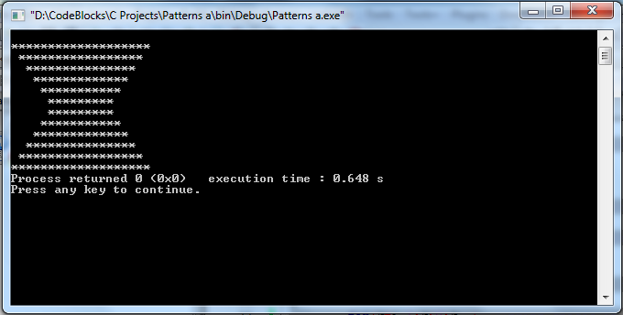

**b. \*\*\*\*\*\*\*\*\*\*\*\*\*\*\*\*\*\*\***

**\*\*\*\*\*\*\*\*\***

**\*\*\*\*\*\*\*\*\*\*\*\*\*\*\*\*\***

**\*\*\*\*\*\*\*\*\*\*\***

**\*\*\*\*\*\*\*\*\*\*\*\*\*\*\***

**\*\*\*\*\*\*\*\*\*\*\*\*\***

**\*\*\*\*\*\*\*\*\*\*\*\*\***

**\*\*\*\*\*\*\*\*\*\*\*\*\*\*\***

**\*\*\*\*\*\*\*\*\*\*\***

**\*\*\*\*\*\*\*\*\*\*\*\*\*\*\*\*\***

**\*\*\*\*\*\*\*\*\***

**\*\*\*\*\*\*\*\*\*\*\*\*\*\*\*\*\*\*\***

**Program:** In this program, first variables are declared. These variables include two counters and three other variables. Thereafter the main logic of the program comes. The main logic is divided into two parts. The first part is used to print the upper half of the pattern while the second part is used to print the lower half of the pattern. In the first part of the logic after the initialization of the counters the control is entered in a For loop which executes three times. For each iteration of the loop, two lines of the pattern will be printed. In each iteration first of all a printf statement prints the cursor in the beginning of the new line. Secondly white spaces are printed for that line. Then a for loop prints ‘*’ for that line. To print the second line similar logic is used. At the end of the iteration the counters are decremented or incremented by 2 according to the logic.

The second part of logic uses similar approach but the order for the printing of two lines are reversed.

#include <stdio.h>

#include <stdlib.h>

int main( )

{

int counter,counter2,i,k,j;

counter=19; //Initializing Counter

counter2=9; //Initializing Counter

//Logic for printing upper half of the pattern

for(i=0;i<3;i++)

{

printf("\n"); //Print the cursor in new line

for(k=0;k<i;k++) //Print spaces in the beginning of line

printf(" ");

for(j=counter;j>0;j--) //Print * in a line

printf("*");

printf("\n"); //Print the cursor in new line

for(k=0;k<((counter-counter2)/2+i);k++) //Print spaces in the beginning of line

printf(" ");

for(j=counter2;j>0;j--) //Print * in a line

printf("*");

counter-=2; //Decrementing Counter

counter2+=2; //Incrementing Counter2

}

counter+=2; //Incrementing Counter

counter2-=2; //Decrementing Counter2

//Logic for printing upper half of the pattern

for(i=2;i>=0;i--)

{

printf("\n"); //Print the cursor in new line

for(k=((counter-counter2)/2+i);k>0;k--) //Print spaces in the beginning of line

printf(" ");

for(j=counter2;j>0;j--) //Print * in a line

printf("*");

printf("\n"); //Print the cursor in new line

for(k=i;k>0;k--) //Print spaces in the beginning of line

printf(" ");

for(j=counter;j>0;j--) //Print * in a line

printf("*");

counter+=2; //Incrementing Counter

counter2-=2; //Decrementing Counter2

}

return 0;

} //End of the Program

**Output:**

