**Programming Fundamentals**

**Lab 4**

**Submitted To:**

Mr. Dilshad Sabir

**Submitted By:**

Manaal Waseem

FA18-BCE-074

**In Lab:**

**Task 1:**

**Write a C program that solves a simple user-entered mathematical expression. It should take input from the user (two floating type values and operations like *, /, + and -), calculate the result and show it on screen.**

**e.g. if the user inputs “5 + 6” the program should add numbers 5 and 6 and print the answer 11 on to the console.**

**Pre-requisites: understanding of „*int*‟, „*char*‟ and „*float*‟ type variables in C.**

**Use format specifiers „%f‟ for „float‟; „%d‟ for „int‟ and „%c‟ for „char‟ type variables).**

**Program:** In this program, first the variables are declared. Then a statement is printed to input values on command prompt. Next instruction gets input on the Command Prompt. Thereafter the main logic of the program comes. First the if statement checks the operation demanded by the user to be performed and then perform the operation accordingly on the values inputted by the user. Finally the output is displayed on the screen.

#include <stdio.h>

#include <stdlib.h>

int main()

{

float a,b;

char my_operation;

printf("Enter the operation you wish to execute: \n");

scanf("%f %c %f",&a, &my_operation, &b);

if(my_operation=='+')

printf("%f+%f=%f ",a,b,a+b);

if(my_operation=='-')

printf("%f-%f=%f ",a,b,a-b);

if(my_operation=='*')

printf("%f*%f=%f ",a,b,a*b);

if(my_operation=='/')

printf("%f/%f=%f ",a,b,a/b);

**return** 0;

}

**Output:**

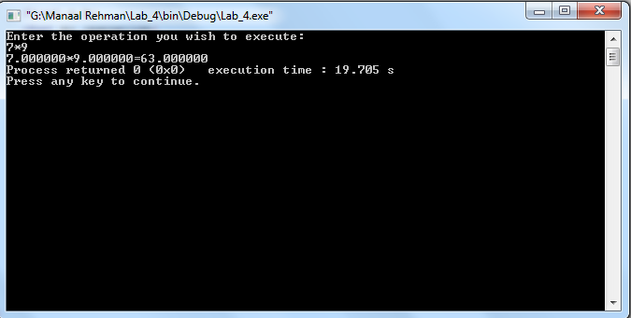

**Task 2(a)**:

**Following program prints a menu. It then takes input from user and displays the entered choice. Type-in the C program given below into a new project, compile and run to see how it works.**

I have implemented the following code in **“Codeblocks”**, and understood how it works on the basis of **“Finite State Machine”**.

#include <stdio.h>

#include <stdlib.h>

int main()

{

int choice=0;

while(choice!=4)

{

printf("\n\tMENU DEMONSTRATION");

printf("\n\t------------------------------");

printf("\n\n\t 1. OPTION 1");

printf("\n\t 2. OPTION 2");

printf("\n\t 3. OPTION 3");

printf("\n\t 4. EXIT");

printf("\n\n Enter Your Choice: ");

scanf("%d",&choice);

**switch**(choice)

{

**case** 1:

printf("\nYOU SELECTED OPTION %d",choice);

**break;**

**case** 2:

printf("\nYOU SELECTED OPTION %d",choice);

**break;**

**case** 3:

printf("\nYOU SELECTED OPTION %d",choice);

**break;**

**case** 4:

printf("\nYOU SELECTED OPTION %d",choice);

exit(0);

**default**:

printf("\nINVALID SELECTION...Please try again");

}

getchar( );

}

}

**Output:**

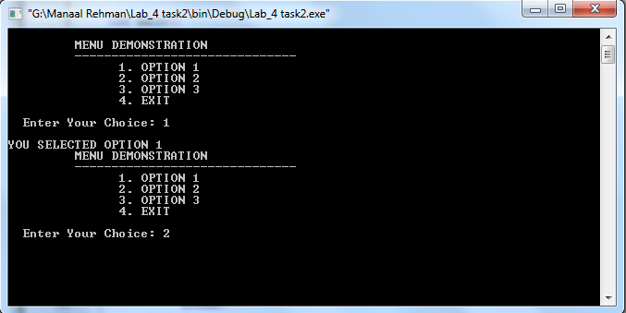

**Task 2(b)**:

**Modify the above program to implement following sate machine. Here ‘a’ and ‘b’ are user input characters. The program should print out appropriate messages to the console when a user enters a character.**

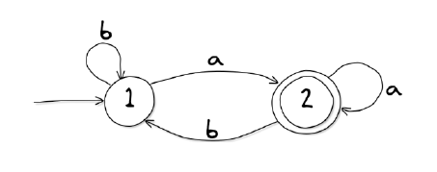

**Program:** In this program, first the variable choice is declared. The variable CS (current state) is declared and its value is set to be 1, another variable; flag is declared and its value is set to be 0. Then a **“Do While”** loop is implemented which works while flag is not equal is 2. The user can avail three choices, **‘a’,** **‘b’** or **‘e’**. As clear from the FSM outline above; CS is either equal to 1 or 2. If CS is equal to 1, choice ‘a’ leads to CS=2 and flag is set to be ‘1’ and choice ‘b’ retains CS=1. Choice ‘e’ can be availed to exit the window. Similarly, when CS is equal to 2 and flag is equal to 1; choice ‘a’ retains CS=2 and choice ‘b’ leads to CS=1. Choice ‘e’ can be availed to exit the window. This logic is implemented via Switch case statements and any choice other than ‘a’, ‘b’ and ‘e’ gives **“Invalid Selection”** message to the user.

#include <stdio.h>

#include <stdlib.h>

int main()

{

char choice;

int CS=1;

int flag=0;

do

{

if(CS==1)

{

printf("\n\t SELECT ONE OF THE FOLLOWING OPTIONS: ");

printf("\n \t 1. a");

printf("\n \t 2. b");

printf("\n \t 3. e to EXIT WINDOW");

printf("\n \n Enter Your Choice: ");

scanf("%c", &choice);

{

switch(choice)

{

case 'a':

printf("You are in state 2 now!!!");

flag=1;

CS=2;

break;

case 'b':

printf("You are in state 1 still!!!");

break;

case 'e':

printf("You are going to exit the window! ");

exit(0);

default:

printf("\nINVALID SELECTION...Please try again");

}

getchar();

}

}

if(CS==2&&flag==1)

{

printf("\n\t SELECT ONE OF THE FOLLOWING OPTIONS: ");

printf("\n \t 1. a");

printf("\n \t 2. b");

printf("\n \t 3. e to EXIT WINDOW");

printf("\n \n Enter Your Choice: ");

scanf("%c", &choice);

{

switch(choice)

{

case 'a':

printf("You are still in state 2!!!");

break;

case 'b':

printf("You are in state 1 now!!!");

CS=1;

flag=0;

break;

case 'e':

printf("You are going to exit the window! ");

exit(0);

default:

printf("\nINVALID SELECTION...Please try again");

}

getchar();

}

}

} while(flag!=2);

}

**Post Lab Task**:

Write a C program to implement the following state machine.

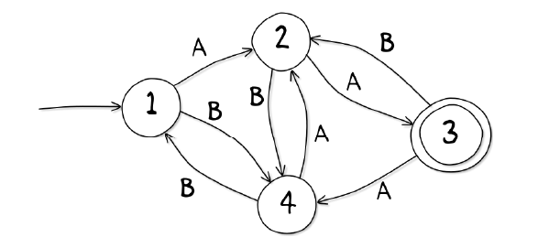

**Program:** In this program, first the variable choice is declared. The variable CR (current room) is declared and its value is set to be 1, another variable action is declared and is initialized with ‘N’. Then a **“Do While”** loop is implemented which works while action is not equal is ‘Y’. The user can avail two choices, **‘A’** or **‘B’**. As clear from the FSM outline above; CR can possibly be 1, 2, 3 or 4. If CR is equal to 1, choice ‘A’ leads to CR=2; choice ‘B’ leads to CR=4. Similarly, when CR is equal to 2; choice ‘A’ leads to CR=3 and choice ‘B’ leads to CR=4. When CR=3; since it is the **“Final State”** of the FSM, user is asked if they want to exit the window by opting either ‘Y’ or ‘N’. User’s selection is stored in variable ‘action’. If action=‘Y’ program is exited else the user is asked to enter choice. Choice ‘A’ leads to CR=4 and choice ‘B’ leads to CR=2 . And when CR is equal to 4; choice ‘A’ leads to CR=2 and choice ‘B’ leads to CR=1. This logic is implemented via Switch case statements and any choice other than ‘A’ and ‘B’ gives **“Invalid Selection”** message to the user.

#include <stdio.h>

#include <stdlib.h>

int main()

{

char choice;

int CR=1;

char action='N';

do

{

if(CR==1)

{

printf("\n\t SELECT ONE OF THE FOLLOWING OPTIONS: ");

printf("\n \t 1. A");

printf("\n \t 2. B");

printf("\n \n Enter Your Choice: ");

scanf(" %c", &choice);

{

**switch**(choice)

{

case 'A':

printf("You are in state 2 now!!!");

CR=2;

break;

case 'B':

printf("You are in state 4 now!!!");

CR=4;

break;

default:

printf("\nINVALID SELECTION...Please try again");

}

}

}

else if(CR==2)

{

printf("\n\t SELECT ONE OF THE FOLLOWING OPTIONS: ");

printf("\n \t 1. A");

printf("\n \t 2. B");

printf("\n \n Enter Your Choice: ");

scanf(" %c", &choice);

{

switch(choice)

{

case 'A':

printf("You are in state 3 now!!!");

CR=3;

break;

case 'B':

printf("You are in state 4 now!!!");

CR=4;

break;

default:

printf("\nINVALID SELECTION...Please try again");

}

}

}

else if(CR==3)

{

printf("You are in final state now. \n Do you want to exit program? (Y or N)\n");

scanf(" %c",&action);

if (action=='Y')

continue;

printf("\n\t SELECT ONE OF THE FOLLOWING OPTIONS: ");

printf("\n \t 1. A");

printf("\n \t 2. B");

printf("\n \n Enter Your Choice: ");

scanf(" %c", &choice);

{

switch(choice)

{

case 'A':

printf("You are in state 4 now!!!");

CR=4;

break;

case 'B':

printf("You are in state 2 now!!!");

CR=2;

break;

default:

printf("\nINVALID SELECTION...Please try again");

}

printf("\naction = %c", action);

}

}

else if(CR==4)

{

printf("\n\t SELECT ONE OF THE FOLLOWING OPTIONS: ");

printf("\n \t 1. A");

printf("\n \t 2. B");

printf("\n \n Enter Your Choice: ");

scanf(" %c", &choice);

{

switch(choice)

{

case 'A':

printf("You are in state 2 now!!!");

CR=2;

break;

case 'B':

printf("You are in state 1 now!!!");

CR=1;

break;

default:

printf("\nINVALID SELECTION...Please try again");

}

}

}

}while(action!='Y');

printf("You have exited the program.");

return 0;

}

**Output:**

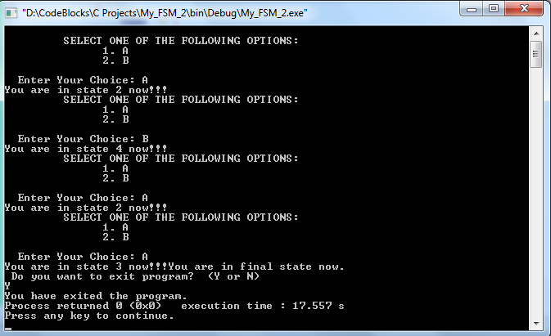

**_______________________**

**THE END**