API Security Framework
Automated Detection of Broken Object Level Authorization (BOLA) using OWASP ZAP and Postman
Project Report
Submitted by: YourName
October 2026

Abstract
Broken Object Level Authorization (BOLA) is the most common and most damaging class of API vulnerability, listed as API1 in the OWASP API Security Top 10. It occurs when an API verifies who a caller is but not whether the requested object belongs to that caller. Because the flaw depends on application logic, generic scanners rarely find it.
This project implements an API Security Framework that automates BOLA detection. A Python two-user test engine replays every endpoint and HTTP method with another user's object identifiers, classifies the outcome, and assigns a severity. The same test matrix is exported as a Postman collection that runs headless through Newman, and an OWASP ZAP spider and active scan are driven through the ZAP API for broader coverage. On a demonstration API containing deliberate flaws, the framework executed 80 test cases, identified 46 vulnerable cases across five endpoints, and correctly flagged a partially fixed DELETE handler in the supposedly secure v2 API.

1. Introduction
Modern applications expose most of their functionality through REST APIs that reference objects by identifier, for example /orders/101 or /users/7/profile. If the server does not confirm that the authenticated user owns the object, an attacker can change the identifier and read, modify or delete other users' data. This is a BOLA (also called IDOR) vulnerability.
Manual testing of BOLA does not scale: every endpoint, method and user pair must be tried, and fixes frequently regress. The goal of this project is to make that testing repeatable, automated and CI-friendly.

2. Objectives
- Build an automated engine that tests every endpoint and HTTP method for cross-user object access.
- Classify results as vulnerable, secure or inconclusive, with severity and data-leak evidence.
- Generate Postman collections from the same test matrix and run them with Newman for CI/CD.
- Automate OWASP ZAP scans through its API to complement the BOLA checks.
- Produce machine-readable (CSV/JSON) and human-readable (Markdown) reports and a pass/fail gate.

3. Background

3.1 Broken Object Level Authorization
BOLA arises when object identifiers supplied by the client are trusted without an ownership check. Typical impacts are disclosure of other users' personal data, unauthorised modification of records, and deletion of data. Predictable numeric identifiers make exploitation trivial, but unpredictable identifiers (UUIDs) only slow an attacker down; the server-side check is the real control.

3.2 Tools
- OWASP ZAP: an open-source web application security scanner with a spider, active scanner and a REST API for automation.
- Postman / Newman: an API platform whose collections and test scripts can be run headless in pipelines via the Newman CLI.
- Python stack: Python, Flask, requests, pandas and matplotlib for the test engine, demo API and reporting.

4. System Architecture
The framework has five cooperating components, all driven from a single Jupyter notebook:
Component | Responsibility
Configuration | Defines target URL, test users, owned object IDs per user, and endpoint templates.
Demo target API | A Flask API with deliberate BOLA flaws so the framework can be demonstrated and validated anywhere.
BOLA test engine | Runs baseline, attack and unauthenticated checks for every combination and classifies the results.
Postman / Newman | Exports the matrix as a v2.1 collection with assertions; runs headless for CI.
OWASP ZAP | Spiders and actively scans the API through the ZAP API using an authenticated session.
Reporting | Summary tables, charts, CSV/JSON/Markdown export, severity ranking and CI exit code.

5. Methodology

5.1 Two-user test matrix
For each endpoint template, each object owned by a victim user, and each other user acting as attacker, the engine performs the following steps:
- Baseline: the owner requests their own object and must receive a 2xx response, which avoids false positives caused by broken test data. (Skipped for DELETE, which would consume the object.)
- Attack: the attacker, using their own valid token, requests the victim's object.
- Verdict: a 2xx response is VULNERABLE (and the response is checked for the victim's data); 401, 403 or 404 is SECURE; anything else is INCONCLUSIVE.
- Unauthenticated check: each endpoint is also called without any token and must return 401 or 403.
Seed data is reset before every request so destructive PUT and DELETE tests stay independent.

5.2 Severity model
Method | Severity | Rationale
DELETE | Critical | Attacker can destroy other users' data.
PUT / PATCH / POST | High | Attacker can tamper with other users' data.
GET (sensitive data) | High | Personal data such as email and address is exposed.
GET (other) | Medium | Information disclosure.

5.3 Postman and Newman
The collection contains a login request per user (storing each token in a collection variable) followed by one request per test case. Each request carries a test script asserting that the status code is one of 401, 403 or 404. A collection-level pre-request script resets the seed data so that each request is independent. The collection runs headless with: newman run bola_collection.postman.json -e local.postman_environment.json.

5.4 OWASP ZAP
ZAP is started as a daemon. The framework adds a replacer rule that injects the attacker's bearer token, runs the spider, then the active scan, and exports the alerts. ZAP cannot know which user owns which object, so it is positioned as a complement: it finds injection, misconfiguration and header issues, while the two-user engine provides authorisation coverage.

6. Implementation
The implementation is delivered as the notebook YourName_APISecurityFramework.ipynb, which contains the following stages:
- Configuration of users, owned resources and endpoints.
- A Flask demo API: v1 performs authentication only; v2 adds ownership checks to GET, PUT and the profile endpoint but misses DELETE.
- The BOLA test engine returning a pandas DataFrame of every test case.
- Summary tables, stacked bar chart and severity ranking.
- Postman collection and environment generation, with optional Newman execution.
- Optional ZAP automation guarded so the notebook still runs when ZAP is absent.
- CSV, JSON and Markdown reports and a CI-style gate (exit code 1 when Critical or High findings exist).

7. Results
The suite executed 80 test cases against the demo API: 72 cross-user attacks (3 users, 5 orders and 3 profiles across 8 endpoint/method combinations) and 8 unauthenticated checks. 46 cases (57.5 percent) were vulnerable. All unauthenticated checks passed, confirming that authentication was enforced but authorisation was not.
Endpoint | Vulnerable | Secure | Inconclusive | Exposure %
v1 GET order | 10 | 1 | 0 | 90.9
v1 PUT order | 10 | 1 | 0 | 90.9
v1 DELETE order | 10 | 1 | 0 | 90.9
v1 GET profile | 6 | 1 | 0 | 85.7
v2 GET order | 0 | 11 | 0 | 0.0
v2 PUT order | 0 | 11 | 0 | 0.0
v2 DELETE order | 10 | 1 | 0 | 90.9
v2 GET profile | 0 | 7 | 0 | 0.0

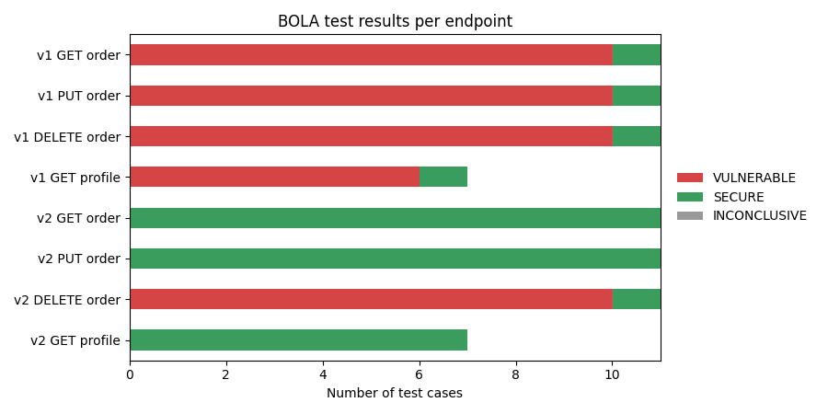
Figure 1: BOLA test results per endpoint

7.1 Findings by severity
Endpoint | Severity | Vulnerable cases
v1 DELETE order | Critical | 10
v2 DELETE order | Critical | 10
v1 PUT order | High | 10
v1 GET profile | High | 6
v1 GET order | Medium | 10

The CI gate reported 36 Critical or High cases and failed, as intended.

8. Discussion
Every v1 endpoint failed every cross-user test, which is the classic BOLA pattern: a valid token was sufficient to access any object. The most instructive result is v2, where the developers fixed GET, PUT and the profile endpoint but forgot DELETE. Because the framework tests every method on every endpoint, it caught this partial fix immediately, a regression that spot checks and single-method scans routinely miss.
Reporting both a baseline and an attack status reduces false positives, and the data-leak check confirms that a 200 response actually contains the victim's data rather than an empty or generic body.

9. Remediation
Object-level authorisation must be enforced on the server, in every handler:
order = Order.query.get_or_404(order_id)
if order.owner_id != current_user.id: # check on EVERY method
abort(403) # or 404 to avoid confirming existence

- Centralise the check in middleware, a decorator or scoped queries so new endpoints cannot omit it.
- Use unpredictable identifiers as defence in depth, never as the only control.
- Run this suite in CI on every release to catch regressions.

10. Limitations and Future Work
- Ownership must be declared in the configuration; automatic discovery of object relationships is not implemented.
- Role-based and function-level authorisation issues (for example BFLA) are out of scope for this version.
- ZAP results are collected but not yet correlated with BOLA findings in a single report.
- Planned: OpenAPI import to generate endpoints automatically, and CI templates for GitHub Actions and GitLab CI.

11. Conclusion
The framework shows that BOLA testing can be fully automated and made repeatable. By combining a two-user test engine, a Postman/Newman collection for pipelines and OWASP ZAP for broader scanning, it detected all deliberately planted flaws, including a partially applied fix, and produced actionable severity-ranked reports with a CI gate.

References
- OWASP API Security Top 10 (2023), API1: Broken Object Level Authorization. https://owasp.org/API-Security/
- OWASP ZAP documentation and API. https://www.zaproxy.org/docs/api/
- Postman documentation: collections and Newman CLI. https://learning.postman.com/docs/

