Title
Author

Heading 3

Heading 4

Heading 5
First Paragraph:
Centered Emphasis
Body Text
- Numbered Items
  - Subitem

Summary Grade Statistics
Minimum | Q1 | Median | Q3 | Maximum
40 | 60 | 72 | 82 | 91
Thin line
- List 2

The following shows the grade histogram for a sample of 45 students:

Solutions
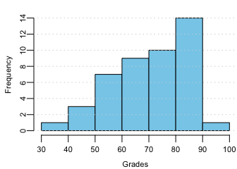
Grade Histogram for 45 Students

