Exam 1 Prep

Define variation in your own words and explain why it is central to statistics.

In the context of a data frame, what do rows represent? What do columns represent?

Which of the following is a quantitative variable?
- Height
- Favorite color
- Gender
- Eye color

Why is sampling necessary in statistics? Provide one reason.

What does it mean for variables to be categorical versus numerical? Give an example of each from a dataset.

In modeling notation, what do the symbols ~ and data= indicate? Offer a brief explanation.

The vector x <- c(2,1,3,3,2,3,1,2,1) is given.
- After sorting x, what pattern becomes visible?
- What does the frequency table of x show?

Using the Fingers dataset (from class):
- What do boxplots of Index ~ Gender visually display about variability?
- Describe center, spread, overlap, and any unusual features.

Consider the following R code:
gf_histogram(~Score, data = Data, binwidth = 2)
- Interpret what the following R code does and what you would expect the plot to show:
- What distribution characteristics would the histogram reveal?

Explain what the five-number summary tells you about a numerical variable and relate it to variation.

Write one sentence comparing the distributions displayed by:
gf_histogram(~Index, data = Fingers, binwidth = 0.25)
gf_histogram(~Index, data = Fingers, binwidth = 0.5)
Focus on how the choice of binwidth affects the appearance.

Explain in plain language what an outlier is and how the 1.5×IQR rule identifies outliers.

What does it tell you if two boxplots (for Index by two groups) show a large difference in medians but overlapping boxes? What does that say about variation within and between groups?

consider the following R output:
favstats(Fingers$Pinkie)
min Q1 median Q3 max mean sd n missing
33 55 58 63 98 59.41252 9.080594 157 0
- What can you say about the center and spread of the Score distribution?
- Use 1.5IQR rule to find if there are any outliers.

Explain why it is important to identify the response variable before choosing a plot to visualize a relationship.

Given these R commands:
mean(Pinkie ~ Gender, data = Fingers) # Returns means for Pinkie in different genders
gf_boxplot(Pinkie ~ Gender, data = Fingers)
Explain what each line does and how the two results complement each other.

Describe in words what the residual represents in the context of a simple model predicting Pinkie using Gender, and why smaller residuals imply a better model.

The following R code calculates proportions:
tally(Gender~Job, data=Fingers)
Job
Gender Not Working Part-time Job Full-time Job
female 65 47 0
male 25 19 1
Give an example of a conditional probability and compute it.

Below is R code that generates a conditional proportion bar chart. Explain how this visualization helps you explain variability in the response.
gf_bar(~Job, data = Fingers, fill = ~Gender, position = "fill")
gf_bar(~Job, data = Fingers, fill = ~Gender, position = "fill")
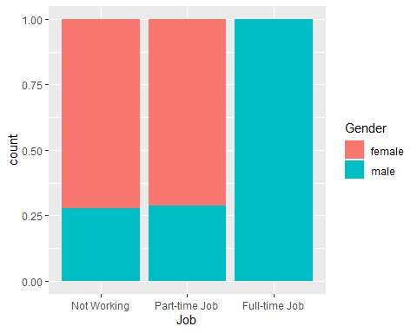

Consider the two plots below:
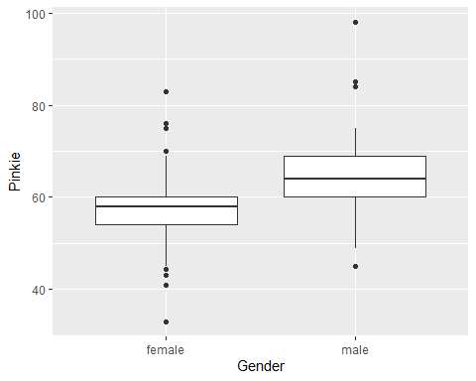
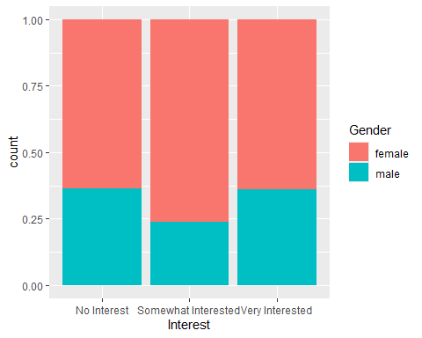
Compare and contrast how these two visuals explain variability in the response variable. In your answer, mention:
- What the plot shows
- How variation is partitioned or summarized
- What conclusions might be drawn about the role of the explanatory variable

