MERIDIAN
High-Level Design
Replacing the SIEM layer with a security data lake, deterministic detection and AI agents over MCP - Azure + Microsoft Foundry and AWS + Amazon Bedrock
Field | Value
Product | MERIDIAN 1.0.1 - SIEM-less detection, investigation and response with AI agents over MCP
Document | High-Level Design
Deployment option | Both: Azure + Microsoft Foundry, AWS + Amazon Bedrock
Version / date | 1.0.1 / 2026-10-02
Author | Peter Akinyele
Classification | Internal
Source | Generated from the repository markdown (docs/) by scripts/build_docx.js

Contents

Right-click the table and choose Update Field if page numbers are not shown.

1. Purpose and scope
Many enterprises pay a SIEM licence that grows with every gigabyte they ingest, and they also pay for the infrastructure and the specialist people needed to keep the SIEM fed and tuned. A large share of that data is stored only for compliance and is rarely queried. MERIDIAN replaces the SIEM layer with three cheaper parts that each do one job well:
- A security data lake in the organisation's own cloud account. Telemetry lands as files, is normalised to OCSF, and is stored as compressed Parquet under write-once retention. Storage costs cents per GB per month, and there is no per-GB ingestion licence.
- A deterministic detection layer. Sigma-compatible rules run on every event as it is ingested, and correlation rules run every five minutes over the lake. This layer is predictable, testable and auditable, which is why it is not an LLM.
- AI agents that work through MCP. They triage every alert, investigate serious cases, hunt on request and propose rule tuning. Agents can only read the lake and context through scoped MCP tools, and they can only request containment. A human approves every change.

In scope: ingestion, normalisation, enrichment, storage, detection, correlation, triage, case management, investigation, hunting, approval-gated response, the hand-off to LODESTAR, and operations on Azure or AWS.
Out of scope: replacing EDR/XDR sensors (they stay as data sources and response targets), SOAR replacement (MERIDIAN can call an existing SOAR), and full UEBA modelling (see section 13).

2. What changes compared with a SIEM
Concern | Traditional SIEM | MERIDIAN
Licence driver | Per GB/day ingested (e.g. Microsoft Sentinel analytics tier pay-as-you-go is published at about $4.30/GB) | No ingestion licence. You pay object storage, serverless query and model tokens
Storage | Proprietary hot store; long retention is an add-on | Parquet in your ADLS / S3 account, tiered, WORM (immutability / Object Lock)
Data model | Vendor schema | OCSF (open), flattened to 42 typed columns
Detection content | Vendor rule language | Sigma-compatible YAML that ports to and from other tools
Triage | Analysts read every alert | Triage agent reads every alert; policy closes clear benign ones, opens or joins cases for the rest
Investigation | Manual pivoting | Investigation agent builds timeline, scope and root cause, and cites evidence (query ids)
Response | Playbooks, often with standing credentials | Agent requests; human approves (four-eyes); executor acts once, with the platform identity
Lock-in | High | Open formats; engines (DuckDB, Athena, ADX) and models (Foundry, Bedrock) are swappable

3. Architecture overview
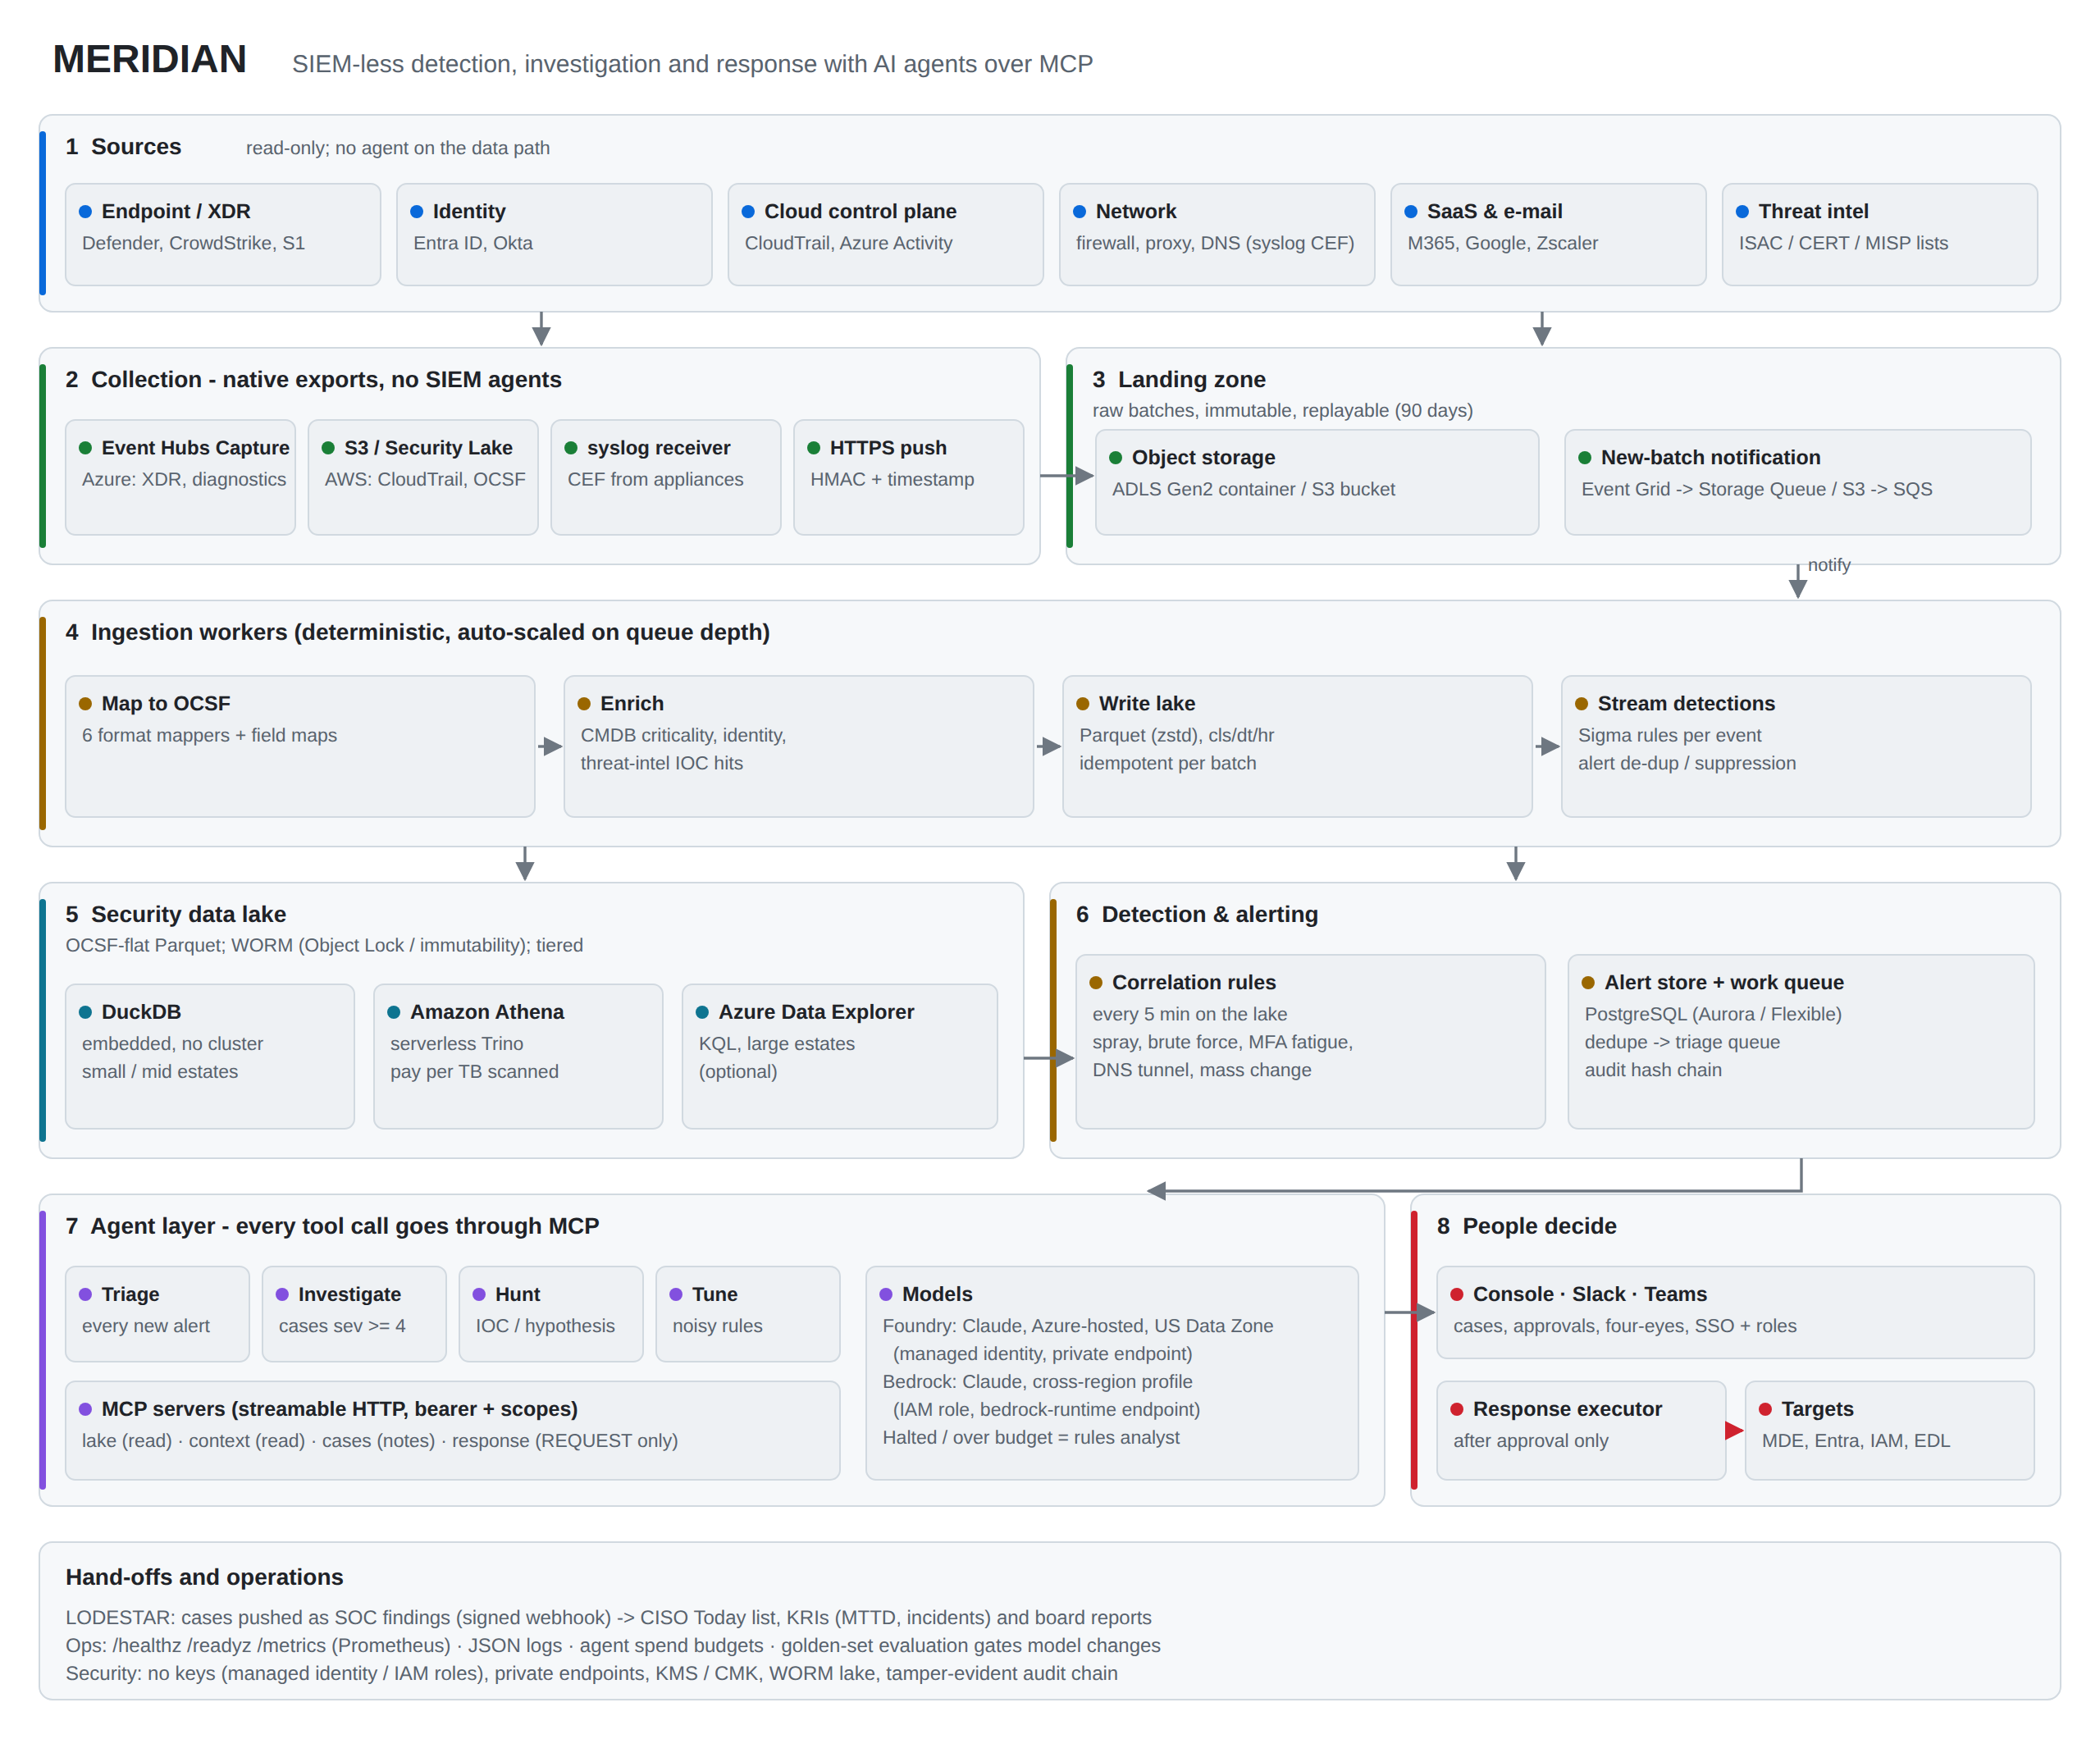
MERIDIAN logical architecture
The platform has eight layers:
# | Layer | Responsibility | Key technology
1 | Sources | Security controls that emit telemetry | Defender/CrowdStrike/S1, Entra/Okta, CloudTrail/Activity, firewalls, proxies, DNS, SaaS, threat intel
2 | Collection | Native exports, so no SIEM agents are needed | Event Hubs Capture, S3/Security Lake, syslog receiver (UDP/TCP/TLS), HTTPS push (HMAC, source tokens, Splunk HEC), API pull, shippers to object storage (LOG-00)
3 | Landing zone | Immutable raw batches, replayable for 90 days | ADLS Gen2 / S3 plus new-object notification
4 | Ingestion workers | Map to OCSF, enrich, write the lake, run streaming rules | Python workers, auto-scaled on queue depth
5 | Security data lake | Long-term, queryable, tamper-evident store | Parquet (zstd) partitioned cls/dt/hr; DuckDB, Athena or ADX
6 | Detection and alerting | Correlation over windows, alert de-duplication, work queue | Scheduler + PostgreSQL
7 | Agent layer | Triage, investigate, hunt, tune | Agent runtime + four MCP servers + Claude in Foundry / Bedrock
8 | People decide | Cases, approvals, response execution | Web console (SSO), Teams/Slack, response executor

3.1 Design principles
- Deterministic first, AI second. Rules decide what is an alert. Agents decide what an alert means and what to do next. Policy, not the model, decides whether an alert is auto-closed.
- Agents never hold credentials for targets. They call MCP tools. The response server can only create approval requests. Execution happens after human approval, inside the API service, using the platform identity.
- Everything an agent sees from telemetry is untrusted. Tool results carry an explicit UNTRUSTED notice, and the system prompt tells the model to treat log content as data. Tool scopes limit the damage a successful prompt injection could do to read-only queries.
- Open formats and replaceable parts. OCSF + Parquet + Sigma + MCP. The query engine and the model provider are configuration choices.
- Production by default. No secrets in configuration, managed identity / IAM roles, private networking, WORM retention, hash-chained audit, health and metrics endpoints, budget guards and a degraded mode.

3.2 Components
Component | Process | Function
api | meridian serve | Console, REST API, MCP endpoints (/mcp/lake, /mcp/context, /mcp/cases, /mcp/response), signed ingest, EDL feed, approvals and response execution
worker | meridian worker | Consumes landing notifications, normalises, enriches, writes Parquet, evaluates streaming rules, enqueues triage
agents | meridian agents | Leases triage / investigate work items and runs agents against the model and the MCP servers
scheduler | meridian scheduler | Correlation rules every 5 minutes (with catch-up), approval expiry, LODESTAR push
syslog | meridian syslog | UDP/TCP/TLS (RFC 6587 / 5425 octet counting, optional mutual TLS) receiver that flushes batches to the landing zone
collect | meridian collect | API pull collector for SaaS audit APIs (cursor, pagination, OAuth2), one active replica
store | PostgreSQL | Alerts, cases, notes, approvals, agent runs, work queue, blocklist, cursors, audit chain
lake | ADLS Gen2 / S3 | Landing (raw) and lake (Parquet), with lifecycle tiering and WORM

4. Data architecture

4.1 Normalised event model
Every event is mapped to an OCSF class and flattened into one wide, typed table. The flat model keeps queries simple for rules and agents and keeps Parquet column pruning effective.
OCSF class | uid | Typical sources
File System Activity | 1001 | EDR file events, ransomware notes
Process Activity | 1007 | EDR process creation
Detection Finding | 2004 | XDR / AV alerts, GuardDuty-style findings
Account Change | 3001 | User and group changes
Authentication | 3002 | Entra / Okta sign-ins, console logins
User Access Management | 3005 | Role assignments, OAuth consent
Network Activity | 4001 | Firewall CEF
HTTP Activity | 4002 | Proxy, WAF
DNS Activity | 4003 | Resolver, DNS firewall
Email Activity | 4009 | Mail gateways
API Activity | 6003 | CloudTrail, Azure Activity, SaaS audit

Key columns include time, class_uid, severity_id, user, src_ip, dst_ip, dst_port, dst_domain, device, device_id, process_name, process_cmdline, file_sha256, url, dns_query, api_operation, resource, tags, ioc_hits, event_uid and raw. The full list is returned by the describe_schema MCP tool.

4.2 Storage layout
landing/<source>/<yyyy>/<mm>/<dd>/<batch>.jsonl.gz raw, as delivered (90 days)
lake/events/cls=<class_uid>/dt=<YYYY-MM-DD>/hr=<HH>/<batch-hash>.parquet
- The batch file name is derived from the landing key, so re-processing a batch rewrites the same object. Ingestion is therefore idempotent, and a processed-batch table prevents double counting.
- Partitioning by class, day and hour lets every query prune to the classes and hours it needs. Athena uses partition projection, so no partition maintenance is needed.
- Retention: the lake is WORM for the configured period (default 365 days). Landing data expires after 90 days.

4.3 Enrichment
Before an event is written it is enriched from three context sources that the organisation maintains:
Context | Format | Adds
Assets | CSV (CMDB export) | asset:<name>, crit:<1-5>, crown_jewel, internet_facing tags
Identities | CSV (HR / IdP export) | identity:<dept>, privileged_user tags
Threat intel | CSV, STIX 2.1 JSON or plain lists | ioc tag and ioc_hits (IPs, domains including parent domains, hashes, URLs)

5. Detection architecture
- Streaming rules run inside the worker on every event. MERIDIAN uses a Sigma-compatible subset: logsource mapping, selections, field modifiers (contains, startswith, endswith, re, cidr, all, gt/lt), and the full condition grammar (and, or, not, 1 of, all of, parentheses).
- Correlation rules (event_count, value_count, grouped by entity, within a window) compile to a QuerySpec and run on the lake every 5 minutes. The scheduler persists the end of the last evaluated window, and after downtime it catches up from there (up to 24 hours), so a missed window is evaluated late rather than lost.
- Alert identity is a hash of the rule, the entity and the time bucket, so repeated matches update one alert (count, last seen, samples) instead of creating noise.
- Content: 30 rules ship with the product (endpoint, identity, AWS, network, and 7 correlations). meridian rules --check validates every rule in CI.

6. Agent and MCP architecture

6.1 Agents
Agent | Trigger | Model tier | Tools (MCP) | Output (validated schema)
Triage | Every new alert | fast | lake: search, aggregate, timeline; context: all | verdict, confidence, severity, entities, evidence, recommended next step
Investigate | Case severity >= 4, or a malicious verdict | deep | lake, context, cases, response (request only) | summary, timeline, scope, root cause, containment requested, evidence
Hunt | Analyst request (console/API, queued to the agents service; or CLI) | deep | lake, context | findings with query ids, new rule suggestions
Tune | Noisy rule (scheduled or on demand) | fast | lake, get_alert | proposed exclusions with impact estimate (never applied automatically)

Every run is bounded by turn, tool-call, token, time and cost limits, for example triage at 6 turns / 8 tool calls and investigation at 12 turns / 20 tool calls. The agent must finish by calling submit_result, and its arguments are validated against a pydantic schema. Invalid output is rejected and the run is recorded as failed.

6.2 MCP servers
Server | Scope | Tools | Side effects
lake | lake:read | describe_schema, search_events, aggregate_events, entity_timeline, ioc_sweep | None (row cap 200, window cap 30 days per call)
context | context:read | lookup_asset, lookup_identity, check_indicator, get_alert, related_alerts | None
cases | cases:read, cases:write | get_case, add_case_note | Notes only
response | response:request | list_actions, request_containment | Creates a PENDING approval, nothing else

The servers use the MCP Python SDK and are served as stateless streamable HTTP under /mcp/<server>/. They are protected by bearer authentication that accepts three credential types: agent tokens (each with explicit scopes), console API keys (scopes derived from the role), or OIDC JWTs from Entra ID / your IdP (scopes mapped from app roles). The same servers run in-process for the built-in agent runtime and remotely for managed agent services.

6.3 Two ways to run agents
Mode | How it works | When to use
Built-in runtime (default) | The agents service calls the model directly (Claude in Foundry or Bedrock) and the MCP servers in-process | Simplest; everything stays inside your VNet/VPC; deterministic limits
Managed agent service | Microsoft Foundry Agent Service (MCP tool / Toolbox with approval settings), or Amazon Bedrock AgentCore Gateway (MCP targets + Cedar policy), calls MERIDIAN's /mcp/* endpoints with OAuth tokens | Your platform team standardises on Foundry or AgentCore, or you want their tracing and evaluation tooling

In both modes MERIDIAN re-checks scopes and limits on every call. The response server stays request-only, so a managed agent can never execute containment.

6.4 Model choices
Cloud | Default fast model | Default deep model | Auth | Alternative
Azure | Claude Sonnet 5.5, Hosted on Azure, US Data Zone Standard (Haiku 4.5 is Global Standard only) | Claude Sonnet 5.5, same deployment type | Managed identity (Entra), local auth disabled | Global Standard (Haiku for triage) if the DPO accepts any-region processing; foundry_openai for OpenAI-compatible deployments
AWS | Claude Haiku 4.5, global cross-region inference profile from me-central-1 | Claude Sonnet 5.5, global cross-region inference profile | IAM task role; profile and model ARNs allow-listed; private bedrock-runtime endpoint | Geographic profile (eu./us.) in another region to pin processing to one geography; bedrock_converse for any Converse model

Model names are configuration. Residency differs by cloud and is the subject of section 6 of the cloud documents (MERIDIAN-AZ-00, MERIDIAN-AWS-00): on Azure, inference is pinned to the US data zone; on AWS from me-central-1, Claude is reached through global cross-region inference. Neither cloud offers in-region Claude inference in the UAE today.
Degraded mode. If today's spend reaches agents.daily_budget_usd, or the model endpoint fails, triage falls back to the built-in deterministic analyst. Its verdicts are labelled degraded and never auto-close alerts at high confidence, so detection and case creation continue during a model outage.

7. Key flows

7.1 Ingestion and streaming detection
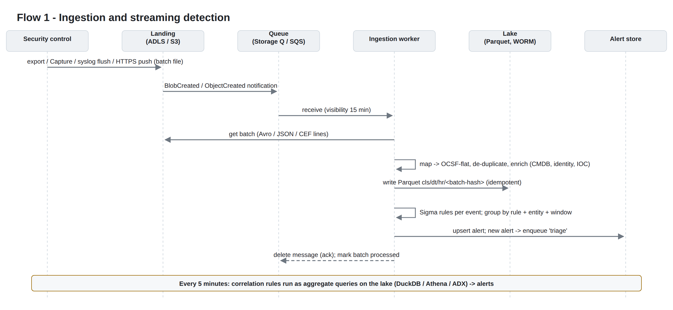
Flow 1
- A control exports a batch to the landing zone (Event Hubs Capture Avro, S3 object, syslog flush, or signed HTTPS push).
- A storage event notifies the queue, and a worker receives the message.
- The worker reads the batch, maps each record to OCSF, removes duplicate event_uids, enriches, and writes Parquet.
- Streaming rules evaluate each event. New alerts are upserted and a triage work item is queued.
- The message is acknowledged only after the batch is marked processed. A failure makes the message visible again, and after the maximum number of receives it moves to the dead-letter queue (AWS) or the poison queue (Azure).

7.2 Triage and case creation
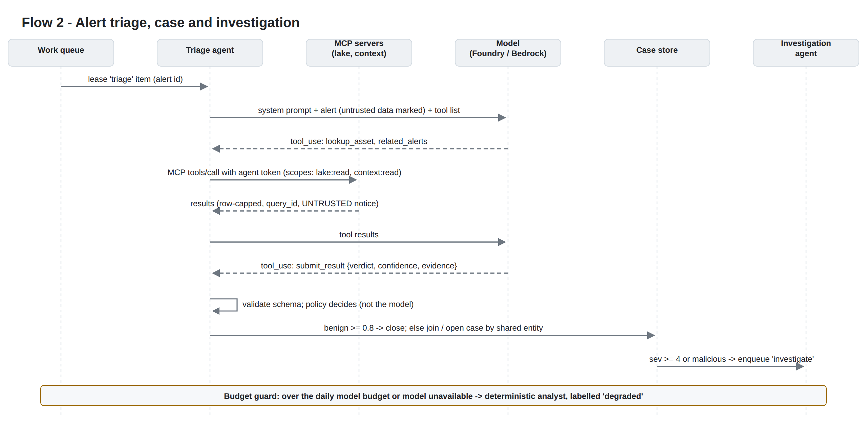
Flow 2
The policy after triage is deterministic:
Verdict | Confidence | Action
benign | >= 0.8, rule severity <= 2, no crown-jewel asset, not degraded | Alert closed as benign, with rationale stored
benign | any other case | Kept open for an analyst
suspicious / malicious | any | Joined to an open case that shares a user or device within 24 h, or a new case is opened if severity >= 3
malicious, or case severity >= 4 | any | investigate work item queued

7.3 Investigation, approval and containment
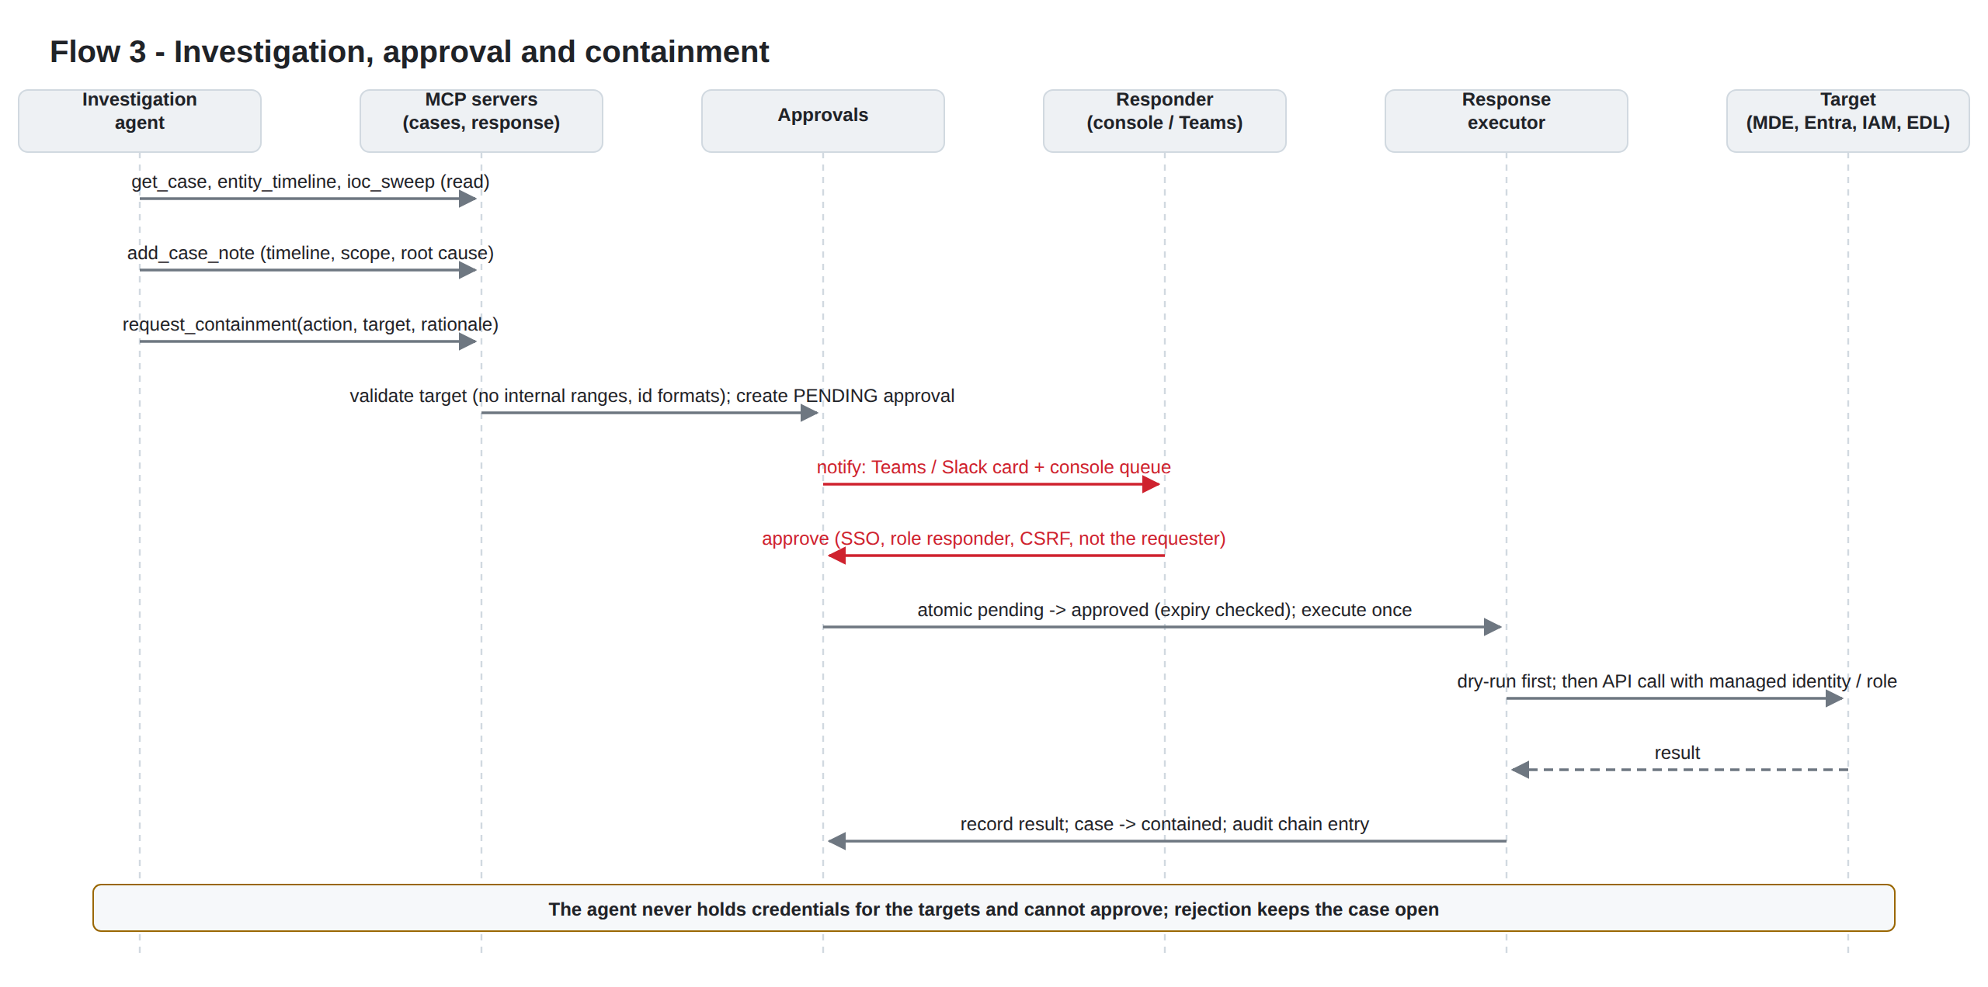
Flow 3
- Approvals expire after 24 hours by default.
- Only responder and admin roles can decide, and the requester cannot approve their own request (four-eyes). Identities are compared in canonical form, so the same person is recognised whether they acted through the console, the REST API or MCP.
- The decision is atomic (pending and unexpired, then approved), so an approval executes exactly once.
- Every action runs as a dry run first unless the action is configured otherwise. Supported actions:
  - isolate_device (Defender for Endpoint)
  - revoke_sessions and disable_user (Microsoft Graph)
  - block_indicator (internal EDL served to firewalls and proxies)
  - aws_deactivate_access_key
  - aws_quarantine_instance
  - soar_playbook (signed webhook)

7.4 Managed agent services calling MERIDIAN MCP
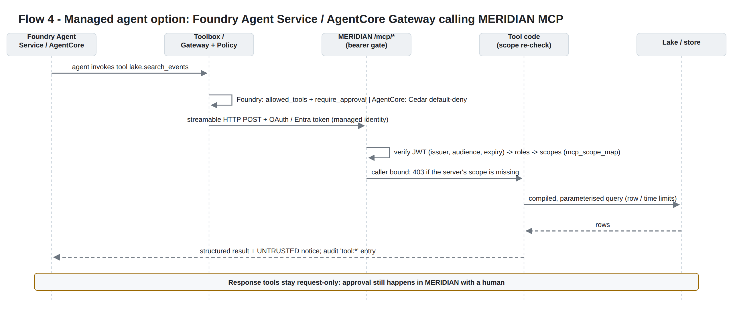
Flow 4

8. Security architecture

8.1 Identity and access
Principal | Authenticates with | Gets
Analysts / responders | OIDC SSO (Entra ID, Okta, Cognito); group-to-role mapping | viewer / analyst / responder / admin
Automation | API keys (MERIDIAN_API_KEYS, constant-time comparison) | A role
Built-in agents | In-process call with an agent caller and explicit scopes | Only the scopes of their agent definition
Managed agents | OAuth / Entra JWT (audience = MERIDIAN MCP app) | Scopes from mcp_scope_map
Platform to cloud | Managed identity (Azure) / IAM task roles (AWS) | Least-privilege data and model access
Ingest senders | HMAC-SHA256 over timestamp.body, 5-minute window, per-source secret | Write to the landing zone only

8.2 Threat model (summary)
Threat | Control
Prompt injection through log content (for example a malicious command line or user agent) | Results are marked UNTRUSTED; the system prompt treats data as data; read-only scopes; response is request-only; human approval; validated output schema
Agent tool misuse or runaway loops | Allow-listed tools per agent, turn / tool-call / token / time / cost limits, query row and window caps
Query injection | Agents never write SQL/KQL; QuerySpec is validated against a field allow-list and compiled with bound parameters and quoted identifiers
Containment of the wrong target | Target validators (no internal ranges, no networks wider than /24, ID formats); dry-run first; four-eyes; AWS actions limited to resources tagged meridian-containable=true
Credential theft | No keys in configuration; managed identity / IAM roles; secrets in Key Vault / Secrets Manager; Foundry local auth disabled
Data exfiltration through the model | Private endpoints / VPC endpoints; model invocation limited to allow-listed deployments / ARNs; minimal fields sent per tool call
Tampering with evidence | Lake WORM; audit table is a SHA-256 hash chain (meridian verify-audit)
Log flooding / cost attack | Ingest size caps (10 MB per push), queue-based back-pressure, per-run and daily model budgets
Model outage | Degraded deterministic analyst; detection and case creation are unaffected

See SECURITY.md for the full control list and residual risks.

9. Non-functional requirements
Requirement | Target (reference deployment) | How it is met
Detection latency (streaming rules) | < 5 min from export to alert | Event-driven queue, worker auto-scaling
Detection latency (correlations) | <= 10 min | 5-minute schedule over hour partitions
Triage latency | < 3 min per alert (p95) | Dedicated agents service, fast model tier
Throughput | 100-500 GB/day per worker pool (scale out) | Stateless workers, partitioned writes
Availability | 99.9% for the console and API | Multi-replica api, zone-redundant DB and storage
RPO / RTO | RPO 0 for the lake (WORM, replicated storage), RPO <= 5 min for the store (PITR); RTO 4 h | Geo-redundant backups, IaC rebuild, landing replay
Retention | 365 days WORM (configurable), 90 days raw | Immutability policy / Object Lock, lifecycle tiering
Auditability | Every tool call, decision and action recorded | Hash-chained audit, agent run records

10. Cost model (indicative)
The figures below use public list prices from late 2026 and simple assumptions. They are not a quote. Replace the assumptions with your volumes and your price sheets.
Assumptions:
- 100 GB/day raw telemetry.
- Parquet + zstd compression gives about 6:1, so roughly 17 GB/day is written to the lake.
- 365-day retention.
- 500 alerts/day reach triage and 20/day are investigated.

Cost line | Microsoft Sentinel (analytics tier) | MERIDIAN on Azure or AWS
Ingestion licence | 100 GB x 30 x $4.30 = about $12,900/month PAYG; about $8,900 with a 100 GB/day commitment tier (about $2.96/GB) | $0
Storage | Included for 90 days, then extra | About 6 TB of Parquet after a year, tiered (cool/IA then archive): low hundreds of $/month
Query | Included (analytics tier) | DuckDB: compute only. Athena: $5 per TB scanned, partition-pruned; low hundreds of $/month for 5-minute correlations
Compute | n/a (SaaS) | 4-5 small containers (about 4-6 vCPU total): about $250-400/month
Database | n/a | PostgreSQL Flexible / Aurora Serverless v2: about $200-400/month
Networking | n/a | Private endpoints / interface endpoints: about $100-250/month
Model tokens | Copilot / add-ons priced separately | Bounded by daily_budget_usd (default $50/day, at most about $1,500/month); typically a fraction of that with a fast model for triage
Indicative total | about $8,900-12,900/month for ingestion alone | about $1,500-3,000/month all-in

What the comparison leaves out, in fairness:
- SIEM suites include UEBA, a large content hub, SOAR and vendor support.
- MERIDIAN is a platform we own: it needs a platform engineer and detection engineers (2-4 FTE in steady state at enterprise scale, more during the build year). These people costs decide the business case at small and medium volumes; see EXECUTIVE_REVIEW.md section 6 for the 3-year TCO, ROI and break-even analysis.
- Some SIEM offers include free data grants (for example certain Microsoft 365 log types).

Amazon Security Lake. On AWS you can collect natively through Amazon Security Lake. It charges $0.75/GB to ingest CloudTrail management events, $0.25/GB for other AWS sources, and $0.035/GB for normalisation; bringing your own data is free apart from S3 storage. MERIDIAN reads Security Lake OCSF data directly.

11. Migration from a SIEM
The migration runs MERIDIAN beside the SIEM until measured gates are passed. Realistic duration: 9 to 15 months to decommission, depending on content and connector gaps. EXECUTIVE_REVIEW.md section 4 holds the plan, its exit criteria and the value delivered at each stage.
Phase | Duration | Gate
0. Foundation | 4-6 weeks | Live deployment healthy; DR restore drilled; residency of model inference approved
1. Shadow lake | 6-8 weeks | >= 90% of in-scope sources flowing (dual-fed with the SIEM); 90-day hunt within the agreed time
2. Detection parity | 3-4 months | >= 95% of the last 12 months' SIEM true positives reproduced
3. AI trust | 2-3 months (overlaps 2) | >= 90% analyst agreement for 4 weeks on 500+ labelled alerts; no missed incident in sampled auto-closures. Full vs hybrid decision
4. Operational parity | 2-3 months (overlaps) | One month with MERIDIAN as the SOC's primary tool, SIEM on standby
5. Decommission | At SIEM renewal | QSA / IAS pre-audit passed; two quarters without detection regression; SIEM data exported to the lake

12. Deployment options
Aspect | Azure + Microsoft Foundry | AWS + Amazon Bedrock
Compute | Azure Container Apps (internal environment) | ECS on Fargate (ARM64)
Landing / lake | ADLS Gen2 (HNS), immutability policy | S3 with Object Lock, SSE-KMS
Notification | Event Grid to Storage Queue | S3 notification to SQS (+ DLQ)
Query engine | DuckDB (default) or Azure Data Explorer | Amazon Athena (Glue + partition projection) or DuckDB
Database | PostgreSQL Flexible Server (zone-redundant HA) | Aurora PostgreSQL Serverless v2
Secrets | Key Vault (RBAC) | Secrets Manager (KMS)
Model | Claude in Microsoft Foundry (AIServices account, deployments) | Claude in Amazon Bedrock (Messages API)
Managed agents (optional) | Foundry Agent Service: MCP tool / Toolbox | Bedrock AgentCore: Gateway + Policy (Cedar)
Native telemetry | Defender XDR streaming API, Entra / Activity diagnostics to Event Hubs | Organisation CloudTrail, Security Lake
IaC | infra/azure (azurerm ~> 5.7) | infra/aws (aws ~> 6.10)

Details are in LLD-azure.md and LLD-aws.md.

13. Known limitations and assumptions
- The Sigma subset covers the constructs used by most rules. Unsupported constructs are rejected with an error at load time, never silently ignored.
- There is no UEBA baseline modelling. Behavioural detections are correlation rules (thresholds, distinct counts) and agent judgement.
- Tested with recorded API responses and stubs, not live tenants:
  - mappers and response adapters for Defender, Graph and AWS;
  - model providers.
Run the onboarding checklist in OPERATIONS.md against your tenant before go-live.
- The Terraform passes validate against the real provider schemas (azurerm 5.7.0, aws 6.48.0) and an offline plan with mocked providers; CI repeats both. It has not been applied to a live subscription or account; apply it first to a non-production one.
- Check model availability, quotas and pricing for your region. The Foundry deployment format for Claude models and the exact Bedrock IAM actions for the Messages endpoint should be confirmed against current documentation at deployment time (they are marked in the Terraform).
- Agents propose; humans decide. MERIDIAN is designed so that no configuration lets an agent execute containment.

14. Glossary
Term | Meaning
MCP | Model Context Protocol: an open protocol for exposing tools and data to AI models
OCSF | Open Cybersecurity Schema Framework
WORM | Write once, read many (immutability policy / S3 Object Lock)
EDL | External dynamic list: a plain-text block list that firewalls pull
QuerySpec | MERIDIAN's validated, engine-neutral query description
Four-eyes | The requester of an action cannot approve it

Appendix A - Security design and controls
This document lists the security controls of MERIDIAN 1.0.1, the threats they address, the residual risks, and the hardening options for regulated estates. It complements HLD section 8.

1. Trust boundaries
Boundary | Crossed by | Control
Security controls to landing zone | Exports, syslog, HTTPS push, API pull | Cloud IAM on the landing container / bucket (AWS: per-source writer policies); HMAC + timestamp (300 s window) or a token bound to one source; 10 MB request and 64 MB decompressed caps; syslog over TLS with optional client certificates; pull credentials only as ${ENV} references from the vault
Landing to lake | Ingestion workers | Mappers reject unknown fields; every value is typed; raw record kept only in the raw column; Windows XML with DTDs or entities refused
Lake to agents | MCP lake / context tools | Scopes, field allow-list, bound parameters, row / window caps, UNTRUSTED notice
Agents to model | Model API (Foundry / Bedrock) | Private endpoint / VPC endpoint, managed identity / IAM, allow-listed deployments / ARNs, per-run and daily budget
Agents to response | MCP response tool | Request-only: creates a PENDING approval; target validators
Humans to platform | Console, API, chat | OIDC SSO with PKCE, roles, signed session cookie, double-submit CSRF token, four-eyes approvals
Platform to targets | Response executor in the api service | Executes only approved, unexpired requests, once; dry run by default; AWS tag conditions; cross-account role with a 15-minute session
Platform to LODESTAR | Signed webhook | HMAC over timestamp.body, X-Lodestar-Timestamp header

2. Controls catalogue

2.1 Identity, authentication and authorisation
- No secrets in configuration files: the loader rejects literal values for secret-like keys and accepts only ${ENV} references.
- Workloads authenticate with managed identity (Azure) or task roles (AWS). Foundry local (key) authentication is disabled in the reference Terraform.
- Console roles are viewer < analyst < responder < admin. Only responder and admin may decide approvals; only admin may read the audit log.
- API keys must be at least 16 characters and are compared in constant time. Browser sessions are HMAC-signed cookies with Secure, HttpOnly and SameSite=Lax.
- MCP endpoints accept agent tokens, API keys or IdP JWTs. Each is mapped to explicit scopes, and tools re-check the scope at call time.

2.2 Agent safety
- Least tools. Each agent role has an allow-list. Triage cannot see case or response tools.
- Bounded runs. Turns, tool calls, output tokens, wall-clock time and cost per run are limited, and there is a daily spend ceiling.
- Structured output. The run ends only through submit_result, which is validated by pydantic. Invalid output is returned to the model for correction within the run limits; a run that never produces valid output ends as failed or limit, never as a guess.
- Deterministic policy. Thresholds in configuration, not the model, decide auto-close, case creation and investigation. Auto-close also requires rule severity <= 2 (the rule's severity, which the model cannot lower) and never applies to crown-jewel assets.
- Prompt-injection posture. Telemetry is marked UNTRUSTED, the system prompt instructs the model to treat it as data, and no tool executes anything. The worst case of a successful injection is a wrong verdict or an unnecessary containment request, and a human still reviews the request.
- Degraded mode. When the budget is exhausted or the model fails, the deterministic analyst takes over. Its results are labelled and never auto-close alerts.
- Evaluation gate. meridian eval runs the golden set. CI or the release pipeline should block model, prompt or provider changes below the accuracy threshold.

2.3 Response safety
- Target validation rejects:
  - private, loopback, link-local and carrier-grade-NAT ranges;
  - IPv4 networks wider than /24 (IPv6 wider than /48);
  - malformed device ids, user names and instance ids.
- Approvals are deduplicated per case, action and target, and expire after 24 hours by default.
- The requester can never approve their own request.
- The decision is an atomic state change (pending and unexpired, then approved), so double clicks and races cannot execute twice.
- Every action is a dry run unless response.actions.<action>.dry_run: false is set explicitly.
- AWS policies allow containment only of resources tagged meridian-containable=true.

2.4 Data protection
- Encryption at rest:
  - ADLS (Microsoft-managed keys plus infrastructure encryption; customer-managed keys optional);
  - S3, SQS, Secrets Manager, CloudWatch and Aurora (KMS customer-managed key with rotation).
- TLS 1.2+ everywhere (ALB policy TLS 1.3/1.2). TLS verification is never disabled.
- The lake is WORM: an Azure container immutability policy, or S3 Object Lock (GOVERNANCE by default, COMPLIANCE optional).
- Data residency: the lake and store stay in the home region. Only the fields an agent asks for are sent to the model, capped at 200 rows per call. Choose a model region that matches your residency rules (for example, keep Foundry / Bedrock in-region where Claude models are available).

2.5 Integrity and audit
- The audit table is a SHA-256 hash chain covering:
  - every tool call;
  - agent run;
  - approval request and decision;
  - execution;
  - case change;
  - login.
- meridian verify-audit detects any modified or deleted row.
- Agent runs keep a truncated transcript (the last 60 messages) for review.

2.6 Platform hardening
- Containers run as non-root with a read-only root filesystem, dropped capabilities (Compose) and a slim base image. Dependencies are pinned in requirements.txt via pip-compile.
- There are no public data-plane endpoints in the reference deployments. Users reach the console through your edge.
- /readyz refuses traffic while any secret still holds a placeholder value.

3. Threat model (STRIDE summary)
Category | Threat | Mitigation | Residual risk
Spoofing | Forged telemetry pushed to /api/ingest | HMAC + timestamp + per-source secrets | A compromised sender key; rotate keys and use per-source secrets
Spoofing | Stolen agent token used against MCP | Scoped tokens, private network only, audit | Read access to the lake within the token's scopes; prefer IdP JWTs with short lifetimes
Tampering | Altering lake history | WORM retention, write-only role for workers, no delete permissions | Administrators with storage-account owner rights could delete an unlocked policy (Azure) or a GOVERNANCE lock (AWS); use a locked policy / COMPLIANCE for regulated retention
Tampering | Editing cases or audit rows in the database | Hash chain, DB access only from the app subnet | A DB administrator can rewrite the whole chain; ship daily chain heads to an external log or LODESTAR
Repudiation | "I did not approve that" | SSO identity in the approval, audit chain, Teams/Slack notifications | -
Information disclosure | Model provider sees security telemetry | In-region models, private endpoints, minimal fields, provider data-use terms | Review the provider's data processing terms (Foundry / Bedrock) with your DPO
Information disclosure | Agent output leaks data into notifications | Notifications carry summaries, not raw events | Review Teams/Slack channel membership
Denial of service | Log floods or expensive queries | Queue back-pressure, auto-scaling, Athena scan cutoff, query row and window caps, model budgets | Ingestion cost grows with volume (storage, not licence)
Elevation of privilege | Prompt injection makes an agent request containment of a critical asset | Request-only, validators, four-eyes human approval, dry run | A human approving without reading; training plus crown-jewel tags in the approval card

4. Recommended hardening for regulated estates
- Split the Azure workload identity into ingest, agent and api identities, as in the AWS role design.
- Use customer-managed keys for ADLS and PostgreSQL (Azure) and keep the KMS CMK (AWS).
- Lock the Azure immutability policy, or use Object Lock COMPLIANCE, after legal approval.
- Require IdP JWTs (not static agent tokens) for remote MCP clients, with lifetimes under an hour.
- Export audit chain heads daily to an external, write-once location.
- Enable Bedrock model invocation logging or Foundry tracing to your own encrypted store, with a retention matching your policy.
- Run meridian eval in the release pipeline, and keep a monthly human review of 50 auto-closed alerts.

5. Compliance mapping (indicative)
Requirement area | MERIDIAN capability
Log retention and integrity (e.g. UAE NESA IAS, PCI DSS 10, ISO 27001 A.8.15) | WORM lake, hash-chained audit, 365-day default retention
Monitoring and detection (ISO 27001 A.8.16, NIST CSF DE.CM) | Streaming and correlation rules, agent triage, metrics
Incident response (NIST CSF RS.MA, ISO 27001 A.5.26) | Cases, investigation timeline, approvals, containment
Access control (ISO 27001 A.5.15, A.8.2) | SSO, roles, four-eyes, scoped MCP tokens
Data residency (UAE PDPL, GDPR) | In-region storage and compute; model region selectable

This mapping supports, but does not replace, your own control assessment.

6. Reporting a vulnerability
Report suspected vulnerabilities privately to the repository owner. Do not open a public issue. Include the version, the configuration involved (without secrets) and reproduction steps.

Appendix B - Pre-release peer review
An independent reviewer audited the code, Terraform and documentation before release. They verified each finding with a reproduction or by reading the code against the provider documentation. All findings below are fixed in 1.0.0. Each fix has a regression test or an automated check where one is possible.
Further validation added during the review:
- The test suite runs on PostgreSQL 16, not just SQLite (MERIDIAN_TEST_PG). It now runs in CI as well.
- Both Terraform stacks pass validate against the real provider schemas (azurerm 5.7.0, aws 6.48.0) and an offline plan with mocked providers (infra/*/tests/plan.tftest.hcl). The mocked plan found one more defect (R-21).
- terraform fmt normalised seven files that would have failed the CI format check.

Findings and resolutions
ID | Severity | Area | Finding | Resolution | Evidence
R-01 | Critical | Response | Four-eyes bypass: a responder could request containment over MCP and approve it on the console, because the two paths recorded different identity strings | Canonical identities (meridian/identity.py) compared on every decision. Requests made with a human token are stored under the canonical identity, and user JWTs on MCP are treated as people | test_four_eyes_holds_across_mcp_and_console_identities; reviewer probe now returns 403
R-02 | High | Lake | Concurrent DuckDB queries on one shared connection could return another caller's rows | Execute and fetch serialised with a lock | Reviewer race probe: 0 cross-results
R-03 | High | Audit | The hash chain could fork under concurrent writers | Process lock plus a PostgreSQL transaction-scoped advisory lock | 6 processes × 60 writes on PostgreSQL: chain valid (360)
R-04 | High | Azure | The poison-queue path needed queue send rights; a 403 would crash-loop the worker | Storage Queue Data Message Sender role; parking failures are logged and never stop the worker; per-message failures no longer stop the drain | test_azure_queue_parks_poison_messages, test_failed_batch_is_recorded_and_replay_is_idempotent
R-05 | High | Ingest | Azure Activity source options were not passed to the mapper (zero events) | Options nested under settings:; top-level mapper keys are also accepted | test_azure_activity_source_maps_through_the_pipeline
R-06 | High | AWS | Internal ALB listened on 443 behind a security group that only allowed 8090 | Dedicated ALB security group (443 from client_cidrs); app accepts 8090 only from the ALB | Mocked plan
R-07 | High | AWS | Syslog rule used protocol -1 with ports (invalid; would open all ports) | Separate TCP and UDP rules on 5514 from syslog_cidrs | Mocked plan asserts no -1 ingress
R-08 | High | AWS | KMS key had no grants for CloudWatch Logs, S3 notifications or CloudTrail | Explicit key policy; landing bucket policy for CloudTrail; TLS-only bucket policies | validate + mocked plan
R-09 | High | Azure | Terraform could not write Key Vault secrets (private vault, no data-plane role for the deployer) | Key Vault Secrets Officer for the deployer; optional deployer_cidrs; VNet runner documented | Mocked plan
R-10 | Medium | Ingest | Timestamps with UTC offsets landed in the wrong date/hour partition | All timestamps normalised to UTC before partitioning | Unit check; full suite
R-11 | Medium | Store | Long attacker-controlled values (entities, titles) failed PostgreSQL length limits and crash-looped the scheduler | Truncating string type for all non-key columns; per-alert error isolation | PostgreSQL suite
R-12 | Medium | Detection | Correlation catch-up after downtime was a fixed 10 minutes | Persisted cursor; catch-up from the last evaluated time (up to 24 h) | test_scheduler_cycle_isolates_failures_and_persists_state
R-13 | Medium | Scheduler | An unreachable LODESTAR crashed the scheduler, and restarts re-sent approval notifications | Each scheduler step isolated; notified approvals persisted | Same test
R-14 | Medium | Syslog | A failed flush lost the buffered lines; no flush on shutdown | Lines restored on failure (bounded, drops counted); SIGTERM handled with a final flush | test_syslog_buffer_keeps_lines_when_storage_fails; live UDP/TCP + SIGTERM smoke test
R-15 | Medium | Response | Hex-only domains (bad.cafe) were classified as IPs; ::ffff:10.x passed the internal-range check | Classification by parsing; IPv4-mapped, reserved and unspecified addresses refused | test_indicator_validation_edge_cases
R-16 | Medium | AWS | Console hunts ran in the api task, which has no model permissions (silent degraded mode) | Hunts are queued to the agents service; GET /api/hunt/{id} returns the result | test_hunts_are_queued_for_the_agents_service
R-17 | Medium | Agents | 600 s work lease shorter than the longest run (duplicate investigations across replicas) | 3600 s lease plus a wall-clock limit per run (600 s fast, 1800 s deep) | Full suite
R-18 | Medium | AWS | S3 writes requested the AWS-managed key instead of the bucket's customer-managed key | SSE header removed so the bucket default (CMK with bucket key) applies | Code review
R-19 | Low | Response | SOAR webhook URL (may contain a token) stored in results visible to viewers | URL redacted to scheme and host | Code review
R-20 | Low | Docs | Several documentation claims did not match the code (health check path, metric label, wall-clock limit, case auditing, approval TTL, ADX wiring) | Code fixed where the claim was the right behaviour (wall-clock limit, case-change audit, TTL setting); docs corrected otherwise (ADX post-apply steps documented) | This document
R-21 | High | AWS | Security group names began with sg-, which AWS rejects (found by the mocked plan) | Names changed to <prefix>-alb/-app/-db/-vpce | Mocked plan

Additional hardening made during documentation review
- /readyz returns 503 while any secret still holds a Terraform placeholder or an .env.example value. The AWS ALB health check uses /readyz.
- Heartbeats for worker, agents and scheduler appear in /readyz and as meridian_heartbeat_age_seconds.
- meridian replay --prefix re-processes landing batches after a mapper or rule fix.
- In degraded mode (budget exhausted or model down), triage never auto-closes alerts.
- Cross-account AWS response through a member-account role (role_arn, 15-minute session).
- meridian demo --serve prints one-time sign-in keys.

Residual items (not defects, to confirm at deployment)
- The Claude model deployment format, name and version in the Foundry model catalog; Claude model ids or inference profiles and the exact IAM actions for the Bedrock endpoint in use.
- AgentCore Gateway target configuration and Cedar action names for the gateway version in use.
- ADX private endpoint and data connection (post-apply steps in LLD-azure §5.3).
- Vendor adapters (Defender, Graph, AWS) and model providers have been tested against stubs and recorded responses, not live tenants. Run the onboarding checklist (OPERATIONS.md) in a non-production tenant first.

Second review: production readiness (executive review cycle)
A second, independent review assessed whether MERIDIAN can replace a SIEM on day one. Its verdict and phased plan are in EXECUTIVE_REVIEW.md. The items below were cheap to fix and material to readiness, so they were fixed in this release:
ID | Area | Finding | Resolution | Evidence
R-22 | AI policy | Auto-close relied only on the model's confidence; a severity-5 alert could be auto-closed | Auto-close also requires rule severity <= 2 (configurable) and never applies to crown-jewel assets | test_auto_close_is_gated_by_rule_severity_and_crown_jewels
R-23 | HA | A second scheduler replica would duplicate notifications and pushes | Lease-based leader lock in the store | test_scheduler_leader_lock_and_source_health
R-24 | Compliance | No detection of silent log sources (PCI DSS 10.7) | meridian_source_last_batch_age_seconds per source; runbook alert | Same test; OPERATIONS.md §4
R-25 | Reporting | Coverage sent to LODESTAR was hard-coded at 100% | Coverage measured from sources that delivered data in the last 24 h | test_lodestar_coverage_is_measured_not_assumed
R-26 | API | Interactive API docs (/docs, /openapi.json) were public | Opt-in with MERIDIAN_API_DOCS=1 | test_interactive_api_docs_are_off_by_default
R-27 | Container | The Dockerfile health check could never fail (it ended with an unconditional exit 0) | Removed; health checks are defined per role (Compose, ALB, Container Apps probes) | Review
R-28 | Agents | The tune agent was defined but could not be triggered | meridian tune --rule <id> (proposals only, never applied automatically) | test_tune_agent_recommends_without_applying
R-29 | Docs | The HLD migration plan (weeks) and the 0.5 FTE estimate contradicted the evidence | HLD aligned to the 9-15 month phased plan and the TCO model | This document
R-30 | AWS ops | The runbooks assumed ECS Exec, which was not enabled | One-off tasks (aws ecs run-task) with new Terraform outputs | DEPLOY-AWS.md step 8

Capability gaps that remain (content breadth, connectors, analyst UX, schema migrations, compaction, AI evidence on your own alerts) are planned in the phased implementation. They are not defects.

Third review: build documents and the LODESTAR integration
Writing the build documents (AZ-00, AWS-00) against the PHALANX layout, and the integration document (INT-00) against a running LODESTAR, exposed the gaps below. All were fixed in this release.
ID | Area | Finding | Resolution | Evidence
R-31 | Residency (Azure) | Foundry deployments defaulted to Global Standard, so inference could run in any Azure geography | Default is Sonnet 5.5, Azure-hosted (version 2), Data Zone Standard (US); Terraform refuses version 1 and any SKU other than DataZoneStandard / GlobalStandard | infra/azure/variables.tf validations; tofu test; check 5 of verify_deployment.py azure
R-32 | Residency (AWS) | The Bedrock client used a plain model id, which has no in-region offer in me-central-1 | Global inference profile ids (bedrock_fast_model, bedrock_deep_model) called through the bedrock-runtime VPC endpoint; IAM covers profile and foundation-model ARNs | test_bedrock_provider_uses_the_private_runtime_endpoint; check 9 of verify_deployment.py aws
R-33 | AI governance | Nothing proved that the agent which ran was the agent that was approved | SHA-256 fingerprint of each agent's definition recorded on every run and in the audit chain; meridian baseline prints the approved set | test_constitution_fingerprint_is_recorded_and_sensitive_to_change
R-34 | AI governance | No way to stop an agent quickly | Kill switch: meridian halt, POST /api/agents/<name>/halt (responder); resume is admin only; a halted agent falls back to the deterministic analyst and never auto-closes | test_kill_switch_halts_agents_and_keeps_triage_running
R-35 | Assurance | Deployed controls could only be checked by reading the console | scripts/verify_deployment.py runs 12 read-only checks per cloud; a check that cannot run is a FAIL | tests/test_verify_deployment.py
R-36 | Integration | IP addresses and cloud accounts were sent to LODESTAR as asset_id, and the first host seen was reported instead of the most important | Entity mapping: devices, accounts and resources to asset_id (most critical by the shared CMDB), users to user_id, IPs to entity_keys only | test_payload_shape_and_identity_mapping, test_most_critical_asset_is_reported
R-37 | Integration | Confirmed incidents did not reach LODESTAR's Today list | actively_exploited_in_env set for malicious, unresolved cases | Live run: phishing case on Today with FS-01 (INT-00 §9)
R-38 | Integration | KPI name sources_silent did not match LODESTAR's log_sources_silent; MTTR was not sent | Renamed; mttr_hours added | test_payload_validates_against_lodestar_model (CI job lodestar-contract)
R-39 | Integration | The scheduler advanced its push cursor even when LODESTAR rejected the push | Cursor advances only after a 2xx; status and age exported as meridian_lodestar_last_push_status / _age_seconds | test_lodestar_push_cursor_only_advances_after_success, test_metrics_and_mcp_gate
R-40 | Integration | Terraform created the webhook secret but never set the LODESTAR URL or organisation, so the integration could not be switched on without editing task definitions | lodestar_url (https only) and lodestar_org variables on both clouds | tofu validate; INT-00 §7

Fourth review: log ingestion for hybrid estates
Writing LOG-00 checked every documented ingestion method against the code. The gaps below were closed in this release.
ID | Area | Finding | Resolution | Evidence
R-41 | Windows | No mapper for Windows Security, System, Sysmon or PowerShell events, so on-premises servers without an EDR were invisible and the process_creation rules could not use them | windows mapper for NXLog, Winlogbeat, Fluent Bit (map) and rendered XML; Sysmon UtcTime preferred; naive times take the source timezone; DTDs and entities refused; two new rules (privileged group add, event log cleared) | test_windows_mapper_reads_every_common_shipper_shape, test_demo_on_premises_storyline_is_detected_from_windows_and_syslog
R-42 | Syslog | Only CEF lines were understood; plain syslog, LEEF and Linux auth messages were rejected and lost from the lake | syslog mapper: RFC 5424 / 3164 headers, CEF and LEEF routing, JSON payloads, built-in sshd / sudo / user patterns, user patterns; unrecognised lines kept as OCSF Base Event (class 0) | test_syslog_routes_cef_leef_patterns_and_keeps_the_rest, test_structured_syslog_records_from_journald_and_vector
R-43 | Time | ISO timestamps with fractional seconds and a non-UTC offset lost the offset (events misplaced by hours) | Fractional-second trimming keeps the offset | test_iso_offsets_with_fractions_are_honoured
R-44 | Syslog transport | TLS syslog relied on an external terminator | Native TLS (RFC 5425) with optional mutual TLS; PEM from the vault held in memory; Azure TLS syslog Container App (syslog_receiver) | test_tls_syslog_receiver_with_mutual_tls; Terraform test
R-45 | Push | Log shippers cannot compute HMAC, so the push endpoint was usable only by custom code; gzip bodies were refused | Source-bound tokens, gzip with a decompression cap, NDJSON, and a Splunk HEC-compatible endpoint | test_token_push_gzip_and_hec
R-46 | SaaS | No way to collect APIs that cannot push (Microsoft 365 Management Activity, Okta, GitHub) | API pull collector (meridian collect) with OAuth2, pagination, two-step expansion and safe cursors; extra_secrets in Terraform | test_pull_collector_*, test_pull_auth_secrets_must_be_environment_references
R-47 | Retention | The lake was WORM and tiered but never expired, so storage grew forever and log types could not have different lifetimes; the processed-batch ledger also grew forever | lake_expire_days and lake_expire_days_by_class (validated against WORM) on both clouds; daily housekeeping of the ledger and finished work items | Terraform tests; test_housekeeping_removes_old_ledger_rows_only
R-48 | Onboarding and operations | No way to preview normalisation before go-live; no reject-rate metric; on AWS no least-privilege way for external shippers to write the landing bucket | meridian map-test; meridian_ingest_*_24h and meridian_pull_last_run_ok metrics; per-source landing_writer_sources policies | test_map_test_previews_normalisation; Terraform test

Fifth review: repository review of v1.0.0 (release 1.0.1)
A review of the repository as published on GitHub (fresh clone, CI steps re-run, links and secrets scanned).
ID | Area | Finding | Resolution | Evidence
R-49 | Time | Unknown time-zone names fell back to UTC silently; on Windows (no time-zone database) every IANA name was unknown, shifting events by hours | tzdata dependency; unknown zones and out-of-range offsets raise; sources validated at start-up | test_unknown_time_zones_fail_at_start_up_not_silently
R-50 | Supply chain | Actions referenced by moving tags; dependencies pinned by version only; no image scan or SBOM | Actions pinned to SHAs; hash-locked requirements installed with --require-hashes; Trivy scan and CycloneDX SBOM in CI; Dependabot | .github/workflows/ci.yml, .github/dependabot.yml
R-51 | CI | The LODESTAR contract job could never read the private LODESTAR repository, so it always skipped on GitHub | Optional LODESTAR_READ_TOKEN secret | CI job lodestar-contract
R-52 | Repository | No changelog, code owners or tracked roadmap; Dockerfile comments out of date | CHANGELOG, CODEOWNERS, ROADMAP with issue script; Dockerfile updated | test_roadmap_issues_are_consistent

