Supplementary Materials
Landscape dynamics and conservation policy effectiveness in reservoir riparian buffers: fourteen reservoirs under Brazil’s Forest Code, 1985 to 2024
The supplementary material contains eight tables and three figures. Table S5, the property-level transition table covering all 199 holding records, and Table S6, the declared APP by reservoir, are provided as a spreadsheet rather than reproduced here. The extracted series and complete R analysis code are available in the repository described in the Data Availability Statement so that readers can recompute every value reported in the main text.
Table S1. Crosswalk from the 35-class MapBiomas Collection 10 legend to the five analytical classes. We applied the reclassification in Earth Engine before export, so we did not drop any class in an intermediate step. Classes absent from the study area are listed for completeness.
Analytical class (code) | MapBiomas code | MapBiomas class name | Rationale
Forest (4) | 1 | Forest (parent class) | Aggregated as native forest
Forest (4) | 3 | Forest Formation | Closed-canopy native forest
Forest (4) | 4 | Savanna Formation | Native woody formation
Forest (4) | 5 | Mangrove | Native forest, coastal
Forest (4) | 6 | Floodable Forest | Native forest, seasonally flooded
Forest (4) | 49 | Wooded Sandbank Vegetation | Native woody restinga
Herbaceous and shrub vegetation (5) | 10 | Herbaceous and Shrubby Vegetation (parent) | Open native vegetation
Herbaceous and shrub vegetation (5) | 11 | Wetland | Native, non-forest
Herbaceous and shrub vegetation (5) | 12 | Grassland | Native, non-forest
Herbaceous and shrub vegetation (5) | 13 | Other Non-Forest Formations | Native, non-forest
Herbaceous and shrub vegetation (5) | 50 | Herbaceous Sandbank Vegetation | Native, non-forest
Farming and pasture (15) | 9 | Forest Plantation | Silviculture is land use, not native cover
Farming and pasture (15) | 14 | Farming (parent class) | Anthropic use
Farming and pasture (15) | 15 | Pasture | Anthropic use
Farming and pasture (15) | 18 | Agriculture | Anthropic use
Farming and pasture (15) | 19 | Temporary Crop | Anthropic use
Farming and pasture (15) | 20 | Sugar cane | Anthropic use
Farming and pasture (15) | 21 | Mosaic of Uses | Anthropic use
Farming and pasture (15) | 35 | Palm Oil | Anthropic use
Farming and pasture (15) | 36 | Perennial Crop | Anthropic use
Farming and pasture (15) | 39 | Soybean | Anthropic use
Farming and pasture (15) | 40 | Rice | Anthropic use
Farming and pasture (15) | 41 | Other Temporary Crops | Anthropic use
Farming and pasture (15) | 46 | Coffee | Anthropic use
Farming and pasture (15) | 47 | Citrus | Anthropic use
Farming and pasture (15) | 48 | Other Perennial Crops | Anthropic use
Farming and pasture (15) | 62 | Cotton | Anthropic use
Non-vegetated area (22) | 22 | Non-vegetated Area (parent) | Bare or impervious
Non-vegetated area (22) | 23 | Beach, Dune and Sand Spot | Bare, natural
Non-vegetated area (22) | 24 | Urban Area | Impervious, anthropic
Non-vegetated area (22) | 25 | Other Non-Vegetated Areas | Bare or impervious
Non-vegetated area (22) | 29 | Rocky Outcrop | Bare, natural
Non-vegetated area (22) | 30 | Mining | Impervious, anthropic
Non-vegetated area (22) | 32 | Hypersaline Tidal Flat | Bare, natural
Water (30) | 26 | Water (parent class) | Aquatic surface
Water (30) | 31 | Aquaculture | Aquatic surface
Water (30) | 33 | River, Lake and Ocean | Aquatic surface
Water (30) | 37 | Aquaculture (current code) | Aquatic surface

Table S2. Effect of boundary treatment on the clumpiness index across 216 combinations of reservoir, band, and benchmark. We computed the index twice: once excluding the analysis frame from the adjacency denominator and once including it, to isolate that decision. Distortion depends on analysis window width: largest in the APP band (3.3 cells wide) and smallest in the control band. The last column counts values outside the index’s defined interval. The remaining seven configuration metrics are unaffected by this choice and are reported as landscapemetrics computes them.
Subset | n | Pearson r | Median relative difference (%) | Outside [-1, 1], excluded then counted
All cases | 216 | 0.049 | 24.3 | 0 and 1
APP band, 0 to 100 m | 104 | -0.100 | 34.6 | 0 and 1
Control band, 100 to 500 m | 112 | 0.255 | 7.5 | 0 and 0

Table S3. Event-study coefficients for 2024 and forest cover by reservoir, ordered by surface area, support Figure 5a and enable sensitivity analysis under different inclusion rules. Coefficients are rounded to two decimals; the median of 14 unrounded values is 1.04 pp, the reported value. Tukey’s fences for the 2024 coefficient are -7.25 and 10.73 pp.
Reservoir | Surface area (ha) | APP band area (ha) | Forest in APP band, 2011 (%) | Forest in APP band, 2024 (%) | Forest in control band, 2024 (%) | Event-study coefficient 2024 (pp)
Santa Branca | 0.3 | 6.9 | 0.0 | 0.0 | 6.3 | -2.29
Tocos | 12.5 | 50.0 | 38.1 | 38.1 | 38.9 | -0.24
Santa Rosa | 21.7 | 36.4 | 13.0 | 5.0 | 29.3 | -9.67
Saracuruna | 48.3 | 45.5 | 78.5 | 84.1 | 90.4 | -0.60
Rosal | 67.9 | 128.6 | 13.5 | 28.0 | 21.4 | 7.02
Pereira Passos | 110.4 | 138.5 | 21.3 | 34.2 | 41.4 | 4.94
Paracambi | 219.9 | 284.6 | 6.0 | 17.0 | 15.3 | 4.25
Vigário | 281.8 | 434.5 | 36.4 | 38.9 | 41.6 | 1.23
Santana | 284.1 | 514.0 | 17.9 | 22.7 | 29.2 | 2.45
Ilha dos Pombos | 303.8 | 447.3 | 2.5 | 6.1 | 15.0 | -1.12
Anta | 651.7 | 508.2 | 11.1 | 20.4 | 27.4 | 5.25
Juturnaíba | 2972.2 | 716.2 | 9.7 | 11.3 | 9.7 | 0.44
Funil | 3048.2 | 2150.9 | 18.3 | 22.6 | 25.1 | 3.18
Fontes Nova | 3101.5 | 2668.9 | 87.4 | 88.4 | 86.0 | 0.85

Table S4. Partial redundancy analysis of land cover composition, Hellinger-transformed, with reservoir identity as a covariate. Fractions show shares of total variance. Adjusted R-squared follows Peres-Neto et al. [47]. P-values from 4,999 permutations within reservoirs; reservoir identity cannot be tested under that. Values from the vegan package, reproduced by R/04_redundancy_analysis.R. The p-value of the band × period term ranges from 0.82 to 1.00 across versions of the vegan package. The same partition on centered log-ratios is given in results/table_S4_rda_clr.csv in the repository.
Component | R2 | Adjusted R2 | p (restricted permutation)
Reservoir identity | 0.6597 | 0.6459 | not applicable
Distance band | reservoir | 0.2322 | 0.2409 | < 0.001
Period | reservoir | 0.0049 | 0.0041 | 0.0206
Band × period | main effects | 0.0003 | -0.0004 | 1.0000

Table S7. Event study and triple difference for the eleven reservoirs with a stable waterline (Paracambi, Anta, and Rosal excluded). Coefficients in percentage points relative to 2011; the triple difference in percentage points per decade. The q values are Benjamini-Hochberg corrected separately within the pre- and post-reform families. Same sign is not applicable (n.a.) where the median is zero.
Benchmark | Period | Median | 95% CI | Same sign | p | q
1985 | pre-reform | -1.77 | -3.49 to 1.67 | 8 of 11 | 0.110 | 0.438
1990 | pre-reform | -1.20 | -2.57 to 1.27 | 8 of 11 | 0.286 | 0.499
1995 | pre-reform | -0.80 | -4.68 to 2.53 | 7 of 11 | 0.374 | 0.499
2008 | pre-reform | 0.00 | -1.08 to 0.91 | 6 of 11 | 0.508 | 0.508
2011 | reference | 0 (ref)
2014 | post-reform | 0.00 | -1.01 to 1.15 | n.a. | 0.799 | 0.799
2020 | post-reform | 0.56 | 0.00 to 0.74 | 8 of 11 | 0.241 | 0.723
2024 | post-reform | 0.44 | -1.12 to 2.45 | 6 of 11 | 0.594 | 0.799
Triple difference | post minus pre | -0.03 | -3.10 to 2.07 | 6 of 11 | 0.722

Table S8. Water share of the 0 to 30 m band (percentage of the band area) at each benchmark. A sustained increase marks the formation or expansion of the water surface.
Reservoir | 1985 | 1990 | 1995 | 2008 | 2011 | 2014 | 2020 | 2024
Anta | 43.0 | 44.2 | 42.6 | 41.5 | 42.2 | 50.3 | 52.7 | 53.1
Fontes Nova | 43.6 | 43.3 | 42.2 | 34.3 | 33.5 | 34.9 | 35.1 | 37.6
Funil | 54.4 | 49.9 | 44.5 | 41.3 | 42.1 | 30.3 | 34.9 | 40.2
Ilha dos Pombos | 49.0 | 49.8 | 49.0 | 47.8 | 47.7 | 46.3 | 45.0 | 46.0
Juturnaíba | 10.8 | 27.2 | 36.3 | 60.5 | 55.2 | 50.7 | 53.1 | 63.7
Paracambi | 18.7 | 18.2 | 17.7 | 14.8 | 15.3 | 28.8 | 29.6 | 30.4
Pereira Passos | 44.8 | 48.2 | 46.8 | 39.8 | 40.8 | 38.2 | 37.1 | 37.6
Rosal | 20.9 | 19.9 | 20.1 | 49.2 | 48.9 | 50.6 | 50.4 | 51.6
Santa Branca | 0.0 | 0.0 | 0.0 | 0.0 | 0.0 | 0.0 | 0.0 | 0.0
Santana | 31.8 | 30.6 | 40.2 | 39.6 | 36.8 | 35.7 | 31.5 | 27.4
Santa Rosa | 38.1 | 27.0 | 32.5 | 37.3 | 14.3 | 20.6 | 27.8 | 39.7
Saracuruna | 43.9 | 48.0 | 44.6 | 33.8 | 32.4 | 31.8 | 33.8 | 37.8
Tocos | 26.3 | 19.8 | 16.8 | 6.0 | 2.4 | 3.0 | 7.8 | 9.6
Vigário | 38.0 | 45.7 | 42.7 | 41.0 | 39.3 | 36.0 | 40.3 | 36.2

Supplementary figures
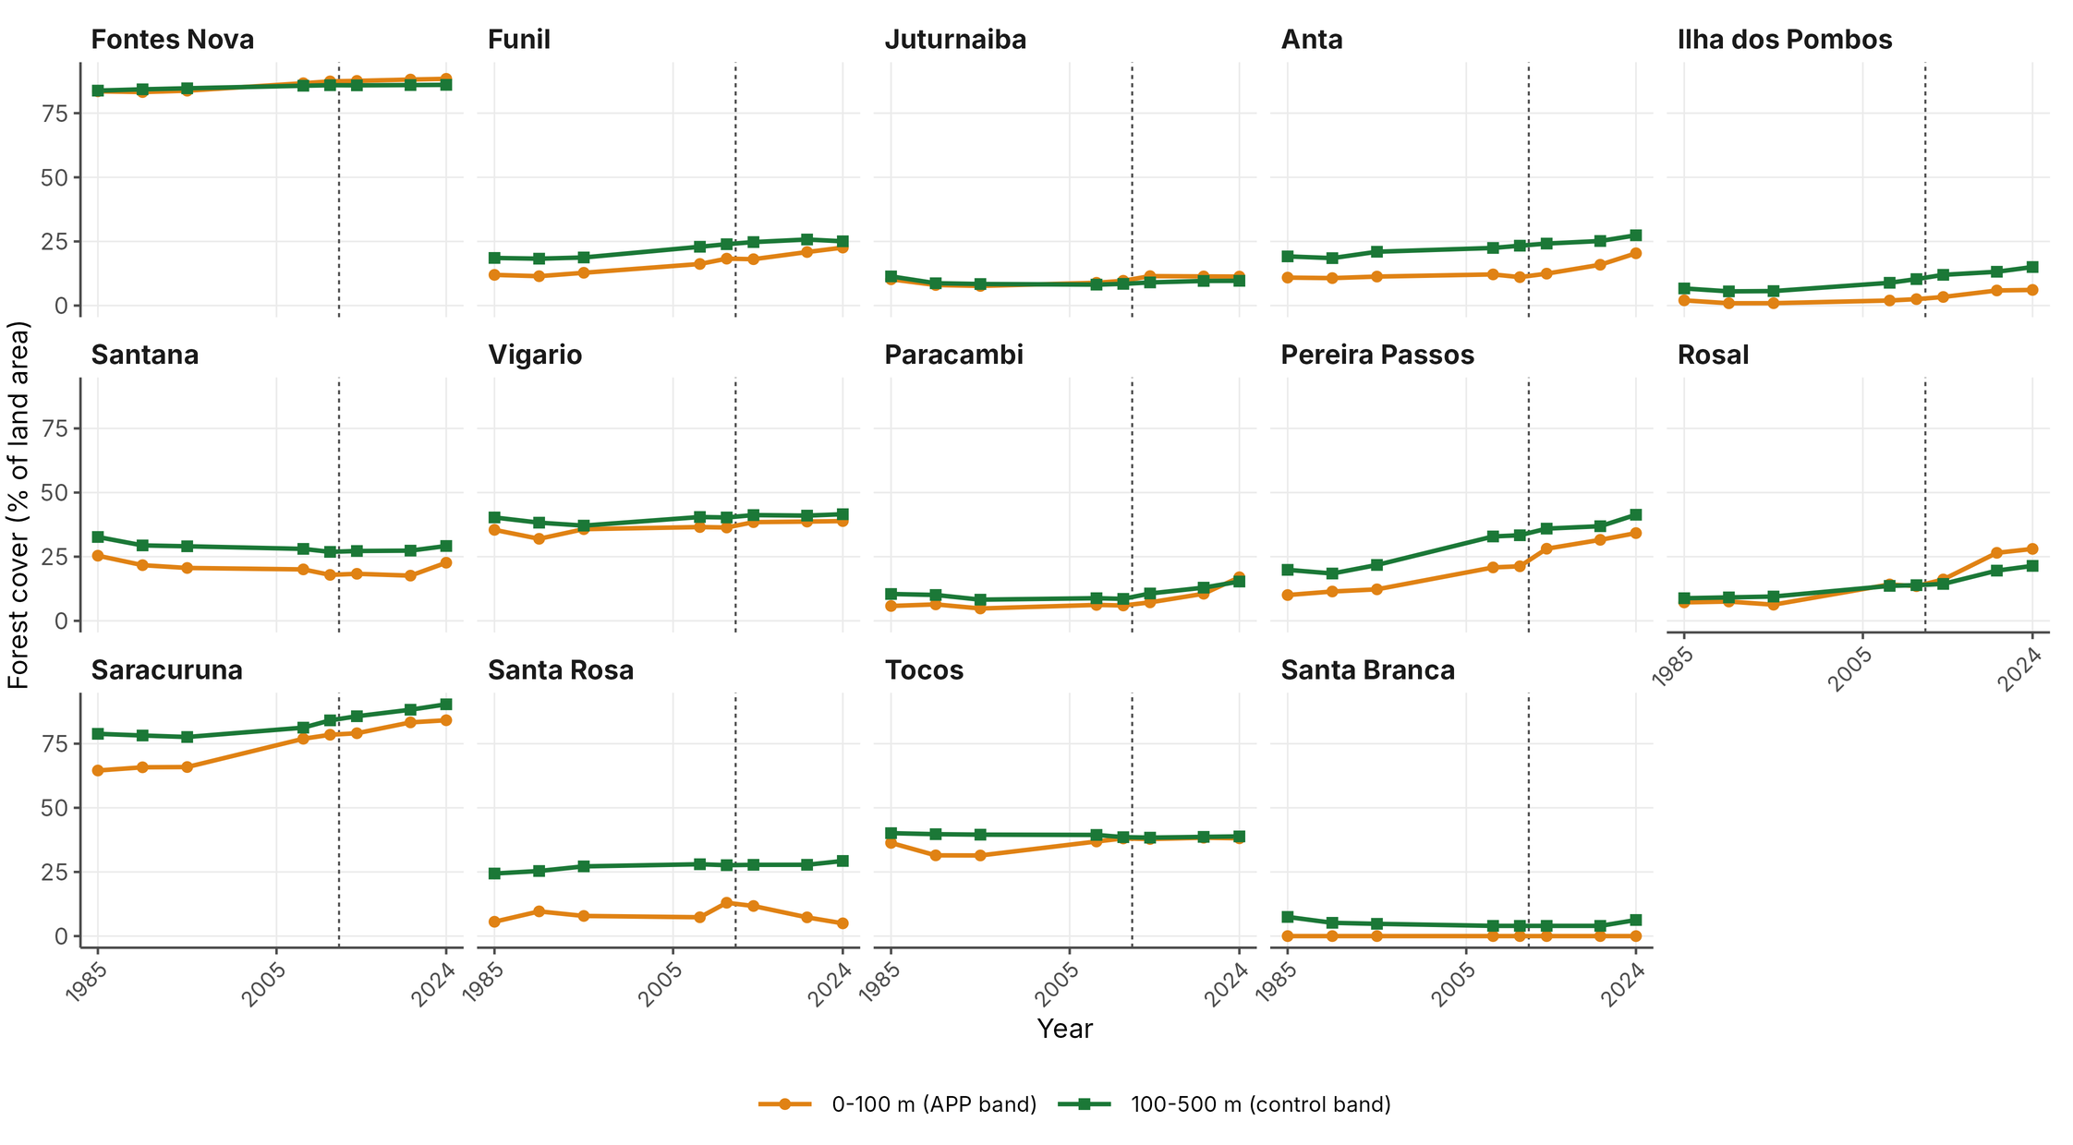
Figure S1. Forest cover in the APP band (0 to 100 m) and in the control band (100 to 500 m), reservoir by reservoir, ordered by surface area. This figure shows the fourteen trajectories summarized by medians in Figure 3.
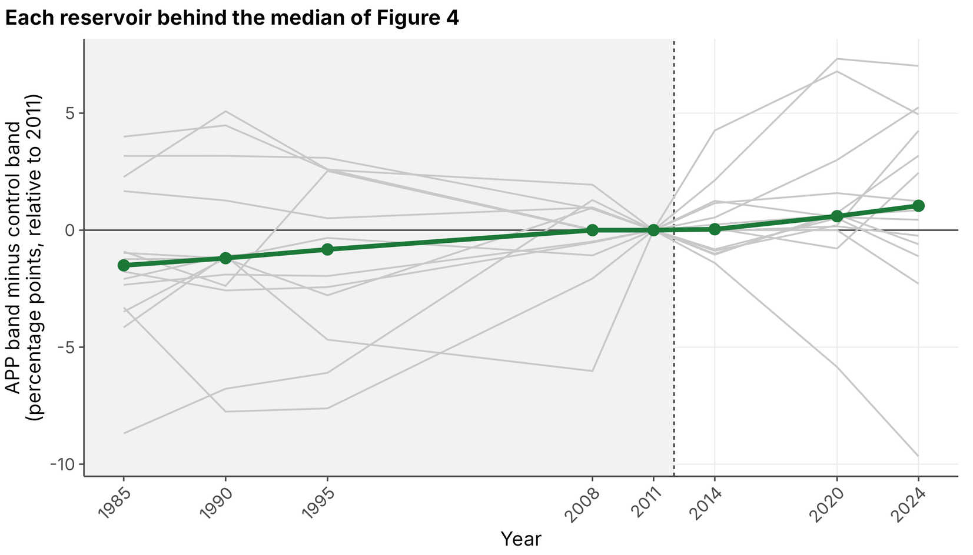
Figure S2. The APP-band-minus-control-band differential of Figure 4, plotted for each reservoir, with the median highlighted. It is the visual counterpart to the parallel-trends test: before 2012, the individual series scatter around the median without a common slope.
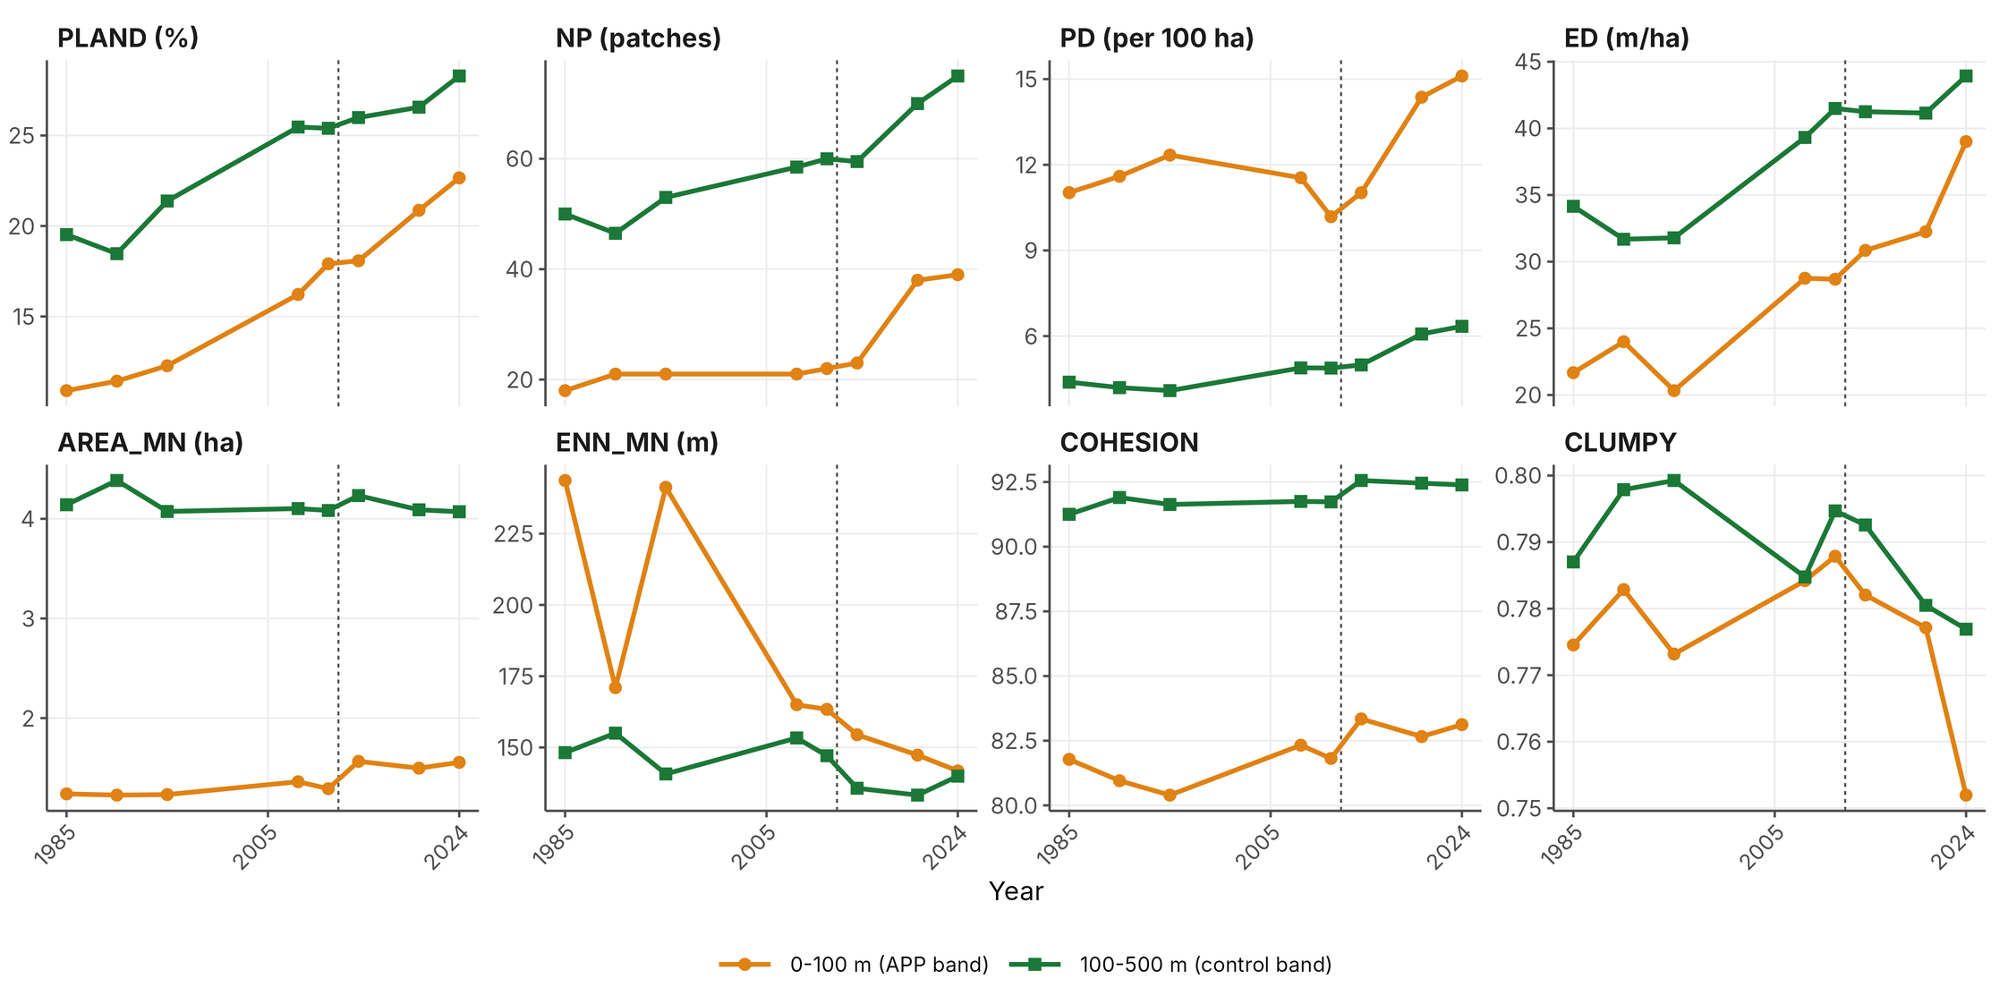
Figure S3. The eight configuration metrics in both bands, with medians across reservoirs (thirteen in the APP band, fourteen in the control band). Clumpiness is shown with the frame correction described in Section 2.4.

