Landscape dynamics and conservation policy effectiveness in reservoir riparian buffers: fourteen reservoirs under Brazil’s Forest Code, 1985 to 2024
Maria Eduarda Machado Macedo Nacif ^{1,*}, Luciana Vidal […], Vinícius Santos Lima […] and […]
¹ Laboratório de Ciências Ambientais, Universidade Estadual do Norte Fluminense Darcy Ribeiro (UENF), Campos dos Goytacazes, RJ [postal code …], Brazil
[…] [Affiliations of the co-authors …]
* Correspondence: manaciff@gmail.com
Abstract: The Brazilian Forest Code (Law 12,651/2012) requires native vegetation in the Permanent Preservation Areas (APPs) around reservoirs, but its effect is difficult to separate from regional forest recovery. We assessed fourteen reservoirs in Rio de Janeiro State at eight benchmarks from 1985 to 2024 using MapBiomas data (30 m), comparing forest cover in a 0 to 100 m APP band with a 100 to 500 m control band through an event study and a triple difference. Before the reform, the APP-minus-control differential did not change significantly. After it, forest cover increased in every band, and the differential reached 1.04 percentage points (pp) in 2024 (95% CI -0.60 to 3.72); the triple difference was 0.48 pp per decade (p = 0.510). Across reservoir sets, the 2024 coefficient ranged from -1.70 to 2.82 pp, and it fell to 0.44 pp without the three reservoirs impounded during the series. Size dependence was not significant. The gain came from new small patches. The median native-vegetation deficit in the APP band was 77.4%, and eight reservoirs had less than 25% forest cover. The divergence follows the reform in time, but its magnitude is indistinguishable from zero and depends on reservoirs whose margins changed during the series.
Keywords: Permanent Preservation Areas; Brazilian Forest Code; riparian vegetation; landscape ecology; Rural Environmental Registry; Atlantic Forest; reservoirs

1. Introduction

1.1. The implementation gap of Brazil’s Forest Code
More than a decade after the enactment of Law 12,651/2012 [1], evidence indicates a persistent gap between the mandate and its effectiveness. Soares-Filho et al. [2] documented a 21 million-hectare deficit in required APPs and Legal Reserves nationwide and showed that the revision granted amnesty for illegal clearing before July 2008. Azevedo et al. [3], using state-level registries in Pará and Mato Grosso, found that CAR registration initially coincided with lower deforestation. However, the difference diminished over time, and only 6% of registered producers reported taking steps to restore illegally cleared areas, which led the authors to conclude that full compliance offers landowners few economic benefits. Soterroni et al. [4] projected that the revised Code would still permit substantial legal conversion, and Freitas et al. [5] showed that the environmental reserve quota mechanism, which allows deficits to be offset elsewhere, redistributes rather than eliminates the restoration obligation.
The Rural Environmental Registry (CAR), introduced as the functional mechanism for compliance assessment, is a self-declared instrument, and registration has not been followed by verification. In November 2025, analysis had started for 24% of the records in the national base and 9% had been validated; in Rio de Janeiro, the corresponding shares were 17% and 2%, and four commitment terms had been signed under the state Environmental Regularization Program (PRA) [6]. Because the polygons are drawn by the landholder and few have been checked, their geometry cannot be taken as a record of the land. The transitional provisions of Article 61-A, in turn, set the width to be restored in consolidated rural areas according to property size, measured in fiscal modules [1]. Metzger et al. [7] argued that weakening the Code’s private land instruments undermines conservation targets that public protected areas alone cannot meet.

1.2. Reservoir margins as a specific case
Artificial reservoirs occupy a specific place in this gap. Law 12,651/2012 protects the land around artificial reservoirs in the strip defined in the environmental license of the undertaking (Article 4). For reservoirs built for power generation or public supply, that strip ranges from 30 to 100 m in rural areas (Article 5), and for those registered or contracted before 24 August 2001 it is the strip between the maximum normal operating level and the maximum flood level (Article 62) [1]. CONAMA Resolution 302/2002 [8] sets minimum APP widths according to the surface area, use, and location of the water body, with 100 m for reservoirs in rural areas. That Resolution was revoked by CONAMA Resolution 500/2020 on 28 September 2020 and restored by the Federal Supreme Court on 29 October 2020, a decision the plenary later confirmed; the norm was therefore in force throughout the period analyzed, except for that interval of about one month, which contains no benchmark in this series. Table 1 sets out which instrument assigns which obligation to which actor, and which of those obligations this study measures. However, enforcement remains sparse where private ownership predominates, and regulatory authority is divided among state agencies, the federal electricity regulator, and landowners.
The ecological stakes are well documented. Guidotti et al. [9] showed that the reduced riparian buffer widths permitted after the 2012 revision measurably reduce those buffers’ capacity to protect the water supply in São Paulo State. Martins et al. [10] and Fachinelli et al. [11] quantified sediment-retention gains from riparian recovery in Brazilian catchments, and Dunn et al. [12] and Robotham et al. [13] reported comparable effects for buffer strips in temperate agricultural landscapes. For reservoirs, sediment retention extends operating lifespan, and Von Sperling [14] and Marques et al. [15] identify riparian conditions as determinants of reservoir water quality and management costs in Brazil.
Table 1. Governance of the APP around reservoirs: which instrument assigns which obligation to which actor, and whether this study measures compliance with that obligation. The final column separates what the design establishes from what would require license documents or recovery commitments that were unavailable.
Instrument | Obligation | Responsible actor | Measured here
Law 12,651/2012, Art. 4, 5 and 62 | Maintain native vegetation in the APP surrounding the reservoir; width set in the environmental license, from 30 to 100 m in rural areas for new reservoirs (Art. 5) and between the normal operating and maximum flood levels for reservoirs contracted before 24 August 2001 (Art. 62). | Landholder; licensing agency | Partly: forest cover over a common 100 m band, not over each licensed width
Law 12,651/2012, Art. 61-A | Recover a fraction of the APP in rural areas consolidated before 22 July 2008, graduated by holding size in fiscal modules. | Landholder, through the Environmental Regularization Program | Partly: consolidated area is classified from 2008 land cover, not from recovery commitments
CONAMA Resolution 302/2002 | Minimum APP widths according to surface area, use, and location of the water body; 100 m for reservoirs in rural areas | Licensing agency | Yes: the 100 m rural minimum is the common reference band
Rural Environmental Registry (CAR) | Self-declaration of the property boundary and of the APP within it | Landholder; state cadastral authority | Yes, as declared geometry compared with the APP band
Environmental license of the undertaking | Define and, where applicable, acquire the APP strip around the impoundment. | Reservoir operator; licensing agency | No: license documents were not consulted

1.3. The identification problem
Forest cover in southeastern Brazil has been recovering since the late twentieth century, largely through regeneration on abandoned pasture. Studies in Rio de Janeiro and in the São Paulo segment of the Paraíba do Sul valley associate this recovery with rural outmigration and the abandonment of degraded pasture [16,17], and, at the scale of São Paulo State, with policies of agricultural modernization and nature protection [18]. A before-and-after comparison restricted to the 0 to 100 m band around a reservoir (hereafter, the APP band) therefore cannot attribute the observed gain to the APP mandate. Adding an unprotected control band addresses part of the problem. However, a design with a single pre-reform observation cannot establish that the two zones were on parallel trajectories beforehand, which is the identifying assumption of any difference-in-differences estimator.
This study addresses that limitation with an eight-benchmark series. Four benchmarks precede the reform, allowing the difference between the APP band and the control band to be tracked over time and the parallel-trends assumption to be tested rather than assumed.

1.4. Objectives
- Quantify the trajectory of forest cover and forest-class configuration within mutually exclusive distance bands across eight benchmarks from 1985 to 2024.
- Test the parallel-trends assumption directly by estimating the difference between the APP band and the unprotected control band at each pre-reform benchmark.
- Estimate whether the APP band departed from the control band after the reform and assess the sensitivity of that estimate to the composition of the reservoir set.
- Assess native vegetation in the APP band and in the declared APP, and use the 2008 benchmark to classify consolidated rural areas based on land cover evidence rather than the cadastral record date.

2. Materials and Methods

2.1. Study area and reservoir set
The study comprised fourteen artificial reservoirs in the State of Rio de Janeiro, southeastern Brazil, distributed across seven hydrographic basins (Figure 1, Table 2). The basin of each reservoir was taken from the state basin layer at 1:50,000 [19], in which the main stem of the Paraíba do Sul is divided into an upper-middle and a lower-middle course; the two are counted here as one basin. Eleven reservoirs belong to the Paraíba do Sul and Guandu system: four in the Sepetiba Bay basin (Fontes Nova, Pereira Passos, and Paracambi on the Ribeirão das Lajes, and Santa Branca on the Santana River), three in the Piraí basin (Tocos, Santana, and Vigário), three in sequence on the main stem of the Paraíba do Sul (Funil, Anta, and Ilha dos Pombos), and one in the basin of the Preto River, a tributary of the Paraíba do Sul (Santa Rosa). The reservoirs of the Piraí and of the Ribeirão das Lajes form the Lajes system, operated for hydropower and for the transposition of water from the Paraíba do Sul to the Guandu [20]. The remaining three lie in the Guanabara Bay (Saracuruna), São João (Juturnaíba), and Itabapoana (Rosal) basins. Twelve reservoirs belong to hydropower schemes, Juturnaíba serves public water supply, and Saracuruna serves industrial supply [20,21].
Surface area spans four orders of magnitude, from 0.3 ha at Santa Branca to 3,102 ha at Fontes Nova. No reservoirs were excluded. This decision follows Biggs et al. [22], who showed that in Rondônia, riparian preservation areas along small water features contain most of the total protected area and most of the deficit yet are routinely absent from assessments that focus on large streams. Excluding the smallest water bodies here would reproduce that documented bias. Instead, Section 3.5 addresses heterogeneity and reports the consequences of every exclusion rule examined. Four reservoirs lie on the state boundary, and their outlines in the reservoir layer cover only the part of the water surface inside Rio de Janeiro: 651.7 of 1,225.9 ha at Anta, 303.8 of 568.0 ha at Ilha dos Pombos, 67.9 of 189.6 ha at Rosal, and 3,048.2 of 3,384.4 ha at Funil (Table 2). The distance bands were not clipped at the state line, so 46.8% of the control band of Anta lies outside Rio de Janeiro, as do 41.8% at Ilha dos Pombos, 39.8% at Rosal, and 9.8% at Funil. On the far bank of a boundary river, however, the bands are measured from the cut line rather than from the shore.
The reservoirs differ in age. According to the reservoir layer of the National Water and Sanitation Agency [21], ten entered operation between 1924 and 1978. Three were impounded during the series: Rosal in 2000 [21], Paracambi in 2012, and Anta, still under construction in 2013 [20]. Juturnaíba was built by the former National Department of Sanitation Works (DNOS) between 1978 and 1982 [23], three years before the first benchmark. The water share of the innermost band agrees with these dates: it rose from 20.1% to 49.2% at Rosal between 1995 and 2008, and from 15.3% to 28.8% at Paracambi and from 42.2% to 50.3% at Anta between 2011 and 2014 (Table S8). At the earlier benchmarks, the bands of these three reservoirs were therefore not yet the margin of a reservoir, and at Paracambi and Anta impoundment and licensing coincide with the reform. At Juturnaíba, the water share of the innermost band rose from 10.8% to 60.5% between 1985 and 2008. Funil, impounded in 1970, received its operating license from the federal environmental agency in June 2012 [20]. These cases define the additional scenarios described in Section 2.6.
Table 2. Characteristics of the fourteen reservoirs, grouped by hydrographic basin. Basin from the state basin layer at 1:50,000 [19]; municipalities, main use, and year of entry into operation from the ANA reservoir layer [21], except where noted. Surface area: this study, from the outline used to build the bands, and ANA, the whole water surface.
Reservoir | Basin | Municipalities | Main use | Year | Surface, this study (ha) | Surface, ANA (ha)
Fontes Nova | Sepetiba Bay (Ribeirão das Lajes) | Piraí, Rio Claro | Hydropower | 1940 | 3,101.5 | 3,103.1
Pereira Passos | Sepetiba Bay (Ribeirão das Lajes) | Piraí | Hydropower | 1962 | 110.4 | 110.5
Paracambi | Sepetiba Bay (Ribeirão das Lajes) | Itaguaí, Paracambi, Piraí | Hydropower | 2012 | 219.9 | 220.0
Santa Branca | Sepetiba Bay (Santana) | Miguel Pereira | Hydropower | 1952 | 0.3 | 0.3
Tocos | Piraí | Rio Claro | Hydropower (diversion) | 1931 | 12.5 | 12.5
Santana | Piraí | Barra do Piraí, Piraí | Hydropower | 1953 | 284.1 | 284.2
Vigário | Piraí | Piraí | Hydropower | 1953 | 281.8 | 281.9
Funil | Paraíba do Sul, upper-middle course | Itatiaia, Resende (RJ); Areias, Queluz, São José do Barreiro (SP) | Hydropower | 1970 | 3,048.2 c | 3,384.4
Anta | Paraíba do Sul, lower-middle course | Sapucaia, Três Rios (RJ); Chiador (MG) | Hydropower | 2013 a | 651.7 c | 1,225.9
Ilha dos Pombos | Paraíba do Sul, lower-middle course | Carmo, Sapucaia (RJ); Além Paraíba (MG) | Hydropower | 1924 | 303.8 c | 568.0
Santa Rosa | Preto | Valença | Hydropower | 1978 | 21.7 | 21.7
Saracuruna | Guanabara Bay | Duque de Caxias | Industrial supply | 1960 | 48.3 | 48.3
Juturnaíba | São João | Araruama, Silva Jardim | Public supply | 1982 b | 2,972.2 | 2,968.9
Rosal | Itabapoana | Bom Jesus do Itabapoana (RJ); Guaçuí (ES) | Hydropower | 2000 | 67.9 c | 189.6
a Under construction in 2013 [20]. b Not recorded in the ANA layer; end of construction according to Prolagos [23]. c Outline restricted to the part of the water surface inside Rio de Janeiro.
Three atmospheric systems govern rainfall in the region: the South Atlantic Convergence Zone, active from October to March; frontal systems, which act throughout the year; and the South Atlantic Subtropical High, which feeds the convergence zone with Atlantic moisture in summer and blocks frontal systems in winter, reducing rainfall [24]. Rainfall is concentrated in summer, and relief controls its distribution: in the basin of the Imbé and Ururaí rivers, annual rainfall on the Serra do Mar escarpment approaches twice that of the adjacent coastal plain [24]. Across the state, annual rainfall ranges from about 870 mm in the north, the driest region, to about 2,020 mm on the southern slope of the Serra do Mar, the wettest, and about 70% of the annual total falls in the rainy season in both [25]. Under the Köppen classification, the tropical climate with a dry winter (Aw) covers 44.1% of the state and extends over the north and northwest at altitudes up to 250 to 300 m; the subtropical climates with a dry winter (Cwa) and without a dry season (Cfa) cover 17.9% and 14.3%; Cfa occupies a narrow strip of the Serra do Mar, the highland climate Cwb follows the boundary with Minas Gerais, and the tropical monsoon climate (Am) occurs around Guanabara Bay [26]. Because every comparison in this study is made between bands of the same reservoir, these climatic differences are held constant within each comparison and enter only through the heterogeneity among reservoirs.

2.2. Land cover data and raster extraction
Land cover data were obtained from MapBiomas Collection 10 [27] at 30 m resolution. Eight benchmarks were selected: 1985, 1990, 1995, and 2008, preceding the reform; 2011, the last observation before Law 12,651/2012 took effect; and 2014, 2020, and 2024, following the reform. The 2008 benchmark also serves as the cutoff in Article 61-A and is used for that purpose in Section 2.5.
MapBiomas assesses accuracy against a stratified random sample of visually interpreted reference points [27]. For Collection 10, mean global accuracy at the first legend level is 93.4% for Brazil, with producer’s and user’s accuracies of 96.6% and 95.1% for forest and of 95.7% and 91.7% for water [28]; for the Atlantic Forest, global accuracy is 91.5% at the first level and 86.1% at the second [29]. The forest and water classes used here group the same MapBiomas classes as the first-level forest and water classes (Table S1). Class-level accuracies for the Atlantic Forest, confidence intervals, and area-adjusted estimates are not reported in the documentation of this collection, so the shares reported here are map proportions without adjustment. In the Atlantic Forest, the spatial filter that removes patches smaller than about 0.5 ha is not applied to riparian forest, which a terrain mask exempts [29].
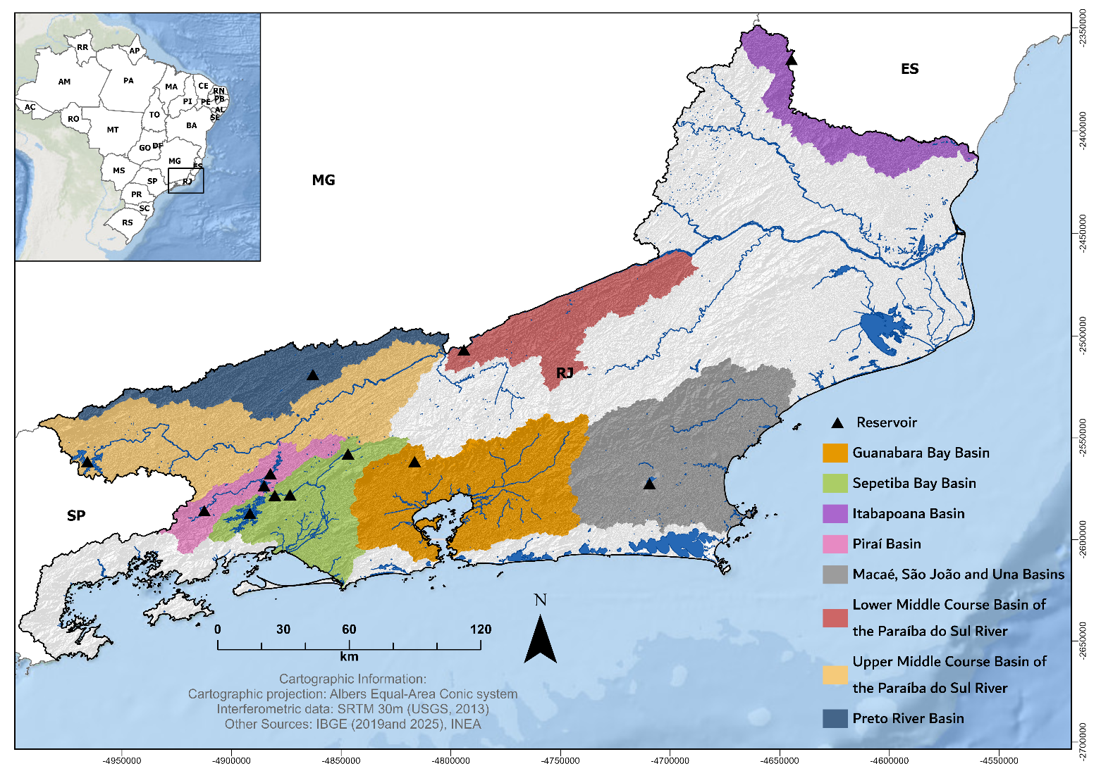
Figure 1. Location of the fourteen reservoirs (triangles) and of the hydrographic basins in which they lie, State of Rio de Janeiro, Brazil.
Rasters were exported directly from Google Earth Engine and clipped to a rectangle extending 1,500 m from each reservoir waterline. Because MapBiomas is a continuous national mosaic, this strategy eliminates dependence on state boundaries. The 35-class legend was reclassified into five analytical classes in Earth Engine using the crosswalk in Table S1, ensuring that no intermediate step could silently drop a class. All exports used the same coordinate system and affine transform, with the origin fixed at a multiple of the 30 m cell size; all 112 rasters therefore share the same grid, which was verified before analysis.
The common grid removes a constraint that applied to earlier processing. When rasters are clipped, their grids are offset independently by fractions of a cell, invalidating raster differencing and forcing annuli to be derived by subtracting areas. This operation is exact only under strict nesting and requires auditing residual inversions. With a common grid, the annuli follow from the boolean difference of the band masks, which is exact by construction.

2.3. Distance bands
Buffers of 30, 100, and 500 m were generated around each waterline, and the reservoir surface was removed from all buffers, so each band is a strip of land rather than a disc containing the impoundment. Three mutually exclusive rings were derived, 0 to 30 m, 30 to 100 m, and 100 to 500 m, together with the union of the first two, 0 to 100 m. The 0 to 100 m unit, the APP band, is the treated unit, and the 100 to 500 m ring is the control band. Masks were rasterized once per reservoir and reused across all eight years, so band definitions are identical over time by construction.
The APP band is a reference standard, not the legally required strip of each reservoir. It reproduces the 100 m minimum that CONAMA Resolution 302/2002 sets for reservoirs in rural areas [8]. Under Law 12,651/2012, the width is set in the environmental license, within 30 to 100 m in rural areas for new reservoirs, and, for reservoirs contracted before 24 August 2001, it is the strip between the maximum normal operating level and the maximum flood level [1]. Ten hydropower reservoirs in the set entered operation before 2001 (Table 2); if their concessions predate August 2001, Article 62 applies, and their statutory strip may be narrower than 100 m. A uniform band buys comparability across fourteen reservoirs with different legal obligations at the cost of precision at each one: where the licensed strip is narrower than 100 m, the band takes in land that the Code does not protect, and where it is wider, it leaves protected land out. The deficits reported in Section 3.8 are therefore deficits of native vegetation relative to this reference, not findings of illegality at any reservoir. Luke et al. [30], reviewing riparian buffers in tropical agriculture, argue that a single width criterion cannot serve the range of functions a buffer performs, which is the reason the distinction between the measured band and each licensed width is kept explicit throughout.

2.4. Landscape metrics
Class-level metrics were computed for the forest class in the APP band and in the control band: percentage of landscape (PLAND), number of patches (NP), patch density (PD), edge density (ED), mean patch area (AREA_MN), mean Euclidean nearest-neighbour distance (ENN_MN), cohesion (COHESION), and clumpiness (CLUMPY), following FRAGSTATS conventions [31] with an eight-neighbour rule and an edge depth of one cell, the smallest value representable at this resolution. Configuration was not computed for the 0 to 30 m and 30 to 100 m bands. At 30 m, these bands are 1.0 and 2.3 cells wide, so no patch can be wider than the band that contains it, and any shape metric would describe the geometry of the analysis window rather than the arrangement of forest within it. That constraint is stated once here and governs every configuration result reported below. In the APP band, the analysis covers thirteen reservoirs: Santa Branca retains no forest cell inside its APP band at any benchmark. Hence, no patch exists to measure, and the metrics are undefined rather than zero. The control band covers all fourteen.
The clumpiness index required a departure from the default implementation because the issue is geometric rather than a matter of preference. CLUMPY is based on the proportion of like adjacencies, a ratio whose denominator counts every adjacency involving a cell of the focal class. In the default landscapemetrics implementation, that denominator includes adjacencies with cells outside the analysis mask, so the frame of the analysis window is counted as class edge. In a compact landscape, the frame is a small fraction of the total perimeter, and the effect is negligible. In a narrow linear feature, it is not. At 30 m, the APP band is 3.3 cells wide, so a forest cell is at most one cell from the frame in the across-band direction, and nearly every forest cell contributes frame adjacencies to the denominator. The index then measures the shape of the strip rather than the arrangement of forest inside it. Riparian buffers are narrow linear features by definition, so this is a systematic hazard for the class of landscapes the Forest Code regulates, not a peculiarity of this dataset.
The default is invalid here, not merely imprecise, because of the index definition. CLUMPY is defined on the closed interval from -1 (complete disaggregation) to +1 (maximal aggregation). At Fontes Nova, the default returns -1.08 in the APP band in 2024, which lies outside that interval and is therefore inadmissible. The same band is 88.4% forest in 2024. A class occupying almost nine tenths of a landscape cannot approach complete disaggregation, because there are not enough cells of other classes to separate its cells. A value below the theoretical floor, returned for a landscape that cannot approach the floor, identifies the computation rather than the landscape as the source of the number. The implementation used here excludes the band frame from the adjacency denominator and returns the index to its defined range. The exclusion is coded from the index definition rather than requested through a package argument, because the boundary-count option of landscapemetrics governs the edge metrics and leaves clumpiness at its default. The decision affects clumpiness alone. The other seven metrics come from landscapemetrics under its documented boundary option and are unaffected by it. To measure the decision’s effect on the index itself, we computed both forms for all 216 combinations of reservoir, band, and benchmark (Table S2). Across the series, the two forms correlate at r = 0.05 and differ by 24.3% in median relative terms. The discrepancy tracks the width of the analysis window, as the argument above predicts: it reaches 34.6% in the APP band, which is 3.3 cells wide, and falls to 7.5% in the control band. Counting the frame also places one value outside the interval on which the index is defined, whereas excluding it places none. Clumpiness is therefore reported here in the corrected form alone.

2.5. Cadastral data and compliance
CAR property and declared APP polygons were obtained from SICAR-RJ, filtered to active or pending status, and dissolved by property code. Active or pending status describes the registration, not its verification: in November 2025, 2% of the records in the state had been validated [6], so the cadastral geometry used here is, with few exceptions, an unverified self-declaration. The registry covers rural landholdings, not water bodies, so the cadastral module assesses the APP band only where a registered holding intersects the reservoir buffer. Two consequences follow, reflected in the results. Reservoir-level results are computed from land cover across the entire APP band and do not depend on the registry, so they are available for all fourteen reservoirs. Property-level results are available only where holdings are registered, excluding Saracuruna and covering 199 holding records elsewhere; one holding of 24,980 ha intersects the buffers of five reservoirs and is counted once for each, so the records correspond to 195 distinct holdings. Throughout, the APP band defined in Section 2.3 stands in for the licensed APP, whose width was not available for any undertaking. We assessed four cadastral zones against MapBiomas 2024: the APP band of the whole reservoir; the APP band intersected with each registered property; the declared APP within the APP band; and the declared APP outside it along the drainage network. The declared polygons were read for all fourteen reservoirs from the state APP layer (412,037 features) under the same active or pending filter.
Two distinct quantities are reported separately. The native-vegetation deficit is the complement of the forest fraction within the terrestrial area of the APP band. It has no threshold because the Code requires native vegetation across the full width of the APP, not a minimum percentage. Ecological sufficiency is a separate question: whether forest cover reaches 25%, a value drawn from the fragmentation literature and conservative relative to the 30 to 45% reported as optimal for riparian buffer function.
The consolidated rural area was classified by land cover rather than by the cadastral record. Article 61-A anchors the concept to the anthropic occupation observed on 22 July 2008, and the CAR cannot provide evidence of it: the registry postdates the cut-off, and the earliest record in the state dataset is from 2014. Using the 2008 benchmark, each cell of the APP band within a registered property was classified as anthropic or native and cross-tabulated with its 2024 status. This procedure yields the quantities required by the fourth objective, namely the share of the present deficit that predates the amnesty cut-off and the share that does not, which are subject to different legal regimes and therefore different remedies.

2.6. Statistical analyses
The unit of analysis is the reservoir, and all comparisons are paired within each reservoir. Rates of change are expressed in percentage points per decade to ensure comparability across windows of different lengths.
The confirmatory quantity is a triple difference that directly addresses the third objective: whether the APP band differed from the control band after the reform. It contrasts the treated-minus-control difference in the rate of forest change between the pre-reform window (1985 to 2011) and the post-reform window (2011 to 2024). The pre-reform window serves as a placebo, so any divergence already present before the law is not attributed to the law. Declared in advance as a single quantity, it constitutes a family of one and is not subject to multiplicity correction.
The event study serves the second objective: to test the parallel-trends assumption rather than assume it. It estimates the same treated-minus-control differential in levels at each benchmark, expressed relative to its 2011 value. The four pre-reform coefficients test parallel trends; the three post-reform coefficients trace the emergence of any effect. Pre- and post-reform coefficients form separate families for false discovery rate correction because they address different questions. The design follows the practice recommended by Wing et al. [32] for difference-in-differences studies in policy research, in particular the requirement that pre-intervention periods be used to examine, rather than assume, the comparability of treated and control units. Marcus and Sant’Anna [33] show that different difference-in-differences procedures rest on different parallel-trends assumptions and recover different parameters, with a trade-off between robustness and capability; the event-study formulation used here occupies the robust, less efficient end of that trade-off, which is appropriate when the assumption itself is under examination. Where no unexposed comparison unit exists, synthetic control offers an alternative identification strategy for deforestation outcomes [34]; it is not used here because an adjacent unprotected band provides a within-reservoir comparison.
No exploratory search for a breakpoint was conducted. The intervention date is known, and the event study already tests for a regime change at that date, with the added advantage of estimating the preceding trajectory. Searching for a breakpoint across eight irregularly spaced benchmarks would leave very few candidate positions, and the conventional Chow p-value would no longer apply once a point is chosen by inspecting the data, requiring a sup-F distribution instead [35]. The known-date formulation remains the defensible one for this design and is what the event study provides.
Because the reservoir set spans four orders of magnitude in surface area, we specified a sensitivity analysis across size thresholds in advance. Its purpose is not to test a separate hypothesis but to show how much the answer to the third objective depends on the set’s composition. We report all thresholds, including those that weaken the result, and select none based on a p-value. We assessed size dependence using the Spearman correlation between log surface area and the 2024 coefficient, and a Mann-Whitney comparison between reservoirs above and below the median size.
Five further scenarios were added during revision, after the impoundment dates and the reservoir outlines had been checked (Section 2.1): all reservoirs except Santa Branca; the eleven reservoirs with a stable waterline, that is, all except Paracambi, Anta, and Rosal; the same set without Juturnaíba, whose water surface expanded before 2008; the same set without Funil, whose operating license dates from 2012; and the set without the four reservoirs on the state boundary. These criteria were defined without reference to the outcome, but they were not part of the original specification, and they are reported as such. For the stable-waterline set, the full event study and the triple difference were recomputed (Table S7). Extreme values of the 2024 coefficient were identified with Tukey’s rule, as values more than 1.5 times the interquartile range beyond the quartiles.
Paired comparisons used the Wilcoxon signed-rank test against a null median of zero, with bootstrap confidence intervals from 10,000 resamples and the rank-biserial correlation as the effect size. The bootstrap interval describes the median, whereas the signed-rank test concerns the symmetry of the distribution about zero, so the two can disagree near the threshold; statements of significance rest on the test, and the interval is reported as a measure of precision. The median of fourteen values is a discrete quantile, so an interval bound moves by a few tenths of a percentage point when the resampling sequence changes. The generator is therefore seeded inside the interval function, at 7, and every interval reported here depends only on the data it summarises rather than on the order in which the tests were run. With fourteen units, we report the number of reservoirs sharing the sign of the median alongside each test because, at this sample size, it conveys consistency more directly than a p-value. We tested the spatial pattern, which addresses the first objective, at each benchmark using the Friedman test, blocking by bands within reservoirs; we report Kendall’s W as the effect size because it measures the extent to which reservoirs agree on the ordering of the bands, not simply whether the bands differ. All tests are two-sided, and the threshold was 0.05. We performed extraction in Google Earth Engine. We carried out band delineation, composition, landscape metrics, and inference in R [36], version […], using terra, sf, vegan [37], and landscapemetrics [38], in the versions listed in the repository; we produced figures with ggplot2 [39]. The code and the extracted series are available as described in the Data Availability Statement.

2.7. Multivariate composition analysis
The tests above use forest cover, one of five classes. A reform could leave forest cover unchanged while reorganizing the remaining classes, and a forest-only measure would not detect it. To examine this possibility, we analyzed the full composition using redundancy analysis (RDA), a constrained ordination that relates a multivariate response to explanatory variables [40]. This approach addresses the first objective in multivariate form: how much variation in land cover composition is attributable to distance from the water, to the period before or after the reform, and to their interaction.
The response matrix comprised the areas of the five classes for each combination of reservoir, exclusive distance band, and benchmark, yielding 336 rows from fourteen independent reservoirs. Because the five classes sum to the band area, the rows are compositional and Euclidean distance does not apply directly; we first applied the Hellinger transformation, the standard remedy for ordination of compositional data [41]. Reservoir identity was entered as a covariate in a partial RDA so that the constrained fractions describe variation within reservoirs rather than differences between them. We partitioned variation among components using adjusted R-squared, which is required because the unadjusted statistic rises with every variable added, regardless of its relevance [42].
We assessed significance using 4,999 permutations, restricted within each reservoir. The count of 4,999 rather than 5,000 follows the convention that the observed value is itself one realization of the null, so the p-value is (k + 1) / (permutations + 1) and the denominator is a round 5,000 [40]. At that number, the Monte Carlo standard error of a p-value near 0.05 is about 0.003, which keeps a decision at the 0.05 threshold from depending on the random seed; 999 permutations would leave a standard error of about 0.007 and a floor of 0.001 for the smallest reportable p-value. Permutation was restricted because the 336 rows are not independent: they are fourteen units observed in three bands and eight years, and free permutation would treat repeated measurements of the same reservoir as separate evidence and inflate significance accordingly [43]. Restricted permutation preserves the nesting and tests only the contrasts of interest. For the same reason, no p-value is reported for reservoir identity: permuting within reservoirs holds that term constant and cannot test it.

2.8. Use of generative artificial intelligence
Claude (Anthropic) was used to assist in writing and debugging the R and Python scripts, in checking the agreement between the manuscript and the outputs of those scripts, and in revising the language of the manuscript. All analyses were executed with the scripts available in the public repository, and every reported value was taken from their outputs; the tool was not used to generate data. The authors reviewed all code and text and take full responsibility for them.

3. Results

3.1. Composition of the distance bands
Farming use was the most extensive terrestrial class across all bands and benchmarks (Figure 2). In 2024, its median share was 41.0% in the 0 to 30 m band, 53.9% in the 30 to 100 m band, and 64.5% in the 100 to 500 m band. Water occupied 37.7% of the innermost band, compared with 1.4% in the control band. This pattern reflects the geometry of a 30 m strip drawn around a waterline and explains why all forest values use a terrestrial denominator.
Forest cover rose in every band across the series, but not steadily (Table 3, Figure 2). Between 1985 and 1995, the median was flat across all four bands. The increase began between 1995 and 2008 and continued after 2011. Figure 2 also shows that the composition of the innermost band changes little overall: farming and pasture dominate the land surface throughout, and the forest gain, although consistent, comes from a low base.
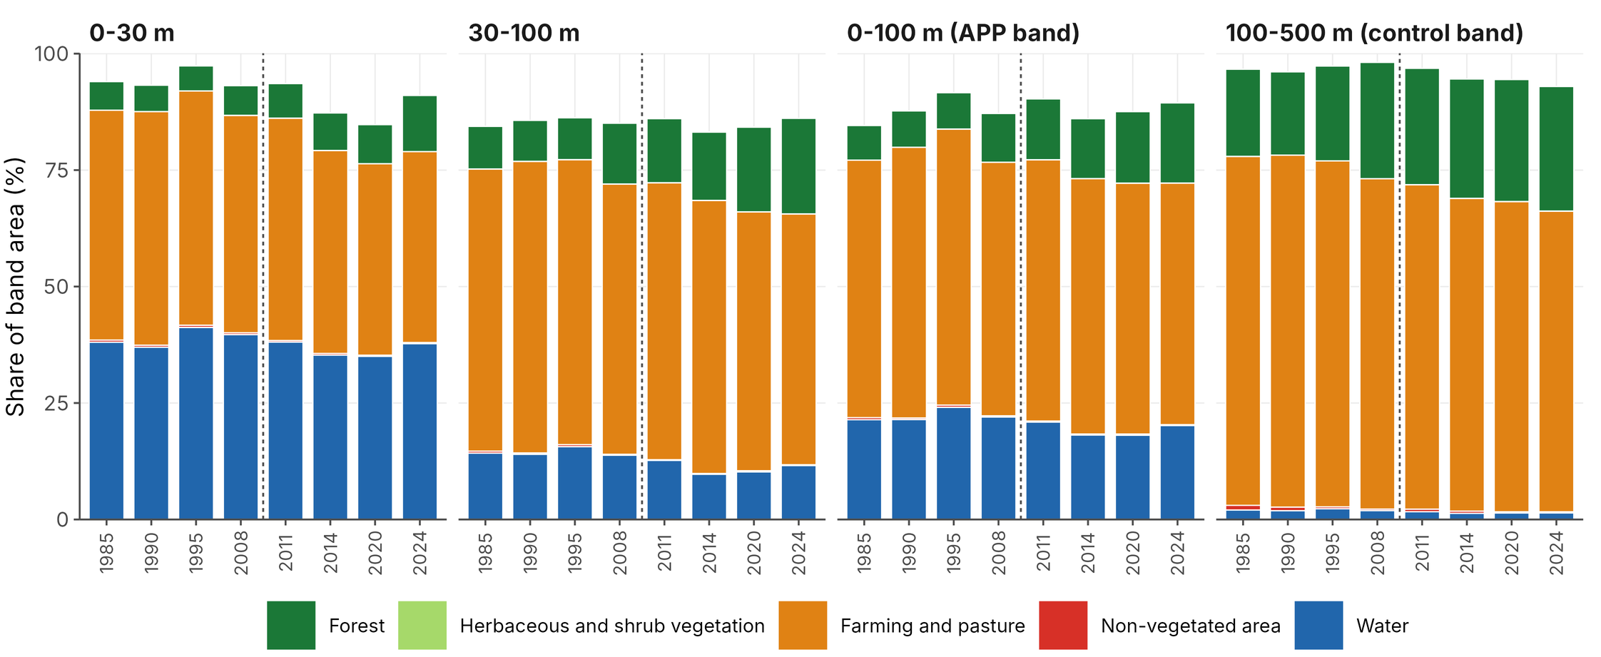
Figure 2. Land cover within each distance band at every benchmark is represented by the median across fourteen reservoirs. Colors denote classes used throughout the paper: blue for water, dark green for forest, light green for herbaceous and shrub vegetation, orange for farming and pasture, and red for non-vegetated areas. The dashed line indicates the 2012 Forest Code. Shares are based on the total band area, including water; the innermost band primarily consists of water, since it is a 30 m ring drawn around the waterline. As each class median is calculated separately across reservoirs, the bars do not sum precisely to 100%.
Table 3. Forest cover (percentage of terrestrial area) by distance band and benchmark, expressed as the median across the fourteen reservoirs with the interquartile range in parentheses.
Band | 1985 | 1990 | 1995 | 2008 | 2011 | 2014 | 2020 | 2024
0-30 m | 9.3 (6.9-23.4) | 9.4 (6.8-19.5) | 9.5 (6.2-18.6) | 10.9 (8.2-23.3) | 12.4 (6.0-25.2) | 13.6 (9.3-27.1) | 13.5 (10.6-27.4) | 19.3 (13.9-29.8)
30-100 m | 11.1 (6.9-35.2) | 11.6 (7.4-31.7) | 12.6 (6.4-32.9) | 17.3 (7.1-34.7) | 17.8 (9.5-34.4) | 19.0 (10.3-37.4) | 21.6 (10.7-39.0) | 24.5 (12.2-39.7)
0-100 m | 10.6 (6.1-32.9) | 11.1 (7.6-29.0) | 11.8 (6.6-28.7) | 15.2 (7.7-32.6) | 15.7 (10.0-32.6) | 17.1 (11.5-35.4) | 19.2 (10.8-36.7) | 22.6 (12.7-37.1)
100-500 m | 19.5 (10.7-38.3) | 18.5 (9.4-36.0) | 21.4 (8.7-35.1) | 25.5 (10.1-37.8) | 25.4 (11.2-37.3) | 26.0 (12.6-37.8) | 26.6 (14.8-38.2) | 28.3 (16.8-40.7)

3.2. Rates of change before and after the reform
Before the reform, median rates ranged from 0.35 to 1.08 percentage points per decade, and no band changed significantly after correction for multiple testing (all q ≥ 0.066; Table 4, Figure 3b). The uncorrected p-values were 0.033 in the 30 to 100 m band and in the APP band, and the bootstrap intervals of these two bands lay above zero, so the pre-reform increase was small rather than absent. After the reform, every band increased significantly: 3.68 points per decade at 0 to 30 m, 2.82 at 30 to 100 m, 3.04 in the APP band, and 1.76 in the control band. The four curves in Figure 3a rise together after 2011, and the control band, which the APP provisions do not cover, responded most consistently, with all fourteen reservoirs moving in the same direction. Because the unprotected band gained forest over the same period, the gain in the APP band cannot by itself be credited to the reform; only the comparison between the two bands, reported next, can separate an effect specific to the APP.
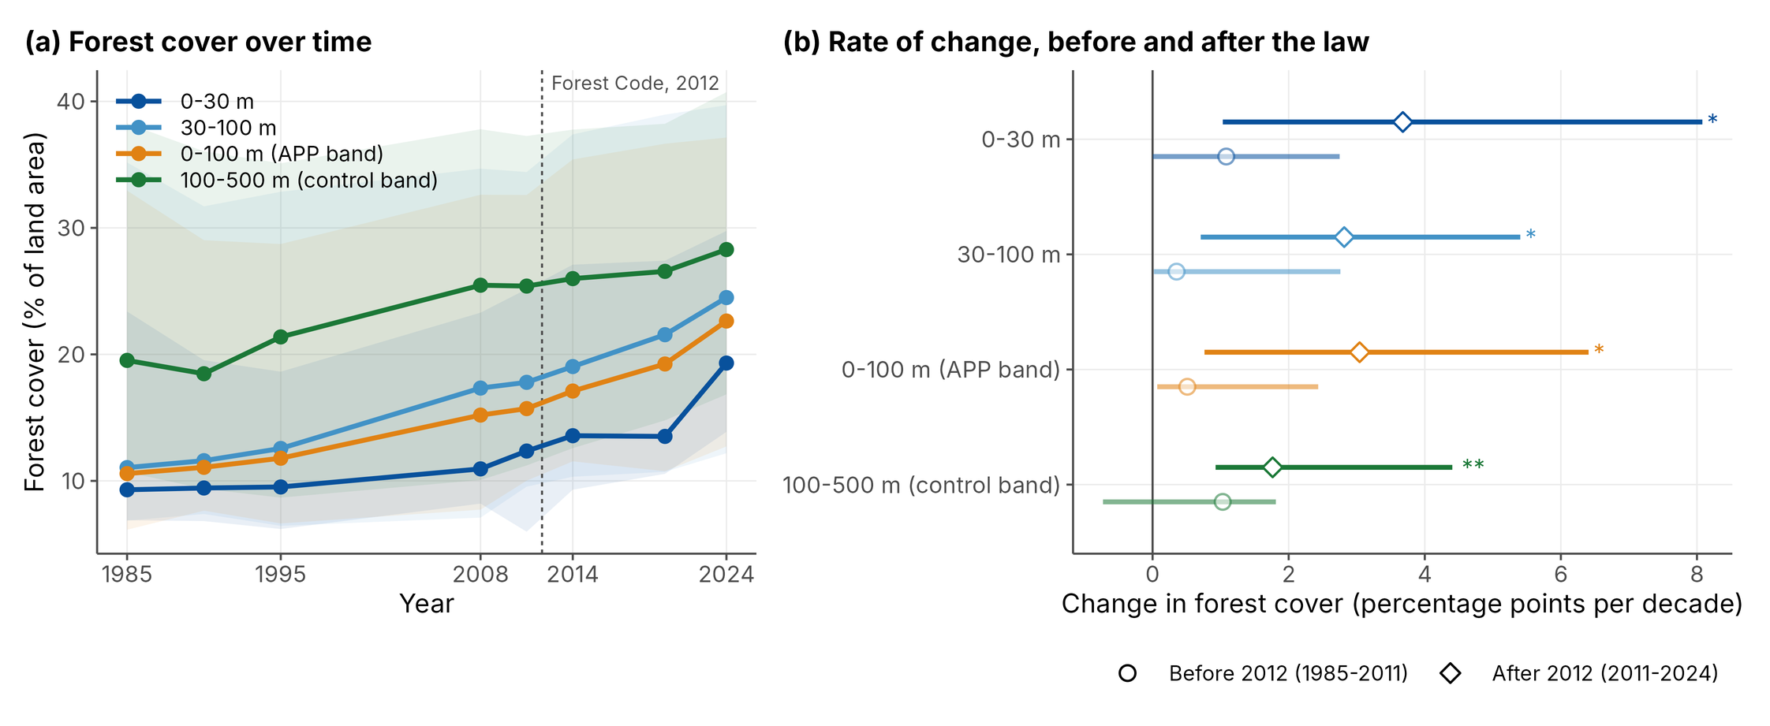
Figure 3. Forest cover over time and its rate of change. (a) Median forest cover across fourteen reservoirs, with the shaded ribbon covering the middle half; the dashed line marks the 2012 Forest Code. (b) Median rate of change in each window, with bootstrap 95% confidence intervals. Open circles represent the period before the law (1985-2011), and filled diamonds represent the period after (2011-2024). Asterisks indicate corrected q < 0.05. Forest cover, expressed as a percentage of land excluding water, makes the four bands comparable.
Table 4. Rate of change in forest cover by band and window, in percentage points per decade, across fourteen reservoirs. Medians with bootstrap 95% confidence intervals; q values are Benjamini-Hochberg corrected within window.
Band | Window | Median | 95% CI | Same sign | q
0-30 m | 1985-2011 | 1.08 | 0.00 to 2.75 | 10 of 14 | 0.073 (ns)
30-100 m | 1985-2011 | 0.35 | 0.02 to 2.76 | 10 of 14 | 0.066 (ns)
0-100 m | 1985-2011 | 0.51 | 0.07 to 2.43 | 11 of 14 | 0.066 (ns)
100-500 m | 1985-2011 | 1.03 | -0.73 to 1.81 | 8 of 14 | 0.177 (ns)
0-30 m | 2011-2024 | 3.68 | 1.03 to 8.08 | 11 of 14 | 0.028 ()
30-100 m | 2011-2024 | 2.82 | 0.71 to 5.40 | 12 of 14 | 0.014 ()
0-100 m | 2011-2024 | 3.04 | 0.76 to 6.41 | 12 of 14 | 0.014 ()
100-500 m | 2011-2024 | 1.76 | 0.93 to 4.40 | 14 of 14 | 0.004 ()

3.3. Event study and the parallel-trends assumption
The difference between the APP band and the control band did not differ significantly from its 2011 value at any pre-reform benchmark (Table 5, Figure 4). Point estimates were negative and declined in magnitude, from -1.50 pp in 1985 to essentially zero in 2008. All four confidence intervals spanned zero, and all corrected q-values were above 0.52.
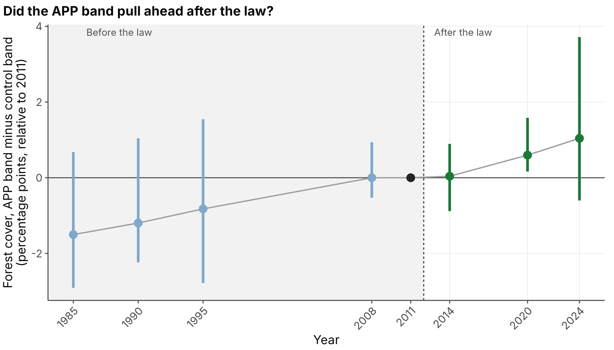
Figure 4. Event study: median difference in forest cover between the APP band (0 to 100 m) and the control band (100 to 500 m) across the fourteen reservoirs, relative to 2011, with bootstrap 95% confidence intervals. Blue points, on the shaded side, precede the law; green points follow it; the black point is the 2011 reference, fixed at zero. The dashed line marks the 2012 Forest Code. Because the quantity is a difference between bands, forest gains shared by both bands, such as the increase between 1995 and 2008 visible in Figure 3a, cancel out and do not appear here.
After the reform, the differential rose: 0.04 pp in 2014, 0.60 pp in 2020, and 1.04 pp in 2024. None of the three post-reform coefficients differed significantly from zero after correction (q ≥ 0.192). The 2024 confidence interval includes zero (-0.60 to 3.72), and the corrected q is 0.237. The 2020 interval (0.16 to 1.58) excludes zero, whereas the corresponding test does not reach significance (p = 0.064), a difference that reflects the distinct quantities the two procedures describe (Section 2.6).
The pre-reform coefficients, although individually not significant, move toward zero between 1985 and 2008 (Figure S2). The event study reports the differential benchmark by benchmark; the triple difference condenses the same comparison into the single quantity specified in advance.
Table 5. Event-study coefficients: the median difference between the APP band and the control band at each benchmark, relative to 2011, in percentage points. The q values are Benjamini-Hochberg corrected separately within the pre- and post-reform families.
Benchmark | Period | Median | 95% CI | Same sign | p | q
1985 | pre-reform | -1.50 | -2.91 to 0.68 | 10 of 14 | 0.198 | 0.529 (ns)
1990 | pre-reform | -1.20 | -2.24 to 1.04 | 10 of 14 | 0.397 | 0.529 (ns)
1995 | pre-reform | -0.82 | -2.78 to 1.55 | 9 of 14 | 0.331 | 0.529 (ns)
2008 | pre-reform | 0.00 | -0.53 to 0.94 | 7 of 14 | 0.917 | 0.917 (ns)
2011 | reference | 0 (ref)
2014 | post-reform | 0.04 | -0.88 to 0.90 | 7 of 14 | 0.600 | 0.600 (ns)
2020 | post-reform | 0.60 | 0.16 to 1.58 | 11 of 14 | 0.064 | 0.192 (ns)
2024 | post-reform | 1.04 | -0.60 to 3.72 | 9 of 14 | 0.158 | 0.237 (ns)

3.4. Triple difference
In the pre-reform window, the APP band gained forest cover 0.58 pp per decade faster than the control band (95% CI: -0.26 to 1.12). In the post-reform window, the same contrast was 0.80 pp per decade (-0.46 to 2.86). The triple difference had a median of 0.48 pp per decade (95% CI: -1.45 to 2.53) and was not significant (p = 0.510); 8 of the 14 reservoirs were positive. This quantity uses forest cover alone. Section 3.9 asks the same question about the full five-class composition to determine whether the reform reorganized land cover in ways that a forest-only measure would miss. Both the event study and the triple difference are medians across a heterogeneous set, so the next section assesses how much each depends on which reservoirs enter the set.

3.5. Sensitivity to the composition of the reservoir set
The reservoir set spans four orders of magnitude in surface area, and the estimate depends on which reservoirs are included (Table 6, Figure 5). Restricting the analysis to water bodies of at least 20 ha raises the 2024 coefficient to 1.84 pp (p = 0.099), to at least 50 ha to 2.82 pp (p = 0.013), and to at least 100 ha to 2.45 pp (p = 0.021). Further restricting to at least 250 ha lowers it to 1.23 pp (p = 0.063). For the first ten reservoirs processed, the coefficient is 1.84 pp (p = 0.017); the four added when the set was extended yield, on their own, a median of -1.70 pp. Under every size threshold and in the original ten, the four pre-reform coefficients remain non-significant and the three post-reform coefficients remain positive (results/event_study_by_scenario.csv in the repository).
The scenarios added during revision lower the estimate. Without the three reservoirs impounded during the series, the 2024 coefficient is 0.44 pp (95% CI -1.12 to 2.45; p = 0.594), with six of the eleven reservoirs positive; it falls to 0.31 pp when Juturnaíba is also removed and to 0.10 pp when Funil is removed instead (p ≥ 0.646). In the stable-waterline set, the pre-reform coefficients remain non-significant (q ≥ 0.438), and the post-reform coefficients are 0.00 pp in 2014, 0.56 pp in 2020, and 0.44 pp in 2024 (Table S7), so the rise after the reform is no longer monotonic. Without the four reservoirs on the state boundary, the 2024 coefficient is 0.65 pp (p = 0.445), and the 1985 coefficient reaches -2.21 pp (uncorrected p = 0.037). Across all twelve rules, the median ranged from -1.70 to 2.82 pp.
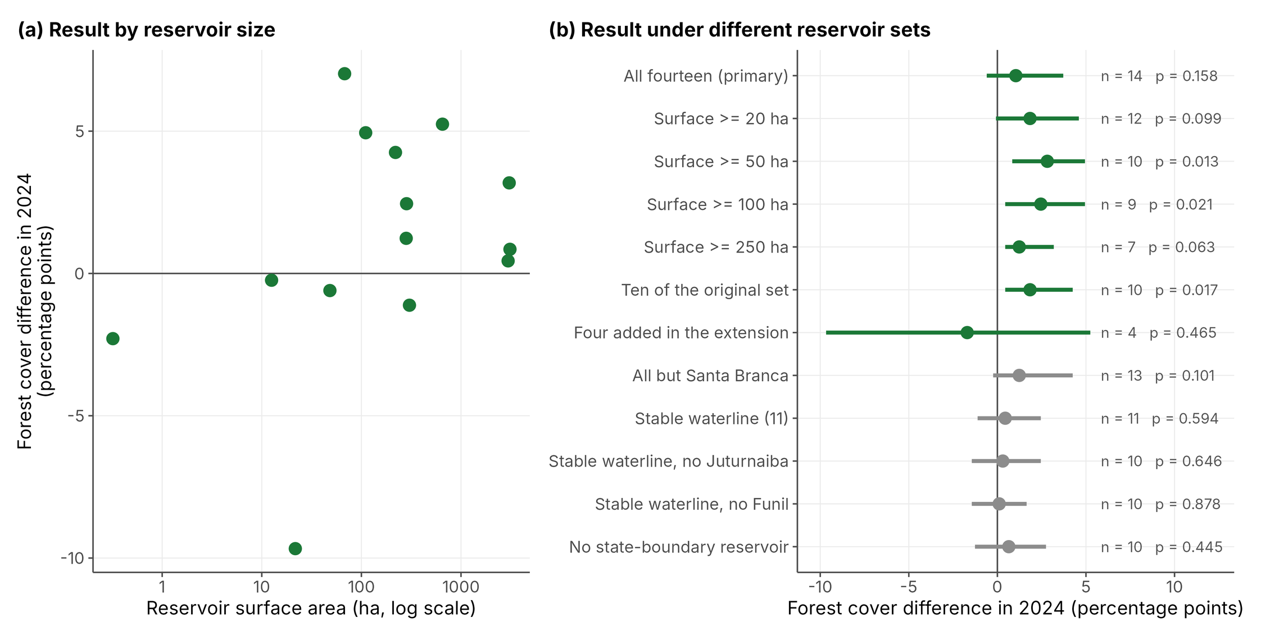
Figure 5. Dependence of the result on the composition of the reservoir set. (a) 2024 differential plotted against surface area on a log scale, spanning four orders of magnitude. (b) Same quantity recomputed under each inclusion rule, with 95% bootstrap confidence intervals, sample size, and p-value displayed. The first five rules are size thresholds, and the next two split the set into the ten reservoirs processed first and the four added afterwards; these seven were specified in advance. The five rules in grey were added during revision (Section 2.6). Every rule is shown, and none was selected on a p-value.
Figure 5a shows two low values among the smaller water bodies, Santa Rosa (-9.67 pp; 21.7 ha) and Santa Branca (-2.29 pp; 0.3 ha). By Tukey’s rule, only Santa Rosa is an extreme value: its coefficient lies below the lower fence of -7.25 pp, whereas that of Santa Branca lies within the fences (Table S3). Santa Branca has an APP band of 6.9 ha, fewer than 80 cells at 30 m resolution, and its coefficients for 2008, 2014, and 2020 are exactly zero.
Size dependence was not supported by the data. The Spearman correlation between log surface area and the 2024 coefficient was 0.35 (p = 0.215), and reservoirs above the median size did not differ significantly from those below it (two-sided Mann-Whitney p = 0.710).
Table 6. Sensitivity of the 2024 event-study coefficient to the composition of the reservoir set. The first seven rules were specified in advance; the last five were added during revision (Section 2.6).
Reservoir set | n | Median (pp) | 95% CI | Same sign | p
All fourteen (primary) | 14 | 1.04 | -0.60 to 3.72 | 9 of 14 | 0.158
Surface area ≥ 20 ha | 12 | 1.84 | -0.08 to 4.60 | 9 of 12 | 0.099
Surface area ≥ 50 ha | 10 | 2.82 | 0.84 to 4.94 | 9 of 10 | 0.013
Surface area ≥ 100 ha | 9 | 2.45 | 0.44 to 4.94 | 8 of 9 | 0.021
Surface area ≥ 250 ha | 7 | 1.23 | 0.44 to 3.18 | 6 of 7 | 0.063
The ten reservoirs of the original set | 10 | 1.84 | 0.44 to 4.25 | 8 of 10 | 0.017
The four reservoirs added in the extension | 4 | -1.70 | -9.67 to 5.25 | 3 of 4 | 0.465
All but Santa Branca | 13 | 1.23 | -0.24 to 4.25 | 9 of 13 | 0.101
Stable waterline (Paracambi, Anta, and Rosal excluded) | 11 | 0.44 | -1.12 to 2.45 | 6 of 11 | 0.594
Stable waterline, Juturnaíba also excluded | 10 | 0.31 | -1.45 to 2.45 | 5 of 10 | 0.646
Stable waterline, Funil also excluded | 10 | 0.10 | -1.45 to 1.65 | 5 of 10 | 0.878
Reservoirs on the state boundary excluded | 10 | 0.65 | -1.26 to 2.74 | 6 of 10 | 0.445

3.6. Spatial variation
Forest cover differed significantly among the three exclusive bands at every benchmark, including 2024 (Figure 6). Concordance among reservoirs, measured by Kendall’s W, declined from 0.78 in 1985 and 0.85 in 1995 to 0.45 between 2008 and 2011, 0.41 in 2020, and 0.25 in 2024 (Friedman chi-square = 6.87, q = 0.032). Across all benchmarks, the modal ordering remained 100 to 500 m > 30 to 100 m > 0 to 30 m: forest cover increased with distance from the waterline throughout the series.
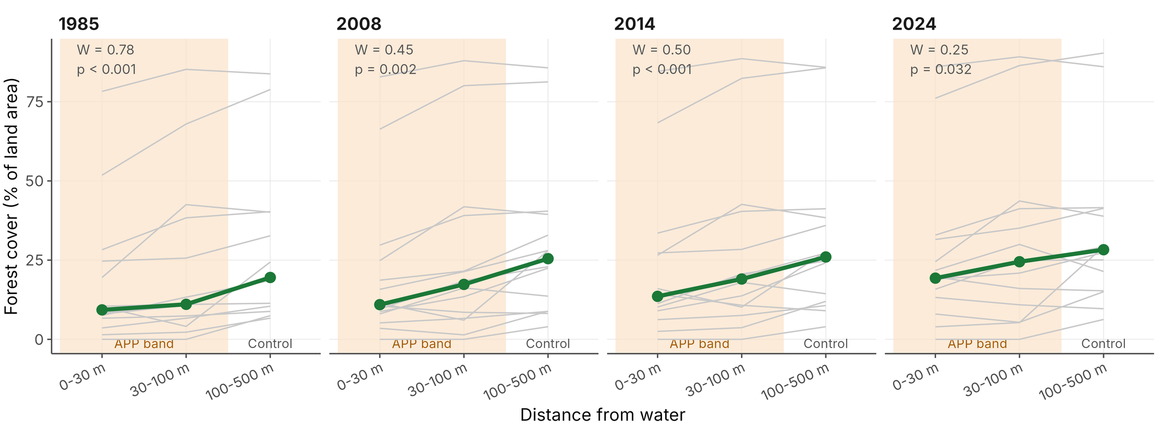
Figure 6. Forest cover by distance from water at four benchmarks. Gray lines show individual reservoirs, and the green line is the median. The shaded rings, 0 to 30 m and 30 to 100 m, form the APP band; the unshaded ring is the control band. Kendall’s W, the agreement among reservoirs on the ordering of the rings, drops from 0.78 in 1985 to 0.25 in 2024.
The two rings of the APP band, shaded in Figure 6, hold the least forest at every benchmark, and they still do at the end of the series. What changed is the strength of the pattern, not its direction. Concordance fell by two-thirds, and the panels in Figure 6 show why: the gray lines, one per reservoir, fan out over time as some reservoirs close the gap and others do not.

3.7. Configuration of the forest class
In the APP band, across the thirteen reservoirs that retain forest within it, the post-reform window produced significant increases in PLAND (3.32 pp per decade, q = 0.034), patch number (5.38 per decade, q = 0.034), and patch density (1.96 per 100 ha per decade, q = 0.034). Edge density also increased but did not reach the corrected threshold (6.10 m per ha per decade, q = 0.078). Mean patch area did not change. In the control band, across all fourteen reservoirs, PLAND, patch number, and patch density also rose significantly. No configuration metric showed a significant triple difference after correction.
The combination of more patches and an unchanged mean patch size indicates that the mechanism is the appearance of new small patches rather than the growth of existing ones. Figure 7 places the two panels that carry the argument side by side: forest area rises while mean patch size remains flat. Clumpiness did not change significantly in either band under the corrected denominator defined in Section 2.4.
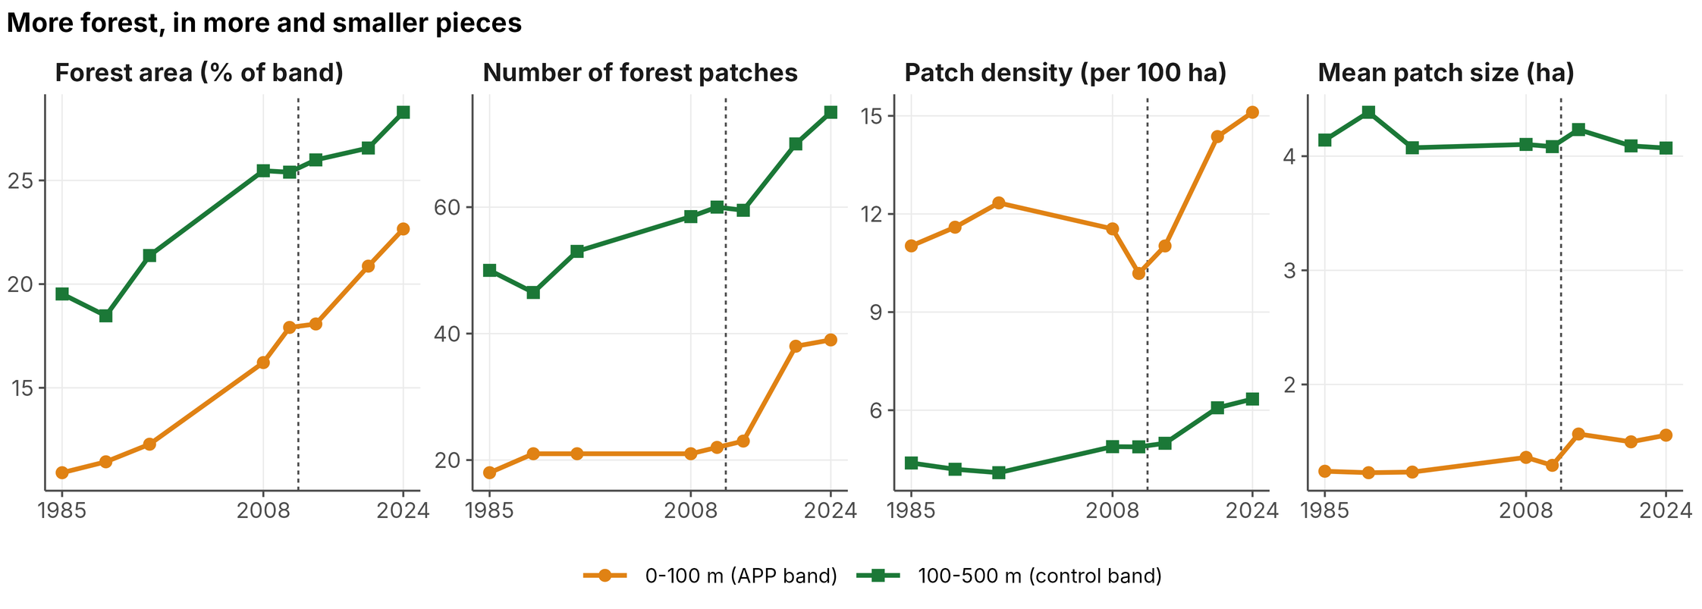
Figure 7. Medians across reservoirs for the APP band, 0 to 100 m (orange; thirteen reservoirs), and the control band, 100 to 500 m (green; fourteen reservoirs). Forest area and the number of patches both increase, as does patch density, while mean patch size remains flat. That combination indicates the gain came from new small patches rather than from existing forest expanding. The dashed line marks the 2012 Forest Code.

3.8. Native vegetation in the APP band, consolidated area, and conversion after 2008
Across the APP band of each reservoir, the median native-vegetation deficit was 77.4%, and six of the fourteen reservoirs reached the 25% ecological threshold (Table 7). The deficit exceeded 60% at twelve reservoirs and did not vary with reservoir size: the Spearman correlation between log surface area and the deficit was -0.14 (p = 0.627). Fontes Nova (11.6%) and Saracuruna (15.9%) are the two exceptions. In contrast, Santa Branca (100%), Santa Rosa (95.0%), and Ilha dos Pombos (93.9%) have almost no native cover in their APP band. Figure 8a ranks the reservoirs by the native forest their APP band still holds: two retain more than 80%, twelve fall below 40%, and four fall below 12%.
At the level of the registered property, the deficit was higher and more dispersed: a median of 95.6% across the 197 holding records that retain terrestrial area within the APP band, with 26.9% meeting the 25% threshold. Two of the 199 holding records intersecting the buffers have no terrestrial area within the APP band and therefore show no deficit; they are retained in the transition analysis below, which does not require a terrestrial denominator. The deficit of the individual holdings ranges from 0 to 100%, a dispersion that no reservoir-level summary shows.
Using the 2008 benchmark, 51.0% of the terrestrial area of the APP band within registered properties was already under anthropogenic use before the amnesty cut-off. Cross-tabulating with 2024 data identifies four situations: consolidated area still in use, 46.6%; consolidated area since restored, 4.3%; native cover maintained, 47.6%; and conversion after 2008, 1.4% (equivalent to 67.9 ha), detected in 49 of the 199 holding records (Figure 8b). The transitional provisions do not apply to the last category because suppression of native vegetation in the APP after 22 July 2008 carries no amnesty, regardless of property size.
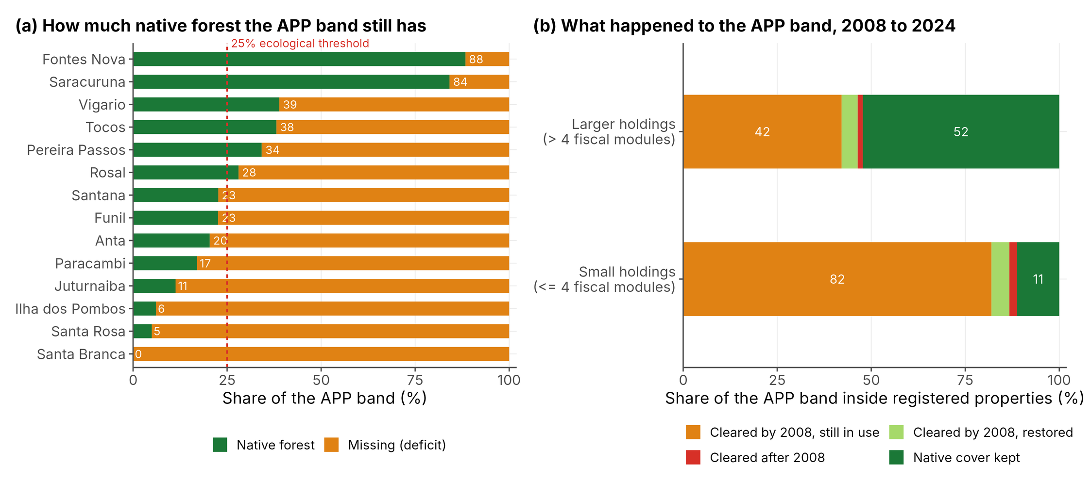
Figure 8. Native forest in the APP band. (a) Share of the APP band of each reservoir covered by native forest. The dashed red line marks the 25% ecological threshold, which eight of the fourteen reservoirs do not reach. (b) Transition of the APP band within registered properties between 2008 and 2024, split by holding size. Orange indicates land cleared by 22 July 2008 and still in use; light green, land cleared by 2008 and since restored; red, land cleared after the cut-off, which carries no amnesty; dark green, native cover retained. Saracuruna has no registered property in its buffer and appears only in panel (a).
The split by property size is the clearest single result from the cadastral module (Figure 8b). In holdings with four fiscal modules or fewer, 82.0% of the APP band was already cleared in 2008 and remains in use, compared with 42.1% in larger holdings, which still have 52.3% under native cover. Article 61-A therefore addresses the situation of smaller holdings almost entirely. In contrast, larger holdings hold 97.7% of the declared area within the buffers and account for most of the area cleared after 2008.
The declared APP behaves as an object separate from the APP band (Table S6). The registry carries 1,235.8 ha of declared APP inside the fourteen buffers, of which 433.7 ha fall within the APP band and 802.3 ha, that is 64.9%, fall outside it along the drainage network of the same holdings. The declaration therefore covers 5.3% of the 8,130.6 ha of the APP band, so an agency assessing compliance from the declared geometry alone would examine a twentieth of that area. A further 170.5 ha of declared polygons fall on the water surface itself, which is 13.8% of everything declared inside the buffers, and the theme reserved for the margin of an artificial reservoir appears in only 66 polygons across the set, absent at four reservoirs and of zero area inside the buffer at three more. At Fontes Nova, where the margin lies inside a single registered holding of 24,980 ha, no declared polygon of any holding reaches the 500 m buffer. However, the registry is a self-declaration and its polygons carry no requirement to be exhaustive, so a low coverage measures the quality of the declaration rather than the vegetation on the ground, and it is for that reason that native vegetation is computed here from land cover over the APP band and not from the declared geometry.

3.9. Composition as a whole
The partial redundancy analysis reproduces the univariate conclusion from the full five-class composition (Table S4). Fractions are expressed as shares of the total compositional variance, the convention in variation partitioning, which makes the components directly comparable [42]. Reservoir identity accounts for 64.6% of that variance. Distance band accounts for an additional 24.1% after removing reservoir identity (adjusted R-squared = 0.241, p < 0.001; no permutation of 4,999 reached the observed value, so 0.0002 is the smallest attainable p rather than a point estimate). The period before or after the reform accounts for 0.4% (adjusted R-squared = 0.004, p = 0.021). The interaction between band and period, the multivariate counterpart of the difference-in-differences contrast, accounts for none of the variation (adjusted R-squared = -0.0004, p = 1.000).
Two readings follow. First, the composition of these buffers is organized primarily by distance from the water and by the reservoir being observed, and only marginally by period. Second, directly relevant to the confirmatory question, the reform is not associated with any reorganization of land cover specific to the APP band. The null triple difference in Section 3.4 is therefore not an artifact of measuring forest cover alone.
Table 7. Native vegetation in the APP band by reservoir, computed from MapBiomas 2024 over the terrestrial area, for the fourteen reservoirs. For Anta, Funil, Ilha dos Pombos, and Rosal, the surface area refers to the part of the reservoir inside Rio de Janeiro (Table 2).
Reservoir | Surface (ha) | APP band (ha) | Forest (%) | Deficit (%) | ≥25%
Santa Branca | 0.3 | 6.9 | 0.0 | 100.0 | No
Santa Rosa | 21.7 | 36.4 | 5.0 | 95.0 | No
Ilha dos Pombos | 303.8 | 447.3 | 6.1 | 93.9 | No
Juturnaíba | 2,972.2 | 716.2 | 11.3 | 88.7 | No
Paracambi | 219.9 | 284.6 | 17.0 | 83.0 | No
Anta | 651.7 | 508.2 | 20.4 | 79.6 | No
Funil | 3,048.2 | 2,150.9 | 22.6 | 77.4 | No
Santana | 284.1 | 514.0 | 22.7 | 77.3 | No
Rosal | 67.9 | 128.6 | 28.0 | 72.0 | Yes
Pereira Passos | 110.4 | 138.5 | 34.2 | 65.8 | Yes
Tocos | 12.5 | 50.0 | 38.1 | 61.9 | Yes
Vigário | 281.8 | 434.5 | 38.9 | 61.1 | Yes
Saracuruna | 48.3 | 45.5 | 84.1 | 15.9 | Yes
Fontes Nova | 3,101.5 | 2,668.9 | 88.4 | 11.6 | Yes
Median |  |  | 22.6 | 77.4 | 6 of 14

4. Discussion

4.1. Timing and magnitude of the divergence
The event study places the divergence between the APP band and the control band after the reform, not before. Four pre-reform benchmarks show no significant difference, and across the full set the three post-reform benchmarks rise. A two-period design cannot make this claim because it must assume what the event study tests. The pre-reform coefficients, although individually not significant, move toward zero between 1985 and 2008, so parallel trends are supported but not established. If an effect exists, it appears late, at the last two benchmarks. That timing is consistent with the interval required for regeneration to become detectable at 30 m, and also with coincidence, and the design cannot distinguish the two.
The timing evidence is also weaker than the full set suggests. Three reservoirs, Rosal, Anta, and Paracambi, were impounded during the series, and at Anta and Paracambi impoundment and licensing coincide with the reform. They hold three of the four largest 2024 coefficients in the set (Table S3). Without them, the post-reform coefficients no longer rise steadily, the 2024 coefficient falls from 1.04 to 0.44 pp, and the triple difference falls to -0.03 pp per decade (Table S7). Part of the post-reform divergence therefore comes from reservoirs whose APP band changed with impoundment and licensing during the period, a process that this design cannot separate from the reform.
The design does not yield a magnitude distinguishable from zero. The 2024 difference of 1.04 percentage points has a confidence interval from -0.60 to 3.72, and the triple difference is 0.48 points per decade with p = 0.510. Forest cover rose significantly in every band, including the unprotected control band, where the response was most consistent: fourteen of fourteen reservoirs moved in the same direction (Figure 3b). The redundancy analysis reaches the same conclusion from the full composition rather than from forest alone: distance from the water organizes the composition of these buffers, accounting for 24.1% of the total variance once reservoir identity is removed, whereas the interaction between band and period, which is the multivariate form of the difference-in-differences contrast, accounts for none of it. Taken together, the parsimonious interpretation is that a regional forest transition dominates and that any additional effect specific to the APP band is small relative to it. This agrees with the regional literature, which documents forest regrowth on abandoned pasture in Rio de Janeiro and in the Paraíba do Sul valley [16,17] and attributes part of the transition in São Paulo to environmental policy [18].
This interpretation also qualifies what the control band measures. The 100 to 500 m band lies outside the APP but not outside regulation: the Atlantic Forest Law regulates the clearing of primary and secondary native vegetation throughout the biome [44]. The triple difference therefore estimates the effect of APP status in addition to the general regime of the biome, not the effect of regulation as opposed to its absence.
This reading aligns with the policy literature. Azevedo et al. [3] found that the initial difference in deforestation between registered and unregistered properties narrowed over time and that few registered landholders reported steps to restore illegally cleared areas. If the binding constraint is enforcement and incentives rather than the mandate itself, a modest differential is expected, and the low share of validated records in Rio de Janeiro (Section 1.1) points in the same direction. Section 4.5 returns to this point with the compliance results.

4.2. Instability with respect to the reservoir set
The magnitude of the estimate depends on which reservoirs are included in the set, which is why the size thresholds were specified in advance. The 2024 coefficient ranges from 1.04 pp across the full set to 2.82 pp when reservoirs below 50 ha are excluded, and it falls to between 0.10 and 0.65 pp under the scenarios added during revision (Table 6). Two statements follow, and they should be kept separate. First, no restricted value can be presented as the headline without amounting to outcome selection. Second, the temporal pattern holds under the size thresholds, under which the four pre-reform coefficients remain non-significant and the three post-reform coefficients remain positive, but not under the removal of the reservoirs impounded during the series. The instability therefore affects the size of the effect and part of the timing evidence; it does not affect the absence of divergence before the reform.
Two features of the smaller reservoirs bear on these values. Santa Branca’s coefficients of exactly zero in 2008, 2014, and 2020 are the signature of a series too coarse to detect any change, a measurement limitation rather than evidence that nothing happened. In addition, CONAMA Resolution 302/2002 sets a minimum strip of 15 m for hydropower reservoirs of up to 10 ha [8], which applies to Santa Branca, so the 100 m band does not correspond to its protected strip. These considerations suggest that the effect could depend on size, but the formal tests do not support it (Section 3.5).
Three considerations support retaining the full set as the primary analysis. First, exclusion yields no inferential gain. Removing Santa Branca, the only reservoir whose series is arguably degenerate, shifts the 2024 coefficient from 1.04 to 1.23 pp and the p-value from 0.158 to 0.101 (Table 6). The qualitative conclusion remains unchanged, so exclusion would introduce a selection step that requires justification and would not alter the inferences. Second, exclusion would introduce a documented bias. Biggs et al. [22] showed that riparian preservation areas along small water features hold most of the protected area and most of the deficit yet are systematically omitted from assessments focused on large water bodies; dropping the smallest reservoirs here would reproduce that omission. Third, the compliance results answer the same question independently. The native-vegetation deficit does not track reservoir size (Spearman r = -0.14, p = 0.627), so removing small reservoirs would leave the compliance picture unchanged while reducing the sample. The stable-waterline scenario differs in kind from these exclusions: its criterion concerns whether the pre-reform benchmarks describe a reservoir margin, not the size of the water body, and it is reported alongside the primary analysis for that reason.
The evidence does not support a point estimate of the effect, and the claim about its timing holds for the full set but not for the reservoirs with a stable waterline. This suggests a concrete design change for the field. Studies of riparian policy should register a minimum effect size in advance, defined by the licensed APP width of each water body rather than by coefficients estimated on the same data. The licensed width varies with surface area, use, and the date of the concession. Hence, a reservoir whose legal strip is narrower than the measured band contributes a diluted signal by construction, and a threshold anchored to that width removes the dilution without consulting the outcome. Registering the criterion before analysis converts what is here a reported instability into a stated design parameter, and it is a change any comparable study can adopt.
The scope of these conclusions follows the same reasoning. The set covers fourteen reservoirs in one state, spanning four orders of magnitude in surface area and including hydropower, public supply, and industrial supply. The event-study design transfers to any protected zone with an adjacent unprotected reference and a land cover series extending before the intervention. The estimated magnitude does not transfer, for the reason given above. Four conditions define where the design applies most directly: an explicit statutory buffer obligation, an occupation history in which reservoir margins were settled before the reform, enforcement capacity sufficient for a mandate to be visible in land cover, and land cover data of comparable resolution and temporal depth. Where land tenure or enforcement differ substantially, the design remains applicable, and the parameters must be re-estimated.

4.3. A gradient that weakens without reversing
The pattern in Figure 6 is the opposite of what binding riparian protection would produce. Forest cover increases with distance from the waterline at every benchmark from 1985 to 2024, and the ordering never reverses. Concordance among reservoirs declines from 0.78 to 0.25. The historical configuration reflects the long occupation of reservoir margins for pasture and access, established well before the first benchmark. The compression of the gradient is consistent with faster gains in the inner bands. The APP band still holds less forest than the control band twelve years after the reform, which is the clearest single statement of the implementation gap in these data. Whether the gained forest functions as a riparian buffer depends on its arrangement, as the configuration results show.

4.4. Fragmented recovery
Forest gain was accompanied by increases in patch number and patch density, with no change in mean patch area, in both bands (Figure 7). This pattern indicates regeneration through new small patches rather than expansion of existing remnants. The ecological consequence is that the area statistic overstates the functional gain: small, high-edge patches provide less interior habitat per hectare, and fragmented riparian strips filter nutrients and retain sediment less effectively than continuous ones, as reported in the buffer-function literature [11–13]. Guidotti et al. [9] made the same point specifically for buffer width: narrower and discontinuous buffers translate directly into reduced water-supply protection.
The correction defined in Section 2.4 determines what can be claimed about this fragmentation. Under the default denominator, clumpiness declined significantly after the reform in both bands (results/clumpy_default_trend.csv in the repository), which would have supported a claim of progressive spatial disaggregation. That decline is an artifact with a traceable mechanism: as forest cover rises within a narrow band, more forest cells come into contact with the analysis frame, the frame is counted as a class edge, and the index falls even though the arrangement of forest has not changed. Once the frame is excluded, aggregation is stable, and the fragmentation signal rests on patch counts and patch density alone. The corrected claim is narrower and better supported, whereas the discarded one would have been an inference about the analysis window, presented as an inference about the landscape. The general caution is that software defaults for landscape metrics assume compact analysis extents, so applying them to linear features should include verifying boundary treatment before interpreting the values.

4.5. Compliance and the reach of Article 61-A
The median native-vegetation deficit is 77.4% at the reservoir level and 95.6% at the property level (Figure 8a), placing the reservoirs at the upper end of the range reported in comparable literature. Biggs et al. [22] found that 64% of the riparian preservation area in Rondonia was illegally deforested by 2017, and Valera et al. [45], assessing riparian buffer capacity in a legally protected catchment in Minas Gerais, concluded that the widths permitted under the revised Code are insufficient for water-quality control. The occupation history suggests that reservoir margins in an urbanized, long-settled state should perform worse than those on an Amazonian frontier. The recovery documented in Section 3.2 has therefore not translated into compliance, and the gap is widest where enforcement acts, namely at the individual holding level. The registry has not yet closed this gap. With 2% of the state’s records validated and four commitment terms signed under the PRA in November 2025, and with most states still relying on self-monitoring by the landholder to follow restoration [6], the recovery obligations attached to these holdings remain, for the most part, undefined and unmonitored.
Classifying consolidation by land cover rather than by cadastral date changes what can be said about the transitional provisions. Slightly more than half the APP band within registered properties was already anthropic in 2008. Hence, a substantial part of the deficit predates the reform and falls within the scope of Article 61-A for eligible properties. The 67.9 ha converted after 2008 is small in area but categorically distinct because no transitional provision covers it, and it was detected in 49 of the 199 holding records. That distribution indicates dispersed, incremental clearing rather than a small number of large events, which affects how enforcement should be organized. One caveat limits temporal precision: MapBiomas assigns one classification per calendar year, so clearing between January and July 2008 would be recorded as post-cut-off. The 1.4% figure is therefore an upper bound on conversion outside the amnesty.
Two economic analyses explain why a deficit of this size persists rather than closing. Koch et al. [46] found that higher farming productivity is associated with greater forest conservation under the Forest Code, implying that the opportunity cost of leaving riparian land uncultivated binds when productivity is low. Sant’Anna and Costa [47] documented that repeated debt renegotiation among rural borrowers weakened the deterrent effect of environmental regulation in the Amazon, showing that enforcement credibility, rather than the law’s text, varies. Both analyses point to the same conclusion as the event study: the mandate exists, but the incentive structure that would make property-level compliance rational does not.

4.6. Reservoir margins and water security
The ecosystem services of riparian vegetation around a reservoir do not depend on whether the impounded water is used for electricity or water supply. In this set, large deficits occur both in hydropower reservoirs and in the public-supply reservoir of Juturnaíba (88.7%), which is consistent with a deficit that tracks land tenure and occupation history rather than operational purpose. Von Sperling [14] and Marques et al. [15] identify riparian condition as a determinant of reservoir management costs in Brazil, and Cuartas et al. [48] document how recent hydrological droughts translate into generation losses. The condition of these perimeters is therefore a water-security question, not only a compliance question.

4.7. Limitations
Statistical power is the binding constraint. With fourteen paired units, the design detects only large effects, and the primary 2024 coefficient is not significant. The result is inconclusive rather than negative. The sequence of pre- and post-reform coefficients holds under the size thresholds, whereas the point estimate does not. Increasing power would require more reservoirs with stable margins rather than more benchmarks, because the constraint is the number of paired units, not the series length.
Heterogeneity in reservoir size is the second constraint, and Section 4.2 reports it in full rather than resolving it by exclusion. It bounds the interpretation of magnitude and leaves the sign and timing unaffected under every size threshold examined. Changes in the waterline are a third constraint. Three reservoirs were impounded during the series, and the outlines of the four boundary reservoirs cover only the part of the water surface inside Rio de Janeiro, so on the far bank of the Paraíba do Sul and of the Itabapoana the bands are measured from the state line rather than from the shore. Rebuilding the bands from the full outlines would remove the second issue; the first is a property of the reservoirs, and the stable-waterline scenario reports its consequence.
The set is also spatially concentrated. Eleven of the fourteen reservoirs belong to the Paraíba do Sul and Guandu system, ten of them in the Sepetiba Bay and Piraí basins or on the main stem of the Paraíba do Sul, and the Guanabara Bay, São João, and Itabapoana basins contribute one reservoir each. Because the design compares bands within each reservoir rather than regions, this concentration does not bias the paired comparisons, but it precludes any comparison between basins and limits the generalization of the results to other basins and climates.
The 30 m pixel bounds every result and matters most for the smallest water bodies, the narrowest declared APP polygons, and the shoreline itself. The APP band is 3.3 cells wide, the accuracy of 30 m products declines in narrow riparian buffers [49], and the published accuracy of MapBiomas refers to the product as a whole rather than to riparian bands. Mixed cells along the waterline are resolved into a single class, so forest narrower than a cell may go unrecorded. No in situ validation was performed, so composition and configuration are read here as descriptors of land cover rather than direct measures of buffer function. The multi-temporal comparison is also sensitive to the internal evolution of the MapBiomas product across four decades of sensor history. That sensitivity is not symmetric in its consequences, and the asymmetry is what makes the design defensible. Because every band is measured on the same product, the same grid, and the same date, any classification drift common to the scene affects the APP and control bands alike and cancels in the APP-minus-control differential on which the event study and the triple difference are built. Error specific to the shoreline does not cancel between bands, but while it is constant over time it cancels in the event-study coefficients, which are measured relative to 2011; where the waterline moved, it does not, which is one reason for the stable-waterline scenario (Section 2.6). Neither form of error cancels in the absolute cover values of Table 3 or in the deficits of Section 3.8, which should therefore be read as product-conditional. Field validation of the shoreline cells would sharpen both.
The declared APP is available for all fourteen reservoirs. What limits it is the object: the registry records what the landholder chose to draw, so the 5.3% coverage reported in Section 3.8 bounds the declaration and not the vegetation, and the conclusions on native vegetation rest on land cover over the APP band, which does not depend on the registry.
The cadaster is self-declared, largely unverified, and varies in completeness, which limits the property-level results. Saracuruna has no registered property intersecting its buffer, so it contributes to the reservoir-level results, not the property-level ones. Holdings that have never registered are absent from the property-level denominator. Property-level figures therefore describe the declared record rather than a census of the holdings bordering each reservoir. If holdings that decline to register are less likely to retain native vegetation, the property-level deficit of 95.6% understates rather than overstates the deficit; no data available here test that assumption. The reservoir-level deficit is computed from land cover over the whole APP band. It does not depend on the registry at all, which is why it, and not the property-level figure, carries the conclusion on native vegetation.
The clumpiness index departs from the default implementation of a widely used package, as explained in Section 2.4. Readers comparing these values with studies that use the default should be aware of the difference, which Table S2 quantifies. The seven remaining configuration metrics are computed with the package defaults and remain directly comparable. Each constraint bounds a specific claim rather than the study as a whole, and the implications below are based only on quantities that survive these constraints.

4.8. Implications for conservation and public policy
Five recommendations follow directly from the quantities measured in this study. Three address the agencies that act on the deficit, and two address how future assessments should be designed. A final set of questions lies outside the study’s evidentiary scope and is identified as such.
First, the state environmental agency should act on the 67.9 ha cleared after 22 July 2008, identified across 49 registered properties. No transitional provision covers this area, so liability does not depend on holding size or registration date. Because the clearing is dispersed across a quarter of the assessed properties rather than concentrated in a few, enforcement organized property by property will reach it. In contrast, enforcement organized reservoir by reservoir will not.
The inconclusive magnitude does not weaken this recommendation; it sharpens it. A design that cannot resolve an aggregate effect can still identify individual holdings where the statutory obligation is unambiguous. Post-2008 conversion is precisely that case: it carries no amnesty regardless of holding size or registration date. Enforcement organized around aggregate regulatory impact has little to act on here, whereas enforcement organized around identified parcels has 67.9 ha and 49 named properties. Satellite series and cadastral geometry are sufficient to generate the alerts, and the same series supports verification once an administrative proceeding is opened.
Second, enrollment in the Environmental Regularization Program should target the individual holding. The property-level deficit has a median of 95.6% and ranges from full compliance to complete absence of native cover, whereas the reservoir-level median of 77.4% obscures that range. A reservoir-level target would treat holdings with no deficit and those with a total deficit as a single case.
Third, the cadastral authority should standardize the construction of declared APP geometries around reservoir water bodies, because the present ones are not usable for assessment. Of the 1,235.8 ha declared inside the buffers, 170.5 ha sit on the water surface and 802.3 ha lie outside the APP band, while the theme reserved for the reservoir margin appears in 66 polygons across fourteen reservoirs. Polygons drawn over water, or drawn to a watercourse width on a reservoir margin, make compliance incomparable across properties and place the burden of reconciling geometries on the assessing agency.
For restoration planning, the configuration results support a specific emphasis: new patches near the waterline should be consolidated and connected rather than counted. Forest area, patch number, and patch density all rose, while mean patch area did not, indicating that the gain took the form of dispersed small patches. Area-based targets would register that gain in full, while the buffer function it is meant to represent lags behind.
For monitoring, the event-study design is directly applicable without modification. Any protected zone with an adjacent unprotected reference and a land cover series spanning periods before the intervention can be assessed this way. The pre-intervention benchmarks provide a falsifiable test that a before-and-after comparison cannot.
Four questions fall outside the scope of this evidence and should not be read into it. The study does not estimate the magnitude of the policy effect because the confirmatory coefficient is not distinguishable from zero and varies with the composition of the reservoir set. It does not attribute the post-reform divergence to the Forest Code, because part of that divergence comes from reservoirs whose margins changed with impoundment and licensing during the period. It does not establish that the effect is larger at larger reservoirs because the formal test of size dependence is not significant. However, the licensed APP width provides a mechanism worth testing on a larger set. It does not measure buffer function because composition and configuration are proxies; whether the observed recovery improves sediment retention or water quality at these reservoirs requires in situ measurement that this design does not provide.

5. Conclusions
An eight-benchmark series across fourteen reservoirs shows that the difference in forest cover between the 0 to 100 m APP band and the unprotected 100 to 500 m control band did not change significantly before the 2012 Forest Code and rose afterward, reaching 1.04 percentage points in 2024. The four pre-reform benchmarks support the parallel-trends assumption that a two-period design must take as given. The magnitude of the divergence is not distinguishable from zero; it ranges from -1.70 to 2.82 percentage points across the reservoir sets examined and falls to 0.44 percentage points when the three reservoirs impounded during the series are excluded.
Forest cover increased significantly in every band after the reform, with the response most consistent in the unprotected control band, which points to a regional forest transition. Recovery took the form of new small patches rather than the expansion of existing remnants, so the functional gain is smaller than the area statistic suggests. Forest cover continues to increase with distance from the waterline at every benchmark, and the APP band still holds the least forest cover twelve years after the reform.
Within the APP band, the median native-vegetation deficit remains 77.4% at the reservoir level and 95.6% at the property level, and it does not vary with reservoir size. Slightly more than half of that area within registered properties was already under anthropic use before the 22 July 2008 cut-off and falls within the scope of the transitional provisions; 1.4%, equivalent to 67.9 ha across 49 properties, was cleared afterward and carries no amnesty. Establishing the magnitude of an effect specific to the APP would require more reservoirs with stable margins rather than more benchmarks, and a minimum effect size registered in advance and anchored to the licensed width of each water body.
Supplementary Materials: The following supporting information can be downloaded at: [link to be inserted by the journal]. Table S1: Crosswalk from the MapBiomas Collection 10 legend to the five analytical classes; Table S2: Effect of boundary treatment on the clumpiness index; Table S3: Event-study coefficients for 2024 and forest cover by reservoir; Table S4: Partial redundancy analysis of land cover composition; Table S5: Property-level transition of the APP band, 2008 to 2024 (spreadsheet); Table S6: Declared APP by reservoir (spreadsheet); Table S7: Event study and triple difference for the eleven reservoirs with a stable waterline; Table S8: Water share of the 0 to 30 m band by benchmark; Figure S1: Forest cover in the APP and control bands, reservoir by reservoir; Figure S2: APP-band-minus-control-band differential by reservoir; Figure S3: The eight configuration metrics in both bands.
Author Contributions: Conceptualization, […]; methodology, […]; software, M.E.M.M.N.; formal analysis, M.E.M.M.N.; investigation, […]; data curation, M.E.M.M.N.; writing, original draft preparation, M.E.M.M.N.; writing, review and editing, L.V., V.S.L., […]; visualization, M.E.M.M.N.; supervision, […]; funding acquisition, […]. All authors have read and agreed to the published version of the manuscript.
Funding: This research was funded by the National Council for Scientific and Technological Development (CNPq), through an undergraduate research scholarship linked to the National Institute of Science and Technology […], grant number […].
Institutional Review Board Statement: Not applicable.
Informed Consent Statement: Not applicable.
Data Availability Statement: The data and code that support the findings of this study are openly available on GitHub at [repository URL …] and archived in Zenodo at [DOI …]. Running R/02_tests.R reproduces all inferential quantities and the tables of the main text and of the supplementary material; R/03_figures.R reproduces Figures 2 to 8 and S1 to S3; R/04_redundancy_analysis.R reproduces the multivariate check in Section 3.9 and Table S4; and R/05_reservoir_characteristics.R rebuilds Table 2 from the public reservoir and basin layers. The repository contains the extracted series in data/ (one row per observation), including land cover composition by reservoir, band, benchmark, and class; configuration metrics for the forest class; the cadastral tables; and the characteristics of the reservoirs. The analysis scripts in R/ run in numerical order, and their output tables and figures are written to results/ and figures/. The Earth Engine scripts used to export and reclassify the rasters are in docs/. Code is released under the MIT License and derived data under CC BY 4.0. MapBiomas Collection 10 is publicly available from the MapBiomas project. We do not redistribute the 112 source rasters or the cadastral shapefile. The rasters can be reproduced using the provided Earth Engine scripts; the cadastral layer is publicly available through SICAR, but the derived tables identify holdings by sequential codes rather than by their registry codes. Neither is required to reproduce any quantity reported in this manuscript.
Acknowledgments: During the preparation of this manuscript and study, the authors used Claude (Anthropic) [version information …] for the purposes of revising the language of the manuscript and writing and debugging the analysis scripts. The authors have reviewed and edited the output and take full responsibility for the content of this publication.
Conflicts of Interest: The authors declare no conflicts of interest.

References
- Brasil. Lei nº 12.651, de 25 de maio de 2012. Dispõe sobre a proteção da vegetação nativa. Diário Oficial da União, Brasília, Brazil, 2012.
- Soares-Filho, B.; Rajão, R.; Macedo, M.; Carneiro, A.; Costa, W.; Coe, M.; Rodrigues, H.; Alencar, A. Cracking Brazil’s Forest Code. Science 2014, 344, 363–364. https://doi.org/10.1126/science.1246663
- Azevedo, A.A.; Rajão, R.; Costa, M.A.; Stabile, M.C.C.; Macedo, M.N.; dos Reis, T.N.P.; Alencar, A.; Soares-Filho, B.S.; Pacheco, R. Limits of Brazil’s Forest Code as a means to end illegal deforestation. Proc. Natl. Acad. Sci. USA 2017, 114, 7653–7658. https://doi.org/10.1073/pnas.1604768114
- Soterroni, A.C.; Mosnier, A.; Carvalho, A.X.Y.; Câmara, G.; Obersteiner, M.; Andrade, P.R.; Souza, R.C.; Brock, R.; Pirker, J.; Kraxner, F.; et al. Future environmental and agricultural impacts of Brazil’s Forest Code. Environ. Res. Lett. 2018, 13, 074021. https://doi.org/10.1088/1748-9326/aaccbb
- Freitas, F.L.M.; Sparovek, G.; Mörtberg, U.; Silveira, S.; Klug, I.; Berndes, G. Offsetting legal deficits of native vegetation among Brazilian landholders: effects on nature protection and socioeconomic development. Land Use Policy 2017, 68, 189–199. https://doi.org/10.1016/j.landusepol.2017.07.014
- Lopes, C.L.; Didonet, N.; Chiavari, J. Onde Estamos na Implementação do Código Florestal? Radiografia do CAR e do PRA nos Estados Brasileiros, Edição 2025; Climate Policy Initiative: Rio de Janeiro, Brazil, 2025. Available online: https://www.climatepolicyinitiative.org/wp-content/uploads/2025/12/Onde-Estamos-2025.pdf (accessed on 19 October 2026).
- Metzger, J.P.; Bustamante, M.M.C.; Ferreira, J.; Fernandes, G.W.; Librán-Embid, F.; Pillar, V.D.; Prist, P.R.; Rodrigues, R.R.; Vieira, I.C.G.; Overbeck, G.E. Why Brazil needs its Legal Reserves. Perspect. Ecol. Conserv. 2019, 17, 91–103. https://doi.org/10.1016/j.pecon.2019.07.002
- Brasil. Resolução CONAMA nº 302, de 20 de março de 2002. Dispõe sobre os parâmetros, definições e limites das Áreas de Preservação Permanente de reservatórios artificiais e sobre o regime de uso do entorno. Conselho Nacional do Meio Ambiente: Brasília, Brazil, 2002.
- Guidotti, V.; Ferraz, S.F.B.; Pinto, L.F.G.; Sparovek, G.; Taniwaki, R.H.; Garcia, L.G.; Brancalion, P.H.S. Changes in Brazil’s Forest Code can erode the potential of riparian buffers to supply watershed services. Land Use Policy 2020, 94, 104511. https://doi.org/10.1016/j.landusepol.2020.104511
- Martins, W.A.; Martins, L.L.; De Maria, I.C.; Moraes, J.F.L.; Pedro Júnior, M.J. Reduction of sediment yield by riparian vegetation recovery at distinct levels of soil erosion in a tropical watershed. Ciênc. Agrotec. 2021, 45, e028220. https://doi.org/10.1590/1413-7054202145028220
- Fachinelli, N.P.; Pereira, A.O., Jr. Effects of restoration and conservation of riparian vegetation on sediment retention in the catchment area of Corumbá IV hydroelectric power plant, Brazil. World 2023, 4, 637–652. https://doi.org/10.3390/world4040040
- Dunn, R.; Hawkins, J.; Blackwell, M.; Zhang, Y.; Collins, A. Impacts of different vegetation in riparian buffer strips on runoff and sediment loss. Hydrol. Process. 2022, 36, e14733. https://doi.org/10.1002/hyp.14733
- Robotham, J.; Old, G.; Rameshwaran, P.; Sear, D.; Trill, E.; Bishop, J.; Gasca-Tucker, D.; Old, J.; McKnight, D. Nature-based solutions enhance sediment and nutrient storage in an agricultural lowland catchment. Earth Surf. Process. Landf. 2023, 48, 243–258. https://doi.org/10.1002/esp.5483
- von Sperling, E. Hydropower in Brazil: overview of positive and negative environmental aspects. Energy Procedia 2012, 18, 110–118. https://doi.org/10.1016/j.egypro.2012.05.023
- Marques, E.T.; Gunkel, G.; Sobral, M.C. Management of tropical river basins and reservoirs under water stress: experiences from Northeast Brazil. Environments 2019, 6, 62. https://doi.org/10.3390/environments6060062
- Rezende, C.L.; Uezu, A.; Scarano, F.R.; Araujo, D.S.D. Atlantic Forest spontaneous regeneration at landscape scale. Biodivers. Conserv. 2015, 24, 2255–2272. https://doi.org/10.1007/s10531-015-0980-y
- Silva, R.F.B.; Batistella, M.; Moran, E.F.; Lu, D. Land changes fostering Atlantic forest transition in Brazil: evidence from the Paraíba Valley. Prof. Geogr. 2017, 69, 80–93. https://doi.org/10.1080/00330124.2016.1178151
- Calaboni, A.; Tambosi, L.R.; Igari, A.T.; Farinaci, J.S.; Metzger, J.P.; Uriarte, M. The forest transition in São Paulo, Brazil: historical patterns and potential drivers. Ecol. Soc. 2018, 23, 7. https://doi.org/10.5751/ES-10270-230407
- INEA (Instituto Estadual do Ambiente). Bacia Hidrográfica, 1:50.000 (INEA:gpl_bacia_hidro_50) [Vector Dataset]. GeoINEA. Available online: https://geoservicos.inde.gov.br/geoserver/INEA/ows (accessed on […]).
- INEA (Instituto Estadual do Ambiente); Fundação COPPETEC. Elaboração do Plano Estadual de Recursos Hídricos do Estado do Rio de Janeiro. R3-A Temas Técnicos Estratégicos. RT-05: Aproveitamentos Hidrelétricos no Estado do Rio de Janeiro; INEA: Rio de Janeiro, Brazil, 2014.
- ANA (Agência Nacional de Águas e Saneamento Básico). Massas d’Água, Versão 2019 [Vector Dataset]. 2020. Available online: https://metadados.snirh.gov.br/geonetwork/srv/api/records/7d054e5a-8cc9-403c-9f1a-085fd933610c (accessed on […]).
- Biggs, T.W.; Santiago, T.M.O.; Sills, E.; Caviglia-Harris, J. The Brazilian Forest Code and riparian preservation areas: spatiotemporal analysis and implications for hydrological ecosystem services. Reg. Environ. Change 2019, 19, 2381–2394. https://doi.org/10.1007/s10113-019-01549-w
- Prolagos. Plano de Segurança da Barragem de Juturnaíba. Volume IV, Plano de Ação de Emergência (PAE); Report PRO-GSF001C-0155.1-RT001, Revision 2; Prolagos: Brazil, 2024. Available online: https://www.prolagos.com.br/wp-content/uploads/2025/06/Plano-de-Seguranca-da-Barragem-de-Juturnaiba-1.pdf (accessed on 19 October 2026).
- Lima, V.S. Relações Sistêmicas na Bacia do Rio Imbé-Ururaí (RJ) e Seus Reflexos nas Inundações. Ph.D. Thesis, Universidade Federal Fluminense, Niterói, Brazil, 2019.
- André, R.G.B.; Marques, V.S.; Pinheiro, F.M.A.; Ferraudo, A.S. Identificação de regiões pluviometricamente homogêneas no estado do Rio de Janeiro, utilizando-se valores mensais. Rev. Bras. Meteorol. 2008, 23, 501–509. https://doi.org/10.1590/S0102-77862008000400009
- Alvares, C.A.; Stape, J.L.; Sentelhas, P.C.; Gonçalves, J.L.M.; Sparovek, G. Köppen’s climate classification map for Brazil. Meteorol. Z. 2013, 22, 711–728. https://doi.org/10.1127/0941-2948/2013/0507
- Souza, C.M., Jr.; Shimbo, J.Z.; Rosa, M.R.; Parente, L.L.; Alencar, A.A.; Rudorff, B.F.T.; Hasenack, H.; Matsumoto, M.; Ferreira, L.G.; Souza-Filho, P.W.M.; et al. Reconstructing three decades of land use and land cover changes in Brazilian biomes with Landsat archive and Earth Engine. Remote Sens. 2020, 12, 2735. https://doi.org/10.3390/rs12172735
- Ferreira, L.G., Jr.; Matos, A.P.; Mesquita, V.V.; Rocha, J.M.; Parente, L.; Bauman, L.; Andrade, T. Accuracy Assessment, Appendix 15. MapBiomas Collection 10, Algorithm Theoretical Basis Document, Version 1; MapBiomas: Brazil, 2025. Available online: https://brasil.mapbiomas.org/wp-content/uploads/sites/4/2025/08/Accuracy-assessment-Appendix-ATBD-Collection-10-v1-1.pdf (accessed on 19 October 2026).
- Crusco, N.; Guedes Pinto, L.; Paternost, F.F.; Kloosterman, Y.G.; Rosa, M.R.; Freitas, J. Atlantic Forest, Appendix. MapBiomas Collection 10, Algorithm Theoretical Basis Document, Version 1; MapBiomas: Brazil, 2025. Available online: https://brasil.mapbiomas.org/wp-content/uploads/sites/4/2025/08/MataAtlantica-Appendix-ATBD-Collection-10-v1.docx.pdf (accessed on 19 October 2026).
- Luke, S.H.; Slade, E.M.; Gray, C.L.; Annammala, K.V.; Drewer, J.; Williamson, J.; Agama, A.L.; Ationg, M.; Mitchell, S.L.; Vairappan, C.S.; et al. Riparian buffers in tropical agriculture: scientific support, effectiveness and directions for policy. J. Appl. Ecol. 2019, 56, 85–92. https://doi.org/10.1111/1365-2664.13280
- McGarigal, K.; Cushman, S.A.; Ene, E. FRAGSTATS v4: Spatial Pattern Analysis Program for Categorical and Continuous Maps; University of Massachusetts: Amherst, MA, USA, 2012.
- Wing, C.; Simon, K.; Bello-Gomez, R.A. Designing difference in difference studies: best practices for public health policy research. Annu. Rev. Public Health 2018, 39, 453–469. https://doi.org/10.1146/annurev-publhealth-040617-013507
- Marcus, M.; Sant’Anna, P.H.C. The role of parallel trends in event study settings: an application to environmental economics. J. Assoc. Environ. Resour. Econ. 2021, 8, 235–275. https://doi.org/10.1086/711509
- Sills, E.O.; Herrera, D.; Kirkpatrick, A.J.; Brandão, A., Jr.; Dickson, R.; Hall, S.; Pattanayak, S.; Shoch, D.; Vedoveto, M.; Young, L.; et al. Estimating the impacts of local policy innovation: the synthetic control method applied to tropical deforestation. PLoS ONE 2015, 10, e0132590. https://doi.org/10.1371/journal.pone.0132590
- Andrews, D.W.K. Tests for parameter instability and structural change with unknown change point. Econometrica 1993, 61, 821–856. https://doi.org/10.2307/2951764
- R Core Team. R: A Language and Environment for Statistical Computing; R Foundation for Statistical Computing: Vienna, Austria, 2024.
- Oksanen, J.; Simpson, G.L.; Blanchet, F.G.; Kindt, R.; Legendre, P.; Minchin, P.R.; O’Hara, R.B.; Solymos, P.; Stevens, M.H.H.; Szoecs, E.; et al. vegan: Community Ecology Package; R package, 2025.
- Hesselbarth, M.H.K.; Sciaini, M.; With, K.A.; Wiegand, K.; Nowosad, J. landscapemetrics: an open-source R tool to calculate landscape metrics. Ecography 2019, 42, 1648–1657. https://doi.org/10.1111/ecog.04617
- Wickham, H. ggplot2: Elegant Graphics for Data Analysis, 2nd ed.; Springer: New York, NY, USA, 2016.
- Borcard, D.; Gillet, F.; Legendre, P. Numerical Ecology with R; Springer: New York, NY, USA, 2011. https://doi.org/10.1007/978-1-4419-7976-6
- Legendre, P.; Gallagher, E.D. Ecologically meaningful transformations for ordination of species data. Oecologia 2001, 129, 271–280. https://doi.org/10.1007/s004420100716
- Peres-Neto, P.R.; Legendre, P.; Dray, S.; Borcard, D. Variation partitioning of species data matrices: estimation and comparison of fractions. Ecology 2006, 87, 2614–2625. https://doi.org/10.1890/0012-9658(2006)87[2614:VPOSDM]2.0.CO;2
- Anderson, M.J.; ter Braak, C.J.F. Permutation tests for multi-factorial analysis of variance. J. Stat. Comput. Simul. 2003, 73, 85–113. https://doi.org/10.1080/00949650215733
- Brasil. Lei nº 11.428, de 22 de dezembro de 2006. Dispõe sobre a utilização e proteção da vegetação nativa do Bioma Mata Atlântica, e dá outras providências. Diário Oficial da União, Brasília, Brazil, 2006.
- Valera, C.A.; Pissarra, T.C.T.; Martins Filho, M.V.; Valle Júnior, R.F.; Oliveira, C.F.; Moura, J.P.; Sanches Fernandes, L.F.; Pacheco, F.A.L. The buffer capacity of riparian vegetation to control water quality in anthropogenic catchments from a legally protected area: a critical view over the Brazilian new Forest Code. Water 2019, 11, 549. https://doi.org/10.3390/w11030549
- Koch, N.; zu Ermgassen, E.K.H.J.; Wehkamp, J.; Oliveira Filho, F.J.B.; Schwerhoff, G. Agricultural productivity and forest conservation: evidence from the Brazilian Amazon. Am. J. Agric. Econ. 2019, 101, 919–940. https://doi.org/10.1093/ajae/aay110
- Sant’Anna, A.A.; Costa, L. Environmental regulation and bail outs under weak state capacity: deforestation in the Brazilian Amazon. Ecol. Econ. 2021, 186, 107071. https://doi.org/10.1016/j.ecolecon.2021.107071
- Cuartas, L.A.; Cunha, A.P.M.A.; Alves, J.A.; Parra, L.M.P.; Deusdará-Leal, K.; Costa, L.C.O.; Molina, R.D.; Amore, D.; Broedel, E.; Seluchi, M.E.; et al. Recent hydrological droughts in Brazil and their impact on hydropower generation. Water 2022, 14, 601. https://doi.org/10.3390/w14040601
- Goetz, S.J. Remote sensing of riparian buffers: past progress and future prospects. J. Am. Water Resour. Assoc. 2006, 42, 133–143. https://doi.org/10.1111/j.1752-1688.2006.tb03829.x

