MOORI INTERIORS · WEBSITE GROWTH PROGRAMME
CRO & UX Audit — moori.ae
Where the website loses qualified homeowners between first visit and consultation request, and what to change first.
Client | Moori Interiors (Dubai)
Site audited | https://www.moori.ae — 53 live pages crawled, 8 key templates inspected on mobile and desktop
Audit date | 27 October 2026
Frameworks | Page CRO framework (7 dimensions, impact-ordered) + UI/UX Pro Max rule set (accessibility, interaction, performance, layout, typography, forms, navigation)
Prepared for | Sooraj Sekhar (Co-Founder), Naura Fathima (Operations)
Prepared by | Growthmak — Vishnu Shaji Kumar, Fathima Sh
Prepared by Growthmak for Moori Interiors. Confidential — for internal planning and client review.
Contents
1. Executive summary — the five leaks and the scorecard
2. Scope, method and evidence — what was measured, frameworks, limits
3. What the website has to do — goals from the 27 October call
4. The conversion path today — step-by-step funnel with measured distances
5. Key issue A — the friction-heavy 3-step path from homepage to project
6. Key issue B — weak trust signals on the project (product) page
7. Further findings by severity — critical, high, medium, low
8. Prioritised recommendations — quick wins, high-impact changes, tests, copy
9. Measurement plan — events and KPIs to install before launch
Appendices — measured data and sources

1. Executive summary
Moori's work is genuinely premium, and the site already does several things competitors in Dubai do not: a free consultation offer, a published fee table, 20+ long-form design guides, named designers on project pages and a sticky WhatsApp button. The problem is not the quality of the material. It is that the material is arranged as a brand book rather than a lead-generation system.
Measured against the goal agreed on the 27 October call — 15 qualified, non-referral enquiries per month, with visitors who "cannot leave without at least putting an inquiry" — the site currently leaks at five points:
# | Leak | Evidence (measured) | Severity
1 | The path from homepage to a project is three steps and very long | Homepage shows no projects. Portfolio page is 31,896 px tall on mobile (≈39 screens), 160 images, first project link at 3,895 px. Project page CTA sits at 4,303 px. | Critical
2 | Project ("product") pages carry almost no trust proof | 0 of 10 residential project pages show a testimonial, rating, award, budget band, size, timeline or before/after. All 4 testimonials live only on the consultation page, 5,728 px down. | Critical
3 | Live template shop pages damage credibility | 8 leftover e-commerce template pages (e.g. "Face Serum — AED 51.00", sunglasses, wool sweater) are live under the Moori brand and listed in the sitemap. | Critical
4 | The mobile menu hides the two highest-intent links | Menu panel is fixed at 406 px with a hidden internal scroll; Pricing and Complimentary Consultation sit below its edge with no scroll cue. | High
5 | Enquiry forms do not qualify | Both forms ask only name, email, phone, message. No property type, community, size, budget band, timeline or "designer vs contractor" filter — the exact qualification gap Sooraj raised. | High

Bottom line
The fastest gains come from re-ordering what already exists, not producing new content: put real projects on the homepage, turn each project page into a proof-led landing page, remove the template pages, fix the mobile menu and add three qualifying questions to the form. These five changes can ship inside two weeks on the current Hostinger build.
Separately, Moori did not appear on page one of Google UAE for any of the 10 buyer searches tested (including "interior designer DAMAC Hills" and "minimalist interior design dubai"), so the site is currently only converting traffic that already knows the brand.

1.1 Scorecard
Dimension (impact order) | Rating | One-line verdict
Value proposition clarity | Weak | Hero says "Participatory Design Experience" — it does not say what Moori does, for whom, or where, within 5 seconds.
Headline effectiveness | Weak | Abstract, split across three H1 tags; no outcome, no proof, no location.
CTA placement & hierarchy | Partial | Good hero CTA on mobile; but project pages bury it and visually favour "Back to Portfolio".
Visual hierarchy & scannability | Partial | Beautiful imagery; long text blocks, centred paragraphs, image-first pages with no wayfinding.
Trust signals & social proof | Weak | Strong assets exist (AD Middle East, ISOLA, Dubai Design Week, 4 testimonials) but are hidden on two pages.
Objection handling | Partial | FAQs and fee table exist; the "why pay a designer when a contractor designs for free?" objection is never addressed.
Friction points | Weak | Long paths, hidden mobile menu items, pricing inconsistencies, conflicting addresses, template pages.
Accessibility & mobile UX | Partial | Viewport and tap targets are fine; images missing alt text, justified text, pricing table cropped on mobile.
Performance | Partial | Server response 2.0–4.1 s in three uncached samples; automated Lighthouse audits were refused (HTTP 403).

2. Scope, method and evidence

2.1 What was audited
- Full crawl: 53 live URLs crawled with the Apify Website Content Crawler (54 succeeded, 3 failed); sitemap.xml reviewed (64 URLs).
- Hands-on inspection: homepage, portfolio, one representative residential project page (Villa, DAMAC Hills), complimentary consultation, pricing, blogs, design guides and the mobile navigation — at 375 × 812 (mobile) and 1280 × 800 (desktop) in a real browser.
- DOM measurement: page heights, CTA positions, form fields, image alt coverage, heading structure, structured data, navigation behaviour.
- Search visibility check: 10 buyer-intent Google UAE searches via the Apify Google Search Scraper.
- Brand channels: Instagram (60 most recent posts), LinkedIn company page and Pinterest profile via Apify actors.

2.2 Frameworks applied
Page CRO framework — every key page is assessed in impact order: value proposition, headline, CTA, visual hierarchy, trust, objections, friction. UI/UX Pro Max — the priority rule set (1 Accessibility → 2 Touch & interaction → 3 Performance → 4 Style → 5 Layout → 6 Typography & colour → 7 Animation → 8 Forms → 9 Navigation) is used as the checklist for every UX finding, so each issue below names the rule it breaks.

2.3 Limits of this audit
- No analytics, Search Console, Google Ads or CRM data was available. Drop-off is inferred from page structure and measured distances, not from session data. Section 9 lists what to install so the next audit can use real funnel numbers.
- Automated Lighthouse/PageSpeed audits were refused by the server (HTTP 403 to the Lighthouse agent). Speed figures here are three uncached browser samples and should be confirmed in Google PageSpeed Insights.
- Image provenance (completed-site photography vs. 3D visualisation) was not verified with Moori; findings that depend on it are marked "to confirm".

3. What the website has to do
The audit is judged against the goals and constraints Sooraj set out on the 27 October call, not against generic best practice.
Lead source today | 80–90% referral (industry ecosystem, past clients, contractors without in-house designers); ~10% social media, little from Google Ads.
Pipeline today | 5–6 enquiries per month; 70–80% convert.
Target | 10–15 qualified enquiries per month from ads and organic, on top of referrals (Growthmak proposed 15).
Ideal project | Upscale residential (Vishnu proposed "at least 4–5 BHK"; not confirmed by Sooraj). Wants to grow F&B — cafés and restaurants. Not office fit-out.
Qualification problem | Must separate people who want a designer from people who only want a contractor. Contractors offer design "free" because they earn on the build.
Past paid media | ~AED 5,000/month on Google Ads, not tied to an outcome; experience described as "quite bad".
Website brief from the call | "If someone comes on your website, they cannot leave without at least putting an inquiry." Enquiries to route to the team via WhatsApp or CRM.

Every recommendation that follows is tested against one question: does it raise the number of qualified designer-seeking homeowners who submit an enquiry?

4. The conversion path today
A paid or organic visitor who wants to see "a villa like mine" before enquiring follows this route today:
Step | What the visitor does | Measured cost (mobile) | Where they can drop
1. Homepage | Reads an abstract hero, scrolls philosophy sections. Sees no specific project, community or result. | 5,705 px page; 3 generic "Explore Our Interior Design Portfolio" buttons, all to the same page | No reason to continue if the hero does not match their need
2. Portfolio | Lands on one long page with all 21 entries stacked. Must scroll past philosophy copy before the first project. | 31,896 px (≈39 screens); 160 images; first "See More" at 3,895 px; no filters | Fatigue; cannot find "villa in my community"; concept and built work mixed
3. Project page | Reads location, type, year, design narrative; scrolls a gallery. | 5,971 px; first CTA at 4,303 px (≈5.3 screens); CTA is an underlined text link under a black "Back to Portfolio" button | No proof, no price signal, no next project; dominant button sends them backwards
4. Consultation | Fills a 4-field form. | Form starts at 719 px — good | No qualifying questions; no response-time promise

Why this matters for paid media
If Google Ads keep landing on the homepage (as the AED 5,000/month campaigns likely did), a visitor must take three steps and roughly 8,000+ px of scrolling to reach both a relevant project and a CTA. That is the structural reason ad spend did not produce outcome-tied leads, independent of targeting.

5. Key issue A — the friction-heavy 3-step path to a project
This confirms the issue already noted by the team, and quantifies it.

5.1 Evidence
- The homepage shows zero projects. Its only portfolio entry points are three identical buttons ("Explore Our Interior Design Portfolio") plus a "Design Principles" text link — all pointing to /portfolio-page, not to any project.
- The portfolio is a single 39-screen scroll on mobile (31,896 px; 17,042 px on desktop) with 160 images and 21 entries. The page opens with design-philosophy copy; the first project link appears at 3,895 px.
- No way to self-select. There is no filter for villa / apartment / townhouse / F&B / landscape, or by community, although the content exists to support it (DAMAC Hills, Tilal Al Ghaf, Al Barari, Dubai Marina, Jumeirah Golf Estates, Nadd Al Sheba, Yas Island).
- Delivered and concept work are mixed. Built client projects (with location and completion year) sit in the same stream as House of the Future competition entries and untitled concept sets (The Minimal Abode, House of Contours) that have no location, year or detail page.
- Generic link labels. Every project link reads "See More", which tells the visitor nothing and gives search engines no anchor text.
- Above the fold on first load, the portfolio and homepage show blank space while images lazy-load (captured on mobile).
  Portfolio, mobile, first paint: blank viewport under the header | 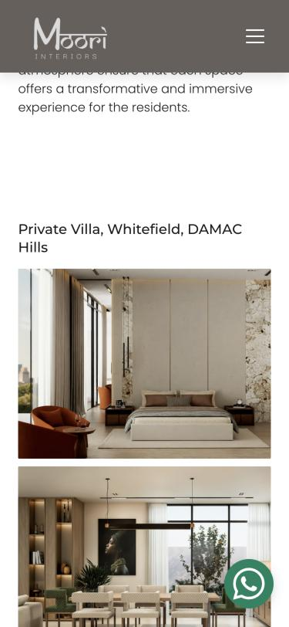  First project appears ≈2,400 px down

5.2 UX rules broken
Rule (UI/UX Pro Max) | How it is broken here
9 · Navigation — nav-hierarchy, deep linking | Projects are only reachable through one long index page; no direct paths from homepage, services or ads.
5 · Layout — content-priority | Mobile shows philosophy copy before the content visitors came for (projects).
3 · Performance — progressive-loading / content-jumping | Blank viewports on first load; no placeholder or skeleton.
4 · Style — primary-action | Project page shows a solid black "Back to Portfolio" button and a text-link CTA — the backwards action is visually primary.

5.3 Fix
- Homepage "Selected work" strip directly under the hero: 6 delivered residential projects + 1 F&B, each card = photo, project name, community, type, year → links straight to the project page. Removes one step entirely.
- Split the portfolio into a filterable grid (Villas · Apartments · Townhouses · Hospitality/F&B · Landscape · Concepts & Awards). Cards above the fold on mobile; no philosophy copy before the grid.
- Separate "Concepts & Competition entries" (House of the Future 2024/2025, Shift Chaise, Table-Scape) into their own tab so built work is judged on its own.
- Rename links from "See More" to "View the DAMAC Hills villa →".
- From ads, land on a project-type landing page (e.g. "Villa interiors in DAMAC Hills"), never the homepage. Each one is one scroll from proof and one tap from the form.

6. Key issue B — weak trust signals on the project (product) page
For a design studio, the project page is the product page: it is where a homeowner decides whether to trust Moori with a AED 100,000+ project. It currently carries almost none of the proof the brand already owns.

6.1 What a project page shows today vs. what a buyer needs
Trust element | On project pages today | Where it exists on the site
Client testimonial | Missing | Only on /complimentary-consultation (4 quotes, at 5,728 px)
Award / press badge | Missing | /recognitions and consultation page only (AD Middle East Jul 2025, ISOLA finalist 2024, Dubai Design Week 2024)
Google rating / review count | Missing | Not shown anywhere on the site. Google Business Profile exists: 5.0 from 3 reviews (Sports City address)
Project facts: location, type, year | Yes | All 10 residential project pages
Scope incl. execution / turnkey | Missing | All 10 list "Interior Design & Spatial Planning" or "Landscape & Exterior Design"; none shows Moori delivered the build, although turnkey is offered
Size, budget band, duration | Missing | Pricing page only (fee table as an image)
Before / after or challenge → solution | Missing | Not on site
Named design team | Partial | 7 of 10 pages name the team; names are not linked to profiles
Next step / related project | Weak | One underlined text link + "Back to Portfolio"; no "similar projects"

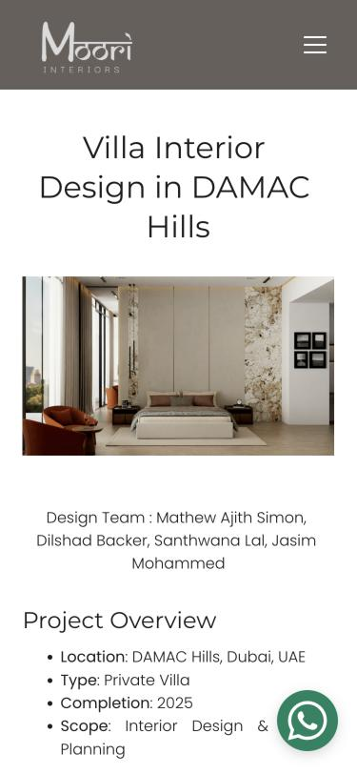  Project page top: facts but no proof | 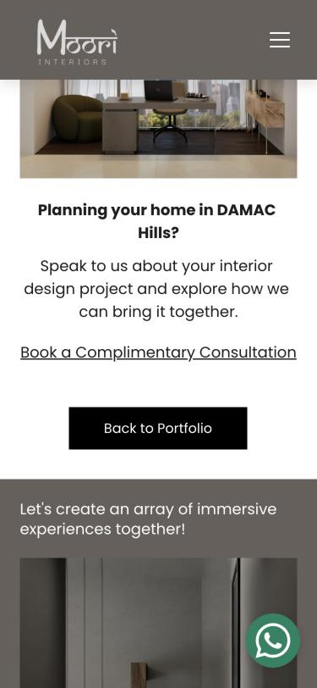  Project page end: text-link CTA under a dominant "Back to Portfolio" button

6.2 Why it costs enquiries
Sooraj noted that the visual medium is how people "connect with the work", and that Moori does not know the drop-off before enquiry. A visitor arriving cold from an ad has no referral to vouch for Moori. Without third-party proof next to the work, the decision rests entirely on imagery — and the visitor cannot tell whether the images show a delivered home or a proposal. The four testimonials Moori already has speak directly to the fears this buyer has (being heard, budget transparency, managing a home remotely, multigenerational needs) but sit on a page the visitor only reaches after they have decided.

6.3 Fix — a proof-led project page template
- Proof bar under the H1: "Featured in Architectural Digest Middle East · ISOLA Awards finalist · Dubai Design Week 2024" + the Google rating (the Business Profile exists — 5.0 from only 3 reviews — so grow the review count first).
- Project facts box: community, property type, bedrooms / area, scope (design only / design + execution), duration, budget band (e.g. "AED 150–250k fit-out"), status (completed / in progress / concept).
- Client quote on the page it belongs to (e.g. Shikha's DAMAC Hills testimonial on the DAMAC Hills villa; the multigenerational testimonial on a family villa). Add photo or initials and community.
- Brief → approach → outcome in three short blocks, replacing the single narrative paragraph.
- Label imagery "Completed — photographed" vs "Design visualisation" (to confirm with Moori which applies).
- Primary CTA as a solid button ("Plan my villa in DAMAC Hills") repeated after the gallery midpoint and at the end; demote "Back to Portfolio" to a text link; add "Similar projects" (3 cards).
- Designer card with photo linking to the About page, reinforcing the "every designer is assigned to a client" differentiator stated in the FAQ.

7. Further findings by severity

7.1 Critical

C1. Template e-commerce pages are live under the Moori brand
Eight template product pages are publicly reachable and listed in sitemap.xml: classic-cap, face-serum, handmade-vase, hand-soap, set-of-plates, sunglasses, wooden-chair, wool-sweater. Each renders with the Moori logo and a price (e.g. "Face Serum — AED 51.00"). A homeowner or journalist landing on one would question the studio's attention to detail; search engines may index them as Moori content.
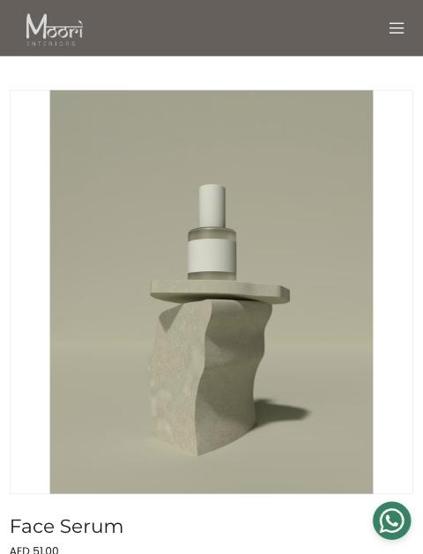
moori.ae/face-serum-gxrcld — live, branded, in the sitemap
Fix: delete the pages and the store module in Hostinger, return 410/404, remove from sitemap, request removal in Search Console. Also review /design-challenge and /thank-you (both in the sitemap) — the thank-you page should be no-indexed.

C2. Value proposition fails the 5-second test
The hero reads "Participatory Design Experience — an invitation for an exciting endeavour of designing a space you call home". It does not say interior design, luxury villas/apartments, Dubai, or why Moori. The headline is coded as three separate H1 tags. Nothing in the first screen shows a project, a client or a credential.
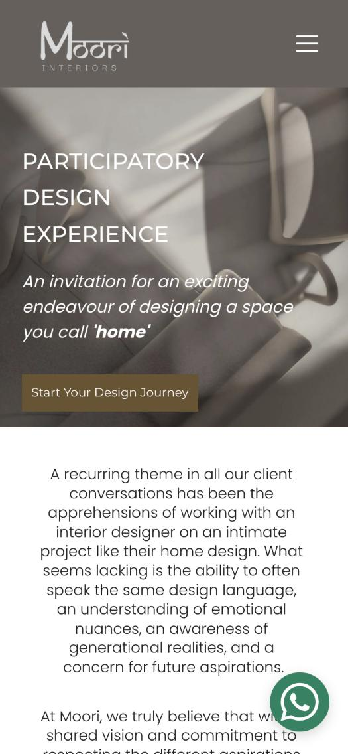  Mobile hero | 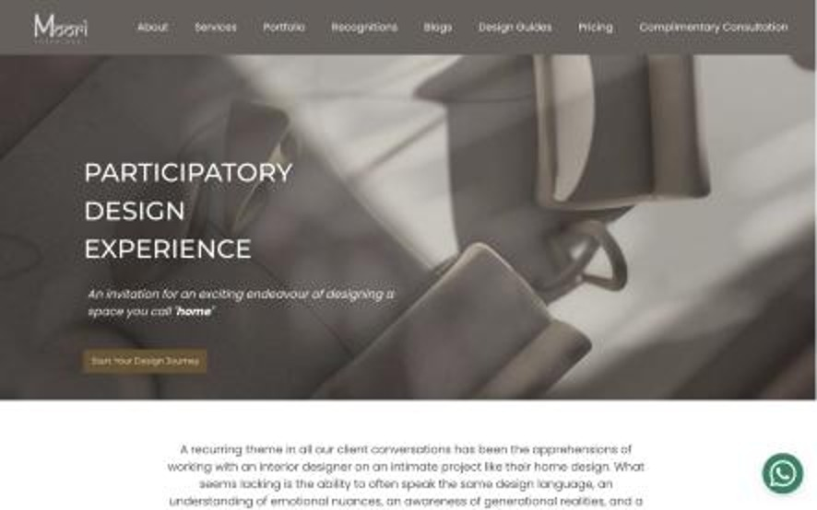  Desktop hero: small, low-contrast CTA

Fix: see copy alternatives in section 8.4. Keep "participatory" as the how, not the what.

7.2 High
ID | Finding | Evidence | Fix
H1 | Mobile menu hides Pricing and Consultation | Dropdown fixed at 406 px with overflow:auto; 8 items need 534 px. Last two (Pricing, Complimentary Consultation) are below the panel edge with no scroll indicator. | Show "Book consultation" as a persistent button in the mobile header; shorten menu to ≤6 items (Work, Services, Pricing, About, Journal, Contact).
H2 | Forms do not qualify leads | Consultation form: Name*, Email, Phone*, Message*. Footer form (every page): same fields, no heading, button "Submit". | Add 3 tap-to-select fields: property type, community, project stage/budget band; plus "Are you looking for: design only / design + execution". Title the footer form and rename the button "Request my consultation".
H3 | Three different starting prices | Fee table image: AED 12,000–40,000 (consultation), from AED 100,000 (projects), from AED 1,000/space (procurement). FAQ: "start at AED 20,000". Schema: priceRange "AED 25,000+". Copy says "two main structures" above a three-tier table. | Pick one floor, use it everywhere; rebuild the table as live HTML.
H4 | Pricing table is an image, cropped on mobile | Left column cut off at 375 px ("onsultation", "curement and Styling"); text not crawlable or accessible. | HTML table or stacked cards on mobile.
H5 | Two different office addresses | Footer on every page: Central Plaza, DIP 1. About page, services FAQ and LocalBusiness schema: Emirates Sports Hotel Apartments, Sports City. | One address across site, schema, Google Business Profile (currently Sports City), Instagram and LinkedIn.
H6 | No search visibility for buyer queries | Moori absent from page one for all 10 tested Google UAE queries, including its own communities and "minimalist interior design dubai". Algedra, Antonovich, Spazio and Accouter appear repeatedly. | Community + project-type landing pages; fix technical issues; Google Business Profile with reviews (see Competitor Analysis).
H7 | Recognitions are buried | AD Middle East, ISOLA and Dubai Design Week appear only on /recognitions and the consultation page. | Proof bar on homepage, project pages and forms.
H8 | "Designer vs contractor" objection is never addressed | No page compares Moori with design-and-build contractors that bundle design. | Add a comparison block on Services and Pricing: what a contractor's "free design" includes vs Moori's scope.

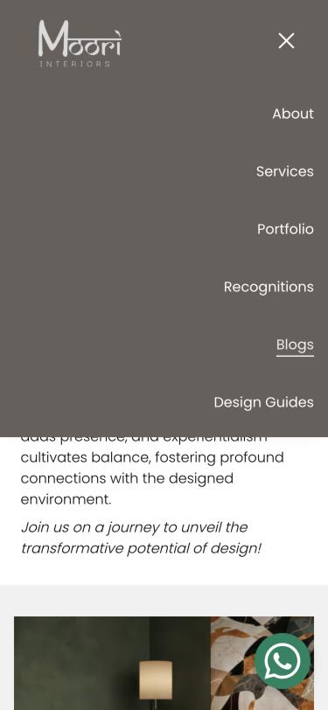  Mobile menu ends at "Design Guides" | 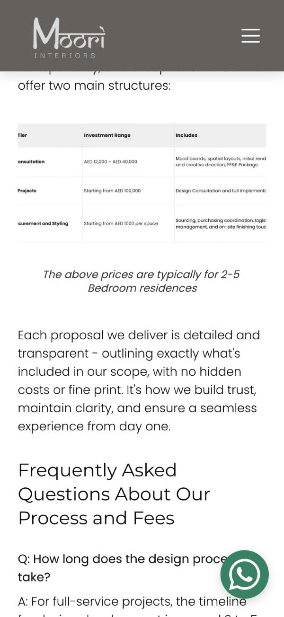  Fee table image cropped on mobile

7.3 Medium
ID | Finding | Evidence | Fix
M1 | Slow server response | Time to first byte 3.8 s (home), 4.1 s (portfolio), 2.0 s (project) in uncached samples; portfolio fully loaded at 7.3 s. Lighthouse agent refused with HTTP 403. | Confirm in PageSpeed Insights; enable caching/CDN on Hostinger plan; split the 160-image portfolio; allow Lighthouse.
M2 | Content not surfaced | Blog index links 6 articles and Design Guides lists 8. At least 7 further articles (e.g. luxury kitchen renovation, bathroom remodelling, why hire an interior designer, timeless minimalism) are linked from neither index. | One "Journal" index with categories; each article ends with a contextual CTA and related project.
M3 | Homepage headings and alt text | 3 H1 tags on the homepage; 4 of 12 homepage images and 2 of 22 project-page images lack alt text. | One H1; descriptive alt text on every project image (also helps image search).
M4 | Footer form has no context | No heading, no promise, generic "Submit"; WhatsApp float overlaps social icons on mobile. | Heading + response-time promise ("We reply within one working day"); offset the WhatsApp button.
M5 | F&B ambition has no landing page | Two F&B projects (Savane, Levante) and one showroom; no hospitality service page, although Sooraj named F&B as the commercial focus. | Hospitality & F&B service page with its own form fields (covers, opening date, location).
M6 | Canonical/host inconsistency | Canonical is https://www.moori.ae; schema URL is https://moori.ae; non-www and http requests failed or returned 502 for the crawler. | Force one host with 301s; align schema.

7.4 Low
- Justified text in project fact lists creates uneven spacing on mobile ("Interior Design &"). Use left alignment (Typography rule: line-length / whitespace-balance).
- Centred body paragraphs on the homepage reduce readability for long copy (Layout: readable-font-size / line-length-control).
- Instagram bio links to Linktree rather than moori.ae; Pinterest profile (5 followers) has an unverified domain.
- LinkedIn company page has no posts returned by the scraper; LinkedIn describes the firm as a sole proprietorship founded 2021 with 6 employees — consistent with the About page team of five.

8. Prioritised recommendations

8.1 Quick wins — week 1
# | Action | Addresses | Effort
1 | Delete the 8 template shop pages; remove from sitemap; no-index /thank-you | C1 | Low
2 | Persistent "Book consultation" button in the mobile header; trim menu to ≤6 items | H1 | Low
3 | One price floor everywhere; replace fee image with HTML table | H3, H4 | Low
4 | One office address across footer, About, FAQ, schema | H5 | Low
5 | Swap "Back to Portfolio" (button) and "Book a Complimentary Consultation" (link) styles on all project pages | B | Low
6 | Add the AD Middle East / ISOLA / Dubai Design Week proof bar site-wide | B, H7 | Low
7 | Rename "See More" links and footer "Submit"; add a footer form heading | A, M4 | Low

8.2 High-impact changes — weeks 2–6
# | Action | Expected effect | Effort
1 | Homepage rebuild: outcome headline + "Selected work" strip + proof bar + process in 4 steps + testimonials + form | Removes a full step from the path; first screen shows proof | Medium
2 | Filterable portfolio grid; concepts separated | Visitors reach a relevant project in one tap | Medium
3 | Proof-led project template (facts box, client quote, brief → approach → outcome, similar projects, repeated CTA) | Converts project views into enquiries | Medium
4 | Qualifying consultation form (property type, community, stage/budget band, design-only vs design + execution) with routing to WhatsApp/CRM | Delivers the qualification filter Sooraj asked for | Medium
5 | Community landing pages (DAMAC Hills, Tilal Al Ghaf, Al Barari, Dubai Marina, Jumeirah Golf Estates) and an F&B page — used as ad landing pages | Message match for ads; organic entry points | Medium
6 | Grow Google reviews from 3 (5.0 rating) — ask past clients, starting with the four testimonial authors | Rating worth showing on site and in Maps; the most visible competitors show 63–154 reviews | Low

8.3 Test ideas (A/B, once traffic allows)
Hypothesis | Variant | Primary metric
A specific, outcome-led hero lifts consultation clicks | "Participatory Design Experience" vs. "Luxury villa interiors in Dubai, designed around how your family lives" | Hero CTA click-through
Showing a budget band on project pages filters out contractor-seekers without reducing qualified enquiries | Facts box with vs. without budget band | Qualified-lead rate (form answers)
A 2-step form (qualify first, contact second) completes better than one long form | Single step vs. 2-step with progress | Form completion rate
WhatsApp-first CTA outperforms form-first on mobile | "Chat on WhatsApp" primary vs. "Book consultation" primary | Contacts per 100 mobile sessions

8.4 Copy alternatives
Element | Current | Alternatives
Hero headline | Participatory Design Experience | 1. Luxury villa & apartment interiors in Dubai — designed with you, not for you  2. Minimal, material-led homes for Dubai families who want to be part of the design  3. Bespoke villa interiors in DAMAC Hills, Tilal Al Ghaf and Al Barari — from first sketch to handover
Hero sub-line | An invitation for an exciting endeavour… | Featured in Architectural Digest Middle East. Every client is matched with a dedicated designer.
Primary CTA | Start Your Design Journey | 1. Book a free design consultation  2. Plan my villa interior  3. See if we're the right fit (15-min call)
Project CTA | Book a Complimentary Consultation (text link) | Plan a home like this in [Community] (button)
Form button | Submit | Request my consultation

9. Measurement plan
Moori currently "does not know the drop-off rate" before enquiry. Before any redesign goes live, install the following so the 15-qualified-leads target can be tracked month by month.
Event / KPI | Definition | Tool
Qualified enquiry (north-star) | Form submitted with property type + community + budget band inside the agreed threshold, and "designer" selected | GA4 conversion + CRM field
Form start → submit rate | Started forms ÷ submitted forms, per page | GA4 events
WhatsApp / call taps | Clicks on wa.me and tel: links, per page | GA4 events
Project page → CTA rate | Sessions on project pages that click a consultation CTA | GA4
Scroll depth on portfolio / project pages | 25/50/75/100% markers | GA4 or Microsoft Clarity
Session recordings & heatmaps | Where visitors stop on mobile | Microsoft Clarity (free)
Lead source | Referral / Google Ads / Meta / organic / Instagram — captured on the form and in the CRM | UTMs + hidden field

Appendix A — Measured data
Page | Viewport | Height | First CTA / key element | Notes
Homepage | Mobile 375 | 5,705 px | Hero CTA at 403 px | 12 images, 4 without alt; 3 H1 tags
Homepage | Desktop 1440 | 4,702 px | Hero CTA above fold | 8-item text nav; consultation link not styled as a button
Portfolio | Mobile 375 | 31,896 px | First "See More" 3,895 px; consultation CTA 25,930 px | 160 images; 17 project links; "Get In Touch" at 787 px
Portfolio | Desktop 1280 | 17,042 px | First "See More" 2,944 px | ≈21 screens
Project — DAMAC Hills villa | Mobile 375 | 5,971 px | Consultation text link 4,303 px | 22 images, 2 without alt; no testimonial
Complimentary consultation | Mobile 375 | 11,942 px | Form at 719 px | Testimonials at 5,728 px; second form at 11,048 px
Pricing | Mobile 375 | 8,227 px | Fee table (image) at 4,505 px | Table cropped on mobile

Appendix B — Sources
- moori.ae — homepage, /portfolio-page, /services, /pricing, /complimentary-consultation, /recognitions, /about, /blogs, /design-guides, 10 residential project pages, 2 F&B project pages, sitemap.xml, robots.txt (accessed 27 Oct 2026).
- Apify Website Content Crawler run (53 pages), Google Search Scraper (10 queries, google.ae), Instagram Scraper (@moori_interiors), LinkedIn Company Scraper (moori-interiors), Pinterest Profile Scraper (mooriinterior).
- Growthmak × Moori Interiors discovery call transcript, 27 October 2026 (Fathom).

