2026
Managa Moabelo
BITWS
9/12/2026
WAS262
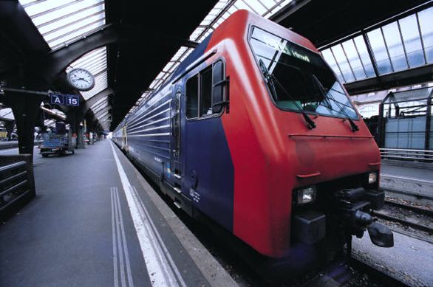
Table of Contents
Task 1 2
GitHub Repository Setup 2
Installation/Setup Instructions 2
Initial Folder Structure 2
African Problem Investigation 2
Wireframe and AI Reflection 0
Wireframe 0
AI Usage discloser 0

Task 1

GitHub Repository Setup

Installation/Setup Instructions
The

Initial Folder Structure
- Managa_Moabelo_WebAnime_WAS262_SF1
  - Index.html
  - Managa_WAS262_SF1.docx
  - README.md
  - Script.js
  - Style.css
  - Wireframes.svg
- Assets
  - Sounds
    - Background.mp3
    - Collision.mp3
    - Move.mp3

African Problem Investigation
The problem we are trying to address with EcoDash is how load-shedding can affect deliveries and access to essential resources in South Africa. The project uses a drone to deliver resources while navigating through urban environments such as Johannesburg, where electricity interruptions can affect normal delivery and charging infrastructure. The drone must also avoid environmental obstacles such as birds, buildings, and other objects while delivering resources to small buildings. Trigonometry and vector mathematics are used in EcoDash to simulate realistic drone movement and environmental challenges. The drone uses Math.cos(this.angle) to calculate its horizontal movement and Math.sin(this.angle) to calculate its vertical movement, allowing it to travel in the direction it is facing. Vector mathematics is also used to simulate wind by applying windForce, which pushes the drone sideways and represents a crosswind. Friction gradually reduces the drone's speed when it is not accelerating, simulating resistance from the environment. Distance calculations using the x and y differences between objects are used to detect collisions with birds and other obstacles. The game also includes battery drain while the drone is moving, requiring the player to manage energy and use charging zones, while load-shedding can disable the charging zones. Rain, wind, friction, battery consumption, and collision detection therefore create environmental challenges that affect gameplay and require the player to manage the drone's movement, safety, and resources.

Wireframe and AI Reflection

Wireframe
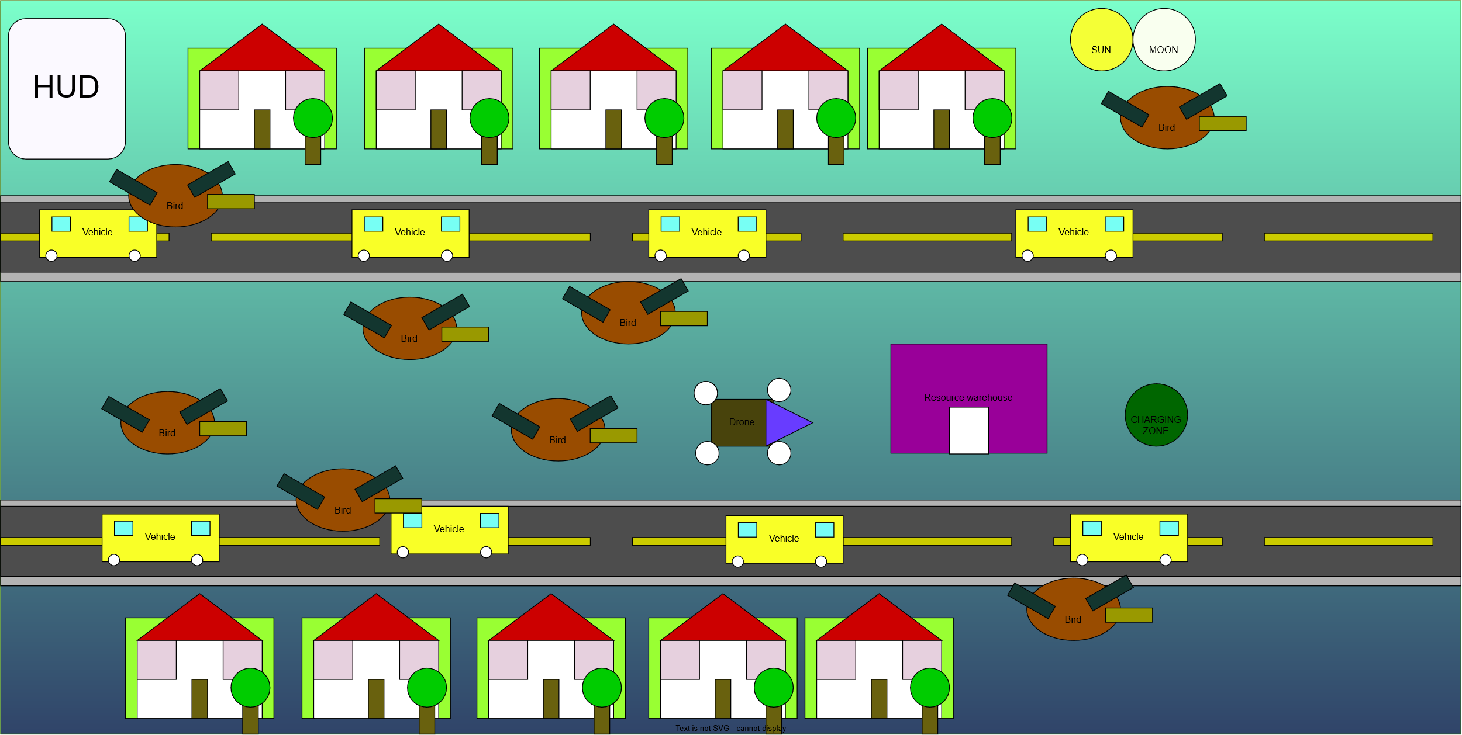

AI Usage discloser
Prompt | AI Output | Modification
Help me with drone movement code | Provided base movement logic | Added battery and collision manually
How to add collision sound | Provided base logic for collision sound | Added collision sounds
How to add move sound | Provided base logic for moving sound | Added moving sounds
How to add background music | Provided logic for background music | Added background music
How can I add weather patterns like rain, wind, | Provided logic to add weather patterns | Added weather patterns
Where can I find background music, movement, and collision sounds | Provided sources to background music, movement and collision sounds that are royalty free | Included background music, movement and collision sounds
How to get day and night cycles | Provided different source codes for day and night cycles | Added day and night cycles
How to code and get start, pause, restart, and game over screens | Provided source codes for pause menu, restart menu, start menu, and game over menu screens | Added pause menu, restart menu, start menu, and game over menu screens
How to implement score system with local feature | Provided score system code with local feature | Added score system code with local save feature

References
Klemenflerin, 2025. Pixabay. [Online]
Available at: https://pixabay.com/users/klemenflerin-52045420/
[Accessed 28 September 2026].
Universfield, 2025. Pixabay. [Online]
Available at: https://pixabay.com/sound-effects/film-special-effects-impact-thud-291047/
[Accessed 28 Septtember 2026].
XtremeFreddy, 2023. Pixabay. [Online]
Available at: https://pixabay.com/music/video-games-game-music-loop-10-145572/
[Accessed 28 September 2026].

