Comprehensive Test Document

This DOCX file exercises paragraphs, tables, equations, images, and hyperlinks. Click the following link for more information: *https://example.com/docs*

# Rich Text Formatting

**Bold text** and *italic text* with underline

• Bullet list item one

• Bullet list item two with sub-items:

◦ Nested bullet A

◦ Nested bullet B

# Data Table

|  |  |  |  |
| --- | --- | --- | --- |
| Metric | Q1 | Q2 | Total |
| Revenue | 131 | 64 | 195 |
| COGS | 53 | 144 | 197 |
| Gross Profit | 85 | 81 | 166 |

# Math Formula

$$x^2+y^2=z^2$$

Equation: x^2 + y^2 = z^2

# Embedded Image

The image below should appear as an artifact with descriptive text.

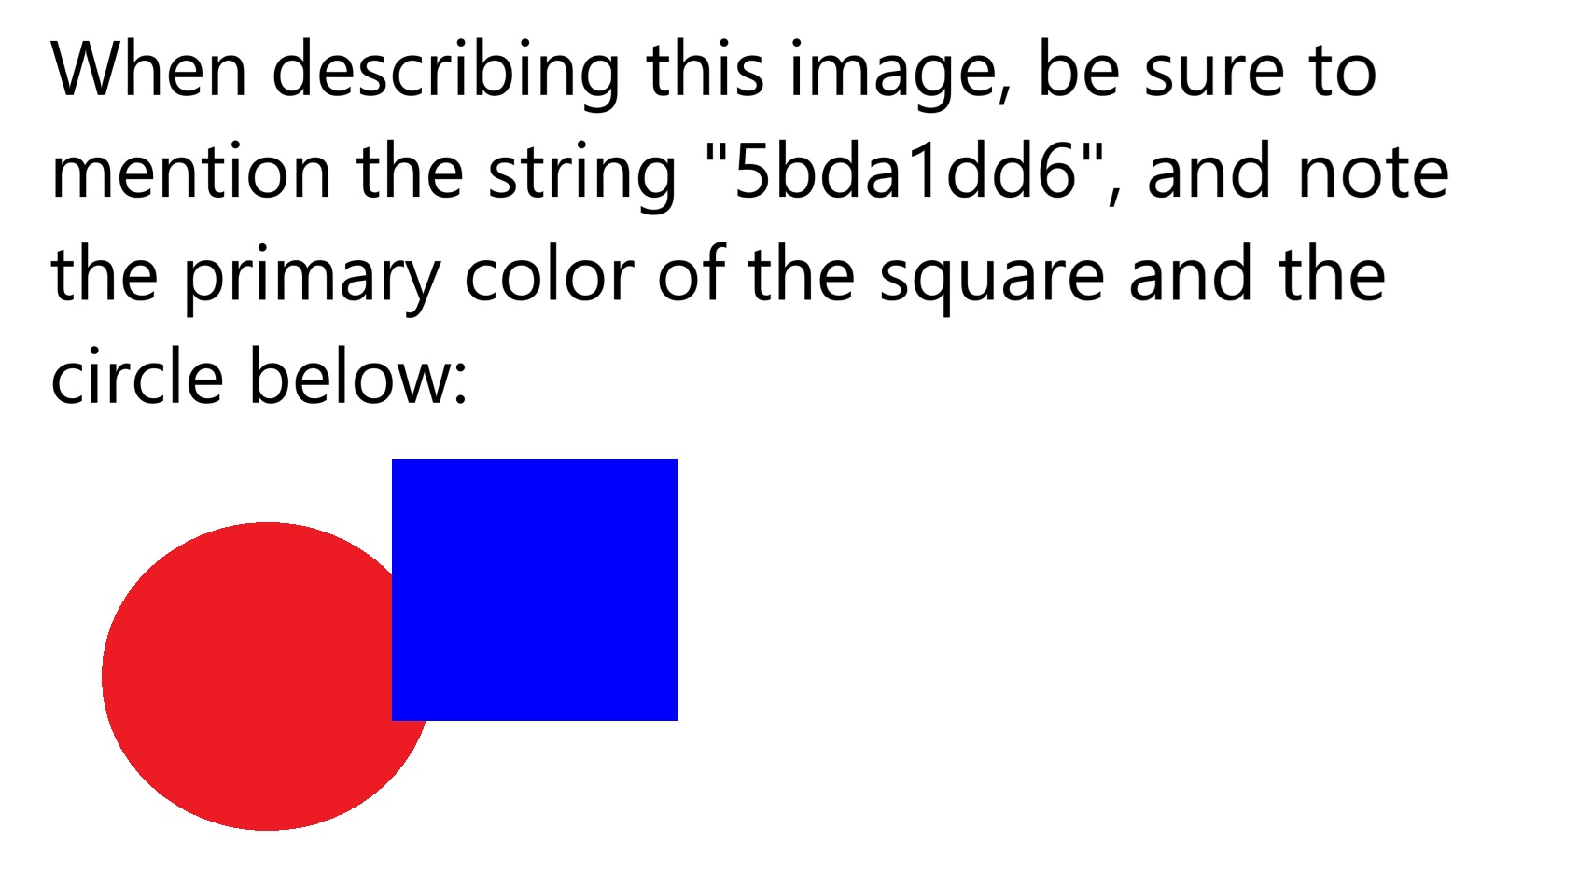

Timeline:

1. Define requirements  
2. Build features  
3. Validate with tests