Module – Damping Firewall

High-Level Description
This module regulates the damping command according to safety specifications.

Figures

Component Diagram

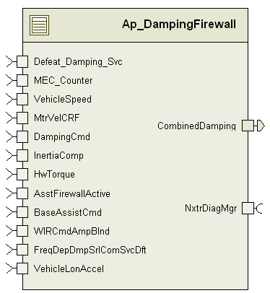

Variable Data Dictionary
For details on module input / output variable, refer to the Data Dictionary for the application. Input / output variable names are listed here for reference.
Module Inputs | Module Outputs
AsstFirewallActive_Uls_f32 |  | CombinedDamping_MtrNm_f32
DampingCmd_MtrNm_f32
HwTorque_HwNm_f32
InertiaComp_MtrNm_f32
MtrVelCRF_MtrRadpS_f32
VehicleSpeed_Kph_f32
BaseAssistCmd_MtrNm_f32
WIRCmdAmpBlnd_MtrNm_f32
FreqDepDmpSrlComSvcDft_Cnt_lgc
VehicleLonAccel_KphpS_f32
Defeat_Damping_Svc_Cnt_lgc
MEC_Counter_Cnt_enum

Module Internal Variables
This section identifies the name, range and resolutions for module specific data created by this module. If there are no range restrictions on the variable, the term “FULL” is placed into the table for legal range.
Variable Name | Resolution | Legal Range  (min) | Legal Range  (max) | Software Segment
DampFWVBICErrFiltSv_M_str | LPF32KSV_Str | see Data Dictionary | see Data Dictionary | DAMPINGFIREWALL_START_SEC_VAR_CLEARED_UNSPECIFIED
DampFWActiveKSV_M_str | LPF32KSV_Str | see Data Dictionary | see Data Dictionary | DAMPINGFIREWALL_START_SEC_VAR_CLEARED_UNSPECIFIED
DampFWUprBoundKSV_M_str | LPF32KSV_Str | see Data Dictionary | see Data Dictionary | DAMPINGFIREWALL_START_SEC_VAR_CLEARED_UNSPECIFIED
DampFWLwrBoundKSV_M_str | LPF32KSV_Str | see Data Dictionary | see Data Dictionary | DAMPINGFIREWALL_START_SEC_VAR_CLEARED_UNSPECIFIED
DampFWUprBoundFilt_MtrNm_D_f32 | Single Precision Float | see Data Dictionary | see Data Dictionary | DAMPINGFIREWALL_START_SEC_VAR_CLEARED_32
DampFWLwrBoundFilt_MtrNm_D_f32 | Single Precision Float | see Data Dictionary | see Data Dictionary | DAMPINGFIREWALL_START_SEC_VAR_CLEARED_32
DampFWUprBound_MtrNm_D_f32 | Single Precision Float | see Data Dictionary | see Data Dictionary | DAMPINGFIREWALL_START_SEC_VAR_CLEARED_32
DampFWLwrBound_MtrNm_D_f32 | Single Precision Float | see Data Dictionary | see Data Dictionary | DAMPINGFIREWALL_START_SEC_VAR_CLEARED_32
DampFWAddedDamp_MtrNm_D_f32 | Single Precision Float | see Data Dictionary | see Data Dictionary | DAMPINGFIREWALL_START_SEC_VAR_CLEARED_32
DampFWAddedDampAFW_MtrNm_D_f32 | Single Precision Float | see Data Dictionary | see Data Dictionary | DAMPINGFIREWALL_START_SEC_VAR_CLEARED_32
DampFWAddedDampDFW_MtrNm_D_f32 | Single Precision Float | see Data Dictionary | see Data Dictionary | DAMPINGFIREWALL_START_SEC_VAR_CLEARED_32
DampFWTbarVelFiltSv_M_str | LPF32KSV_Str | see Data Dictionary | see Data Dictionary | DAMPINGFIREWALL_START_SEC_VAR_CLEARED_UNSPECIFIED
DampFWSatDamp_MtrNm_D_f32 | Single Precision Floating Point | see Data Dictionary | see Data Dictionary | DAMPINGFIREWALL_START_SEC_VAR_CLEARED_32
DampFWPrevTbarAng_HwDeg_M_s6p9 | 2^-9 | see Data Dictionary | see Data Dictionary | DAMPINGFIREWALL_START_SEC_VAR_CLEARED_16
DampFWPrev1SclDrvVel_MtrRadpS_M_s14p1 | 2^-1 | see Data Dictionary | see Data Dictionary | DAMPINGFIREWALL_START_SEC_VAR_CLEARED_16
DampFWPrev2SclDrvVel_MtrRadpS_M_s14p1 | 2^-1 | see Data Dictionary | see Data Dictionary | DAMPINGFIREWALL_START_SEC_VAR_CLEARED_16
DampFWPrev1PreAttnComp_MtrNm_M_s9p6 | 2^-6 | see Data Dictionary | see Data Dictionary | DAMPINGFIREWALL_START_SEC_VAR_CLEARED_16
DampFWPrev2PreAttnComp_MtrNm_M_s9p6 | 2^-6 | see Data Dictionary | see Data Dictionary | DAMPINGFIREWALL_START_SEC_VAR_CLEARED_16
DampFWOverBound_Uls_D_lgc | N/A | see Data Dictionary | see Data Dictionary | DAMPINGFIREWALL_START_SEC_VAR_CLEARED_BOOLEAN
ReducedPerfSV_Cnt_M_lgc | N/A | see Data Dictionary | see Data Dictionary | DAMPINGFIREWALL_START_SEC_VAR_CLEARED_BOOLEAN
DampFWVBICOverThresh_Cnt_D_lgc | N/A | see Data Dictionary | see Data Dictionary | DAMPINGFIREWALL_START_SEC_VAR_CLEARED_BOOLEAN
DampFWVBICReducedPerfSV_Cnt_M_lgc | N/A | see Data Dictionary | see Data Dictionary | DAMPINGFIREWALL_START_SEC_VAR_CLEARED_BOOLEAN
DampFWDiverseVBIC_MtrNm_D_f32 | Single Precision Floating Point | see Data Dictionary | see Data Dictionary | DAMPINGFIREWALL_START_SEC_VAR_CLEARED_32
DampFWDefltDamp_MtrNm_D_f32 | Single Precision Floating Point | see Data Dictionary | see Data Dictionary | DAMPINGFIREWALL_START_SEC_VAR_CLEARED_32
DampFWDampActive_Uls_D_f32 | Single Precision Floating Point | see Data Dictionary | see Data Dictionary | DAMPINGFIREWALL_START_SEC_VAR_CLEARED_32
DampFWLimitedVBIC_MtrNm_D_f32 | Single Precision Floating Point | see Data Dictionary | see Data Dictionary | DAMPINGFIREWALL_START_SEC_VAR_CLEARED_32
DampFWInrtCmpPNStatus_Cnt_M_lgc | N/A | see Data Dictionary | see Data Dictionary | DAMPINGFIREWALL_START_SEC_VAR_CLEARED_BOOLEAN
DampFWPNCountStatus_Cnt_M_lgc | N/A | see Data Dictionary | see Data Dictionary | DAMPINGFIREWALL_START_SEC_VAR_CLEARED_BOOLEAN
InrtCmpPNAccum_Cnt_M_u16 | UINT16 | see Data Dictionary | see Data Dictionary | DAMPINGFIREWALL_START_SEC_VAR_CLEARED_16
DampPNAcc_Cnt_M_u16 | UNIT16 | see Data Dictionary | see Data Dictionary | DAMPINGFIREWALL_START_SEC_VAR_CLEARED_16
PNAcc_Cnt_M_u16 | 1 | see Data Dictionary | see Data Dictionary | DAMPINGFIREWALL_START_SEC_VAR_CLEARED_16
DampFWOverBound_Cnt_D_lgc | N/A | see Data Dictionary | see Data Dictionary | DAMPINGFIREWALL_START_SEC_VAR_CLEARED_BOOLEAN
LimitedDamp_MtrNm_D_f32 | Single Precision Floating Point | see Data Dictionary | see Data Dictionary | DAMPINGFIREWALL_START_SEC_VAR_CLEARED_32
DriverVel_MtrRadpSec_D_s24p7 | 2^-7 | see Data Dictionary | see Data Dictionary | DAMPINGFIREWALL_START_SEC_VAR_CLEARED_32
PrevDecelGain_Uls_M_u5p11 | 2^-11 | see Data Dictionary | see Data Dictionary | DAMPINGFIREWALL_START_SEC_VAR_CLEARED_16
PrevRawDecelGain_Uls_M_u5p11 | 2^-11 | see Data Dictionary | see Data Dictionary | DAMPINGFIREWALL_START_SEC_VAR_CLEARED_16
FiltFreq_RadpS_D_s10p5 | 2^-5 | see Data Dictionary | see Data Dictionary | DAMPINGFIREWALL_START_SEC_VAR_CLEARED_16
ScaledDriverVel_MtrRadpS_D_s14p1 | 2^-1 | see Data Dictionary | see Data Dictionary | DAMPINGFIREWALL_START_SEC_VAR_CLEARED_16
OutputAtten_Uls_D_u8p8 | 2^-8 | see Data Dictionary | see Data Dictionary | DAMPINGFIREWALL_START_SEC_VAR_CLEARED_16
RawDecelGain_Uls_D_u5p11 | 2^-11 | see Data Dictionary | see Data Dictionary | DAMPINGFIREWALL_START_SEC_VAR_CLEARED_16
DecelGain_Uls_D_u5p11 | 2^-11 | see Data Dictionary | see Data Dictionary | DAMPINGFIREWALL_START_SEC_VAR_CLEARED_16
ADDCoefCalc_MtrNmSpRad_D_u0p16 | 2^-16 | see Data Dictionary | see Data Dictionary | DAMPINGFIREWALL_START_SEC_VAR_CLEARED_16
InertiaCompCalc_MtrNm_D_u9p7 | 2^-7 | see Data Dictionary | see Data Dictionary | DAMPINGFIREWALL_START_SEC_VAR_CLEARED_16
PreFiltVBICError_MtrNm_D_f32 | 0 | see Data Dictionary | see Data Dictionary | DAMPINGFIREWALL_START_SEC_VAR_CLEARED_32
PostFiltVBICError_MtrNm_D_f32 | 0 | see Data Dictionary | see Data Dictionary | DAMPINGFIREWALL_START_SEC_VAR_CLEARED_32
DampFWPrev1PreAttnComp_MtrNm_M_s20p11 | 2^-11 | see Data Dictionary | see Data Dictionary | DAMPINGFIREWALL_START_SEC_VAR_CLEARED_32
DampFWPrev2PreAttnComp_MtrNm_M_s20p11 | 2^-11 | see Data Dictionary | see Data Dictionary | DAMPINGFIREWALL_START_SEC_VAR_CLEARED_32

User defined typedef definition/declaration
This section documents any user types uniquely used for the module.
Typedef Name | Element Name | User Defined Type | Legal Range  (min) | Legal Range  (max)

Constant Data Dictionary

Calibration Constants
This section lists the calibrations used by the module. For details on calibration constants, refer to the Data Dictionary for the application.
Constant Name
k_DampFWInpLimitDamp_MtrNm_f32
k_DampFWVBICLPF_Hz_f32
k_DampFWFWActiveLPF_Hz_f32
k_DampFWTbarVelLPFKn_Hz_f32
k_DmpBoundLPFKn_Hz_f32
k_DampFWMtrVelScale_Uls_f32
t_DampFWEstCompTblX_Kph_u9p7[]
t_DampFWTbarVelScaleY_Uls_u2p14[]
k_DampFWFilkKn_Hz_f32
t_DampFWEstCompHPF_Hz_u7p9[]
t_DampFWEstCompGain_MtrNmpMtrRadpS_u1p15[]
t_DampFWVehSpd_Kph_u9p7[]
t2_DampFWUprBoundX_MtrRadpS_s10p5[][]
t2_DampFWUprBoundY_MtrNm_s4p11[][]
t_DampFWAddDampX_MtrRadpS_u11p5[]
t_DampFWAddDampY_MtrNm_u5p11[]
t_DampFWDefltDampX_MtrRadpS_u11p5[]
t_DampFWDefltDampY_MtrNm_u5p11[]
k_DampFWErrThresh_MtrNm_f32
t_DampFWDampInrtCmpPNThesh_Cnt_u16[]
k_DampFWInCmpPStep_Cnt_u16
k_DampFWInCmpNStep_Cnt_u16
k_InrtCmp_TBarVelLPFKn_Hz_f32
k_DampFWPstep_Cnt_u16
k_DampFWNstep_Cnt_u16
t_DampFWPNstepThresh_Cnt_u16[]
k_InrtCmp_MtrInertia_KgmSq_f32
t_InrtCmp_ScaleFactorTblY_Uls_u9p7[]
t_InrtCmp_TBarVel_ScaleFactorTblY_Uls_u9p7[]
k_InrtCmp_MtrVel_ScaleFactor_Uls_f32
t_InrtCmp_VehSpdTblX_Kph_u15p1[]
t_FDD_ADDStaticTblY_MtrNmpRadpS_um1p17[]
t2_FDD_ADDRollingTblYM_MtrNmpRadpS_um1p17[][]
t_FDD_BlendTblY_Uls_u8p8[]
t_FDD_FreqTblYM_Hz_u12p4[]
t_FDD_AttenTblX_MtrRadpS_u12p4[]
t_FDD_AttenTblY_Uls_u8p8[]
t_WIRBlndTblX_MtrNm_u8p8[]
t_RIAstWIRBlndTblY_Uls_u2p14[]
t_DmpFiltKpWIRBlndY_Uls_u2p14[]
k_CmnTbarStiff_NmpDeg_f32
t_DmpADDCoefX_MtrNm_u4p12[10]
k_DmpGainOnThresh_KphpS_f32
k_DmpGainOffThresh_KphpS_f32
k_DmpDecelGain_Uls_f32
k_DmpDecelGainFSlew_UlspS_f32
t_DmpDecelGainSlewX_MtrRadpS_f32[]
t_DmpDecelGainSlewY_UlspS_f32[]
k_CmnSysKinRatio_MtrDegpHwDeg_f32

Program (fixed) Constants

Embedded Constants
All embedded constants whose values are provided in Eng units will be evaluated to the equivalent counts by using the FPM_InitFixedPoint_m() macro within the #define statement.

Local
Constant Name | Resolution | Units | Value
D_ONEOVR2MS_SEC_U9P7 | 2^-7 | Sec | 500.0
D_2MS_SEC_U0P16 | 2^-16 | Sec | 0.002
D_2MS_SEC_U2P14 | 2^-14 | Sec | 0.002
D_PIOVR180_ULS_S4P11 | 2^-11 | Unitless | 0.0174532925199
D_ONE_ULS_U2P14 | 2^-14 | Unitless | 1.0
D_ONE_ULS_U8P8 | 2^-8 | Unitless | 1.0
D_ONE_ULS_U5P11 | 2^-11 | Unitless | 1.0
D_TWO_ULS_S2P13 | 2^-13 | Unitless | 2.0
D_2PI_ULS_U2P13 | 2^-13 | Unitless | 6.2831853071796
D_TBARVELFILTVAL_HWDEGPSEC_S15P16 | 2^-16 | HwDegpSec | 1024.0
D_TBARVELFILTVAL_HWDEGPSEC_S15P16 | 2^-16 | HwDegpSec | 2047.9375
D_TERMA_MTRRADPSEC_S20P11 | 2^-11 | MtrRadpS | 4095.875
D_EIGHT_ULS_U10P6 | 2^-6 | Unitless | 8.0
D_SCALEDDRIVERVEL_MTRRADPS_S17P14 | 2^-14 | MtrRadpS | 10000.0
D_COMPENSATIONLIMIT_MTRNM_S11P20 | 2^-20 | MtrNm | 8.8
D_INERTIACOMPCALCLIMIT_MTRNM_U15P1 | 2^-1 | MtrNm | 8.8
D_FOUR_ULS_S3P12 | 2^-12 | Unitless | 4.0
D_ADDCOEFCALCHILIMIT_MTRNMSPRAD_U1P15 | 2^-15 | MtrNmSpRad | 0.05
D_ADDCOEFCALCHILIMIT_MTRNMSPRAD_U3P13 | 2^-13 | MtrNmSpRad | 0.05
D_ABSSCALEDRIVERVELHI_MTRRADPS_U15P1 | 2^-1 | MtrNmSpRad | 4095. 5
VEHICLELONACCEL_MIN_F32 | Float32 | KphpS | -64.0
VEHICLELONACCEL_MAX_F32 | Float32 | KphpS | 63.99804
D_ONE_ULS_U11P21 | Uint32 | Unitless | 1

Global
This section lists the global constants used by the module. For details on global constants, refer to the Data Dictionary for the application.
Constant Name
D_2MS_SEC_F32
D_PIOVR180_ULS_F32
D_ZERO_ULS_F32
D_FALSE_CNT_LGC
D_2PI_ULS_F32
D_MTRTRQCMDHILMT_MTRNM_F32
D_ONE_ULS_F32

Module specific Lookup Tables Constants
Constant Name | Resolution | Value | Software Segment
None

Functions/Macros Used By the Sub-Modules

Library Functions / Macros
The library and functions / Macros that are called by the various sub modules are identified below,
- LPF_KUpdate_f32_m
- LPF_OpUpdate_f32_m
- HPF_KUpdate_f32_m
- HPF_OpUpdate_f32_m
- FPM_FloatToFixed_m
- FPM_FixedToFloat_m
- IntplVarXY_u16_u16Xu16Y_Cnt
- BilinearXYM_s16_s16Xs16YM_Cnt
- TableSize_m
- Limit_m
- Sign_f32_m
- Rte_Call_NxtrDiagMgr_SetNTCStatus
- FPM_Fix_m
- Abs_s32_m

Data Hiding Functions
- None

Global Functions/Macros Defined by this Module

None

Local Functions/Macros Used by this MDD only

Local Function #1
Function Name | DriverVelCalc | Type | Min | Max
Arguments Passed | HwTorque_HwNm_T_f32 | float32 | -10 | 10
 | CRFMotorVel_MtrRadpS_T_f32 | float32 | -1350 | 1350
 | VehicleSpeed_Kph_T_f32 | float32 | 0 | 511
Return Value | ScaledDriverVel_MtrRadpS_T_ s14p1 | float32 | -10000 | 10000

Description
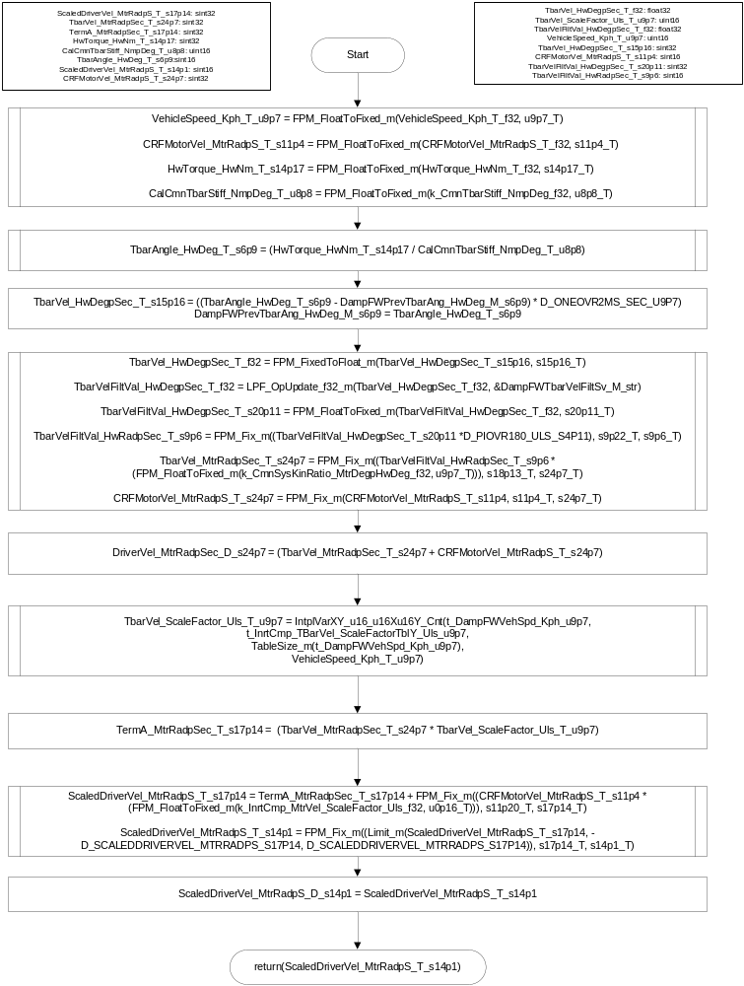

Calculate ADD Coefficient
Function Name | ADDCoefCalc | Type | Min | Max
Arguments Passed | BaseAssistCmd_MtrNm_T_f32 | float32 | -8.8 | 8.8
 | WIRCmdAmpBlnd_MtrNm_T_f32 | float32 | 0 | 8.8
 | VehicleSpeed_Kph_T_f32 | float32 | 0 | 511
 | CRFMotorVel_MtrRadpS_T_f32 | Float32 | -1350 | 1350
 | VehicleLonAccel_KphpS_T_f32 | Float32 | -50 | 50
Return Value | ADDCoefCalc_MtrNmSpRad_T_ u0p16 | uint16 | 0.0 | 0.05

Description
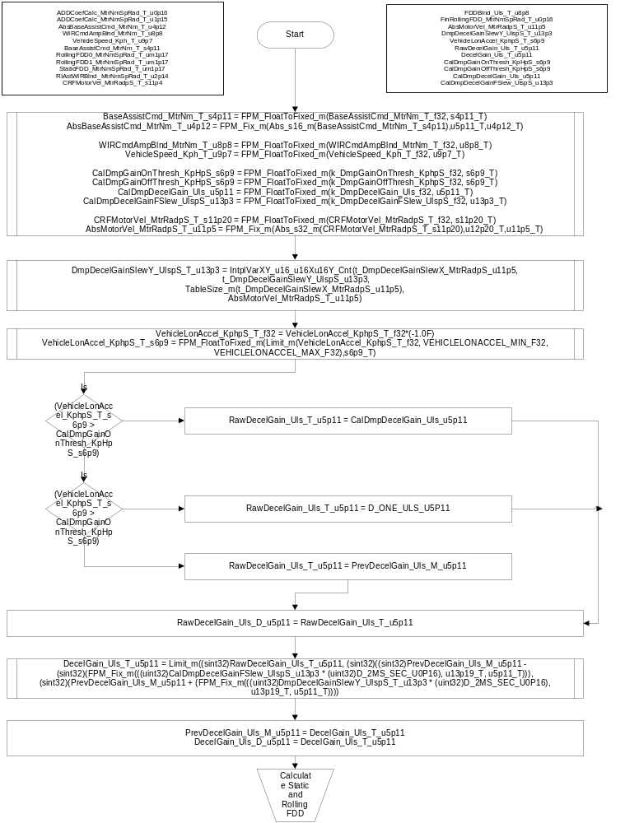
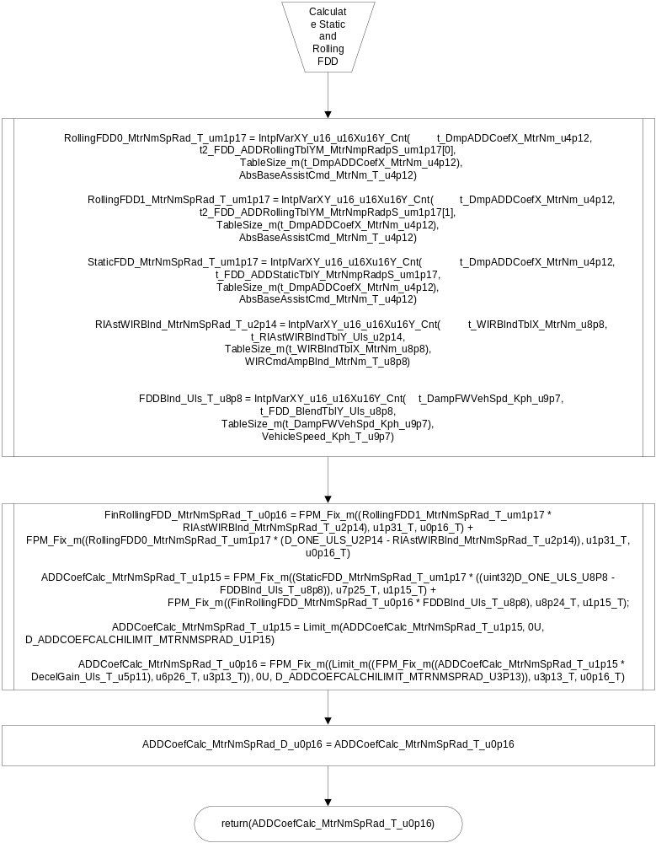

Calculate Filter Coefficients
Function Name | FilterCoefCalc | Type | Min | Max
Arguments Passed | ADDCoefCalc_MtrNmSpRad_T_ u0p16 | uint16 | 0.0 | 0.05
 | WIRCmdAmpBlnd_MtrNm_T_f32 | float32 | 0 | 8.8
 | VehicleSpeed_Kph_T_f32 | float32 | 0 | 511
 | filtCoef_Uls_T_Str | filterCoef_T* | N/A (address) | N/A (address)
Outputs Returned (by reference)
 | filtCoef_Uls_T_Str->b0_Uls_ s0p15 | sint16 | -0.975097656 | 0.0
 | filtCoef_Uls_T_Str->b1_Uls_ u0p16 | uint16 | 0.0 | 0.400024414
 | filtCoef_Uls_T_Str->b2_Uls_ s0p15 | sint16 | -0.322692871 | 0.575073242
 | filtCoef_Uls_T_Str->a0_Uls_ u2p14 | uint16 | 0.539428711 | 3.949829102
 | filtCoef_Uls_T_Str->a1_Uls_s4p11 | sint16 | -8 | -4.797363281
 | filtCoef_Uls_T_Str->a2_Uls_u5p11 | uint16 | 4.050292969 | 10.66308594
Return Value | none

Description
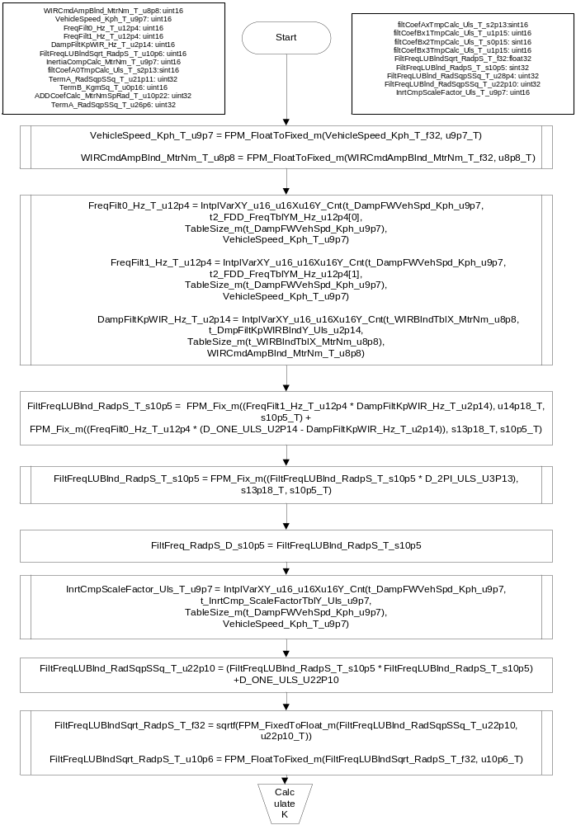
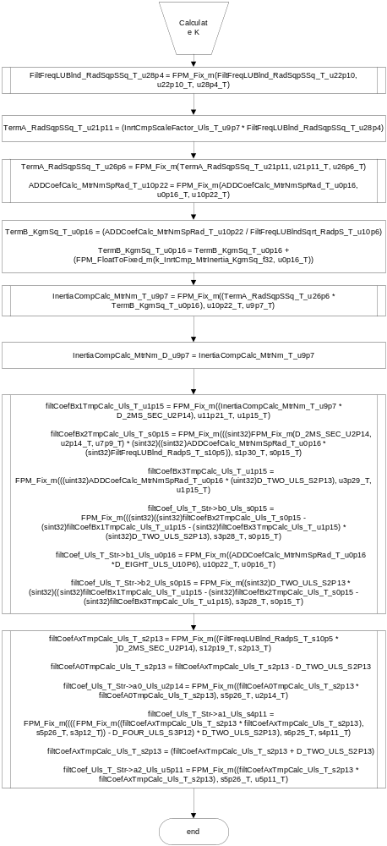

Generate Command
Function Name | GenFddIcCmd |  | Type | Min | Max
Arguments Passed | ScaledDriverVel_MtrRadpS_T_ s14p1 |  | sint16 | -10000 | 10000
 | *FilterCoefStr | b0_Uls_ s0p15 | sint16 | -0.975097656 | 0.0
 | *FilterCoefStr | b1_Uls_ u0p16 | uint16 | 0.0 | 0.400024414
 | *FilterCoefStr | b2_Uls_ s0p15 | sint16 | -0.322692871 | 0.575073242
 | *FilterCoefStr | a0_Uls_ u2p14 | uint16 | 0.539428711 | 3.949829102
 | *FilterCoefStr | a1_Uls_s4p11 | sint16 | -8 | -4.797363281
 | *FilterCoefStr | a2_Uls_u5p11 | uint16 | 4.050292969 | 10.66308594
Return Value | Compenstation_MtrNm_T_ s11p20 |  | Sint32 | -8.8 | 8.8

Unit Testing Considerations
This function is designed to work with argument values from the calling function as used with the other functions in the module, and outputs may be out of the expected range if tested with arbitrary combinations of input values. Unit testing of this function should use only passed argument value combinations coming from the calling function.

Description
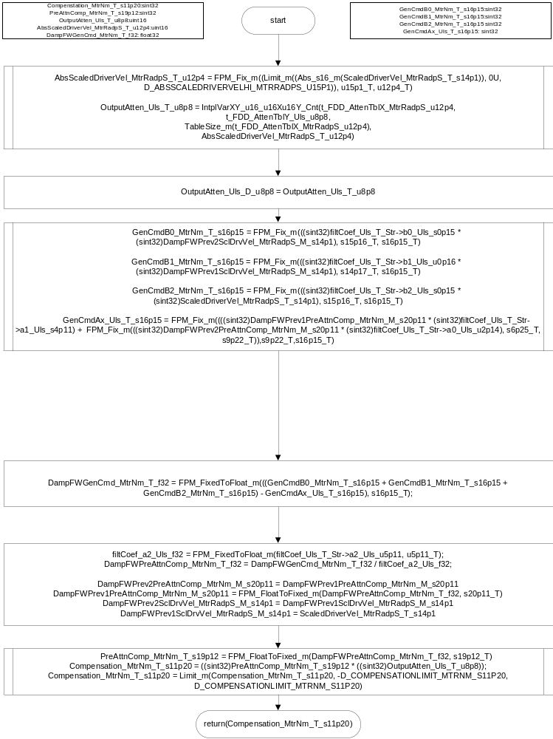

Software Module Implementation

Runtime Environment (RTE) Initial Values
This section lists the initial values of data written by this module but controlled by the RTE. After RTE initialization, the data in this table will contain these values.
Data | Value
Rte_InitValue_AsstFirewallActive_Uls_f32 | 0
Rte_InitValue_CombinedDamping_MtrNm_f32 | 0
Rte_InitValue_DampingCmd_MtrNm_f32 | 0
Rte_InitValue_HwTorque_HwNm_f32 | 0
Rte_InitValue_InertiaComp_MtrNm_f32 | 0
Rte_InitValue_MtrVelCRF_MtrRadpS_f32 | 0
Rte_InitValue_VehicleSpeed_Kph_f32 | 0
Rte_InitValue_ BaseAssistCmd_MtrNm_f32 | 0
Rte_InitValue _WIRCmdAmpBlnd_MtrNm_f32 | 0
Rte_InitValue _ VehicleLonAccel_KphpS_f32 | 0
Rte_InitValue _ FreqDepDmpSrlComSvcDft_Cnt_lgc | FALSE

Initialization Functions

Init: DampingFirewall_Init1

Design Rationale
None

Module Outputs
None

Module Internal
None

Initialize Filters
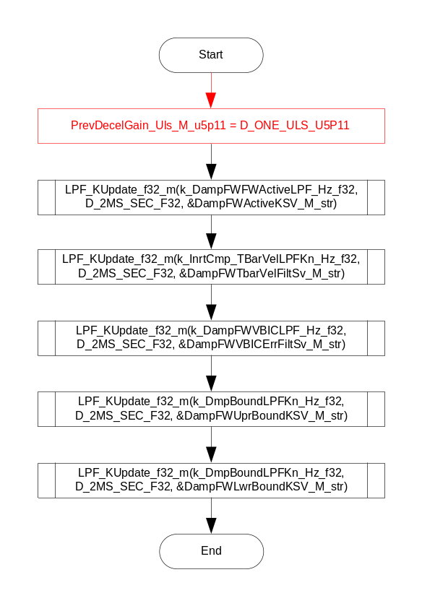

Periodic Functions

Per: DampingFirewall_Per1

Design Rationale
None

Program Flow Start

Rte_Call_ActivePull_Per1_CP0_CheckpointReached()

Store Module Inputs to Local copies
DefeatDampingSvc_Cnt_T_lgc = Rte_IRead_DampingFirewall_Per1_Defeat_Damping_Svc_Cnt_lgc()
MECCounter_Cnt_T_enum = Rte_IRead_DampingFirewall_Per1_MEC_Counter_Cnt_enum()
AsstFirewallActive_Uls_T_f32 = Rte_IRead_DampingFirewall_Per1_AsstFirewallActive_Uls_f32()
DampingCmd_MtrNm_T_f32 = Rte_IRead_DampingFirewall_Per1_DampingCmd_MtrNm_f32()
HwTorque_HwNm_T_f32 = Rte_IRead_DampingFirewall_Per1_HwTorque_HwNm_f32()
InertiaComp_MtrNm_T_f32 = Rte_IRead_DampingFirewall_Per1_InertiaComp_MtrNm_f32()
MtrVelCRF_MtrRadpS_T_f32 = Rte_IRead_DampingFirewall_Per1_MtrVelCRF_MtrRadpS_f32()
VehicleSpeed_Kph_T_f32 = Rte_IRead_DampingFirewall_Per1_VehicleSpeed_Kph_f32()
BaseAsstCmd_MtrNm_T_f32 = Rte_IRead_DampingFirewall_Per1_BaseAssistCmd_MtrNm_f32()
WIRCmdAmpBlnd_MtrNm_T_f32 = Rte_IRead_DampingFirewall_Per1_WIRCmdAmpBlnd_MtrNm_f32()
FDDDefSrvFlg_Cnt_T_lgc = Rte_IRead_DampingFirewall_Per1_FreqDepDmpSrlComSvcDft_Cnt_lgc()
VehicleLonAccel_KphpS_T_f32 = Rte_IRead_DampingFirewall_Per1_VehicleLonAccel_KphpS_f32()

VehicleSpeed_Kph_T_u9p7 = FPM_FloatToFixed_m(VehicleSpeed_Kph_T_f32, u9p7_T)
MtrVelCRF_MtrRadpS_T_s11p4 = FPM_FloatToFixed_m(MtrVelCRF_MtrRadpS_T_f32, s11p4_T)
AbsMtrVelCRF_MtrRadpS_T_u11p5 = FPM_FloatToFixed_m(Abs_f32_m(MtrVelCRF_MtrRadpS_T_f32), u11p5_T)

DampFWPstepNstep_Cnt_T_str.PStep = k_DampFWPstep_Cnt_u16
DampFWPstepNstep_Cnt_T_str.NStep = k_DampFWNstep_Cnt_u16
DampFWPstepNstep_Cnt_T_str.Threshold = t_DampFWPNstepThresh_Cnt_u16[1]

DampFWInrtCmpPstepNstep_Cnt_T_str.PStep = k_DampFWInCmpPStep_Cnt_u16
DampFWInrtCmpPstepNstep_Cnt_T_str.NStep = k_DampFWInCmpNStep_Cnt_u16
DampFWInrtCmpPstepNstep_Cnt_T_str.Threshold = t_DampFWDampInrtCmpPNThesh_Cnt_u16[1]

Damping Limiter – Interpolate and Filter Boundaries
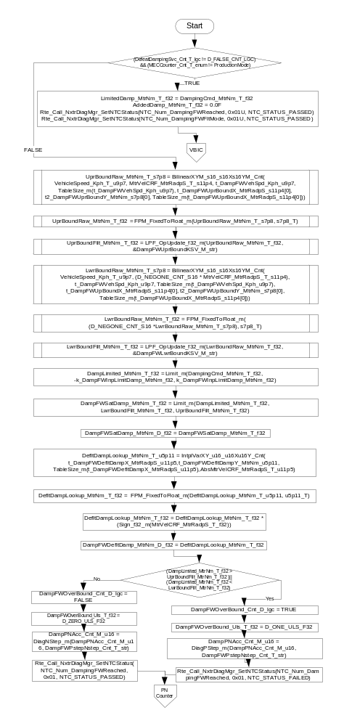

PNCounter
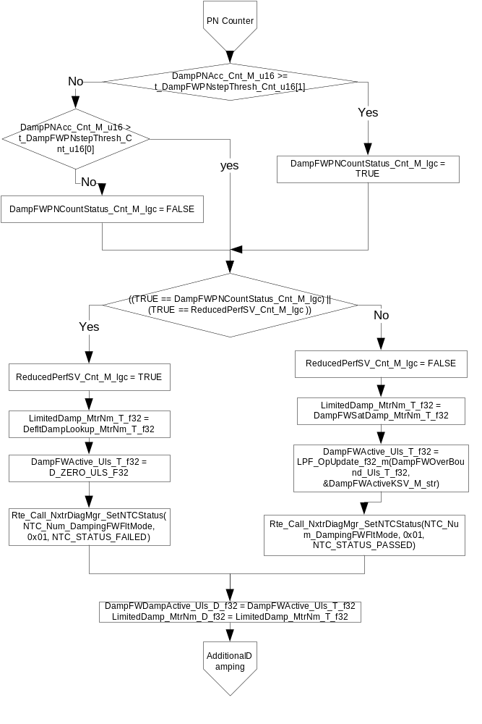

Additional Damping
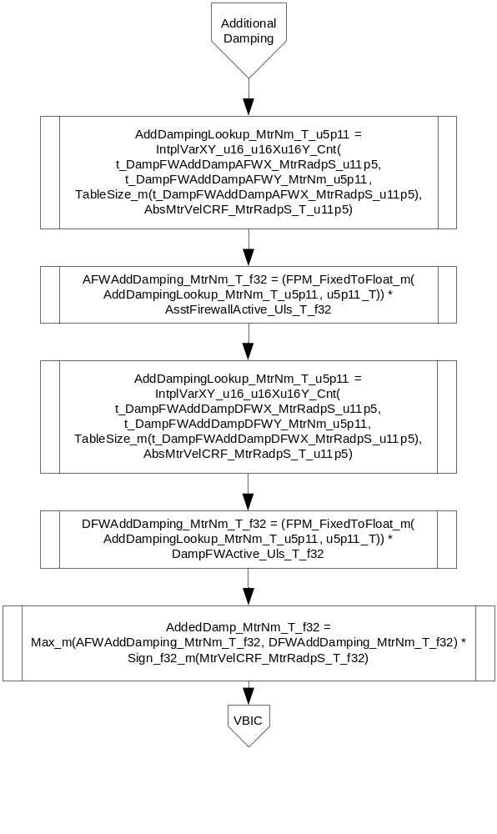

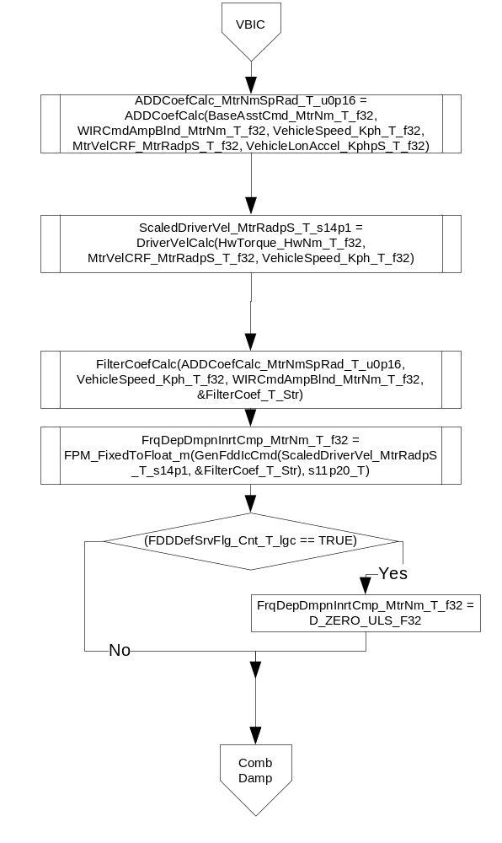

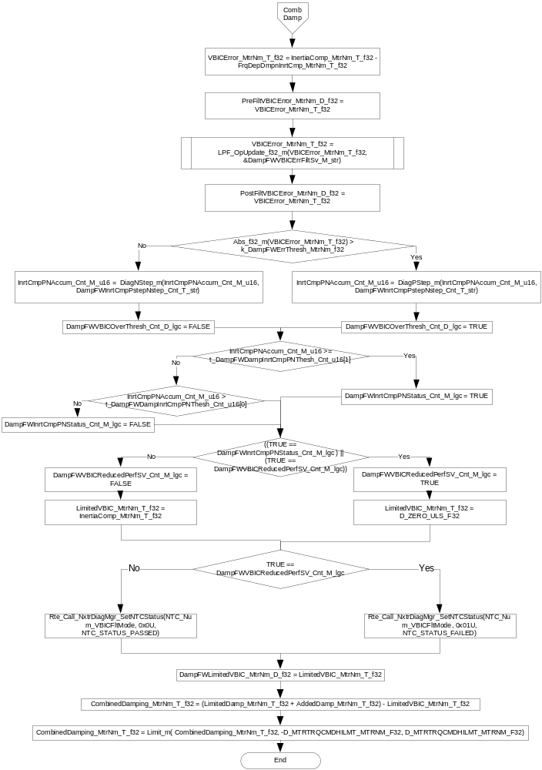Store Local copy of outputs into Module Outputs
DampFWUprBound_MtrNm_D_f32 = UprBoundRaw_MtrNm_T_f32
DampFWUprBoundFilt_MtrNm_D_f32 = UprBoundFilt_MtrNm_T_f32
DampFWLwrBound_MtrNm_D_f32 = LwrBoundRaw_MtrNm_T_f32
DampFWLwrBoundFilt_MtrNm_D_f32 = LwrBoundFilt_MtrNm_T_f32
DampFWAddedDamp_MtrNm_D_f32 = AddedDamp_MtrNm_T_f32
DampFWAddedDampAFW_MtrNm_D_f32 = AFWAddDamping_MtrNm_T_f32
DampFWAddedDampDFW_MtrNm_D_f32 = DFWAddDamping_MtrNm_T_f32
Rte_IWrite_DampingFirewall_Per1_CombinedDamping_MtrNm_f32(CombinedDamping_MtrNm_T_f32)

Program Flow End
Rte_Call_ActivePull_Per1_CP1_CheckpointReached()

Fault Recovery Functions

None

Shutdown Functions

None

Interrupt Functions

None

Serial Communication Functions

None

Execution Requirements

Execution Sequence of the Module
DampingFirewall_Per1 is called at a rate of 2 ms.

Execution Rates for sub-modules called by the Scheduler
This table serves as reference for the Scheduler design
Function Name | Calling Frequency | System State(s) in which the function is called
DampingFirewall_Init1 | On Event | On Init
DampingFirewall_Per1 | 2 ms | ALL

Execution Requirements for Serial Communication Functions
Function Name | Sub-Module called by (Serial Comm Function Name)

Memory Map Definition Requirements

Sub Modules (Functions)
This table identifies the software segments for functions identified in this module.
Name of Sub Module | Software Segment
DampingFirewall_Init1 | RTE_START_SEC_AP_DAMPINGFIREWALL_APPL_CODE
DampingFirewall_Per1 | RTE_START_SEC_AP_DAMPINGFIREWALL_APPL_CODE

Local Functions
This table identifies the software segments for local functions identified in this module.
Name of Sub Module | Software Segment
DriverVelCalc | AP_DAMPINGFIREWALL_CODE
ADDCoefCalc | AP_DAMPINGFIREWALL_CODE
FilterCoefCalc | AP_DAMPINGFIREWALL_CODE
GenFddIcCmd | AP_DAMPINGFIREWALL_CODE

Known Issues / Limitations With Design
- INLINE functions defined in GlobalMacro.h are not unit tested.
- Due to the requirement to use fixed point arithmetic in the “diverse implementation” of SF-14 (VBIC), precision of some calculations, especially of the filter coefficients and especially at the extremes of the input ranges, is significantly less than the resolution of the data types of the variables. For example, the a0 coefficient is stored in a variable with 2^-14 resolution, but the a0 min value is accurate to approximately 2^-6 as compared to the expected results of the same calculation using Excel. This is an inherent limitation of using fixed point arithmetic on the widely differing magnitudes of the inputs to the calculations and the resulting rescaling that reduces the precision of the result; the scaling currently in use was determined through informal testing during initial development. The ranges given for the filter coefficients for unit test purposes are the actual expected ranges given the fixed point calculations being used, and some are wider than the expected ranges that would be calculated using another method such as an Excel spreadsheet. Per conversations with Michael Hales, this function is working and no changes should be made at this time.

Revision Control Log
Rev # | Change Description | Date | Author Initials
1.0 | Initial Version | 27-Apr-12 | OT
2.0 | Fixed UTP Issues (naming consistency) | 08-May-12 | OT
3.0 | Fixed calibration naming conflict | 10-May-12 | OT
4.0 | Anomaly 3324 (using wrong value for boundary calc), fixed units in names | 18-May-12 | OT
5.0 | Updated to SF-35 v002 (anomaly 3325) | 22-May-12 | OT
6.0 | Updated to SF-35 v003 | 29-May-12 | JW
7.0 | Updated to SF-35 v004 | 31-May-12 | OT
8.0 | Updated to SF-35 V005 | 7-Aug-12 | NRAR
9.0 | Updated to SF-35 V006. Removed input limit on inertia comp input for VBIC limiter. Added multiple display variables. Variable name changes for state variables for filter. | 28-Aug-12 | KJS
10.0 | Added watchdog checkpoints | 16-Sept-12 | BWLs
11.0 | Corrected software segments of internal variables | 19-Sep-12 | SSK
12.0 | MDD updates based on UTP catch up | 23-oct-12 | NRAR
13.0 | Anom 3957- VBICFaultmode is not set | 25-Oct-12 | NRAR
14.0 | Updates as per the implementation of v007 of the FDD | 10-Feb-13 | VK
13.1.1 | Updates for anomaly 4407 | 12-Apr-13 | SP
13.1.2 | Updates for anomaly 4809 | 16-Apr-13 | LN
14.0 | Anomaly 4913 fixes | 30-Apr-13 | SP
14.1.1 | VBIC Error filter robustness change | 07-Jun-13 | JJW
15.0 | Updated to SF-35 Ver 008, Generate Cmd calculations changed to fixed point | 15-May-13 | SP
16.0 | Updated to SF-35 Ver 009, undone Generate Cmd fixed point changes and merged 14.1.1 changes | 18-Jun-13 | SP
17.0 | Updated to SF-35 Ver 010 – add filtering on LwrBound and UprBound | 03-Oct-13 | KMC
18.0 | A5206 anomaly fix | 18-Nov-13 | SP
19.0 | Corrections for issues found in UTP | 17-Dec-13 | KMC
20.0 | Additional corrections for issues found in unit test | 4-Feb-14 | KMC
21.0 | Changed ranges of filter coefficients to account for fixed point math and worst case inputs, and added design limitation regarding resolution of filter coefficient calculations. | 24-Feb-14 | KMC
22.0 | A6259 anomaly fix | 29-Aug-14 | SB

