Module – EOTDampingFirewall

High-Level Description
This MDD describes the summation of all assist and limit terms used in an Electric Power Steering application.

Figures

Diagram – Component Diagram

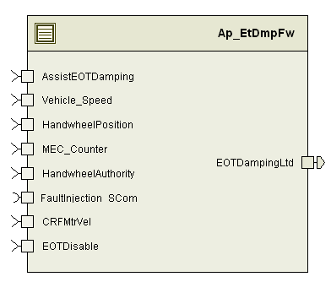

Variable Data Dictionary
For details on module input / output variable, refer to the Data Dictionary for the application. Input / output variable names are listed here for reference.
Module Inputs | Module Outputs
AssistEOTDamping_MtrNm_f32 |  | EOTDampingLtd_MtrNm_f32
CRFMtrVel_MtrRadpS_f32
HandwheelAuthority_Uls_f32
HandwheelPosition_HwDeg_f32
Vehicle_Speed_Kph_f32
EOTDisable_Cnt_lgc
MEC_Counter_Cnt_enum

Module Internal Variables
This section identifies the name, range and resolutions for module specific data created by this module. If there are no range restrictions on the variable, the term “FULL” is placed into the table for legal range.
Variable Name | Resolution | Legal Range  (min) | Legal Range  (max) | Software Segment
EOTDmpFWActvLtd_MtrNm_D_f32 | Single Precision Float | -16 | 16 | ETDMPFW_START_SEC_VAR_CLEARED_32
EOTDmpFWInActvLtd_MtrNm_D_f32 | Single Precision Float | -8.8 | 8.8 | ETDMPFW_START_SEC_VAR_CLEARED_32
UprBndActive_MtrNm_D_f32 | Single Precision Float | -16 | 16 | ETDMPFW_START_SEC_VAR_CLEARED_32
LwrBndActive_MtrNm_D_f32 | Single Precision Floating Point | -16 | 16 | ETDMPFW_START_SEC_VAR_CLEARED_32
EOTDmpFWActvRegion_Cnt_D_lgc | n/a | FALSE | TRUE | ETDMPFW_START_SEC_VAR_CLEARED_BOOLEAN
EOTDmpFWHWAuth_Cnt_D_lgc | n/a | FALSE | TRUE | ETDMPFW_START_SEC_VAR_CLEARED_BOOLEAN
EOTDmpFWMode_Cnt_M_u08 | Uint8 | 0 | 2 | ETDMPFW_START_SEC_VAR_CLEARED_08

User defined typedef definition/declaration
This section documents any user types uniquely used for the module.
Typedef Name | Element Name | User Defined Type | Legal Range  (min) | Legal Range  (max)
None

Constant Data Dictionary

Calibration Constants
This section lists the calibrations used by the module. For details on calibration constants, refer to the Data Dictionary for the application.
Constant Name
k_MinRackTrvl_HwDeg_u12p4
t2_EOTPosDepDmpTblX_HwDeg_u12p4
k_EOTDynConf_Uls_u8p8
t_EOTDmpFWActiveBoundX_MtrRadpS_s11p4
t2_EOTDmpFWActiveBoundY_MtrNm_s7p8
k_EOTDmpFWInactiveLim_MtrNm_f32
t_EOTDmpFWVehSpd_Kph_u9p7

Program(fixed) Constants

Embedded Constants
All embedded constants whose values are provided in Eng units will be evaluated to the equivalent counts by using the FPM_InitFixedPoint_m() macro within the #define statement.

Local
Constant Name | Resolution | Units | Value
D_INACTIVEREGION_ULS_U08 | N/A | Unitless | 0
D_ACTIVEREGION_ULS_U08 | N/A | Unitless | 1
D_FIREWALLLDISABLED_ULS_U08 | N/A | Unitless | 2

Global
This section lists the global constants used by the module. For details on global constants, refer to the Data Dictionary for the application.
Constant Name
D_ZERO_ULS_F32
D_MTRTRQCMDHILMT_MTRNM_F32
D_MTRTRQCMDLOLMT_MTRNM_F32
BC_ETDMPFW_FAULTINJECTIONPOINT
STD_ON
FLTINJ_EOTDAMPING_ETDMPFW
D_NEGONE_CNT_S16
D_FALSE_CNT_LGC

Module specific Lookup Tables Constants
(This is for lookup tables (arrays) with fixed values, same name as other tables)
Constant Name | Resolution | Value | Software Segment
None

Functions/Macros used by the Sub-Modules

Library Functions / Macros
The library and functions / Macros that are called by the various sub modules are identified below,
- Limit_m()

- Abs_f32_m()
- BilinearXYM_s16_s16Xs16YM_Cnt()
- FPM_FloatToFixed_m()

Data Hiding Functions
- N/A

Global Functions/Macros Defined by this Module
N/A

Local Functions/Macros Used by this MDD only
N/A

Software Module Implementation

Runtime Environment (RTE) Initial Values
This section lists the initial values of data written by this module but controlled by the RTE. After RTE initialization, the data in this table will contain these values.
Data | Value
Rte_InitValue_AssistEOTDamping_MtrNm_f32 | 0
Rte_InitValue_CRFMtrVel_MtrRadpS_f32 | 0
Rte_InitValue_EOTDampingLtd_MtrNm_f32 | 0
Rte_InitValue_HandwheelAuthority_Uls_f32 | 0
Rte_InitValue_HandwheelPosition_HwDeg_f32 | 0

Initialization Functions
N/A

Periodic Functions

Per: EtDmpFw_Per1

Design Rationale

Program Flow Start
Rte_Call_EtDmpFw_Per1_CP0_CheckpointReached()

Store Module Inputs to Local copies
Local Copy | Module Input Name
AsstEOTDamping_MtrNm_T_f32 | Rte_IRead_EtDmpFw_Per1_AssistEOTDamping_MtrNm_f32
HandwheelPosition_HwDeg_T_f32 | Rte_IRead_EtDmpFw_Per1_HandwheelPosition_HwDeg_f32
HandwheelAuthority_Uls_T_f32 | Rte_IRead_EtDmpFw_Per1_HandwheelAuthority_Uls_f32
CRFMtrVel_MtrRadpS_T_f32 | Rte_IRead_EtDmpFw_Per1_CRFMtrVel_MtrRadpS_f32
VehicleSpeed_Kph_T_f32 | Rte_IRead_EtDmpFw_Per1_Vehicle_Speed_Kph_f32
EOTDisable_Cnt_T_lgc | Rte_IRead_EtDmpFw_Per1_EOTDisable_Cnt_lgc
MECCounter_Cnt_T_enum | Rte_IRead_EtDmpFw_Per1_MEC_Counter_Cnt_enum

(Processing of function)………

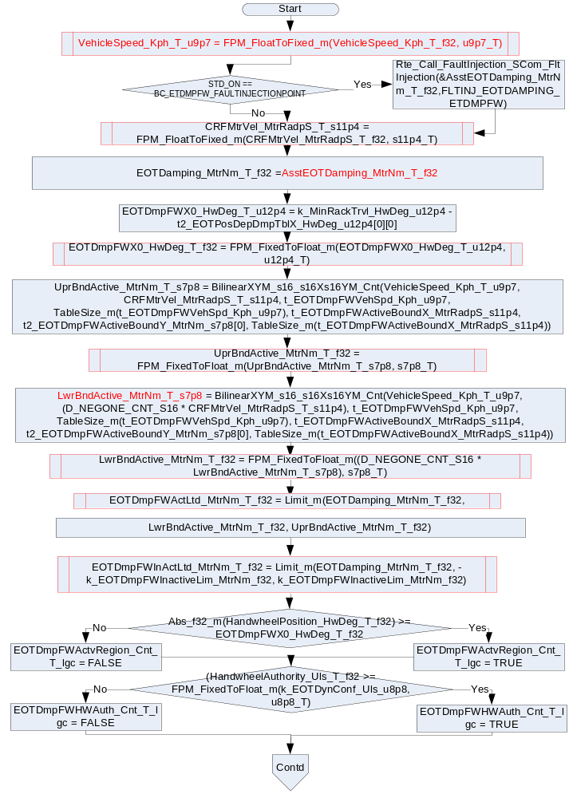
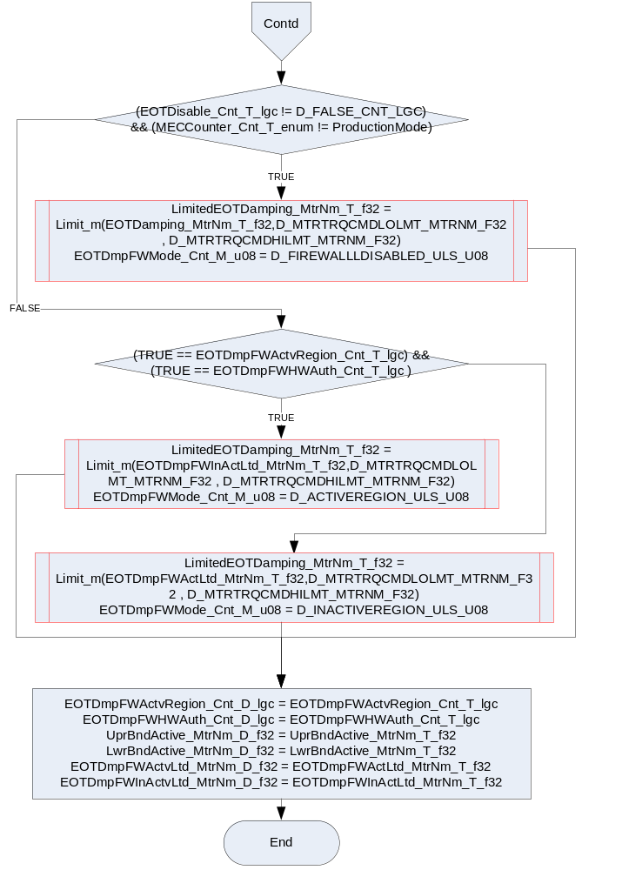

Store Local copy of outputs into Module Outputs
Local Copy | Module Output Name
LimitedEOTDamping_MtrNm_T_f32 | Rte_IWrite_EtDmpFw_Per1_EOTDampingLtd_MtrNm_f32

Program Flow End
Rte_Call_EtDmpFw_Per1_CP1_CheckpointReached()

Fault Recovery Functions
N/A

Shutdown Functions
N/A

Interrupt Functions
N/A

Serial Communication Functions
N/A

Execution Requirements

Execution Sequence of the Module

Execution Rates for sub-modules called by the Scheduler
This table serves as reference for the Scheduler design
Function Name | Calling Frequency | System State(s) in which the function is called
EtDmpFw_Per1 | 2ms | All

Execution Requirements for Serial Communication Functions
Function Name | Sub-Module called by (Serial Comm Function Name)
None

Memory Map Definition Requirements

Sub Modules (Functions)
This table identifies the software segments for functions identified in this module.
Name of Sub Module | Software Segment
EtDmpFw_Per1 | RTE_START_SEC_AP_ETDMPFW_APPL_CODE

Local Functions
This table identifies the software segments for local functions identified in this module.
Name of Sub Module | Software Segment
None

Known Issues / Limitations With Design
- INLINE functions defined in globalmacro.h are not unittested.

Revision Control Log
Item # | Rev # | Change Description | Date | Author Initials
1 | 1.0 | Document creation for component based design process | 6-Sep-12 | NRAR
2 | 2.0 | Added watchdog checkpoints | 16-Sept-12 | BWL
3 | 3.0 | Corrected for static variable software section | 19 Sep 12 | Selva
4 | 4.0 | Updated as per FDDVer002, FaultInjectionPoint added to AsstEOTDamping_MtrNm_T_f32 signal | 29 Jan 13 | Selva
5 | 5.0 | Updated to SF-27 v003 | 16-May-13 | SP
6 | 6.0 | Removed calibration k_EOTDmpFWInputLim_MtrNm_f32 per anomaly 6850 | 21-Aug-14 | KJS
7 | 7.0 | Updated as per Unit Test Findings | 27-Aug-14 | KPIT_SM

