Module -- PICurrCntrl

High-Level Description
Non-AUTOSAR PI driver required to perform EPS motor control PWM profiles.

Figures

Diagram – Function Data Sharing
This diagram shows all data that is shared between functions within the module.
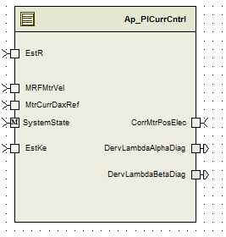

Module Inputs and Outputs
For details on module input / output variable, refer to the Data Dictionary for the application. Input / output variable names are listed here for reference.
(Note: Full variable names required in table.)
(Note: All global variables including End Of Line data used should be shown here)
Module Inputs (Global Variable Name) | Module Outputs (Global Variable Name)
MtrCurrQax_Amp_f32 | EstKe_VpRadpS_f32
MtrCurrDax_Amp_f32 | MtrCurrQaxFinalRef_Amp_f32
MtrCurrQaxRef_Amp_f32 | MtrDaxVoltage_Volt_f32
MtrCurrDaxRef_Amp_f32 | MtrQaxVoltage_Volt_f32
PIDaxIntegralGain_Uls_f32 | ModIdx_Uls_u16p16
PIDaxPropotionalGain_Uls_f32 | PhaseAdvanceFinal_Rev_u0p16
PIQaxIntegralGain_Uls_f32 | CommOffset_Cnt_u16
PIQaxPropotionalGain_Uls_f32 | MtrVolt_Volt_f32
ElecPosDelayComp_Rad_f32 | MtrCurrDaxIntg_Volt_f32
MtrVoltDaxFF_Volt_f32 | MtrCurrQaxIntg_Volt_f32
MtrVoltQaxFF_Volt_f32 | DervLambdaAlphaDiag_Volt_T_f32
Vecu_Volt_f32 | DervLambdaBetaDiag_Volt_T_f32
ModIdxSrlComSvcDft_Cnt_lgc | SlowDataAccessBufIndex_Cnt_M_u16
SysState_Cnt_Enum
MtrCurrOffComOffset_Cnt_u16
MtrCurrQaxRpl_Amp_M_f32
MtrCurrQaxCog_Amp_M_f32
MRFMtrVel_MtrRadpS_f32
MtrVoltDaxFF_Volt_f32
MtrVoltQaxFF_Volt_f32
MtrCurrQaxRpl_Amp_f32
FastDataAccessBufIndex_Cnt_M_u16
EstKe_VpRadpS_f32
CorrMtrPosElec_Rev_f32
EstR_Ohm_f32

Module Internal Variables
This section identifies the name, range and resolutions for module specific data created by this module. If there are no range restrictions on the variable, the term “FULL” is placed into the table for legal range.
(Note: If no module specific variables are used by the design, place the text “None” in the first Variable Name cell in the table)
Variable Name | Resolution | Legal Range  (min) | Legal Range  (max) | Software Segment
MtrCurrQaxPrevIntg_Volt_M_f32 | single precision float | -31 | 31 | PICURRCNTRL_START_SEC_VAR_CLEARED_32
MtrCurrDaxPrevIntg_Volt_M_f32 | single precision float | -31 | 31 | PICURRCNTRL_START_SEC_VAR_CLEARED_32
MtrVoltQaxPrevFinalLimit_Volt_M_f32 | single precision float | -31 | 31 | PICURRCNTRL_START_SEC_VAR_CLEARED_32
MtrVoltPrevDaxFinal_Volt_M_f32 | single precision float | -31 | 31 | PICURRCNTRL_START_SEC_VAR_CLEARED_32
MtrCurrQaxError_Amp_D_f32 | single precision float | -220 | 220 | PICURRCNTRL_START_SEC_VAR_CLEARED_32
MtrCurrDaxError_Amp_D_f32 | single precision float | -220 | 220 | PICURRCNTRL_START_SEC_VAR_CLEARED_32
MtrVoltQaxFinal_Volt_D_f32 | single precision float | -31 | 31 | PICURRCNTRL_START_SEC_VAR_CLEARED_32
MtrVoltQaxFinalLimit_Volt_D_f32 | single precision float | -31 | 31 | PICURRCNTRL_START_SEC_VAR_CLEARED_32
MtrVoltDaxFinal_Volt_D_f32 | single precision float | -31 | 31 | PICURRCNTRL_START_SEC_VAR_CLEARED_32
MtrVoltQaxProp_Volt_D_f32 | single precision float | -31 | 31 | PICURRCNTRL_START_SEC_VAR_CLEARED_32
MtrVoltDaxProp_Volt_D_f32 | single precision float | -31 | 31 | PICURRCNTRL_START_SEC_VAR_CLEARED_32
MtrVoltQaxInt_Volt_D_f32 | single precision float | -31 | 31 | PICURRCNTRL_START_SEC_VAR_CLEARED_32
MtrVoltDaxInt_Volt_D_f32 | single precision float | -31 | 31 | PICURRCNTRL_START_SEC_VAR_CLEARED_32
PICurrCntrl_MtrCurrQax_Amp_D_f32 | single precision float | FULL | FULL | PICURRCNTRL_START_SEC_VAR_CLEARED_32
PICurrCntrl_MtrCurrDax_Amp_D_f32 | single precision float | FULL | FULL | PICURRCNTRL_START_SEC_VAR_CLEARED_32
MtrVoltDax_Volt_M_f32[2] | single precision float | See data Dictionary | See data Dictionary | PICURRCNTRL_START_SEC_VAR_CLEARED_32
MtrVoltQax_Volt_M_f32[2] | single precision float | See data Dictionary | See data Dictionary | PICURRCNTRL_START_SEC_VAR_CLEARED_32
MtrCurrQaxFinalRef_Amp_M_f32[2] | single precision float | See data Dictionary | See data Dictionary | PICURRCNTRL_START_SEC_VAR_CLEARED_32
PICurrCntrl_DervLambdaQax_Volt_D_f32 | single precision float | See data Dictionary | See data Dictionary | PICURRCNTRL_START_SEC_VAR_CLEARED_32
PICurrCntrl_DervLambdaDax_Volt_D_f32 | single precision float | See data Dictionary | See data Dictionary | PICURRCNTRL_START_SEC_VAR_CLEARED_32

User defined typedef definition/declaration
This section documents any user types uniquely used for the module.
Variable Name | Typedef Name | Storage Type | Safety Critical Classification
None

Constant Data Dictionary

Calibration Constants
This section lists the calibrations used by the module. For details on calibration constants, refer to the Data Dictionary for the application.
(Note: If no calibrations are used by the design, place the text “None” in the first location in the table)
Constant Name
k_PiSamplingTs_Sec_f32
t_CommOffsetTblX_Uls_u3p13[2]
t_CommOffsetTblY_Cnt_u16[2]
k_NoofPoles_Uls_f32

Program(fixed) Constants

Embedded Constants
All embedded constants whose values are provided in Eng units will be evaluated to the equivalent counts by using the FPM_InitFixedPoint_m() macro within the #define statement.

Local
Constant Name | Resolution | Units | Value
D_SCALERADTOCNTS_ULS_F32 | Single Precision Float | Unitless | 10430.3783505F
D_REVWITHROUND_ULS_F32 | Single Precision Float | Unitless | 65536.5F
D_ROUND_ULS_F32 | Single Precision Float | Unitless | 0.5F
D_DEG2RAD_ULS_F32 | Single Precision Float | Unitless | 0.0174532925199F
D_GAIN_ULS_F32 | Single Precision Float | Unitless | 0.5
D_VECUMAX_VOLTS_F32 | Single Precision Float | Volts | 31
D_SQRT3OVR2_ULS_F32 | Single Precision Float | Unitless | 0.866025403784

Global
This section lists the global constants used by the module. For details on global constants, refer to the Data Dictionary for the application.
Constant Name
D_ZERO_ULS_F32
D_VECUMIN_VOLTS_F32

Module specific Lookup Tables Constants
(This is for lookup tables (arrays) with fixed values, same name as other tables)
Constant Name | Resolution | Value | Software Segment
None

Functions/Macros used by the Sub-Modules

Library Functions / Macros
The library functions / Macros that are called by the various sub modules are identified below,
- IntplVarXY_u16_u16Xu16Y_Cnt_m()
- FPM_FloatToFixed_m
- Sign_f32_m
- Sqrtf
- Sinf
- Cosf

Data Hiding Functions
The data hiding functions / macros used in this module are identified below,
Rte_ModeType_StaMd_Mode
MtrCntrl_Read_MtrCurrQax_Amp_f32
MtrCntrl_Read_MtrCurrDax_Amp_f32

MtrCntrl_Read_Vecu_Volt_f32
MtrCntrl_Read_ModIdxSrlComSvcDft_Cnt_lgc
MtrCntrl_Read_SysState_Cnt_Enum
MtrCntrl_Read_MtrCurrOffComOffset_Cnt_u16
MtrCntrl_Read_MtrElecPol_Cnt_s8
MtrCntrl_Read_MtrPosElec_Rev_u0p16
MtrCntrl_Write_MtrCurrQaxFinalRef_Amp_f32
MtrCntrl_Write_MtrDaxVoltage_Volt_f32
MtrCntrl_Write_MtrQaxVoltage_Volt_f32
MtrCntrl_Write_ModIdx_Uls_u16p16
MtrCntrl_Write_PhaseAdvanceFinal_Rev_u0p16
MtrCntrl_Write_CommOffset_Cnt_u16

Local Functions/Macros Used by this MDD only
Header file: Ap_MtrCntrl_Cfg.h

Software Module Implementation

Initialization Functions
None.

Periodic Functions

Per: PICurrCntrl_Per1

Design Rationale
This function is responsible for calculating the amount of current to be supplied to the motor. To control the PWM profiles generated for the motor. FastDataAccessBufIndex allows the buffer synchronization between data calculated on slower periodic loop time(2 milli seconds) and are read by faster periodic run time (ie 0.125ms)

Store Module Inputs to Local copies

MtrCntrl_Read_MtrCurrQax_Amp_f32(&MtrCurrQax_Amp_T_f32);
MtrCntrl_Read_MtrCurrDax_Amp_f32(&MtrCurrDax_Amp_T_f32);
MtrCntrl_Read_Vecu_Volt_f32(&Vecu_Volt_T_f32);
MtrCntrl_Read_ModIdxSrlComSvcDft_Cnt_lgc(&ModIdxSrlComSvcDft_Cnt_T_lgc);
MtrCntrl_Read_SysState_Cnt_Enum(&SysState_Cnt_T_Enum);
FwdDataAcessBuffer_Cnt_T_u16= (ActWriteAccBufIndex_Cnt_T_u16)
MtrCurrQaxRef_Amp_T_f32=MtrCurrQaxRef_Amp_M_f32[FwdDataAcessBuffer_Cnt_T_u16];
MtrCurrDaxRef_Amp_T_f32=MtrCurrDaxRef_Amp_M_f32[FwdDataAcessBuffer_Cnt_T_u16];
PIDaxIntegralGain_Uls_T_f32=MtrDaxIntegralGain_Uls_M_f32[FwdDataAcessBuffer_Cnt_T_u16];
PIDaxPropotionalGain_Uls_T_f32=MtrDaxPropotionalGain_Uls_M_f32[FwdDataAcessBuffer_Cnt_T_u16]
PIQaxIntegralGain_Uls_T_f32=MtrQaxIntegralGain_Uls_M_f32[FwdDataAcessBuffer_Cnt_T_u16];
PIQaxPropotionalGain_Uls_T_f32=MtrQaxPropotionalGain_Uls_M_f32[FwdDataAcessBuffer_Cnt_T_u16]
ElecPosDelayComp_Rad_T_f32=MtrPosComputationDelay_Rad_M_f32[FwdDataAcessBuffer_Cnt_T_u16]
MtrVoltDaxFF_Volt_T_f32=MtrVoltDaxFF_Volt_M_f32[FwdDataAcessBuffer_Cnt_T_u16]MtrVoltQaxFF_Volt_T_f32=MtrVoltQaxFF_Volt_M_f32[FwdDataAcessBuffer_Cnt_T_u16];
Vecu_Volt_T_f32 = Limit_m(Vecu_Volt_T_f32, D_VECUMIN_VOLTS_F32, D_VECUMAX_VOLTS_F32)

Program Flow Start

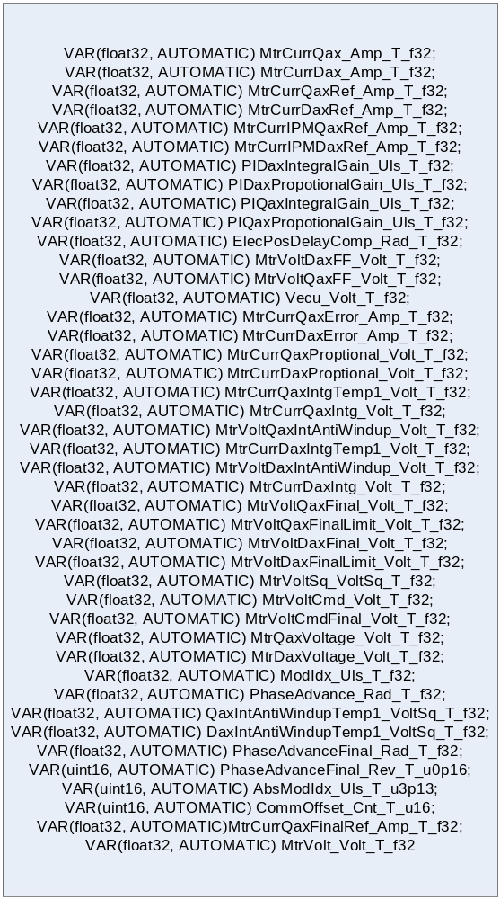

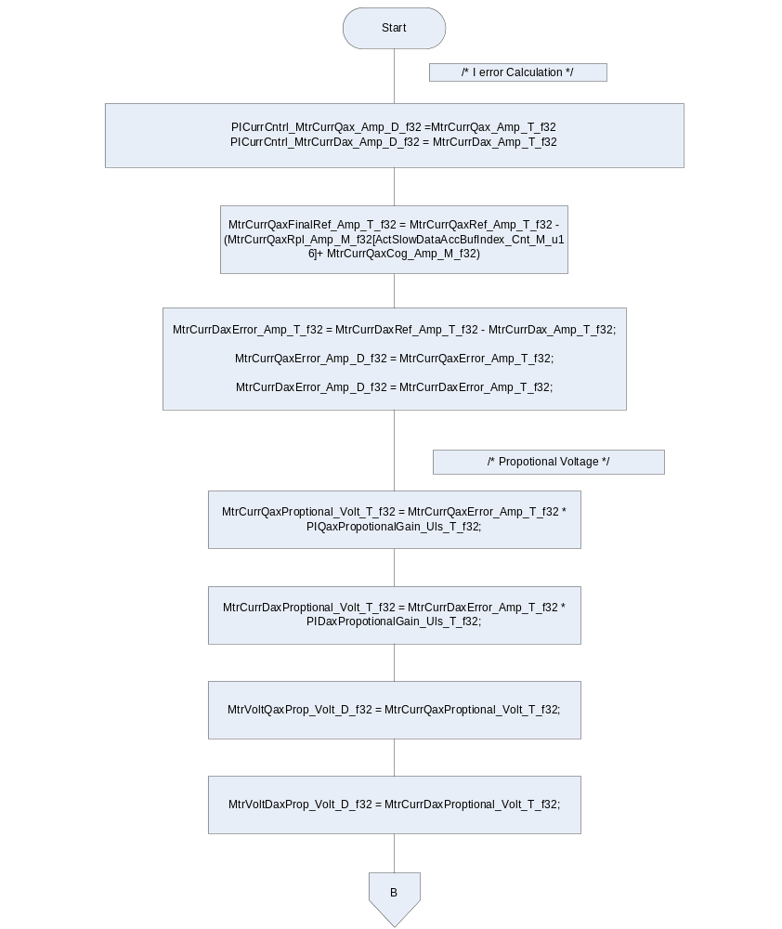

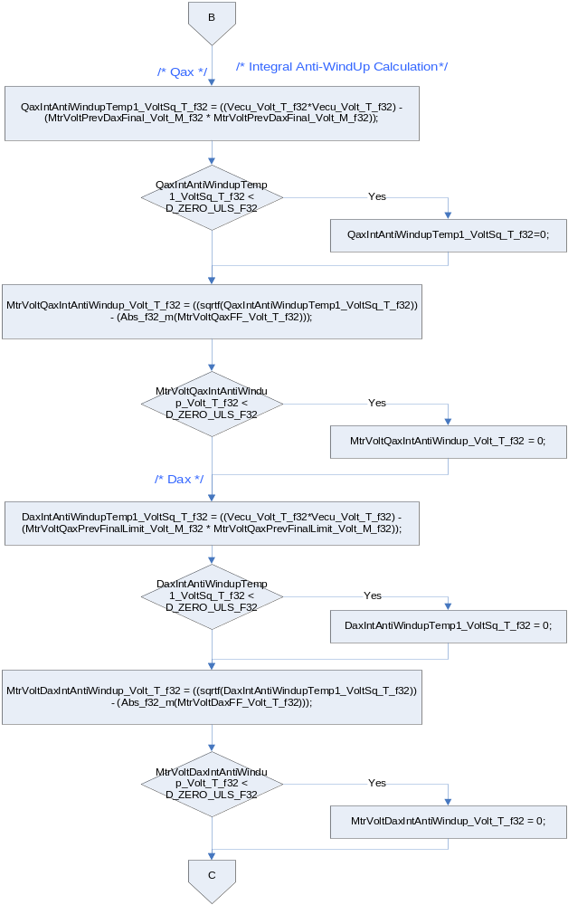
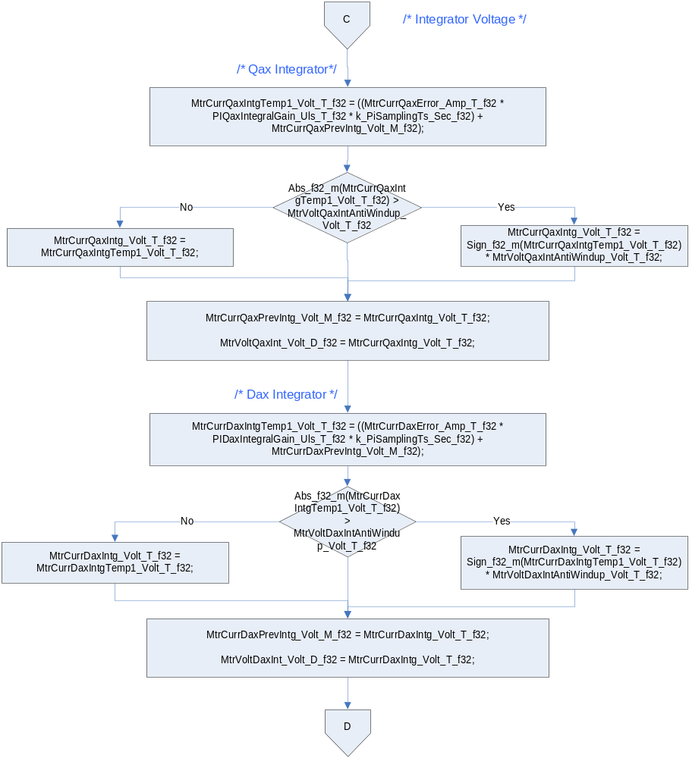

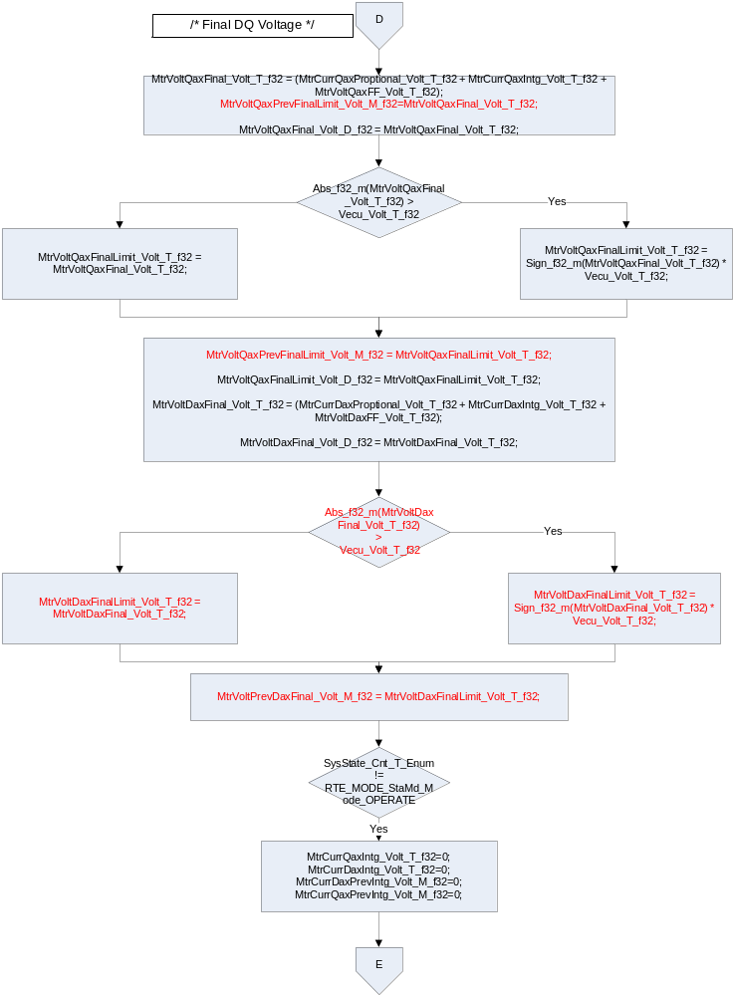
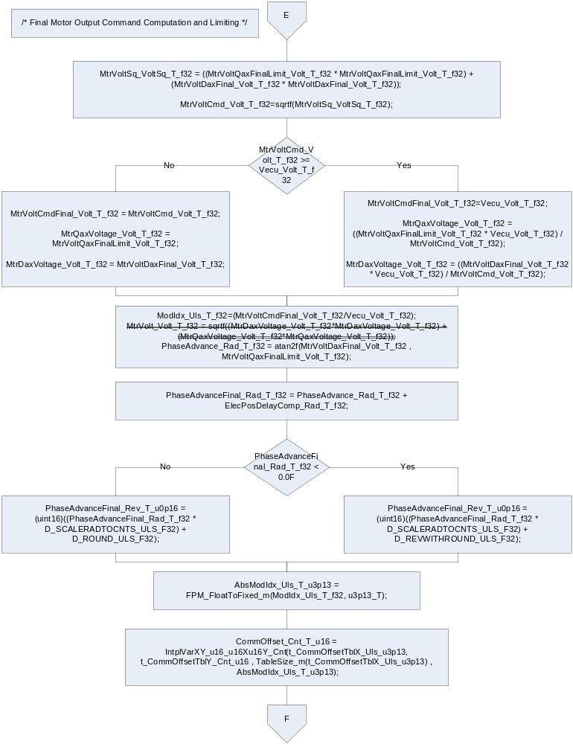
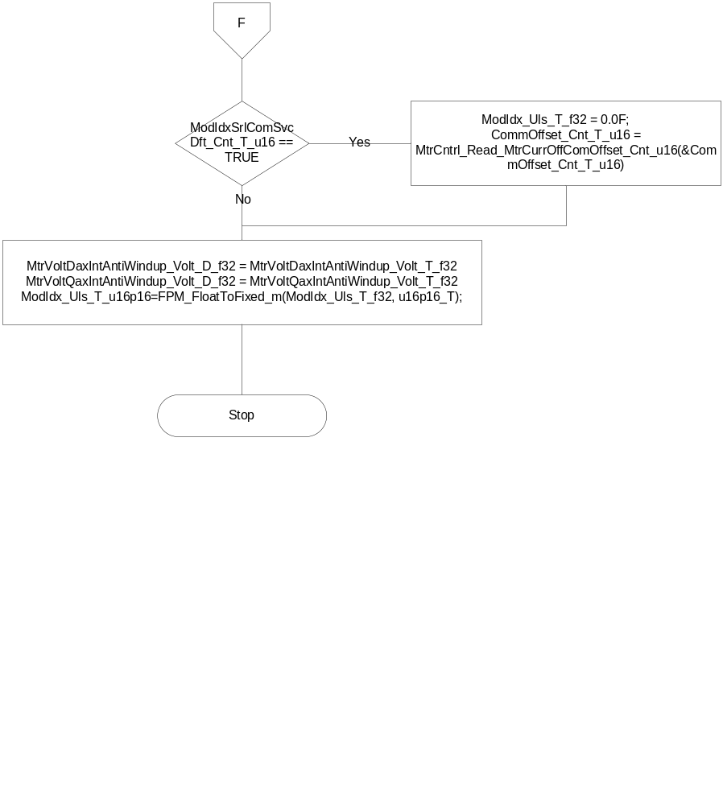

Store Local copy of outputs into Module Outputs
MtrCntrl_Write_MtrCurrQaxFinalRef_Amp_f32(MtrCurrQaxFinalRef_Amp_T_f32)
MtrCntrl_Write_MtrDaxVoltage_Volt_f32(MtrDaxVoltage_Volt_T_f32)
MtrCntrl_Write_MtrQaxVoltage_Volt_f32(MtrQaxVoltage_Volt_T_f32)
MtrCntrl_Write_ModIdx_Uls_u16p16(FPM_FloatToFixed_m(ModIdx_Uls_T_u16p16))
MtrCntrl_Write_PhaseAdvanceFinal_Rev_u0p16(PhaseAdvanceFinal_Rev_T_u0p16)
MtrCntrl_Write_CommOffset_Cnt_u16(CommOffset_Cnt_T_u16)
MtrCntrl_Write_MtrVolt_Volt_f32(MtrVoltCmdFinal_Volt_T_f32)
MtrCntrl_Write_MtrCurrDaxIntg_Volt_f32(MtrCurrDaxIntg_Volt_T_f32)
MtrCntrl_Write_MtrCurrQaxIntg_Volt_f32(MtrCurrQaxIntg_Volt_T_f32)
MtrCurrQaxFinalRef_Amp_M_f32[SlowDataAccessBufIndex_Cnt_M_u16]= MtrCurrQaxFinalRef_Amp_T_f32;
MtrVoltDax_Volt_M_f32[SlowDataAccessBufIndex_Cnt_M_u16] = MtrDaxVoltage_Volt_T_f32;
MtrVoltQax_Volt_M_f32[SlowDataAccessBufIndex_Cnt_M_u16] = MtrQaxVoltage_Volt_T_f32

Program Flow End
N/A

Periodic Functions

Per: PICurrCntrl_Per2

Design Rationale
This function is responsible for calculating the amount of current to be supplied to the motor. To control the PWM profiles generated for the motor.
SlowDataAccessBufIndex allows the buffer synchronization between data calculated on faster periodic loop time(125 micro seconds) and are read by slower periodic run time (ie 2ms)

Store Module Inputs to Local copies

ReadBuffer_Cnt_T_u16 = SlowDataAccessBufIndex_Cnt_M_u16
WriteBuffer_Cnt_T_u16 = (ReadBuffer_Cnt_T_u16 & 1U) ^ 1U
SlowDataAccessBufIndex_Cnt_M_u16 = WriteBuffer_Cnt_T_u16
EstKe_VpRadpS_T_f32= Rte_IRead_PICurrCntrl_Per2_EstKe_VpRadpS_f32();
EstR_Ohm_T_f32 = Rte_IRead_PICurrCntrl_Per2_EstR_Ohm_f32();
MRFMtrVel_MtrRadpS_T_f32 = Rte_IRead_PICurrCntrl_Per2_MRFMtrVel_MtrRadpS_f32();
CorrMtrPosElec_Rev_T_f32 = Rte_IRead_PICurrCntrl_Per2_CorrMtrPosElec_Rev_f32();
MtrCurrDaxRef_Amp_T_f32 = Rte_IRead_PICurrCntrl_Per2_MtrCurrDaxRef_Amp_f32();
MtrVoltDax_Volt_T_f32 = MtrVoltDax_Volt_M_f32[ReadBuffer_Cnt_T_u16];
MtrVoltQax_Volt_T_f32 = MtrVoltQax_Volt_M_f32[ReadBuffer_Cnt_T_u16];
MtrCurrQaxFinalRef_Amp_T_f32 = MtrCurrQaxFinalRef_Amp_M_f32[ReadBuffer_Cnt_T_u16];

Program Flow Start
Rte_Call_PICurrCntrl_Per2_CP0_CheckpointReached()

Processing
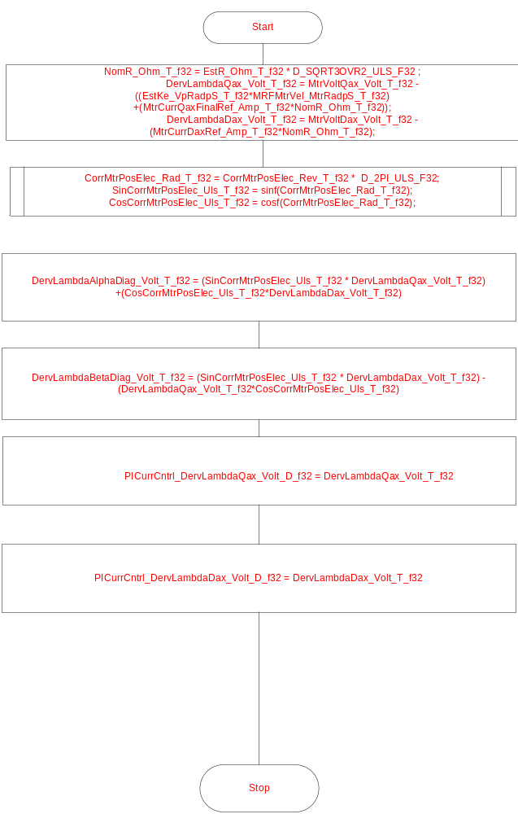

Store Local copy of outputs into Module Outputs

Rte_IWrite_PICurrCntrl_Per2_DervLambdaAlphaDiag_Volt_f32(DervLambdaAlphaDiag_Volt_T_f32);
Rte_IWrite_PICurrCntrl_Per2_DervLambdaBetaDiag_Volt_f32(DervLambdaBetaDiag_Volt_T_f32);

Program Flow End
Rte_Call_PICurrCntrl_Per2_CP1_CheckpointReached()

Execution Requirements

Execution Sequence of the Module
N/A

Execution Rates for sub-modules called by the Scheduler
This table serves as reference for the Scheduler design
Function Name | Calling Frequency | System State(s) in which the function is called
PICurrCntrl_Per1 | 0.125ms | All
PICurrCntrl_Per2 | 2ms | All

Execution Requirements for Serial Communication Functions
Function Name | Sub-Module called by (Serial Comm Function Name)
N/A

Memory Map Definition Requirements

Sub Modules (Functions)
This table identifies the software segments for functions identified in this module.
Name of Sub Module | Software Segment
PICurrCntrl_Per1 | PICurrCntrl_CODE
PICurrCntrl_Per2 | RTE_START_SEC_AP_PICURRCNTRL_APPL_CODE

Local Functions
This table identifies the software segments for local functions identified in this module.
- - Denotes functions that are vector call-backs only included to avoid compiler errors.
Name of Sub Module | Software Segment
N/A

Known Issues / Limitations With Design
The computation of commoffset and ModIndex service defeat part of FDD15D is implemented in this component inaddition to 99B requirements
The reason for the implementation is to keep the sine voltage driver common across components

Revision Control Log
Item # | Rev # | Change Description | Date | Author Initials
1 | 1.0 | Initial release with changes for IPM | 6/12/2012 | AD/KPIT
2 | 1.0 | Changes for memap statements added | 11/20/2012 | Selva
3 | 2.0 | Updated for SF99B –v8 with only changes needed for voltage command  integrity check for torque reasonableness | 02/24/2013 | Selva
4 | 3.0, | Updated for SF99B –v8 | 03/21/2013 | Selva
5 | 4.0 | Corrected for SF99B –v8 | 04/19/2013 | Selva
6 | 5.0 | Updated for SF99B –v10 | 21-Oct-13 | Selva
7 | 6.0 | Updated for SF99B –v10 | 7-Nov-13 | Selva
8 | 7.0 | Updated for V12 of FDD SF99 | 27-Nov-13 | Selva

