Module -- Motor Velocity

High-Level Description

Figures

Diagram – Function Data Sharing
This diagram shows all data that is shared between functions within the module.
No Shared Data

Diagram – MtrVel
This diagram describes the functional characteristics and data flow of a given function.

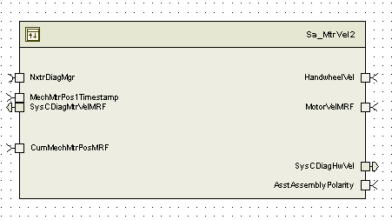

Variable Data Dictionary
For details on module input / output variable, refer to the Data Dictionary for the application. Input / output variable names are listed here for reference.
(Note: Full variable names required in table.)
(Note: All global variables including End Of Line data used should be shown here)
Module Inputs (Global Variable Name) | Module Outputs (Global Variable Name)
AsstAssemblyPolarity _Cnt_s08 | SysCDiagMtrVelMRF_MtrRadpS_f32
HandwheelVel_HwRadpS_f32 | SysCDiagHwVel_HwRadpS_f32
MotorVelMRF_MtrRadpS_f32
CumMechMtrPosMRF_Deg_f32
MechMtrPos1Timestamp_USec_u32

Module Internal Variables
This section identifies the name, range and resolutions for module specific data created by this module. If there are no range restrictions on the variable, the term “FULL” is placed into the table for legal range.
Variable Name | Resolution | Legal Range  (min) | Legal Range  (max) | Software Segment
MtrVel2_SysCMtrVelMRF_MtrRadpS_M_f32 | Single Precision Floating Point | -1350 | 1350 | MTRVEL2_START_SEC_VAR_CLEARED_32
MtrVel2_SysCHwVelCRF_HwRadpS_M_f32 | Single Precision Floating Point | -42 | 42 | MTRVEL2_START_SEC_VAR_CLEARED_32
MtrVel2_SysCMtrVelDiffAcc_Cnt_M_u16 | 1 | 0 | 255 | MTRVEL2_START_SEC_VAR_CLEARED_16
MtrVel2_SysCHwVelDiffAcc_Cnt_M_u16 | 1 | 0 | 255 | MTRVEL2_START_SEC_VAR_CLEARED_16
MtrVel2_PrevSysCDiagCumMtrPos_Rad_M_f32 | Single Precision Floating Point | -6.283185307164 | 6.283185307164 | MTRVEL2_START_SEC_VAR_CLEARED_32
MtrVel2_SysCMtrVelCorrLimDiff_MtrRadpS_D_f32 | Single Precision Floating Point | 0 | 2700 | MTRVEL2_START_SEC_VAR_CLEARED_32
MtrVel2_SysCHwVelCorrLimDiff_HwRadpS_D_f32 | Single Precision Floating Point | 0 | 2700 | MTRVEL2_START_SEC_VAR_CLEARED_32
* Note: These ranges are based on the range of the normalized sine and cosine global inputs, which in turn are based on the maximum amount of signal variation that can be caused by temperature changes on the MSB signals.

User defined typedef definition/declaration
This section documents any user types uniquely used for the module.
Typedef Name | Element Name | User Defined Type | Legal Range  (min) | Legal Range  (max)
(Name given for the user defined typdef of type struct/union)  (Variable name qualified similar to all other variables) | (Variable name qualified similar to all other variables) | as other variables

Constant Data Dictionary

Calibration Constants
This section lists the calibrations used by the module. For details on calibration constants, refer to the Data Dictionary for the application.
Constant Name
k_GearRatio_Uls_f32
k_MtrVelCorrLim_Cnt_Str
k_HwVelCorrLim_Cnt_Str
k_MtrVelCorrLim_MtrRadpS_f32
k_HwVelCorrLim_HwRadpS_f32

Program(fixed) Constants

Embedded Constants
All embedded constants whose values are provided in Eng units will be evaluated to the equivalent counts by using the FPM_InitFixedPoint_m() macro within the #define statement.

Local
Constant Name | Resolution | Value
D_MICROSECTOSEC_f32 | Single Precision float | 0.000001
D_MAXHANDWHEELVEL_HWRADPS_F32 | Single Precision float | +42
D_MINHANDWHEELVEL_HWRADPS_F32 | Single Precision float | -42

Global
This section lists the global constants used by the module. For details on global constants, refer to the Data Dictionary for the application.
Constant Name
D_MSECPERSEC_ULS_F32
D_RADPERREV_ULS_F32

Module specific Lookup Tables Constants
(This is for lookup tables (arrays) with fixed values, same name as other tables)
Constant Name | Resolution | Value | Software Segment
None

Functions/Macros used by the Sub-Modules

Library Functions / Macros
The library functions / Macros that are called by the various sub modules are identified below,
- Abs_f32_m()
- LPF_OpUpdate_f32_m ()
- LPF_KUpdate_f32_m

Data Hiding Functions
The data hiding functions / macros used in this module are identified below,

Local Functions/Macros Used by this MDD only
(Note if they are defined in another source file, then reference the appropriate header file)
The local functions/macros in this module are identified below,

Software Module Implementation

Initialization Functions

Init: MtrVel2_Init1

Design Rationale
None

Module Outputs

Module Internal
None

Design

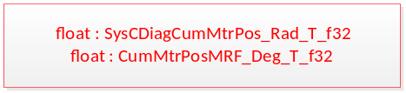

CumMtrPosMRF_Deg_T_f32= Rte_IRead_MtrVel2_Init_CumMechMtrPosMRF_Deg_f32()

SysCDiagCumMtrPos_Rad_T_f32 = (CumMtrPosMRF_Deg_T_f32) * D_PIOVR180_ULS_F32

MtrVel2_PrevSysCDiagCumMtrPos_Rad_M_f32= SysCDiagCumMtrPos_Rad_T_f32

Periodic Functions

Per: MtrVel2_Per1

Design Rationale

Program Flow Start
Rte_Call_MtrVel2_Per1_CP0_CheckpointReached()

Store Module Inputs to Local copies
AsstAssemPol_Cnt_T_s8 = Rte_IRead_MtrVel2_Per1_AsstAssemblyPolarity_Cnt_s08();
MechMtrPosTimeStamp_uSec_T_u32 = Rte_IRead_MtrVel2_Per1_MechMtrPos1Timestamp_USec_u32();

CumMtrPosMRF_Deg_T_f32 = Rte_IRead_MtrVel2_Per1_CumMechMtrPosMRF_Deg_f32();

Calculate SysC Motor Velocity
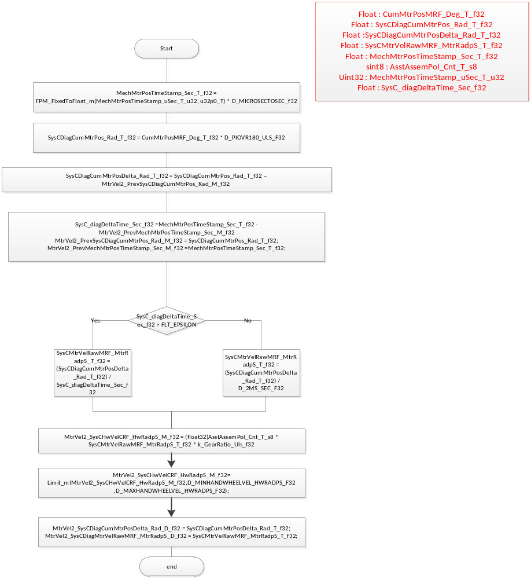

Store Local copy of outputs into Module Outputs
Rte_IWrite_MtrVel2_Per1_SysCDiagHandwheelVel_HwRadpS_f32 (SysCHwVelCRF_HwRadpS_M_f32)
Rte_IWrite_MtrVel2_Per1_SysCDiagMtrVelMRF_MtrRadpS_f32(SysCMtrVelRawMRF_MtrRadpS_T_f32)
MtrVel2_SysCMtrVelMRF_MtrRadpS_M_f32 = SysCMtrVelRawMRF_MtrRadpS_T_f32

Program Flow End
Rte_Call_MtrVel2_Per1_CP1_CheckpointReached()

Periodic Functions

Per: MtrVel2_Per2

Design Rationale

Program Flow Start
N/A

Store Module Inputs to Local copies
Rte_Call_MtrVel2_Per2_CP0_CheckpointReached()
HandwheelVel_HwRadpS_T_f32 = Rte_IRead_MtrVel2_Per2_HandwheelVel_HwRadpS_f32 ()
MRFMotorVel_MtrRadpS_T_f32 = Rte_IRead_MtrVel2_Per2_MotorVelMRF_MtrRadpS_f32 ()

Calculate Raw Motor Velocity
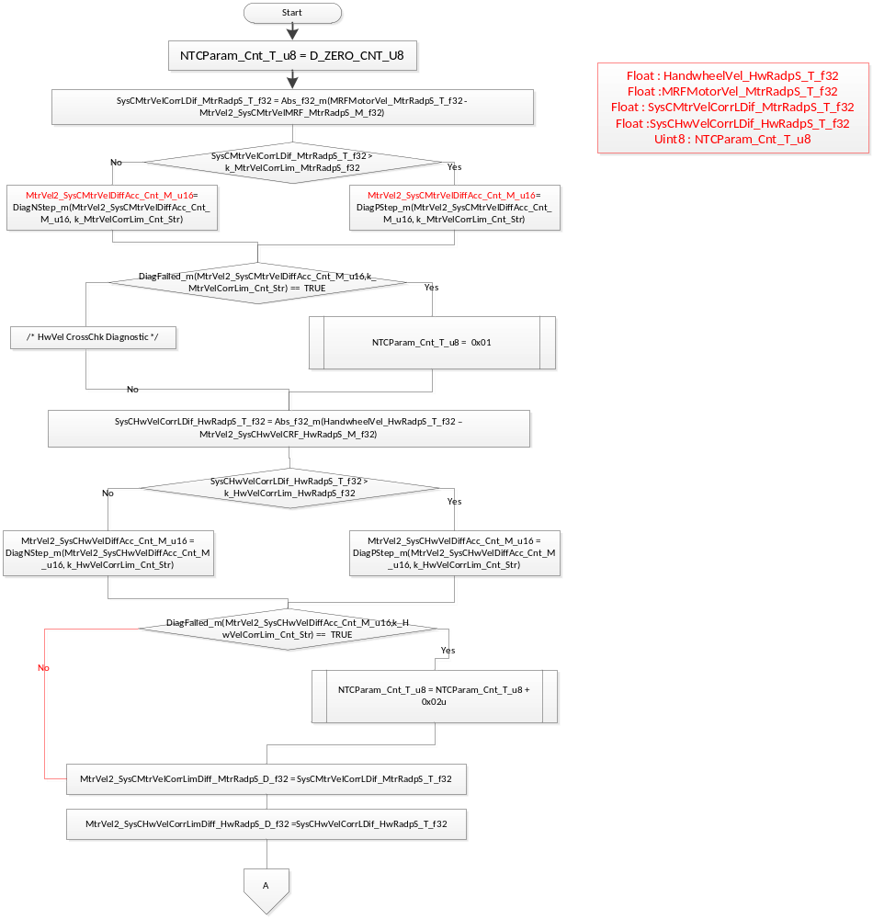

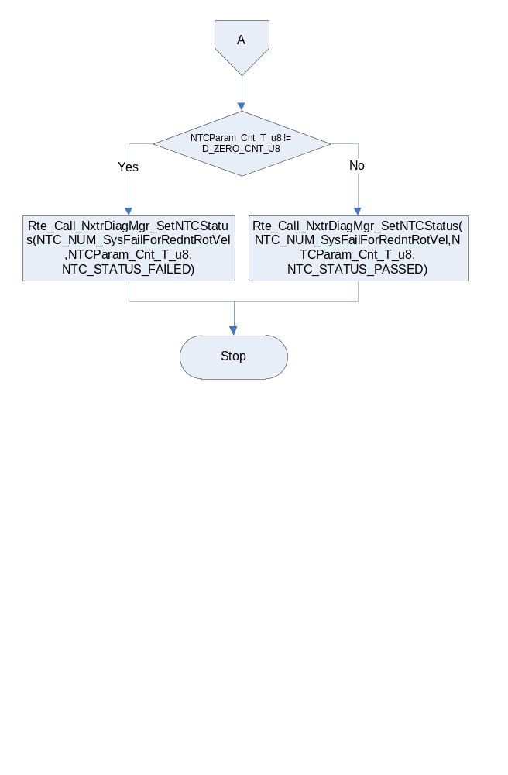

Program Flow End

Rte_Call_MtrVel2_Per2_CP1_CheckpointReached()

Fault Recovery Functions
None

Shutdown Functions
None

Interrupt Functions
None

Serial Communication Functions
None

Local Function/Macro Definitions
None

Execution Requirements

Execution Sequence of the Module
(Describe in words relevant details about the execution sequence of the different sub modules.)

Execution Rates for sub-modules called by the Scheduler
This table serves as reference for the Scheduler design
Function Name | Calling Frequency | System State(s) in which the function is called
MtrVel2_Init1 | Once | ALL STATES
MtrVel2_Per1 | 2ms | ALL STATES
MtrVel2_Per2 | 2ms | ALL STATES

Execution Requirements for Serial Communication Functions
Function Name | Sub-Module called by (Serial Comm Function Name)
N/A

Memory Map Definition Requirements

Sub Modules (Functions)
This table identifies the software segments for functions identified in this module.
Name of Sub Module | Software Segment
MtrVel2_Per1 | RTE_START_SEC_SA_MTRVEL2_APPL_CODE
MtrVel2_Per2 | RTE_START_SEC_SA_MTRVEL2_APPL_CODE

Local Functions
none

Known Issues / Limitations With Design

Revision Control Log
Item # | Rev # | Change Description | Date | Author Initials
1 | 1.0 | Initial AutoSAR release. | 5- June-13 | Selva
2 | 2.0 | Update the Input and output ports of Motor Velocity | 30-July-13 | Selva
3 | 3.0 | Updated Port interface name to match the FDD | 22-Aug-13 | Selva
4 | 4.0 | A-5749 fixes ie replacing MtrVel with raw cal values | 06-Oct-13 | Selva
5 | 5.0 | Update Motor Velocity for A7136, A7138, A7385 (Section 6.2.4 , section 6.8.3 flow chart) | 12-Dec-14 | Selva
6 | 6.0 | Updated as per Unit Test Findings | 29-Dec-14 | KPIT-AB

