Module -- Motor Velocity

High-Level Description

Figures

Diagram – Function Data Sharing
This diagram shows all data that is shared between functions within the module.
No Shared Data

Diagram – MtrVel_Per1
This diagram describes the functional characteristics and data flow of a given function.

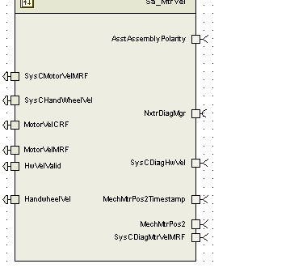

Variable Data Dictionary
For details on module input / output variable, refer to the Data Dictionary for the application. Input / output variable names are listed here for reference.
(Note: Full variable names required in table.)
(Note: All global variables including End Of Line data used should be shown here)
Module Inputs (Global Variable Name) | Module Outputs (Global Variable Name)
AsstAssemblyPolarity_Cnt_s08 | SysCMotorVelMRF_MtrRadpS_f32
SysCDiagHandwheelVel_HwRadpS_f32 | SysCHandwheelVel_HwRadpS_f32
SysCDiagMtrVelMRF_MtrRadpS_f32 | MotorVelCRF_MtrRadpS_f32
MechMtrPos2_Rev_u0p16 | MotorVelMRF_MtrRadpS_f32
MechMtrPos1Timestamp_USec_u32 | HandWheelVel_HwRadpS_f32
MechMtrPos1_Rev_u0p16 | HwVelValid_Cnt_lgc
MechMtrPos2Timestamp_USec_u32
SysCDiagHwVel_HwRadpS_f32

Module Internal Variables
This section identifies the name, range and resolutions for module specific data created by this module. If there are no range restrictions on the variable, the term “FULL” is placed into the table for legal range.
Variable Name | Resolution | Legal Range  (min) | Legal Range  (max) | Software Segment
MtrVel_WestBlendedMtrVel_MtrRadpS_D_f32 | Single Precision Floating Point | -1350 | 1350 | MTRVEL_START_SEC_VAR_CLEARED_32
MtrVel_PrevMtrPosMechMtrPos2_Rad_M_f32 | Single Precision Floating Point | -2*pi | 2*pi | MTRVEL_START_SEC_VAR_CLEARED_32
MtrVel_CrsMtrVel_MtrRadpS_D_f32 | Single Precision Floating Point | -1350 | 1350 | MTRVEL_START_SEC_VAR_CLEARED_32
MtrVel_PriMtrVel_MtrRadpS_D_f32 | Single Precision Floating Point | -1350 | 1350 | MTRVEL_START_SEC_VAR_CLEARED_32
MtrVel_HwVel_HwRadpS_M_f32 | Single Precision Floating Point | -42 | 42 | MTRVEL_START_SEC_VAR_CLEARED_32
MtrVel_MtrVelCorrLimDiff_MtrRadpS_D_f32 | Single Precision Floating Point | 0 | 2700 | MTRVEL_START_SEC_VAR_CLEARED_32
MtrVel_HwVelCorrLimDiff_HwRadpS_D_f32 | Single Precision Floating Point | 0 | 84 | MTRVEL_START_SEC_VAR_CLEARED_32
MtrVel_DiffAcc_Cnt_M_u16 | 1 | 0 | 255 | MTRVEL_START_SEC_VAR_CLEARED_16
MtrVel_HwVelDiffAcc_Cnt_M_u16 | 1 | 0 | 255 | MTRVEL_START_SEC_VAR_CLEARED_16
MtrVel_OsBufSelect_Cnt_M_u08 | 1 | 0 | 4 | MTRVEL_START_SEC_VAR_CLEARED_8
MtrVel_OldPosBuf_Cnt_M_u08 | 1 | 0 | 7 | MTRVEL_START_SEC_VAR_CLEARED_8
MtrVel_PrevMtrPosSampleTime2_uS_M_u32 | 1 | 0 | 4294965495 | MTRVEL_START_SEC_VAR_CLEARED_32
MtrVel_MtrVelMRF_MtrRadpS_M_f32 | Single Precision Floating Point | -1350 | 1350 | MTRVEL_START_SEC_VAR_CLEARED_32
* Note: These ranges are based on the range of the normalized sine and cosine global inputs, which in turn are based on the maximum amount of signal variation that can be caused by temperature changes on the MSB signals.

User defined typedef definition/declaration
This section documents any user types uniquely used for the module.
Typedef Name | Element Name | User Defined Type | Legal Range  (min) | Legal Range  (max)
(Name given for the user defined typdef of type struct/union)  (Variable name qualified similar to all other variables) | (Variable name qualified similar to all other variables) | as other variables

Constant Data Dictionary

Calibration Constants
This section lists the calibrations used by the module. For details on calibration constants, refer to the Data Dictionary for the application.
Constant Name
t_MtrVelBlendTblX_MtrRadpS_u12p4
k_GearRatio_Uls_f32
k_MtrVelCorrLim_Cnt_Str
k_HwVelCorrLim_Cnt_Str
k_MtrVelCorrLim_MtrRadpS_f32
k_HwVelCorrLim_HwRadpS_f32

Program(fixed) Constants

Embedded Constants
All embedded constants whose values are provided in Eng units will be evaluated to the equivalent counts by using the FPM_InitFixedPoint_m() macro within the #define statement.

Local
Constant Name | Resolution | Value
D_USECPERSEC_ULS_F32 | Single Precision Floating Point | 1000000.0
D_MTRVELOSBUFNUM_CNT_U08 | 1 | 4
D_SNAPSHOTBUF_CNT_U08 | 1 | 2
D_MTRVELLOLMT_MTRRADPS_F32 | Single Precision Floating Point | -1350
D_MTRVELHILMT_MTRRADPS_F32 | Single Precision Floating Point | 1350
T_MtrVelBlendTblY_Uls_u2p14[2] | Single Precision Floating Point | {0.1}
D_MAXHANDWHEELVEL_HWRADPS_F32 | Single Precision Floating Point | 42
D_MINHANDWHEELVEL_HWRADPS_F32 | Single Precision Floating Point | -42

Global
This section lists the global constants used by the module. For details on global constants, refer to the Data Dictionary for the application.
Constant Name
D_RADPERREV_ULS_F32
D_ZERO_CNT_U8
D_MTRVELOSBUFSZ_CNT_U08 (from MtrVel_Cfg.h)

Module specific Lookup Tables Constants
(This is for lookup tables (arrays) with fixed values, same name as other tables)
Constant Name | Resolution | Value | Software Segment
T_MtrVelBlendTblY_Uls_u2p14 | 2^-14 | {0, 1}

Functions/Macros used by the Sub-Modules

Library Functions / Macros
The library functions / Macros that are called by the various sub modules are identified below,
- FPM_FixedToFloat_m()
- FPM_FloatToFixed_m()
- FMP_Fix_m()
- Max_m()
- Abs_s16_m()
- Abs_f32_m()
- IntplVarXY_u16_u16Xu16Y_Cnt()
- LPF_SvUpdate_s16InFixKTrunc_m()
- LPF_OpUpdate_s16InFixKTrunc_m()
- Rte_Call_NxtrDiagMgr_GetNTCFailed
- Rte_Call_NxtrDiagMgr_SetNTCStatus
- TableSize_m()

Data Hiding Functions
The data hiding functions / macros used in this module are identified below,

Local Functions/Macros Used by this MDD only
(Note if they are defined in another source file, then reference the appropriate header file)
The local functions/macros in this module are identified below,
- CalcCoarseVel()
- MtrVelBlend()
- RegressionFit()

Software Module Implementation

Initialization Functions

Init: MtrVel_Init1

Design Rationale
None

Module Outputs
None

Module Internal
None

Description
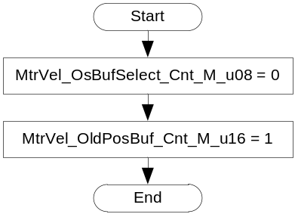

Periodic Functions

Per: MtrVel_Per1

Design Rationale

Program Flow Start
Rte_Call_MtrVel_Per1_CP0_CheckpointReached()

Store Module Inputs to Local copies
AsstAssemPol_Cnt_T_s8 = Rte_IRead_MtrVel_Per1_AsstAssemblyPolarity_Cnt_s08()
MtrPos_SampleTime2_uS_T_u32= Rte_IRead_MtrVel_Per1_MechMtrPos2Timestamp_USec_u32()
MtrPos_MechMtrPos2_Rev_T_u0p16 = Rte_IRead_MtrVel_Per1_MechMtrPos2_Rev_u0p16()

Calculate Raw Motor Velocity
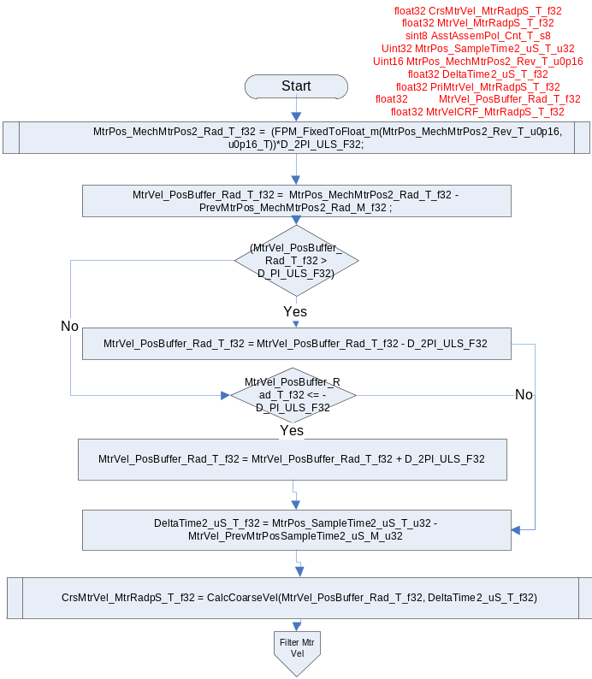
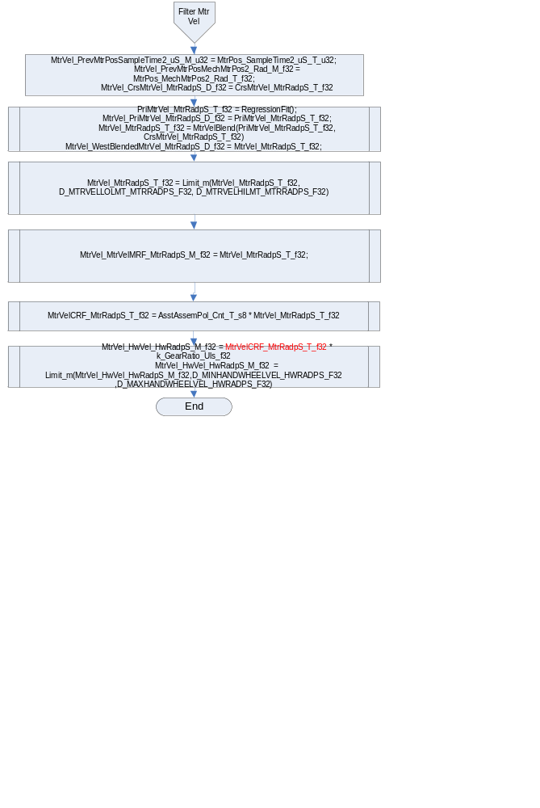

Store Local copy of outputs into Module Outputs

(void)Rte_IWrite_MtrVel_Per1_SysCMotorVelMRF_MtrRadpS_f32(MtrVel_MtrVelMRF_MtrRadpS_M_f32)
(void)Rte_IWrite_MtrVel_Per1_SysCHandwheelVel_HwRadpS_f32(MtrVel_HwVel_HwRadpS_M_f32);
(void)Rte_IWrite_MtrVel_Per1_MotorVelCRF_MtrRadpS_f32(MtrVelCRF_MtrRadpS_T_f32)
(void)Rte_IWrite_MtrVel_Per1_MotorVelMRF_MtrRadpS_f32(MtrVel_MtrVelMRF_MtrRadpS_M_f32)

(void)Rte_IWrite_MtrVel_Per1_HandwheelVel_HwRadpS_f32(MtrVel_HwVel_HwRadpS_M_f32)

Program Flow End
Rte_Call_MtrVel_Per1_CP1_CheckpointReached()

Periodic Functions

Per: MtrVel_Per2

Design Rationale

Program Flow Start
Rte_Call_MtrVel_Per2_CP0_CheckpointReached()

Store Module Inputs to Local copies
SysCDiagMtrVelMRF_MtrRadpS_T_f32 = Rte_IRead_MtrVel_Per2_SysCDiagMtrVelMRF_MtrRadpS_f32()
SysCDiagHandWheelVel_HwRadpS_T_f32 = Rte_IRead_MtrVel_Per2_SysCDiagHwVel_HwRadpS_f32()
(void)Rte_Call_NxtrDiagMgr_GetNTCFailed(NTC_Num_PriMSB_SinCosCorr,&MtrPosFault1_Cnt_T_lgc)
(void)Rte_Call_NxtrDiagMgr_GetNTCFailed(NTC_Num_PriVsSec_SinCosCorr, &MtrPosFault2_Cnt_T_lgc)

Calculate Raw Motor Velocity 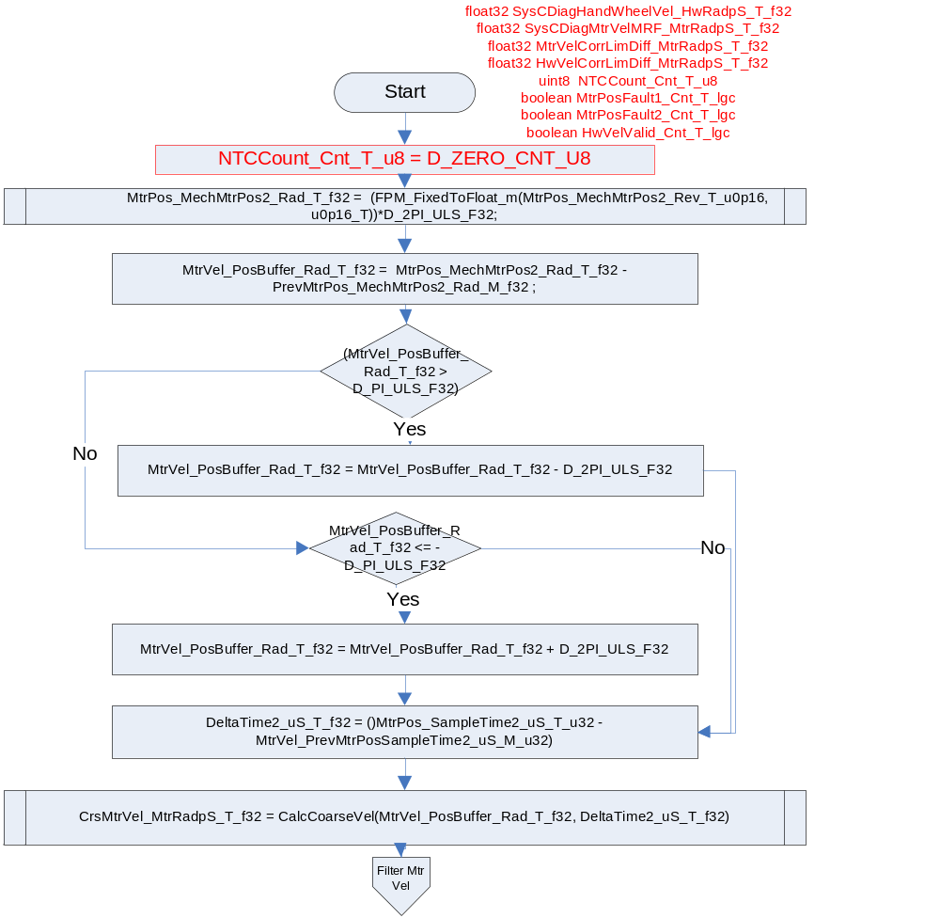
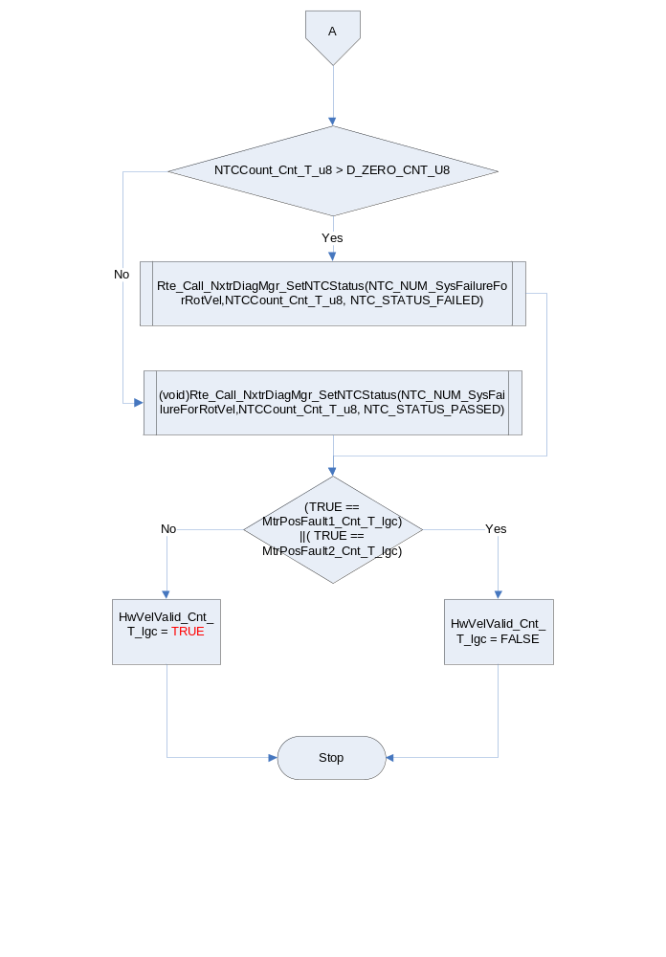

Program Flow End
Rte_Call_MtrVel_Per2_CP1_CheckpointReached()

Fault Recovery Functions
None

Shutdown Functions
None

Interrupt Functions
None

Serial Communication Functions
None

Local Function/Macro Definitions
If these are numerous and defined in a separate source file then reference the source file only.

Calculation Coarse Velocity
Function Name | CalcCoarseVel | Type | Min | Max
Arguments Passed | DeltaPos_Rad_T_f32 | Single Precision Floating Point | -2*pi | 2*pi
 | DeltaTime_uS_T_f32 | Single Precision Floating Point | 1800 | 2200
Return Value | MtrVel_MtrRadpS_T_f32 | Single Precision Floating Point | -1350 | 1350

Description
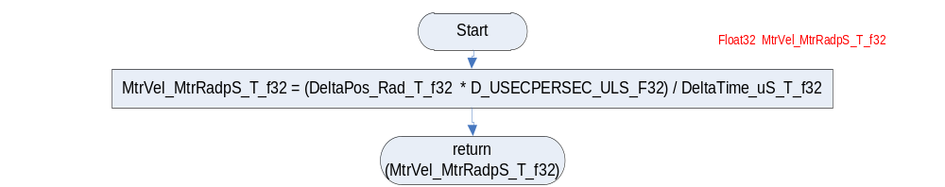

Motor Velocity Blend
Function Name | MtrVelBlend | Type | Min | Max
Arguments Passed | FinMtrVel_MtrRadpS_T_f32 | Single Precision Floating Point | -1350 | 1350
 | CrsMtrVel_MtrRadpS_T_f32 | Single Precision Floating Point | -1350 | 1350
Return Value | MtrVel_MtrRadpS_T_f32 | Single Precision Floating Point | -1350 | 1350

Description
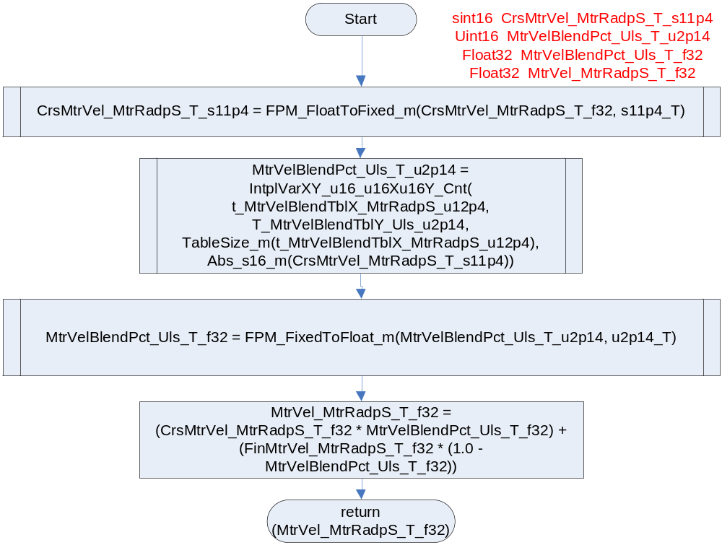

Regression Fit
Function Name | Regression Fit | Type | Min | Max
Arguments Passed
Return | MtrVel_MtrRadpS_T_f32 | Float32 | -1350 | 1350

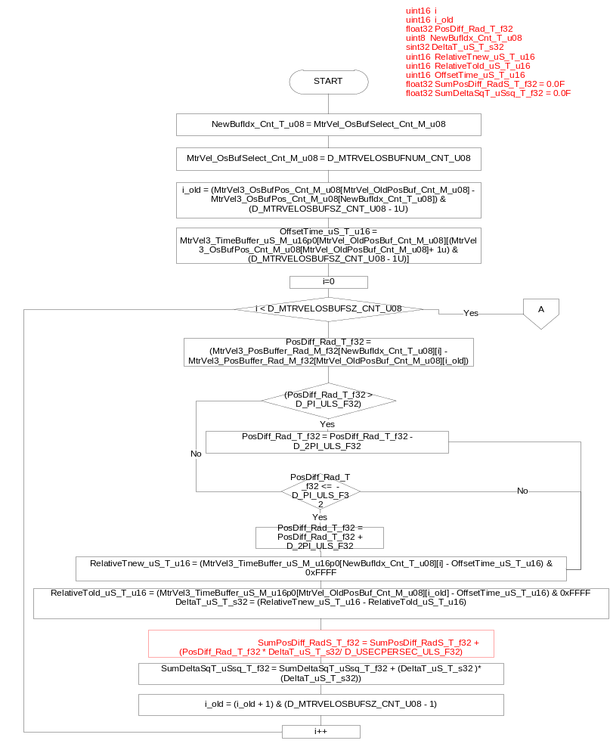

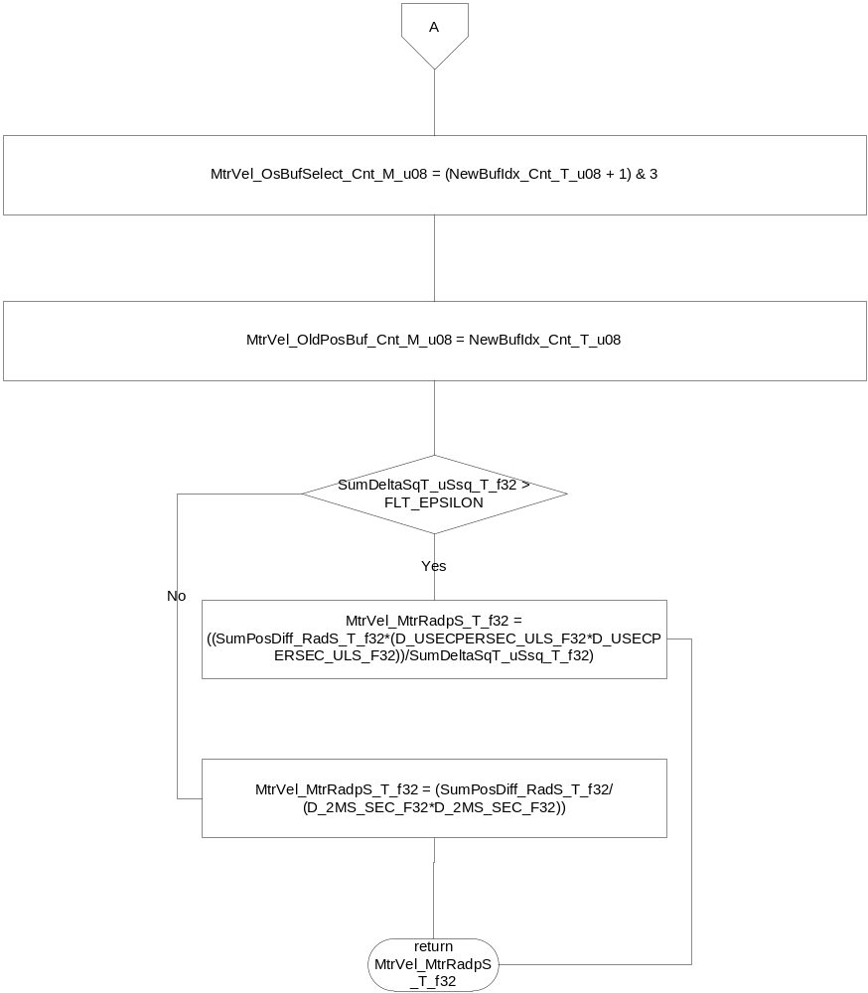

Execution Requirements

Execution Sequence of the Module
(Describe in words relevant details about the execution sequence of the different sub modules.)

Execution Rates for sub-modules called by the Scheduler
This table serves as reference for the Scheduler design
Function Name | Calling Frequency | System State(s) in which the function is called
MtrVel_Init1 | Once | ALL STATES
MtrVel_Per1 | 2ms | ALL STATES
MtrVel_Per2 | 2ms | ALL STATES

Execution Requirements for Serial Communication Functions
Function Name | Sub-Module called by (Serial Comm Function Name)
N/A

Memory Map Definition Requirements

Sub Modules (Functions)
This table identifies the software segments for functions identified in this module.
Name of Sub Module | Software Segment
MtrVel_Per1 | RTE_SA_MTRVEL_APPL_CODE
MtrVel_Per2 | RTE_SA_MTRVEL_APPL_CODE

Local Functions
This table identifies the software segments for local functions identified in this module.
Name of Sub Module | Software Segment
CalcCoarseVel | AP_MTRVEL_CODE
MtrVelBlend | AP_MTRVEL_CODE
RegressionFit | AP_MTRVEL_CODE

Known Issues / Limitations With Design
- In this design, MtrVel3_TimeBuffer_uS_M_u16p0[][] represents a set of independent circular buffers. Each buffer contains a set of continuous timestamps with the most recent timestamp index of each sample set stored in the associated index of MtrVel3_OsBufPos_Cnt_M_u08[] . The design requires monotonically increasing timestamps relative to the starting index value in MtrVel3_OsBufPos_Cnt_M_u08[]. Due to the modulo 65536 behavior of the timestamp, a single timestamp rollover within the active sample set pair is correctly handled by the design. Simultaneous sample points (e.g. ∆t = 0 for consecutive timestamps) are invalid and will result in a divide by zero in the current design. Unit Test vectors for functions which have MtrVel3_TimeBuffer_uS_M_u16p0[4][8] as an input (MtrVel_Per1 and RegressionFit) must provide an input vector value set which conforms to the set of rules in the following table:
Parameter | Min | Max | Notes
Buffer consecutive timestamp value ∆  i.e. MtrVel3_TimeBuffer_uS_M_u16p0 [i][k] - MtrVel3_TimeBuffer_uS_M_u16p0 [i][k+1] | 10 uS | 125 uS | Monotonically increasing in a modulo 65536 fashion (e.g. testing of the 16 bit rollover point allows for a single rollover point within the data buffer that is not monotonically increasing).  The UTP MUST provide at least 1 test vector that provides a data set with a time stamp rollover (See Table 2).  10 uS is the worst case minimum sampling period based on the MtrCtrl ISR runtime.  125uS is twice the nominal execution rate for MtrCtrl ISR. This is to account for a worst case delay scenario.
Cross buffer set timestamp pair ∆  (e.g the ∆ between the oldest samples in each buffer, the ∆ between the second oldest oldest samples in each buffer, etc)  i.e. MtrVel3_TimeBuffer_uS_M_u16p0 [MtrVel_OsBufSelect_M_u08][i] - MtrVel3_TimeBuffer_uS_M_u16p0 [MtrVel_OldPosBuf_M_u08][k]  where k = i + (MtrVel3_OsBufPos_Cnt_M_u08[MtrVel_OldPosBuf_M_u08] - MtrVel3_OsBufPos_Cnt_M_u08[MtrVel_OsBufSelect_M_u08]) modulo 8 | 250 uS | 4000 uS | 250 uS is the minimum required time to guarantee 8 samples at a nominal 62.5 uS sample rate have been completed.  4000 uS is twice the execution rate for MtrVel_Per1. This is to account for a worst case delay scenario.  When computing the delta it is necessary to perform modulo 65536 math compensation to account for rollover situations (e.g. Table 2 [z-7] samples depict a rollover case where the natural delta is 1764 – 65300 = -63536, however this is not the correct delta result for the strictly increasing modulo 65536 accumulator. Since the natural result is negative, 65536 must be added to obtain the actual delta, -63536 + 65536 = 2000.  See Table 2 for a complete example conforming to this rule.
Table 1: Time Buffer UTP Constraints
The following *.bas is a VBA function to validate the timestamp data sets.
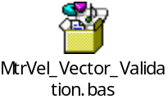
EXAMPLE TimeStamp Buffer Data Set:
The following buffer timestamp data set provides an example when buffers 0 and 1 are active. Values for buffers 2 and 3 are don’t care values for this example and shown as “X” or “Don’t Care”. The samples within the buffers have subscripts which describe the samples order relative to the newest sample in the buffer (e.g. z-1 indicates that the sample is 1 sample period old, z-2 indicates the sample is 2 sample periods old, etc). Samples of the same relative order within each buffer have the same cell shading applied to aid the reader in locating cross buffer sample pairs.
MtrVel_OldPosBuf_M_u08 = 0
MtrVel_OsBufSelect_M_u08 = 1
MtrVel3_OsBufPos_Cnt_M_u08[0] = 0
MtrVel3_OsBufPos_Cnt_M_u08[1] = 2
MtrVel3_OsBufPos_Cnt_M_u08[2] = Don’t Care
MtrVel3_OsBufPos_Cnt_M_u08[3] = Don’t Care

Index | 0 | 1 | 2 | 3 | 4 | 5 | 6 | 7
0 | 198 | 65300_{z-7} | 65362_{z-6} | 65424_{z-5} | 65486_{z-4} | 12_{z-3} | 74_{z-2} | 136_{z-1}
1 | 2074_{z-2} | 2136_{z-1} | 2198 | 1764_{z-7} | 1826_{z-6} | 1888_{z-5} | 1950_{z-4} | 2012_{z-3}
2 | X | X | X | X | X | X | X | X
3 | X | X | X | X | X | X | X | X
Table 2: Example UTP TimeBuffer Roll-Over Sample Set

- The state variables MtrVel_OldPosBuf_M_u08 and MtrVel_OsBufSelect_Cnt_M_u08 have a relationship that is maintained by logic that is executed after their use in RegressionFit(). The RegressionFit() function design requires a valid set of state variables to function properly. Therefore, it is possible to provide an illegal value set for the related state variables in a unit testing environment that will cause an illegal execution of RegressionFit(). All unit test vectors must ensure that MtrVel_OldPosBuf_M_u08 ≠ MtrVel_OsBufSelect_Cnt_M_u08. Failure to do so will result in a divide by 0 exception.
- “D_MTRVELOSBUFSZ_CNT_U08” is defined as Cal “k_BufferSize” in SF40AB. Since the size of the array is based on the Calibration, the calibration is changed to configurable constant.
This allow s integrater to modify the constant before compilation. This saves memory wastage.

Revision Control Log
Item # | Rev # | Change Description | Date | Author Initials
1 | 1.0 | Initial AutoSAR release. | 3-Jun-13 | Selva
2 | 2.0 | Updated the input and the output through RTE ports | 30-July-13 | Selva
3 | 3.0 | Updated the Ports names to match the FDD | 22-Aug-13 | Selva
4 | 4.0 | Updated the Buffer Index in Regression fit A-5803 | 06-Oct-13 | Selva
5 | 5.0 | Update Motor Velocity for A7136, A7138, A7385 (Section 6.2.4 , section 6.8.3 flow chart) | 12-Dec-14 | Selva
6 | 6.0 | Updated sections 3.1 ,4.2.1.1,6.2.1.4,6.3.1.4,6.8.1.4,6.8.2.1,6.8.3.3 according to Unit Test findings. | 24-Dec-14 | KPIT_SK

