Module -- Battery Voltage66

High-Level Description
This module is responsible for applying voltage and time based hysteresis to the battery voltage to determine over voltage and low voltage faults.

Figures

Diagram – Function Data Sharing
This diagram shows all data that is shared between functions within the module.
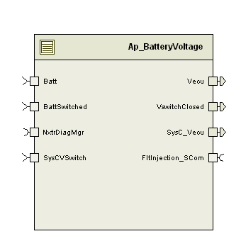

Variable Data Dictionary
For details on module input / output variable, refer to the Data Dictionary for the application. Input / output variable names are listed here for reference.
(Note: Full variable names required in table.)
(Note: All global variables including End Of Line data used should be shown here)
Module Inputs (Global Variable Name) | Module Outputs (Global Variable Name)
Batt_Volt_f32 | VswitchClosed_Cnt_lgc
BattSwitched_Volt_f32 | Vecu_Volts_f32
SysCVSwitch_Volt_f32 | SysC_Vecu_Volt_f32

Module Internal Variables
This section identifies the name, range and resolutions for module specific data created by this module. If there are no range restrictions on the variable, the term “FULL” is placed into the table for legal range.
Variable Name | User Defined Type | Resolution | Legal Range  (min) | Legal Range  (max) | Software Segment
Vecu_Volts_M_f32 | N/A | Volts | 5 | 31 | BATTERYVOLTAGE_START_SEC_VAR_CLEARED_32
VswitchClosed_Cnt_M_lgc | N/A | Cnt | FALSE | TRUE | BATTERYVOLTAGE_START_SEC_VAR_CLEARED_BOOLEAN
VswitchCorrLimDiff_Volts_D_f32 | N/A | Volts | 0 | 26 | BATTERYVOLTAGE_START_SEC_VAR_CLEARED_32
VecuVbatCorrLimDiff_Volts_D_f32 | N/A | Volts | 0 | 26 | BATTERYVOLTAGE_START_SEC_VAR_CLEARED_32
VswitchCorrErrAcc_Cnt_M_u16 | N/A | Cnt | 0 | 255 | BATTERYVOLTAGE_START_SEC_VAR_CLEARED_16
VecuVbatCorrErrAcc_Cnt_M_u16 | N/A | Cnt | 0 | 255 | BATTERYVOLTAGE_START_SEC_VAR_CLEARED_16
Vbatt_Volts_M_f32 | N/A | Volts | 5 | 31 | BATTERYVOLTAGE_START_SEC_VAR_CLEARED_32
OvervoltageFaultSet_Cnt_M_lgc | boolean | Cnt | FALSE | TRUE | BATTERYVOLTAGE_START_SEC_VAR_CLEARED_BOOLEAN

User defined typedef definition/declaration
This section documents any user types uniquely used for the module.
Typedef Name | Element Name | User Defined Type | Legal Range  (min) | Legal Range  (max)
None

Constant Data Dictionary

Calibration Constants
This section lists the calibrations used by the module. For details on calibration constants, refer to the Data Dictionary for the application.
Constant Name
k_MaxSwitchedVolt_Volts_f32
k_MaxBattVoltDiff_Volts_f32
k_VswitchCorrLim_Cnt_Str
k_VecuCorrLim_Cnt_Str
k_VecuVbatCorrLim_Volts_f32
k_VswitchCorrLim_Volts_f32

Program(fixed) Constants

Embedded Constants
All embedded constants whose values are provided in Eng units will be evaluated to the equivalent counts by using the FPM_InitFixedPoint_m() macro within the #define statement.

Local
Constant Name | Resolution | Value
D_VSWITCHEDTHRESH_ULS_F32 | Single precision floating point | 0.8
D_VECUMAX_VOLTS_F32 | Single precision floating point | 31.0

Global
This section lists the global constants used by the module. For details on global constants, refer to the Data Dictionary for the application.
Constant Name
D_VECUMIN_VOLTS_F32
BC_BATTERYVOLTAGE_FAULTINJECTIONPOINT
FLTINJ_VECU_BATTERYVOLTAGE

Module specific Lookup Tables Constants
(This is for lookup tables (arrays) with fixed values, same name as other tables)
Constant Name | Resolution | Value | Software Segment
None

Functions/Macros used by the Sub-Modules

Library Functions / Macros
The library functions / Macros that are called by the various sub modules are identified below,
- FPM_FloatToFixed_m()

Data Hiding Functions
The data hiding functions / macros used in this module are identified below,
- Rte_Call_NxtrDiagMgr_SetNTCStatus()
- Rte_Call_Batt_Batt_V_f32()
- Rte_Call_BattSwitched_BattSwitched_V_f32
- Rte_Call_SysC_Vswitch_BattSwitched_V_f32
- Rte_Call_BatteryVoltage_Per1_CP0_CheckpointReached
- Rte_Call_BatteryVoltage_Per1_CP1_CheckpointReached
- Rte_Call_BatteryVoltage_Per2_CP0_CheckpointReached
- Rte_Call_BatteryVoltage_Per2_CP1_CheckpointReached
- Rte_Pim_OvervoltageData()
- Rte_Call_OvervoltageData_SetRamBlockStatus()

Local Functions/Macros Used by this MDD only
(Note if they are defined in another source file, then reference the appropriate header file)
The local functions/macros in this module are identified below,

Software Module Implementation

Initialization Functions
Module state variables are initialized to 0 at start-up by RAM init.

Init: BatteryVoltage_Init1

Design Rationale
None

Program Flow Start
None

Store Module Inputs to Local copies
None

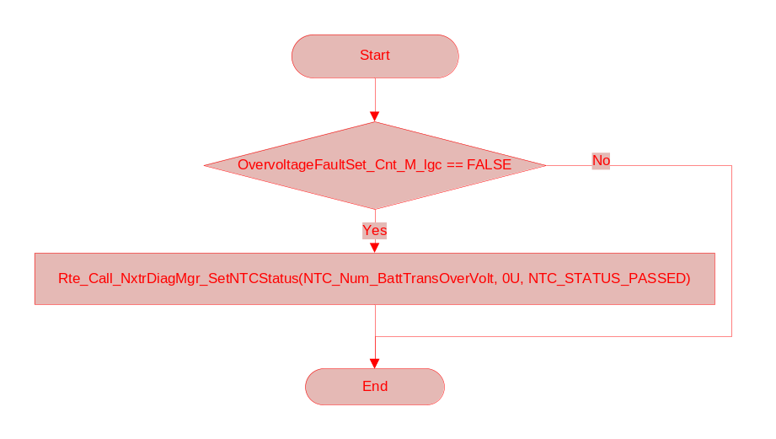

Store Local copy of outputs into Module Outputs
None

Program Flow End
None

Periodic Functions

Per: BatteryVoltage_Per1

Design Rationale
See FDD 08B.

Program Flow Start
Rte_Call_BatteryVoltage_Per1_CP0_CheckpointReached()

Store Module Inputs to Local copies
Vbatt_Volts_T_f32 = Rte_IRead_BatteryVoltage_Per2_Batt_Volt_f32()
Vswitched_Volts_T_f32 = Rte_IRead_BatteryVoltage_Per1_BattSwitched_Volt_f32()

Perform Over and Low Voltage Diagnostics
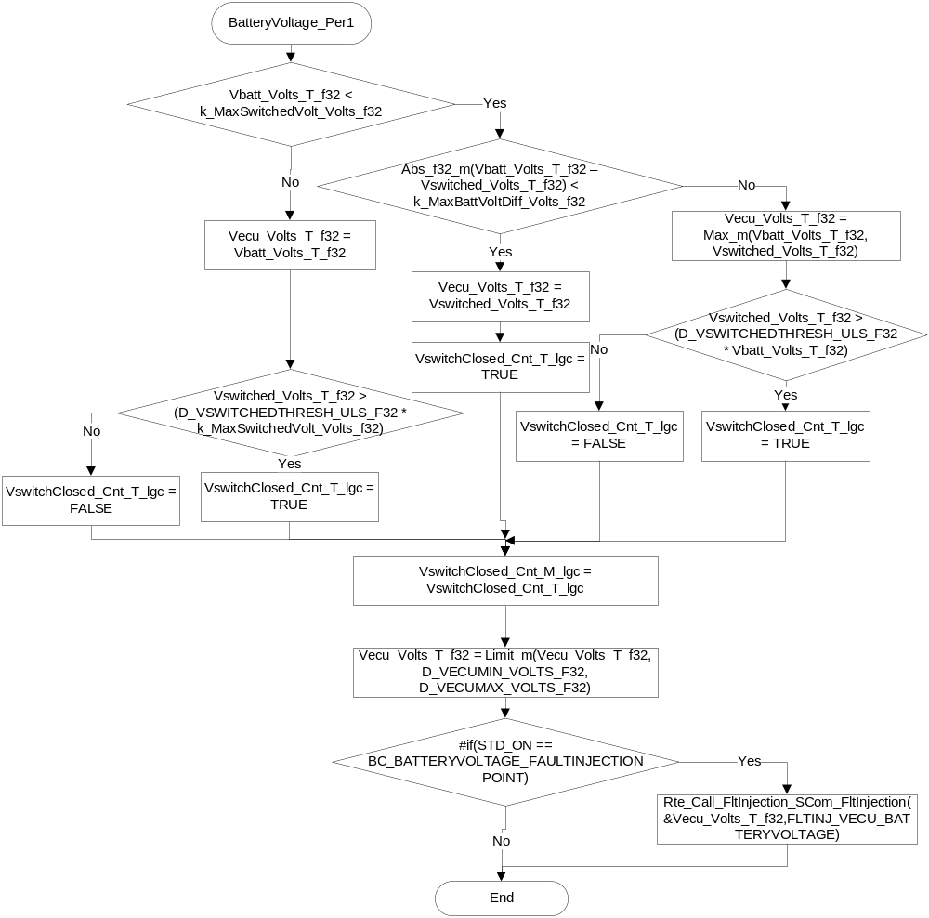

Store Local copy of outputs into Module Outputs
Vecu_Volts_M_f32 = Vecu_Volts_T_f32
Vbatt_Volts_M_f32 = Vbatt_Volts_T_f32
Rte_IWrite_BatteryVoltage_Per1_ VswitchClosed _Cnt_lgc(VswitchClosed_Cnt_T_lgc)
Rte_IWrite_BatteryVoltage_Per1_ Vecu _Volts_f32(Vecu_Volts_T_f32)
Rte_IWrite_BatteryVoltage_Per1_SysC_Vecu_Volt_f32(Vecu_Volts_M_f32)

Program Flow End
Rte_Call_BatteryVoltage_Per1_CP1_CheckpointReached()

Per: BatteryVoltage_Per2

Design Rationale
None.

Program Flow Start
Rte_Call_BatteryVoltage_Per2_CP0_CheckpointReached()

Store Module Inputs to Local copies
VecuVbatCorrLimDiff_Volts_T_f32 =0
NTCSysFailCtrlV_T_lgc = FALSE
Vswitched_Volts_T_f32 = Rte_IRead_BatteryVoltage_Per2_BattSwitched_Volt_f32()
SysCVswitch_Volts_T_f32 = Rte_IRead_BatteryVoltage_Per2_SysCVSwitch_Volt_f32()

VSwitch and Vecu cross correlation diagnostics

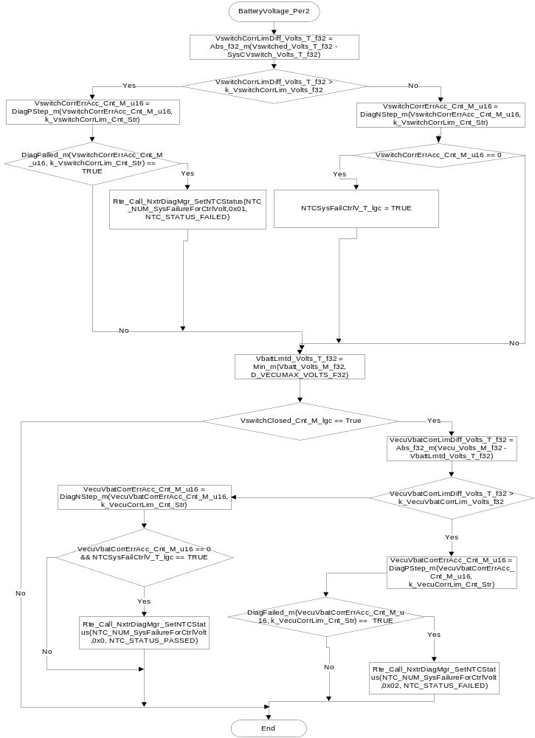

Store Local copy of outputs into Module Outputs
VswitchCorrLimDiff_Volts_D_f32 = VswitchCorrLimDiff_Volts_T_f32
VecuVbatCorrLimDiff_Volts_D_f32 = VecuVbatCorrLimDiff_Volts_T_f32

Program Flow End
Rte_Call_BatteryVoltage_Per2_CP1_CheckpointReached()

Fault Recovery Functions
None

Shutdown Functions
None

Interrupt Functions

Isr: Isr_OvervoltThresh

Design Rationale
None

Description
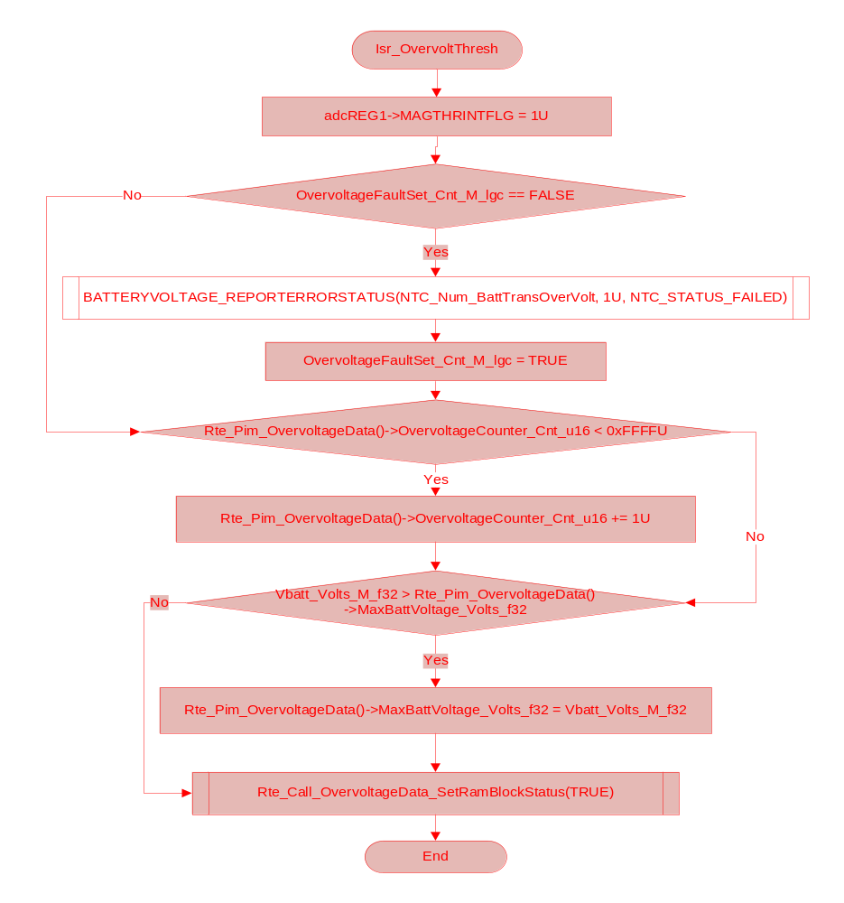

Serial Communication Functions

SCom: BatteryVoltage_SCom_ClearTransOvData
Function Name | BatteryVoltage_SCom_ClearTransOvData | Type | Min | Max | UTP Tol.
Arguments Passed | N/A
Return Value | N/A

Design Rationale
None

Program Flow Start
None

Store Module Inputs to Local Copies
None

Clear Transient Overvoltage Data Service
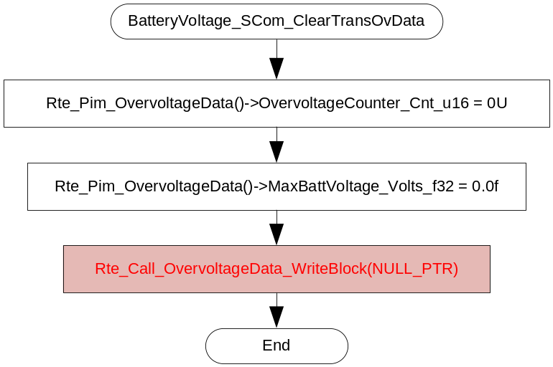

Store Local Copy of outputs into Module Outputs
None

Program Flow End
None

BatteryVoltage_SCom_ReadTransOvData
Function Name | BatteryVoltage_SCom_ReadTransOvData | Type | Min | Max | UTP Tol.
Arguments Passed | *OvervoltageCounter_Cnt_u16 | Uint16 | 0 | 65535 | 0
 | *MaxBattVoltage_Volts_f32 | Float32 | 0 | 31 | 0
Return Value | N/A

Design Rationale
None

Program Flow Start
None

Store Module Inputs to Local Copies
None

Read Transient Overvoltage Data Service
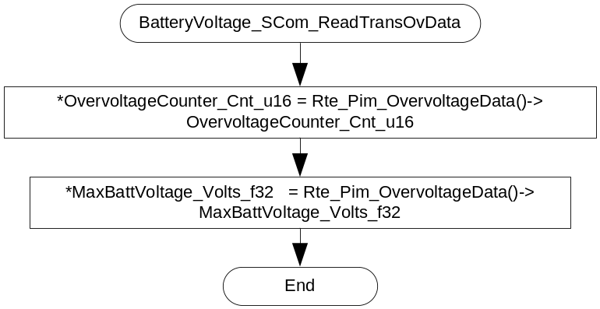

Store Local Copy of outputs into Module Outputs
None

Program Flow End
None

Local Function/Macro Definitions
If these are numerous and defined in a separate source file then reference the source file only.

Execution Requirements

Execution Sequence of the Module
(Describe in words relevant details about the execution sequence of the different sub modules.)

Execution Rates for sub-modules called by the Scheduler
This table serves as reference for the Scheduler design
Function Name | Task List | Calling Frequency | System State(s) in which the function is called
BatteryVoltage_Init1 |  | On Init | WARM INIT
BatteryVoltage_Per1 |  | 2ms | ALL
BatteryVoltage_Per2 |  | 4ms | OPERATE
Isr_OvervoltThresh |  | On Event | ALL

Execution Requirements for Serial Communication Functions
Function Name | Sub-Module called by (Serial Comm Function Name)
BatteryVoltage_SCom_ClearTransOvData | EPS_DiagSrvc
BatteryVoltage_SCom_ReadTransOvData | EPS_DiagSrvc

Memory Map Definition Requirements

Sub Modules (Functions)
This table identifies the software segments for functions identified in this module.
Name of Sub Module | Software Segment
BatteryVoltage_Init1 | RTE_AP_BATTERYVOLTAGE_APPL_CODE
BatteryVoltage_Per1() | RTE_AP_BATTERYVOLTAGE_APPL_CODE
BatteryVoltage_Per2() | RTE_AP_BATTERYVOLTAGE_APPL_CODE
BatteryVoltage_SCom_ClearTransOvData() | RTE_AP_BATTERYVOLTAGE_APPL_CODE
BatteryVoltage_SCom_ReadTransOvData() | RTE_AP_BATTERYVOLTAGE_APPL_CODE
Isr_OvervoltThresh

Local Functions
This table identifies the software segments for local functions identified in this module.
Name of Sub Module | Software Segment

Known Issues / Limitations With Design
- None

Revision Control Log
Item # | Rev # | Change Description | Date | Author Initials
1 | 1.0 | Initial AutoSAR release. | 07-Feb-11 | L.N.
2 | 2.0 | Updated to meet FDD 08B rev 02 Ecu Voltage | 28-Mar-11 | JJW
3 | 3.0 | Updated to meet FDD 08B rev 02 Ecu Voltage | 30-Mar-11 | JJW
4 | 4.0 | Corrected execution states for periodic | 07-Apr-11 | JJW
5 | 5.0 | Updated NTC’s to global constants | 02-Dec-11 | BG
6 | 6 | Updated NTC’s global constants names per latest NTC definitions | 11-Jan-12 | JJW
7 | 7 | Updated as per FDD Ver 004 | 17-Oct-12 | NRAR
8 | 8 | changed from client server port type to Sender/Receiver port | 29 -Oct-12 | NRAR
9 | 9 | MDD updates for UTP catchups | 30-Jan-13 | NRAR
10 | 10 | Checked in the right version of the MDD into synergy | 28-Mar-13 | VK
11 | 11 | Updated to FDD Ver 005 | 16-APR-13 | Jared
12 | 12 | Updated to FDD Ver 006 and anomaly 5138 correction | 26-Jun-13 | SR
13 | 13 | Added missing ISR function for overvoltage diagnostic (A5789) | 3-Jan-14 | Jared
14 | 14 | Add BATTERYVOLTAGE_REPORTERRORSTATUS for program specific integration. | 8-Jan-14 | BDO

