Module Design Document
For
HwTqArbn
August 09, 2016
Prepared For:
Software Engineering
Nexteer Automotive,
Saginaw, MI, USA
Prepared By:
S.Witczak,
Nexteer Automotive,
Saginaw, MI, USAChange History
Sl no | Description | Author | Version | Date
1 | Initial Version | Akilan Rathakrishnan | 1.0 | June 09 2016
2 | - Updated base FDD version  - Updated graphical representation of SWC | S.Witczak | 2.0 | August 09, 2016

Table of Contents

1.1 Purpose 4

3.1 Graphical representation of HwTqArbn 6

3.2 Data Flow Diagram 6

3.2.1 Module level DFD 6

3.2.2 Sub-Module level DFD 6

3.3 Component diagram 6

3.4 Variable Data Dictionary 7

3.4.1 User defined ‘typedef’ definition/declaration 7

3.4.2 Variable definition for enumerated types 7

3.5 Constant Data Dictionary 7

3.5.1 Program Constants 7

3.5.2 Module Specific Lookup Tables 7

3.6 Software Module Implementation 8

3.6.1 Sub-Module Functions 8

3.6.2 Interrupt Service Routines 8

3.6.3 _SCOMM () Functions 8

3.6.4 Module Internal (Local) Functions 9

3.6.5 Transition Functions 9

Introduction

Purpose
MDD for HwTqArbn.

HwTqArbn & High-Level Description
This component arbitrates torque values that are read from multiple torque sensors.

Design details of software module
None

Graphical representation of HwTqArbn

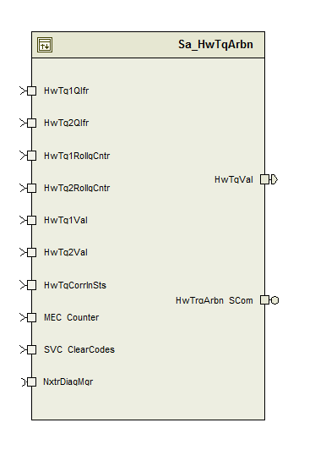

Data Flow Diagram

Module level DFD

Sub-Module level DFD

Component diagram
None

Variable Data Dictionary

User defined ‘typedef’ definition/declaration
None

Variable definition for enumerated types
None

Constant Data Dictionary

Program Constants

Local Constants
Constant Name | Resolution | Units | Value
D_DIFFTRQSCALE_CNT_F32 | Single Precision Float | Cnt | 0.5F
D_TQMAXSTALL_CNT_U08 | 1 | Cnt | 200U
D_HWTQNSTALLCNTRMAX_CNT_U08 | 1 | Cnt | 255U
D_MECCNTRMAX_CNT_U08 | 1 | Cnt | 255U
D_NTCPARAMBYTEVAL_CNT_U08 | 1 | Cnt | 0x01U
D_HWTRQMINLMT_HWNM_F32 | Single Precision Float | HwNm | -10.0F
D_HWTRQMAXLMT_HWNM_F32 | Single Precision Float | HwNm | 10.0F

Global Constants
None

Module Specific Lookup Tables
None

Software Module Implementation
<The detailed design of the function is provided in the FDD. The detail design shall only be add to the MDD when it is not provided in the FDD or the FDD is not adequate and clarification is needed.>

Sub-Module Functions

Initialization: HwTqArbn_Init1
See FDD.

Periodic 1: HwTqArbn_Per1
See FDD.

Periodic 2: HwTqArbn_Per2
See FDD.

Periodic 3: HwTqArbn_Per3
See FDD.

Non Periodic sub-module {_NONPer()}
None

Interrupt Service Routines
None

_SCOMM () Functions

Server Runnable 1: HwTrqArbn_SCom_ClrHwTrqArbOffsetTrim
See FDD.

Server Runnable 2: HwTrqArbn_SCom_ReadHwTrqArbOffsetTrim
See FDD.

Server Runnable 3: HwTrqArbn_SCom_SetHwTrqArbOffsetTrim
See FDD.

Server Runnable 4: HwTrqArbn_SCom_WriteHwTrqArbOffsetTrim
See FDD.

Module Internal (Local) Functions

Local Function #1
Function Name | ArbnSigAvlChk | Type | Min | Max
Arguments Passed | SigRollg_Cnt_T_u08 | uint8 | 0 | 255
Arguments Passed | SigQlfr_Cnt_T_enum | SigQlfr_State_enum | 0 | 2
Arguments Passed | LstRollg_Cnt_T_u08 | uint8 | 0 | 255
Arguments Passed | LstStall_Cnt_T_u08 | uint8 | 0 | 255
Arguments Passed | MaxStall_Cnt_T_u08 | uint8 | 0 | 255
Arguments Passed | *StallCntOutp_Cnt_T_u08 | uint8 | 0 | 255
Return Value | SigAvl_Cnt_T_lgc | boolean | FALSE | TRUE

Description
See any of the following blocks in the Simulink model of the design. These two blocks are similar; hence a common local function is created to perform the operation.
SigAvlChk0
SigAvlChk1

Transition Functions
None

Known Limitations with Design
None

UNIT TEST CONSIDERATION
- Following display variables are not used in the implementation. Please refer equivalent module level variables as below:
HwTqCh1Avl_Lgc → HwTqArb_HwTqCh1Avl_Cnt_M_lgc
- For server runnable services ReadHwTrqArbOffsetTrim and WriteHwTrqArbOffsetTrim full range of input/output parameters shall be used for unit tests.

Abbreviations and Acronyms
Abbreviation or Acronym | Description

Glossary
Note: Terms and definitions from the source “Nexteer Automotive” take precedence over all other definitions of the same term. Terms and definitions from the source “Nexteer Automotive” are formulated from multiple sources, including the following:
- ISO 9000
- ISO/IEC 12207
- ISO/IEC 15504
- Automotive SPICE® Process Reference Model (PRM)
- Automotive SPICE® Process Assessment Model (PAM)
- ISO/IEC 15288
- ISO 26262
- IEEE Standards
- SWEBOK
- PMBOK
- Existing Nexteer Automotive documentation
Term | Definition | Source
MDD | Module Design Document
DFD | Data Flow Diagram

References
Ref. # | Title | Version
1 | AUTOSAR Specification of Memory Mapping (Link:AUTOSAR_SWS_MemoryMapping.pdf) | Process 04.02.01
2 | MDD Guideline | Process 04.02.01
3 | Software Naming Conventions.doc | Process 04.02.01
4 | Software Design and Coding Standards.doc | Process 04.02.01
5 | FDD – ES056C HwTqArbn | V003

