Module -- Hysteresis Compensation

High-Level Description
This module will calculate a motor torque command to add into the low pass assist torque that will compensate for the hysteresis present in the system.

Figures
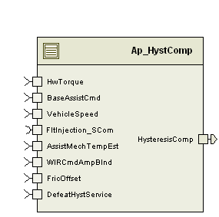

Diagram – Function Data Sharing
This diagram shows all data that is shared between functions within the module.

Diagram – HystComp_Per1
This diagram describes the functional characteristics and data flow of a given function.

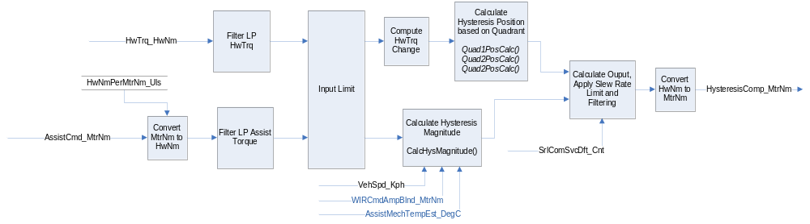

Variable Data Dictionary
For details on module input / output variable, refer to the Data Dictionary for the application. Input / output variable names are listed here for reference.
(Note: Full variable names required in table.)
(Note: All global variables including End Of Line data used should be shown here)
Module Inputs (Global Variable Name) | Module Outputs (Global Variable Name)
HwTorque_HwNm_f32 | HysteresisComp_MtrNm_f32
BaseAssistCmd_MtrNm_f32
DefeatHystService_Cnt_lgc
VehicleSpeed_Kph_f32
WIRCmdAmpBlnd_MtrNm_f32
AssistMechTempEst_DegC_f32
FricOffset_HwNm_f32

Module Internal Variables
This section identifies the name, range and resolutions for module specific data created by this module. If there are no range restrictions on the variable, the term “FULL” is placed into the table for legal range.
Variable Name | Resolution | Legal Range  (min) | Legal Range  (max) | Software Segment
* AssistCmdLPFiltSV_HwNm_M_str | Multiple | Multiple | Multiple | HYSTCOMP_START_SEC_VAR_CLEARED_UNSPECIFIED
- K_Uls_f32 | Single Precision Float | 0.0124877435 | 0.4665119090
- SV_HwNm_f32 | Single Precision Float | -440 | 440
* HwTrqLPFiltSV_HwNm_M_str | Multiple | Multiple | Multiple | HYSTCOMP_START_SEC_VAR_CLEARED_UNSPECIFIED
- K_Uls_f32 | Single Precision Float | 0.0124877435 | 0.4665119090
- SV_HwNm_f32 | Single Precision Float | -10 | 10
* RawHystCompLPFiltSV_HwNm_M_str | Multiple | Multiple | Multiple | HYSTCOMP_START_SEC_VAR_CLEARED_UNSPECIFIED
- K_Uls_f32 | Single Precision Float | 0.0124877435 | 0.4665119090
- SV_HwNm_f32 | Single Precision Float | -15 | 15
HwTrqLastUsed_HwNm_M_f32 | Single Precision Float | -10.0 | 10.0 | HYSTCOMP_START_SEC_VAR_CLEARED_32
Fraction_Uls_M_f32 | Single Precision Float | -1.0 | 1.0 | HYSTCOMP_START_SEC_VAR_CLEARED_32
RawCalc_HwNm_M_f32 | Single Precision Float | -15.0 | 15.0 | HYSTCOMP_START_SEC_VAR_CLEARED_32
RiseX_HwNm_M_f32 | Single Precision Float | -1.0 | 1.0 | HYSTCOMP_START_SEC_VAR_CLEARED_16
AstCmdLastUsed_HwNm_ M_s8p7 | 2⁻⁷ | -255.0 | 255.0 | HYSTCOMP_START_SEC_VAR_CLEARED_16
CompAvail_HwNm_D_f32 | Single Precision Float | -15 | 15.0 | HYSTCOMP_START_SEC_VAR_CLEARED_32
HwTrqFilt_HwNm_D_f32 | Single Precision Float | -15.0 | 15.0 | HYSTCOMP_START_SEC_VAR_CLEARED_32
CoulFric_HwNm_D_f32 | Single Precision Float | -15.0 | 15.0 | HYSTCOMP_START_SEC_VAR_CLEARED_32
PosAvail_HwNm_D_f32 | Single Precision Float | -15.0 | 15.0 | HYSTCOMP_START_SEC_VAR_CLEARED_32
NegAvail_HwNm_D_f32 | Single Precision Float | -15.0 | 15.0 | HYSTCOMP_START_SEC_VAR_CLEARED_32
EffCompTrq_HwNm_D_f32 | Single Precision Float | -15.0 | 15.0 | HYSTCOMP_START_SEC_VAR_CLEARED_32
AssistCmdFilt_HwNm_D_s8p7 | 2⁻⁷ | -15.0 | 15.0 | HYSTCOMP_START_SEC_VAR_CLEARED_16

User defined typedef definition/declaration
This section documents any user types uniquely used for the module.
Typedef Name | Element Name | User Defined Type | Legal Range  (min) | Legal Range  (max)
None

Constant Data Dictionary

Calibration Constants
This section lists the calibrations used by the module. For details on calibration constants, refer to the Data Dictionary for the application.
Constant Name
k_CmnSysTrqRatio_HwNmpMtrNm_f32
k_HysCmpLPAstLPFKn_Hz_f32
k_HysCmpHwTrqLPFKn_Hz_f32
k_HysFinalOutLPFKn_Hz_f32
k_LpFricIpLim_HwNm_u9p7
k_HysRevGain_InvHwNm_f32
k_HysOutLIm_HwNm_f32
t_HysRiseTblX_HwNm_u2p14
t_HysRiseTblY_Uls_u2p14
t_CmnVehSpd_Kph_u9p7
t_EffOffTblY_HwNm_u9p7
t_EffLossTblY_Uls_u4p12
t2_HysHwTrqBlndTblX_HwNm_u9p7
t2_HysHwTrqBlndTblY_Uls_u4p12
t_HysCompCoulFricY_HwNm_u9p7
t_HysCompCoulFricTempScaleX_DegC_s14p1
t_HysCompCoulFricTempScaleY_HwNm_u9p7
t_HysCompHysSatY_HwNm_u9p7
t_HysCompCoulFricWIRBlendX_MtrNm_u8p8
t_HysCompCoulFricWIRBlendY_Uls_u2p14
t_HysCompNegHysCompX_MtrNm_u8p8
t_HysCompNegHysCompY_HwNm_u9p7
t_HysCompNegHysBlendX_HwNm_u9p7
t_HysCompNegHysBlendY_Uls_u2p14

Program(fixed) Constants

Embedded Constants
All embedded constants whose values are provided in Eng units will be evaluated to the equivalent counts by using the FPM_InitFixedPoint_m() macro within the #define statement.

Local
Constant Name | Resolution | Value
D_HYSPOSLMT_ULS_F32 | Single Precision Floating Point | 1.0
D_WIROFF_IDX_U16 | 1 | 0
D_WIRON_IDX_U16 | 1 | 1
D_WIRCMDBLNDFRC_ULS_F32 | Single Precision Floating Point | 1
D_HYSSATLOWLMT_HWNM_F32 | Single Precision Floating Point | 0
D_HYSOUTLMT_MTRNM_F32 | Single Precision Floating Point | 8.8

Global
This section lists the global constants used by the module. For details on global constants, refer to the Data Dictionary for the application.
Constant Name
BC_HYSTCOMP_FAULTINJECTIONPOINT
STD_ON
FLTINJ_HYSTCOMP
D_2MS_SEC_F32

Module specific Lookup Tables Constants
(This is for lookup tables (arrays) with fixed values, same name as other tables)
Constant Name | Resolution | Value | Software Segment
None

Functions/Macros used by the Sub-Modules

Library Functions / Macros
The library functions / Macros that are called by the various sub modules are identified below,
- FPM_FloatToFixed_m()
- FPM_FixedToFloat_m()
- LPF_OpUpdate_f32_m ()
- IntplVarXY_u16_u16Xu16Y_Cnt()
- IntplVarXY_u16_s16Xu16Y_Cnt()
- TableSize_m()
- Abs_s16_m()
- Abs_f32_m()
- Sign_s16_m()
- Sign_f32_m()
- Limit_m()
- BilinearXMYM_u16_u16XMu16YM_Cnt

Data Hiding Functions
The data hiding functions / macros used in this module are identified below,
- None

Local Functions/Macros Used by this MDD only
(Note if they are defined in another source file, then reference the appropriate header file)
The local functions/macros in this module are identified below,
- MoreCompensation()
- LessCompensation()
- CalcAvailComp()

Software Module Implementation

Initialization Functions
(Note: For multiple init functions, insert new headers at the “Header 2” level – subset of “5.1 Initialization Functions” and follow the same sub-section design shown below)

Init: HystComp_Init1()

Design Rationale
LPF_KUpdate_f32 is used to initialize the LPF filter instead of the full LPF_Init_f32 macro as an optimization since the required initial state of the filter is 0, which is the initialized value of the RAM, so there is no need to explicitly initialize the state variables in this init function.

Module Outputs
None

Module Internal
None

Initialize Low Pass Filters

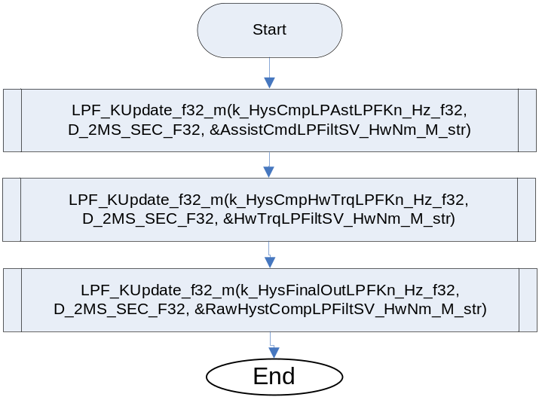

Periodic Functions

Per: HystComp_Per1

Design Rationale
None

Program Flow Start

Rte_Call_HystComp_Per1_CP0_CheckpointReached()Store Module Inputs to Local copies
DefeatHystService_Cnt_lgc as Boolean
VehSpd_Kph_T_f32 of type float32
AssistCmd_MtrNm_T_f32 as float32
HwTrq_HwNm_T_f32 of type float32
AssistCmd_HwNm_T_f32 of type float32
AssistCmdFilt_HwNm_T_s8p7 of type s8p7_T
AssistCmdFilt_HwNm_T_f32 of type float32
HwTrqFilt_HwNm_T_f32 of type float32
RawHysComp_HwNm_St_f32 of type float32
HysComp_HwNm_T_f32 as float32
HysComp_MtrNm_T_f32 as float32
Fraction_Uls_T_f32 as float32
CompAvail_HwNm_T_f32 as float32
TrqChange_HwNm_T_f32 as type float32

PrevRiseY_Uls_T_f32 as float32
RawHysCompZm1_HwNm_T_f32 as float32

PrevRiseY_Uls_T_f32 = Fraction_Uls_M_f32
RawHysCompZm1_HwNm_T_f32 = RawCalc_HwNm_M_f32
DefeatHystService_Cnt_lgc = Rte_IRead_HystComp_Per1_DefeatHystService_Cnt_lgc();
VehSpd_Kph_T_u9p7 = FPM_FloatToFixed_m(Rte_Iread_HystComp_Per1_VehicleSpeed_Kph_f32(), u9p7_T)
AssistCmd_MtrNm_T_f32 = Rte_Iread_HystComp_Per1_ BaseAssistCmd_MtrNm_f32 ()
HwTrq_HwNm_T_f32 =Rte_Iread_HystComp_Per1_HwTorque_HwNm_f32()

Convert Low Pass Assist Command to HwNm
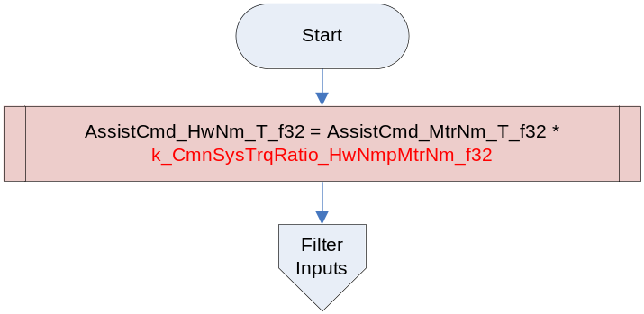

Apply Filtering to Torque Inputs
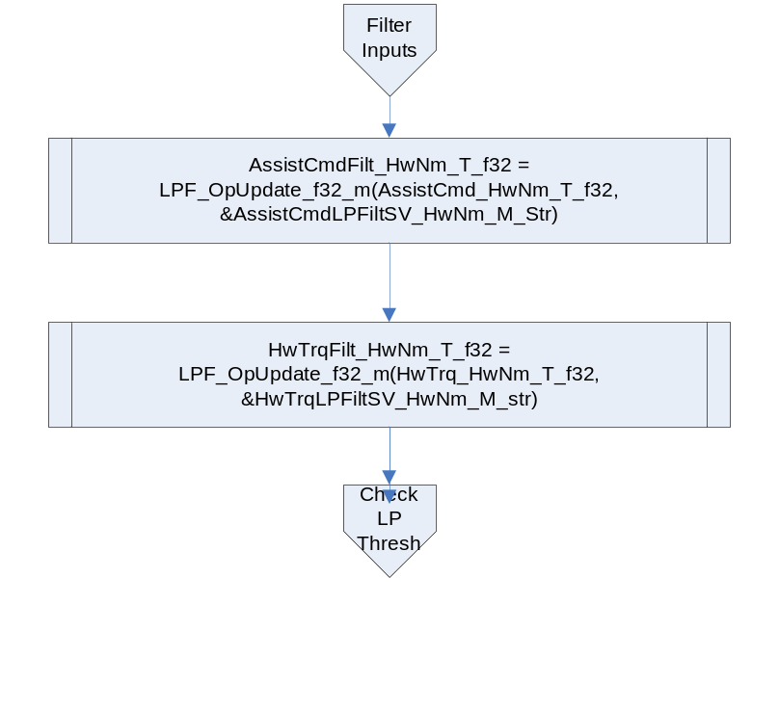

Freeze Input Values if LP Assist Exceeds Threshold
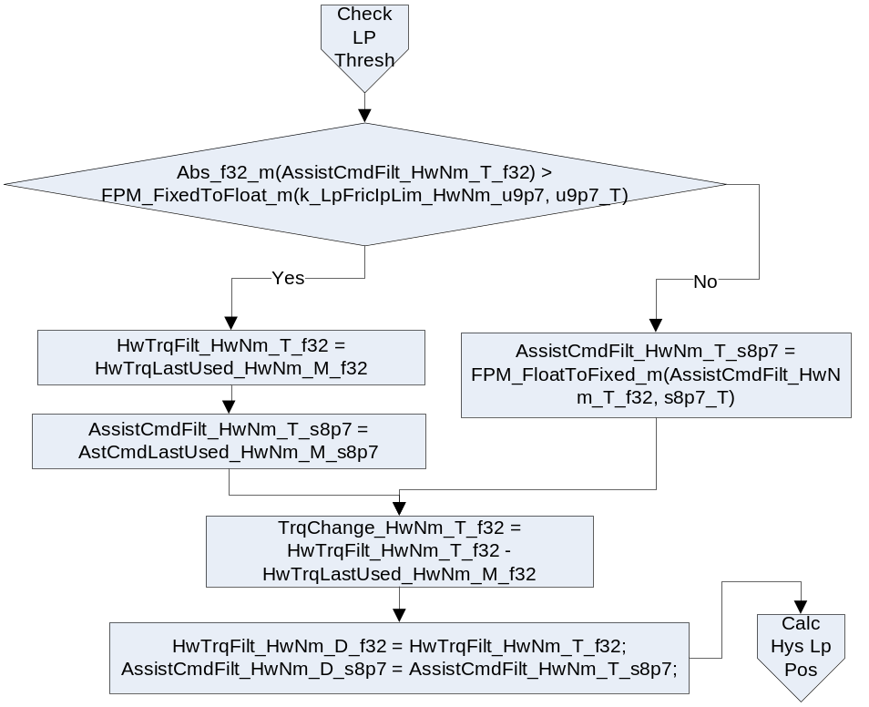

Calculate Hysteresis Loop Position Based on Quadrant
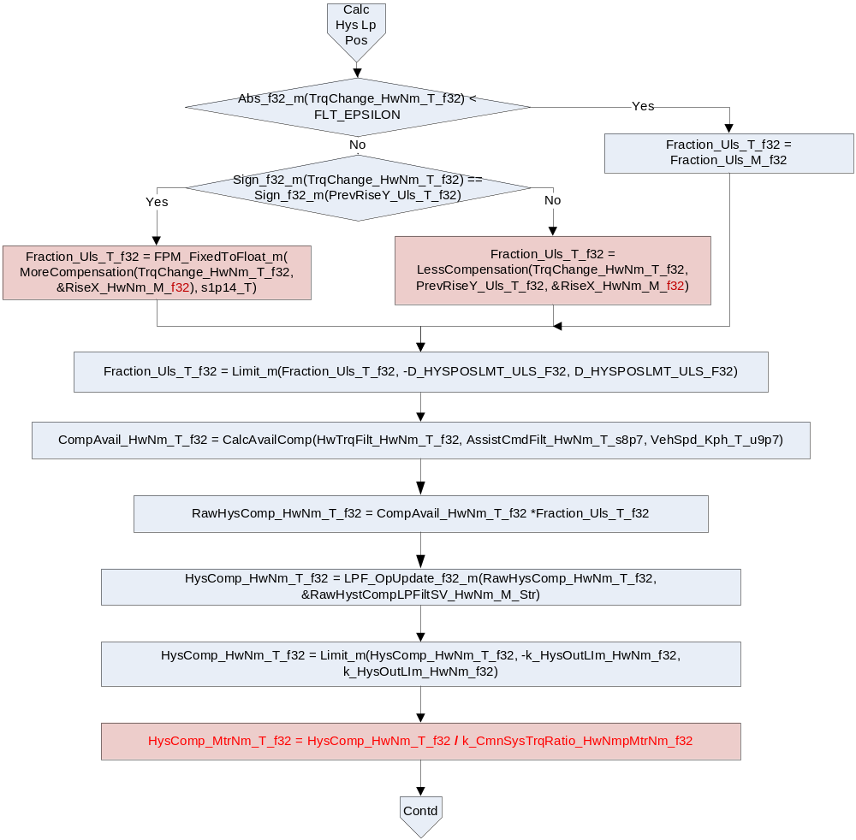

Calculate Hysteresis and Limit Rate of Change
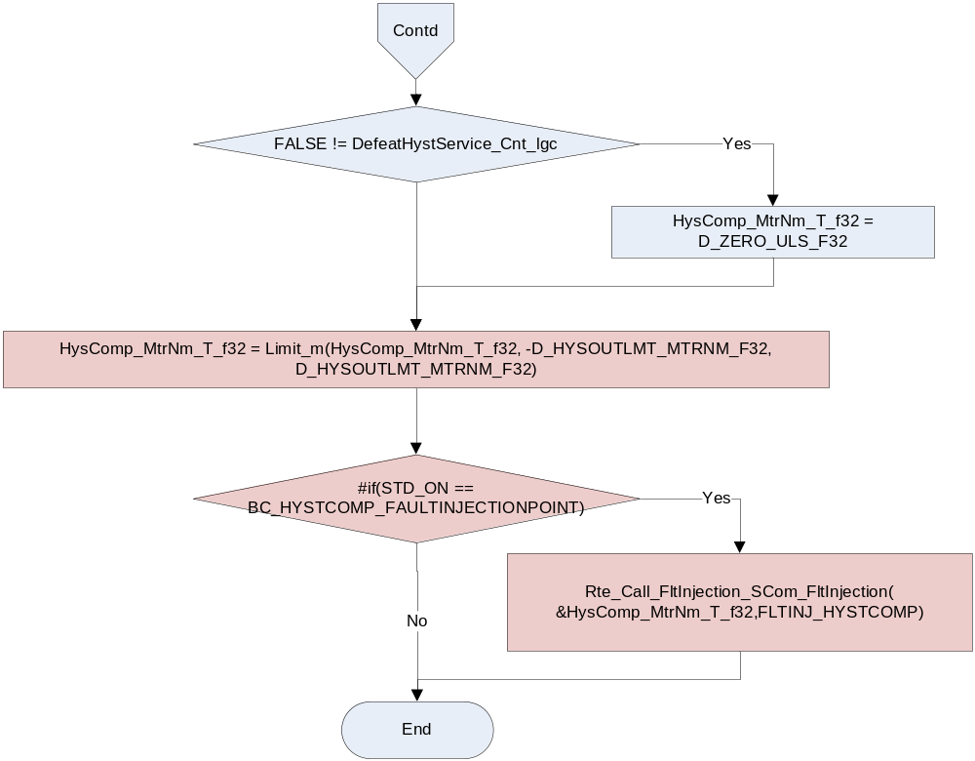

Store Local copy of outputs into Module Outputs
Rte_Iwrite_HystComp_Per1_HysteresisComp_MtrNm_f32(HysComp_MtrNm_T_f32)
AstCmdLastUsed_HwNm_M_s8p7 = AssistCmdFilt_HwNm_T_s8p7;
HwTrqLastUsed_HwNm_M_f32 = HwTrqFilt_HwNm_T_f32;
Fraction_Uls_M_f32 = Fraction_Uls_T_f32;/*HysComp_Fraction*/
RawCalc_HwNm_M_f32 = RawHysComp_HwNm_T_f32;/*HysComp_RawCalc*/
CompAvail_HwNm_D_f32 = CompAvail_HwNm_T_f32 ;/*HysComp_Avail*/

Program Flow End
Rte_Call_HystComp_Per1_CP1_CheckpointReached()

Fault Recovery Functions
None

Shutdown Functions
None

Interrupt Functions
None

Serial Communication Functions
None

Local Function/Macro Definitions
If these are numerous and defined in a separate source file then reference the source file only.

MoreCompensation Calculation
Function Name | MoreCompensation | Type | Min | Max | UTP Tolerance
Arguments Passed | TrqChange_HwNm_T_f32 | float32 | -20.0 | 20.0 | N/A
 | RiseXPtr_HwNm_T_f32 | float32* | -1.0 | 1.0 | 7.81E-03
Return Value | RiseY_Uls_T_s1p14 | s1p14_T | -1.0 | 1.0 | 7.81E-03

Description
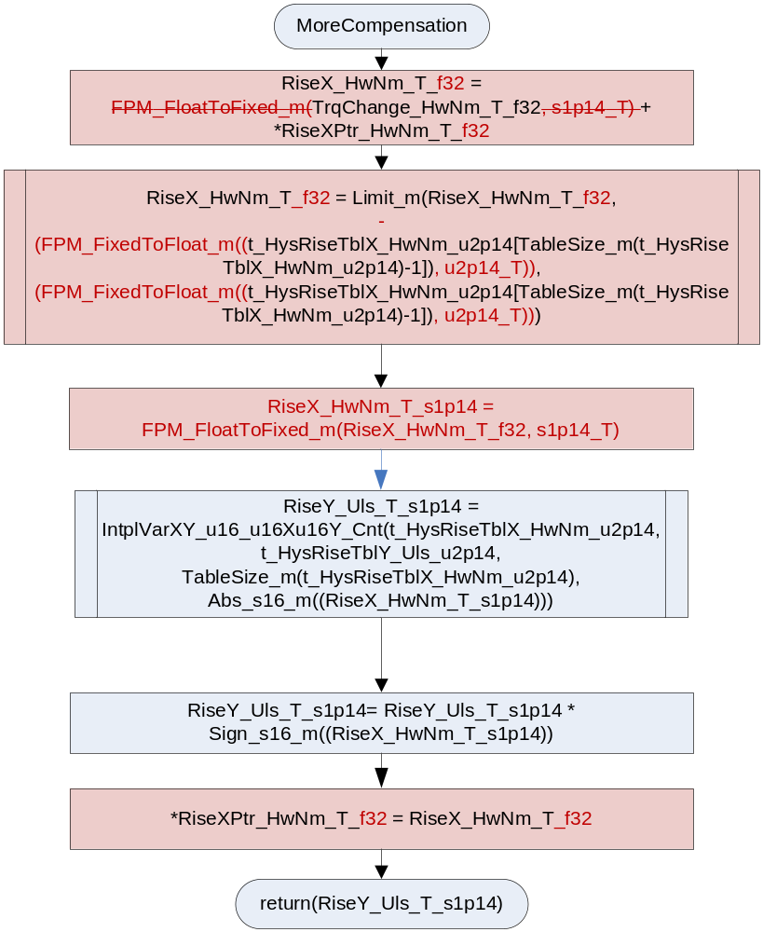

LessCompensation Calculation
Function Name | LessCompensation | Type | Min | Max | UTP Tolerance
Arguments Passed | TrqChange_HwNm_T_f32 | Float32 | -20.0 | 20.0 | N/A
 | PrevRiseY_Uls_T_f32 | Float32 | -1.0 | 1.0 | N/A
 | RiseXPtr_HwNm_T_f32 | float32* | -1.0 | 1.0 | 7.81E-03
Return Value | RiseY_Uls_T_f32 | Float32 | -300.0 | 300.0 | 7.81E-03

Design Rationale
Two saturation blocks from the partial reversal block were omitted from the design as they were redundant. The limiting of the RiseY happens after the merge block and is redundant and the RiseX is implicitly limited by the interpolation lookup.

Description
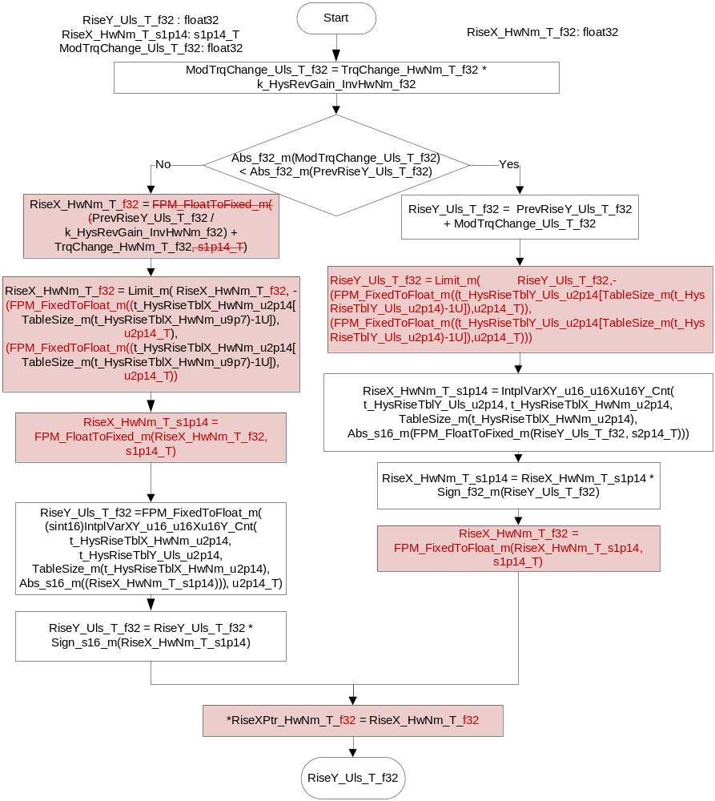

Calculate Available Compensation
Function Name | CalcAvailComp | Type | Min | Max | UTP Tolerance
Arguments Passed | HwTrqFilt_HwNm_T_f32 | Float32 | -10.0 | 10.0 | N/A
 | AssistCmdFilt_HwNm_T_s8p7 | s8p7_T | -255.0 | 255.0 | N/A
 | VehSpd_Kph_T_u9p7 | u9p7_T | 0.0 | 511.0 | N/A
Return Value | CompAvail_HwNm_T_f32 | Float32 | -15.0 | 15.0 | 7.81E-03

Design Rationale
The limit function that bounds HysTrq_HwNm_T_f32 between ZERO and FPSATHILMT was used to match the design in the FDD, however, the HIGH bound of the limit is unreachable as the maximum possible value for the input does not cause a limiting condition. An alternate design choice would have been to use a max() function between HysTrq_HwNm_T_f32 and ZERO as the only limiting factor is the LOWER bound.

Description

Localvariables:
EffOff_HwNm_T_f32
EffLoss_Uls_T_f32
HysTrq_HwNm_T_f32
HysBlend_Uls_T_f32
WIROffFric_HwNm_T_f32
WIROnFric_HwNm_T_f32

WIROffFric_HwNm_T_f32
CoulFricHysBlend_T_f32
HysNegBlend_Uls_T_f32
WIRFric_HwNm_T_f32
TempScale_HwNm_T_f32
CoulFric_HwNm_T_f32
HwTrqFilt_HwNm_T_s7p8
HysSat_HwNm_T_f32
HysNegBlndCmp_T_f32
WIRCmdAmpBlnd_MtrNm_u8p8
WIRCmdBlnd_Uls_T_f32
HysNegComp_Uls_T_f32
WIRFric_HwNm_T_f32
AssistMechTempEst_DegC_T_s14p1
AbsCombinedTrq_HwNm_T_f32
CompAvail_HwNm_T_f32
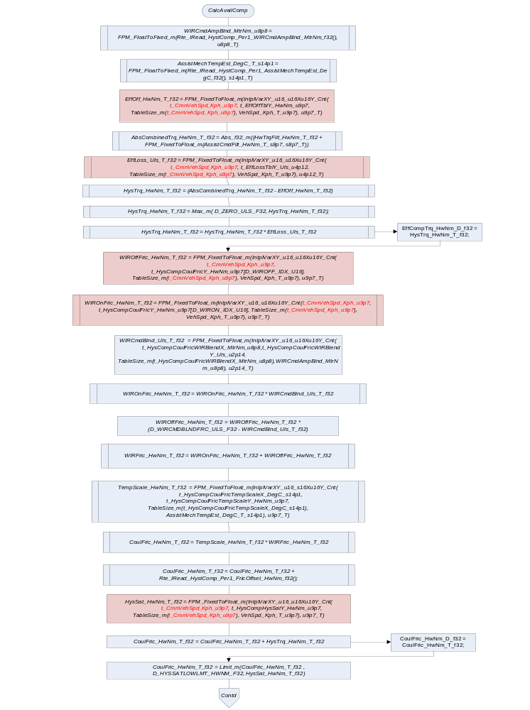

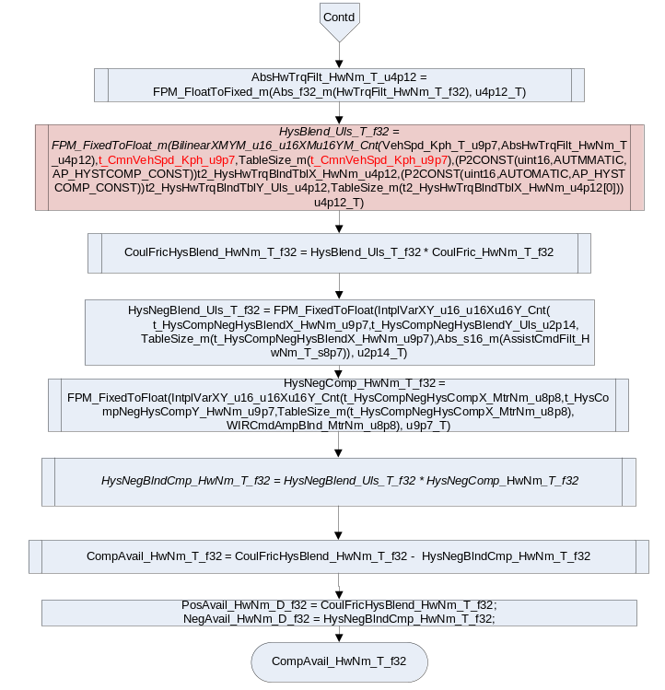

Execution Requirements

Execution Sequence of the Module
(Describe in words relevant details about the execution sequence of the different sub modules.)

Execution Rates for sub-modules called by the Scheduler
This table serves as reference for the Scheduler design
Function Name | Task List | Calling Frequency | System State(s) in which the function is called
HystComp_Per1() |  | 2ms | ALL

Execution Requirements for Serial Communication Functions
Function Name | Sub-Module called by (Serial Comm Function Name)
N/A

Memory Map Definition Requirements

Sub Modules (Functions)
This table identifies the software segments for functions identified in this module.
Name of Sub Module | Software Segment
HystComp_Init1() | RTE_AP_HYSTCOMP_APPL_CODE
HystComp_Per1() | RTE_AP_HYSTCOMP_APPL_CODE

Local Functions
This table identifies the software segments for local functions identified in this module.
Name of Sub Module | Software Segment
MoreCompensation() | AP_HYSTCOMP_CODE
LowCompensation() | AP_HYSTCOMP_CODE
CalcAvailComp() | AP_HYSTCOMP_CODE

Known Issues / Limitations With Design
- INLINE Functions defined in globalmacro.h are not unittested

Revision Control Log
Item # | Rev # | Change Description | Date | Author Initials
1 | 1.0 | Initial AutoSAR version. | 16Feb11 | L.N.
2 | 2.0 | Added negative hysteresis and ConstFric Blending interface | 14Jul11 | LWW
3 | 3.0 | Added ball screw temperature compensation | 16Nov11 | M. Story
4 | 4.0 | Update section9 for INLINE functions | 6Dec11 | N.Reddy
5 | 5.0 | Removed Per1 no longer used | 9Dec11 | M. Story
6 | 6 | Corrections per SWC interface requirements | 12Dec11 | JJW
7 | 7 | Corrected initialization of HwNmPerMtrNm_Uls_T_f32 | 13Jan12 | M. Story
8 | 8 | Anomaly Fixes and removed unused Module level variable PrevRiseX_Uls_M_s8p7 | 6March12 | NRAR
9 | 9 | Changes done as per FaultInjectionTechnique | 1-May-12 | NRAR
10 | 10 | Changed component over to floating point | 25May12 | JWJ
11 | 11 | Added design rationale to CalcAvailComp to document unit test limit path failure | 20JUN12 | JWJ
12 | 12 | Updated to new Average Friction Learninput requirements | 13JUL12 | JWJ
13 | 13 | - Removed SlewRate limit in 6.2.1.7 section  - Replaced Limit with Max and removed D_FPSATHILMT_ULS_F32 in sec 6.7.3.2 | 23JUL12 | NRAR
14 | 14 | Added checkpoints and memmap software segment is updated for static variables | 25-Sep-12 | Selva
15 | 15 | Replaced 1-D AsstMagBlndTbl with 2D HwTrqBlnd Table.Six more Display variables added | 04-Nov-12 | Selva
16 | 16 | Changed precision of t_HysRiseTblY & t_HysRiseTblX per Anom 6855. | 12-Nov-12 | BWL
17 | 17 | Anomaly 4110 correction | 28-Nov-12 | KJS
18 | 17.1.1 | Anom 4937 correction | 1-may-13 | NRAR
19 | 18 | Update to FDD ver 007 | 2-May-13 | Jared

