Module -- Torque Command Scaling4.04.0

High-Level Description
The Torque Command Scale module multiplies the Torque_Command_MRF input signal by a calibration which is set during a manufacturing EOL calibration process. This calibration is provided to reduce overall system output torque variation. This scaled version of the torque command is used by all other sub functions within motor control which have a torque dependent component.

Figures

Diagram – Function Data Sharing
This diagram shows all data that is shared between functions within the module.

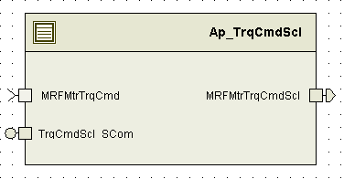

Diagram – Function (Name)
This diagram describes the functional characteristics and data flow of a given function.

(Note – This is not mandatory, only used where a graphical representation helps explain the function. It is left to the author’s discretion. New headers of this level (Level 3) should be created for each function.

Variable Data Dictionary
For details on module input / output variable, refer to the Data Dictionary for the application. Input / output variable names are listed here for reference.
(Note: Full variable names required in table.)
(Note: All global variables including End Of Line data used should be shown here)
Module Inputs (Global Variable Name) | Module Outputs (Global Variable Name)
MRFMtrTrqCmd_MtrNm_f32 | MRFMtrTrqCmdScl_MtrNm_f32

Module Internal Variables
This section identifies the name, range and resolutions for module specific data created by this module. If there are no range restrictions on the variable, the term “FULL” is placed into the table for legal range.
Variable Name | Resolution | Legal Range  (min) | Legal Range  (max) | Software Segment
None

User defined typedef definition/declaration
This section documents any user types uniquely used for the module.
Typedef Name | Element Name | User Defined Type | Legal Range  (min) | Legal Range  (max)
None

Constant Data Dictionary

Calibration Constants
This section lists the calibrations used by the module. For details on calibration constants, refer to the Data Dictionary for the application.
Constant Name
k_MinTrqCmdScl_Uls_f32
k_MaxTrqCmdScl_Uls_f32
TorqueCmdSF_Uls_f32 (NVM)

Program(fixed) Constants

Embedded Constants
All embedded constants whose values are provided in Eng units will be evaluated to the equivalent counts by using the FPM_InitFixedPoint_m() macro within the #define statement.

Local
Constant Name | Resolution | Value
None

Global
This section lists the global constants used by the module. For details on global constants, refer to the Data Dictionary for the application.
Constant Name
None

Module specific Lookup Tables Constants
(This is for lookup tables (arrays) with fixed values, same name as other tables)
Constant Name | Resolution | Value | Software Segment
None

Functions/Macros used by the Sub-Modules

Library Functions / Macros
The library functions / Macros that are called by the various sub modules are identified below,
- Limit_m()

Data Hiding Functions
The data hiding functions / macros used in this module are identified below,
- Rte_Call_TrqCmdScl_WriteBlock()
- Rte_Pim_TorqueCmdSF_Uls_f32()

Local Functions/Macros Used by this MDD only
(Note if they are defined in another source file, then reference the appropriate header file)
The local functions/macros in this module are identified below,

Software Module Implementation

Periodic Functions

Per: TrqCmdScl_Per1

Design Rationale
None

Program Flow Start
Rte_Call_TrqCmdScl_Per1_CP0_CheckpointReached()

Store Module Inputs to Local copies

MRFMtrTrqCmd_MtrNm_T_f32 = Rte_IRead_TrqCmdScl_Per1_MRFMtrTrqCmd_MtrNm_f32()
TorqueCmdSF_Uls_T_f32 = *Rte_Pim_TorqueCmdSF_Uls_f32()

Apply Torque Command Scaling
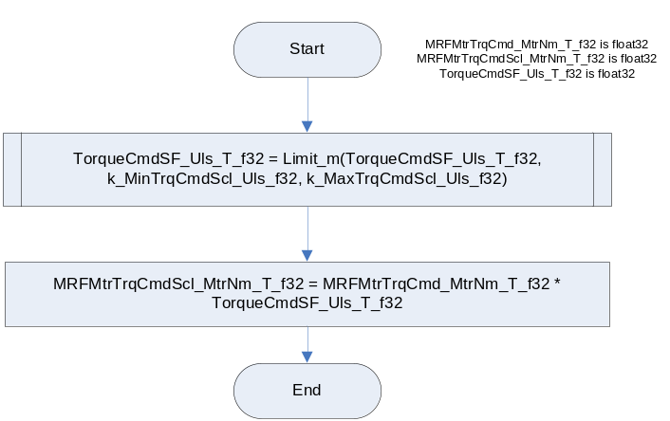

Store Local copy of outputs into Module Outputs
Rte_IWrite_TrqCmdScl_Per1_MRFMtrTrqCmdScl_MtrNm_f32(MRFMtrTrqCmdScl_MtrNm_T_f32)

Program Flow End

Rte_Call_TrqCmdScl_Per1_CP1_CheckpointReached()

Flow End
N/A

Scomm: TrqCmdScl_SCom_Get

Design Rationale
None

Program Flow Start

N/A

Store Module Inputs to Local copies
None

Get Torque Command Scaling
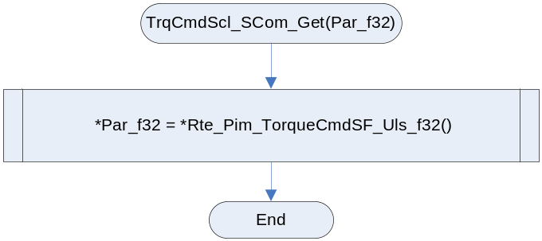

Store Local copy of outputs into Module Outputs
None

Program Flow End

N/A

Scomm: TrqCmdScl_SCom_Set

Design Rationale
None

Program Flow Start
N/A

Store Module Inputs to Local copies
None

Set Torque Command Scaling
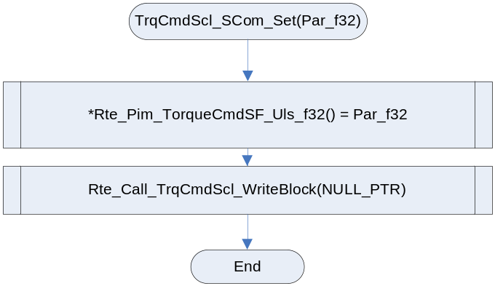

Store Local copy of outputs into Module Outputs
None

Program Flow End
N/A

Local Function/Macro Definitions
If these are numerous and defined in a separate source file then reference the source file only.

Function
Function Name |  | Type | Min | Max | UTP Tol.
Arguments Passed
Return Value

Execution Requirements

Execution Sequence of the Module
TrqCmdScl_Per1 must be executed in the forward path before quadrant detection, the voltage command numerator, phase advance, voltage command denominator, and Modulation Index.

Execution Rates for sub-modules called by the Scheduler
This table serves as reference for the Scheduler design
Function Name | Calling Frequency | System State(s)
TrqCmdScl_Per1 | 2ms | ALL

Execution Requirements for Serial Communication Functions
Function Name | Sub-Module called by (Serial Comm Function Name)
TrqCmdScl_Scom_Get()
TrqCmdScl_Scom_Set()

Memory Map Definition Requirements

Sub Modules (Functions)
This table identifies the software segments for functions identified in this module.
Name of Sub Module | Software Segment
TrqCmdScl_Per1

Local Functions
This table identifies the software segments for local functions identified in this module.
Name of Sub Module | Software Segment
None

Known Issues / Limitations With Design
- None

Revision Control Log
Item # | Rev # | Change Description | Date | Author Initials
1 | 1.0 | Document creation and initial release for the component | 29NOV11 | VK
2 | 1.1 | Corrections to assign EOL scaling factor to temporary variable | 02DEC11 | VK
3 | 3 | Added checkpoints and memmap software segment is updated for static variables | 26Sep12 | Selva
4 | 4 | Heading and format corrected | 21Nov12 | Selva

