Module Design Document
For
Nhet1CfgAndUse

VERSION: 1.0
DATE: 07-19-2016

Prepared By:
Software Engineering Group,
Nexteer Automotive,
Saginaw, MI, USA
Location: The official version of this document is stored in the Nexteer Configuration Management System.

Revision History

Sl. No. | Description | Author | Version | Date
1 | Initial Version | Avinash James | 1.0 | 19-Jul-2016

Table of Contents
1 Abbrevations And Acronyms 5
2 References 6
3 Nhet1 Configuration and use & High-Level Description 7
4 Design details of software module 8
4.1 Graphical representation of Cd_Nhet1cfganduse 8
4.2 Data Flow Diagram 8
4.2.1 Module level DFD 8
4.2.2 Sub-Module level DFD 8
4.3 COMPONENT FLOW DIAGRAM 8
5 Variable Data Dictionary 9
5.1 User defined typedef definition/declaration 9
5.2 Variable definition for enumerated types 9
6 Constant Data Dictionary 10
6.1 Program(fixed) Constants 10
6.1.1 Embedded Constants 10
6.1.1.1 Local 10
6.1.1.2 Global 10
6.1.2 Module specific Lookup Tables Constants 11
7 Software Module Implementation 12
7.1 Sub-Module Functions 12
7.2 Initialization Functions 12
7.2.1 Init: Nhet1CfgAndUse_Init 12
7.2.1.1 Design Rationale 12
7.2.1.2 Module Outputs 12
7.2.1.3 Module Internal 12
7.3 PERIODIC FUNCTIONS 12
7.3.1 Per: Nhet1CfgAndUse _Per1 12
7.3.1.1 Design Rationale 12
7.3.1.2 Store Module Inputs to Local copies 12
7.3.1.3 Processing of function 12
7.3.1.4 Store Local copy of outputs into Module Outputs 13
7.3.2 Per: Nhet1CfgAndUse _Per2 13
7.3.2.1 Design Rationale 13
7.3.2.2 Store Module Inputs to Local copies 13
7.3.2.3 Processing of function 14
7.3.2.4 Store Local copy of outputs into Module Outputs 14
7.4 Interrupt Functions 14
7.4.1 Isr: <ModuleName>_Isr<n)> 14
7.4.1.1 Design Rationale 14
7.4.1.2 (Processing of the ISR function)….. 14
7.5 Serial Communication Functions 15
7.5.1 SComm: <MODULENAME> 15
7.5.1.1 Design Rationale 15
7.5.1.2 Store Module Inputs to Local copies 15
7.5.1.3 (Processing of function)……… 15
7.5.1.4 Store Local copy of outputs into Module Outputs 15
7.6 Local Function/Macro Definitions 15
7.6.1 Local Function #1 15
7.6.1.1 Description 16
7.6.2 Local Function #2 16
7.6.2.1 Description 16
7.7 GLObAL Function/Macro Definitions 17
7.7.1 GLObAL Function #1 17
7.7.1.1 Description 17
7.7.2 GLObAL Function #2 18
7.7.2.1 DESIGN Rationale 18
7.7.2.2 Description 18
8 Known Limitations With Design 19
9 UNIT TEST CONSIDERATION 20
10 Appendix 21

Abbrevations And Acronyms
Abbreviation | Description
DFD | Design functional diagram
MDD | Module design document
FDD | Functional design document

References
This section lists the title & version of all the documents that are referred for development of this document
Sr. No. | Title | Version
1 | MDD Guidelines | 1.4
2 | Software Naming Conventions | 2.0
3 | Coding standards | 2.1
4 | FDD: ES-35D Nhet1CfgAndUse _FDD | Refer eRoom

Nhet1 Configuration and use & High-Level Description

This module implements NHET1 and HTU1 initialization per ES35C FDD for receiving Torque 1 sensor and Torque 2 sensor data using SENT protocol. The SENT protocol is implemented in NHET module using NHET programming. This module calculates the HandWheel torques based on the raw data received from torque sensor 3 and torque sensor 4. This component also will generate SPI50 Start trigger, SPI1m Start Trigger and ePWM Synchronization Trigger.

Design details of software module

Graphical representation of Cd_Nhet1cfganduse
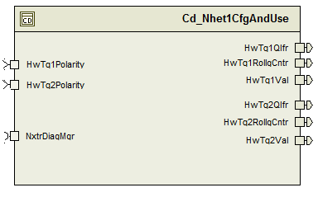

Data Flow Diagram
None

Module level DFD
None

Sub-Module level DFD
None

COMPONENT FLOW DIAGRAM
None

Variable Data Dictionary

User defined typedef definition/declaration
<This section documents any user types uniquely used for the module.>

Typedef Name | Element Name | User Defined Type | Legal Range  (min) | Legal Range  (max)
HtuDataTrq_Str | HtuDataTrq1_Cnt_u32[8] | Uint32 | 0 | Full
HtuDataTrq_Str | HtuDataTrq2_Cnt_u32[8] | Uint32 | 0 | Full

Variable definition for enumerated types
Enum Name | Element Name | Value
NhetDataIndex_Enum | PULSE_MSGCOUNTST | 0u
NhetDataIndex_Enum | PULSE_SYNC | 1u
NhetDataIndex_Enum | PULSE_STATUS | 2u
NhetDataIndex_Enum | PULSE_D0 | 3u
NhetDataIndex_Enum | PULSE_D1 | 4u
NhetDataIndex_Enum | PULSE_D2 | 5u
NhetDataIndex_Enum | PULSE_CRC | 6u
NhetDataIndex_Enum | PULSE_MSGCOUNTEND | 7u

Constant Data Dictionary

Program(fixed) Constants

Embedded Constants
< All program specific constants will be defined in detail >

Local
Constant Name | Resolution | Units | Value
D_CBUFLEN_CNT_U16 | 1 | Cnt | 8
D_CELEMENT_CNT_U16 | 1 | Cnt | 8
D_CFRAME_CNT_U16 | 1 | Cnt | 1
D_BASEADDNHETRAM_CNT_U32 | 1 | Cnt | 0xFF460000UL
D_WCAPHTUADDR1_CNT_U32 | 1 | Cnt | (D_BASEADDNHETRAM_CNT_U32 + (uint32)(16U*(uint16)pHET_T1MSGCNTST_0) + 8UL)
D_WCAPHTUADDR2_CNT_U32 | 1 | Cnt | (D_BASEADDNHETRAM_CNT_U32 +(uint32)(16U*(uint16)pHET_T2MSGCNTST_0) + 8UL)
D_NUMRAWDATA_CNT_U08 | 1 | Cnt | 8
D_STATUSFAULT_CNT_U08 | 1 | Cnt | 4
D_PROTOCOLFAULT_CNT_U08 | 1 | Cnt | 8
D_CRCFAULT_CNT_U08 | 1 | Cnt | 16
D_SYNCTICKS_ULS_F32 | float | Uls | 56.0f
D_HWTRQSCALE_HWNMPCNT_F32 | float | Cnt | (20.0f/4095.0f)
D_HWTRQOFFSET_HWNM_F32 | float | HwNm | 10.0f
D_TESTNOTOK_CNT_U08 | 1 | Cnt | 0
D_TESTOK_CNT_U08 | 1 | Cnt | 1
D_HWTQVALLOWLIMIT_HWNM_F32 | float | HwNm | (-10.0f)
D_HWTQVALHIGHLIMIT_HWNM_F32 | float | HwNm | 10.0f
D_SENTSYNCDELAY_CNT_U32 | 1 | Cnt | 148000UL

Global
<This section lists the global constants used by the module. For details on global constants, refer to the Data Dictionary for the application>
Constant Name
None

Module specific Lookup Tables Constants
<(This is for lookup tables (arrays) with fixed values, same name as other tables)>
Constant Name | Resolution | Value | Software Segment
T_SENTCRC_CNT_U08 | 1 | 0, 13, 7, 10, 14, 3, 9, 4, 1, 12, 6, 11, 15, 2, 8, 5 | NHET1CFGANDUSE_START_SEC_CONST_8

Software Module Implementation

Sub-Module Functions

None

Initialization Functions

Init: Nhet1CfgAndUse_Init

Design Rationale
Nhet1 initialization is not part of the RTE code, see global function’s section

Module Outputs
None

Module Internal

PERIODIC FUNCTIONS

Per: Nhet1CfgAndUse _Per1

Design Rationale
None

Store Module Inputs to Local copies
None

Processing of function
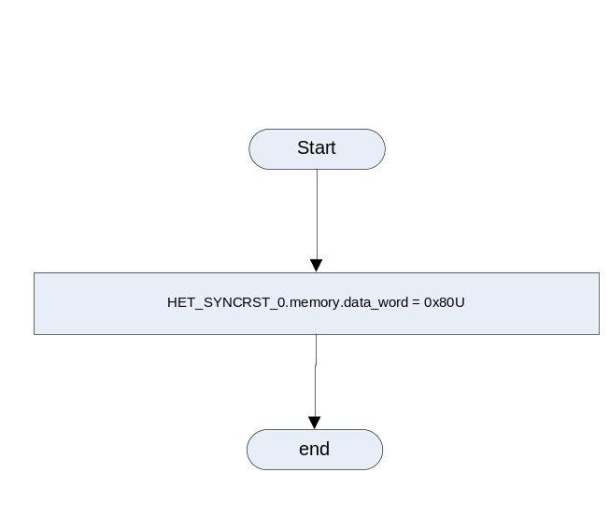

Store Local copy of outputs into Module Outputs
None

Per: Nhet1CfgAndUse _Per2

Design Rationale
In this function, there are a few differences between matlab model FDD and the code. For example: in the model, there are two arrays containing raw input data, but in the code, there is only one input structure and it got splited into two arrays inside the function.
Note: In the model, Nhet1HtuSent1FMsgCnt_Cnts stands for the start cnt, Nhet1HtuSent1LMsgCnt_Cnts stands for the end cnt.

Store Module Inputs to Local copies

HwTq1Polarity_Cnt_T_s08 = Rte_IRead_Nhet1CfgAndUse_Per2_HwTq1Polarity_Cnt_s08();
HwTq2Polarity_Cnt_T_s08 = Rte_IRead_Nhet1CfgAndUse_Per2_HwTq2Polarity_Cnt_s08();

NhetHtuSent1Raw_Cnt_T_u32[PULSE_MSGCOUNTST] = Nhet1CfgAndUse_HtuDataTrq_Cnt_G_str.HtuDataTrq1_Cnt_u32[0];
NhetHtuSent1Raw_Cnt_T_u32[PULSE_SYNC] =
Nhet1CfgAndUse _HtuDataTrq_Cnt_G_str.HtuDataTrq1_Cnt_u32[1];
NhetHtuSent1Raw_Cnt_T_u32[PULSE_STATUS] =
Nhet1CfgAndUse _HtuDataTrq_Cnt_G_str.HtuDataTrq1_Cnt_u32[2];
NhetHtuSent1Raw_Cnt_T_u32[PULSE_D0] =
Nhet1CfgAndUse _HtuDataTrq_Cnt_G_str.HtuDataTrq1_Cnt_u32[3];
NhetHtuSent1Raw_Cnt_T_u32[PULSE_D1] =
Nhet1CfgAndUse _HtuDataTrq_Cnt_G_str.HtuDataTrq1_Cnt_u32[4];
NhetHtuSent1Raw_Cnt_T_u32[PULSE_D2] =
Nhet1CfgAndUse _HtuDataTrq_Cnt_G_str.HtuDataTrq1_Cnt_u32[5];
NhetHtuSent1Raw_Cnt_T_u32[PULSE_CRC] =
Nhet1CfgAndUse _HtuDataTrq_Cnt_G_str.HtuDataTrq1_Cnt_u32[6];
NhetHtuSent1Raw_Cnt_T_u32[PULSE_MSGCOUNTEND] =
Nhet1CfgAndUse _HtuDataTrq_Cnt_G_str.HtuDataTrq1_Cnt_u32[7];

NhetHtuSent2Raw_Cnt_T_u32[PULSE_MSGCOUNTST] =
Nhet1CfgAndUse _HtuDataTrq_Cnt_G_str.HtuDataTrq2_Cnt_u32[0];
NhetHtuSent2Raw_Cnt_T_u32[PULSE_SYNC] =
Nhet1CfgAndUse _HtuDataTrq_Cnt_G_str.HtuDataTrq2_Cnt_u32[1];
NhetHtuSent2Raw_Cnt_T_u32[PULSE_STATUS] =
Nhet1CfgAndUse _HtuDataTrq_Cnt_G_str.HtuDataTrq2_Cnt_u32[2];
NhetHtuSent2Raw_Cnt_T_u32[PULSE_D0] =
Nhet1CfgAndUse _HtuDataTrq_Cnt_G_str.HtuDataTrq2_Cnt_u32[3];
NhetHtuSent2Raw_Cnt_T_u32[PULSE_D1] =
Nhet1CfgAndUse _HtuDataTrq_Cnt_G_str.HtuDataTrq2_Cnt_u32[4];
NhetHtuSent2Raw_Cnt_T_u32[PULSE_D2] =
Nhet1CfgAndUse _HtuDataTrq_Cnt_G_str.HtuDataTrq2_Cnt_u32[5];
NhetHtuSent2Raw_Cnt_T_u32[PULSE_CRC] =
Nhet1CfgAndUse _HtuDataTrq_Cnt_G_str.HtuDataTrq2_Cnt_u32[6];
NhetHtuSent2Raw_Cnt_T_u32[PULSE_MSGCOUNTEND] =
Nhet1CfgAndUse _HtuDataTrq_Cnt_G_str.HtuDataTrq2_Cnt_u32[7];

Processing of function
Refer FDD

Store Local copy of outputs into Module Outputs
Rte_IWrite_Nhet1CfgAndUse_Per2_HwTq1Qlfr_State_enum(Nhet1CfgAndUse_HwTq1Qlfr_Cnt_M_enum);
Rte_IWrite_Nhet1CfgAndUse_Per2_HwTq1RollgCntr_Cnt_u08(Nhet1CfgAndUse_HwTq1RollgCntr_Cnt_M_u08);
Rte_IWrite_Nhet1CfgAndUse_Per2_HwTq1Val_HwNm_f32(Nhet1CfgAndUse_HwTq1Val_HwNm_M_f32 );

Rte_IWrite_Nhet1CfgAndUse_Per2_HwTq2Qlfr_State_enum(Nhet1CfgAndUse_HwTq2Qlfr_Cnt_M_enum);
Rte_IWrite_Nhet1CfgAndUse_Per2_HwTq2RollgCntr_Cnt_u08(Nhet1CfgAndUse_HwTq2RollgCntr_Cnt_M_u08);
Rte_IWrite_Nhet1CfgAndUse_Per2_HwTq2Val_HwNm_f32(Nhet1CfgAndUse_HwTq2Val_HwNm_M_f32 );

Interrupt Functions

Isr: <ModuleName>_Isr<n)>
None

Design Rationale
None

(Processing of the ISR function)…..
None

Serial Communication Functions

SComm: <MODULENAME>
None

Design Rationale
None

Store Module Inputs to Local copies
None

(Processing of function)………
None

Store Local copy of outputs into Module Outputs
None

Local Function/Macro Definitions
<If these are numerous and defined in a separate source file then reference the source file only.>

Local Function #1
Function Name | HTU1_Init | Type | Min | Max
Arguments Passed | None | N/A | N/A | N/A
Return Value | N/A

Description
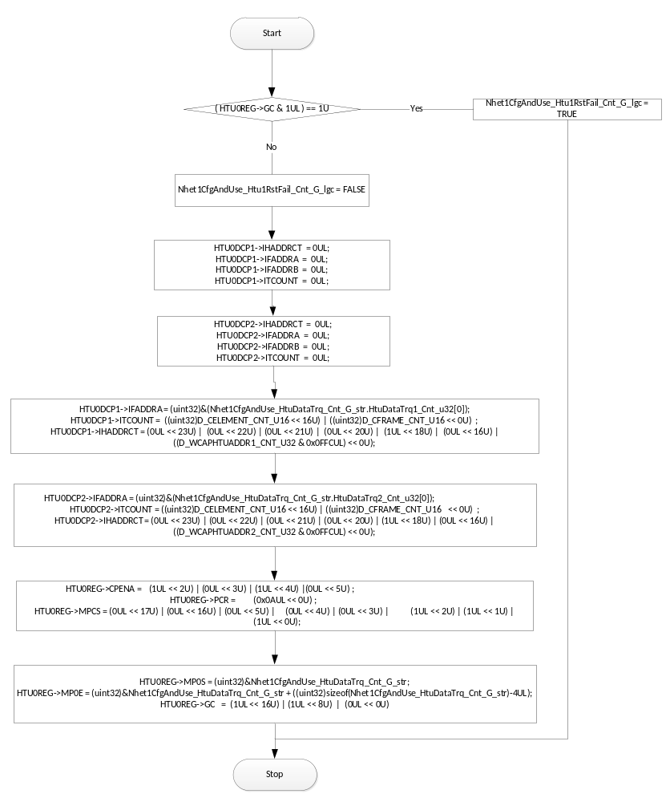

Local Function #2
Function Name | HwTqProtocolFault | Type | Min | Max
Arguments Passed | *RawData_Cnt_T_u32 | Uint32 | 0 | full
Arguments Passed | *PrevPulseCount_Cnt_T_u32 | Uint32 | 0 | full
Arguments Passed | *HwTrqRaw_Cnt_T_f32 | Float32 | 0 | 0
Arguments Passed | *NTCParam_Cnt_T_u08 | Uint8 | 0 | 16
Return Value | HwTrqTest_Cnt_T_u08 | Uint8 | 0 | 1

Description
Refer FDD block HwTqProtocolFault

GLObAL Function/Macro Definitions
<If these are numerous and defined in a separate source file then reference the source file only.>

GLObAL Function #1
Function Name | Nhet1CfgAndUse_Init | Type | Min | Max
Arguments Passed | None
Return Value | None

Description
All NHET1 initialization, including HTU1 initialization, is done before enabling NHET1.
Note: Global function Nhet1CfgAndUse_Init should be triggered in EcuStartup_Init1 (EcuStartup.c) along with ePWM_Init, following the memory initialization routine SchM_InitMemory.

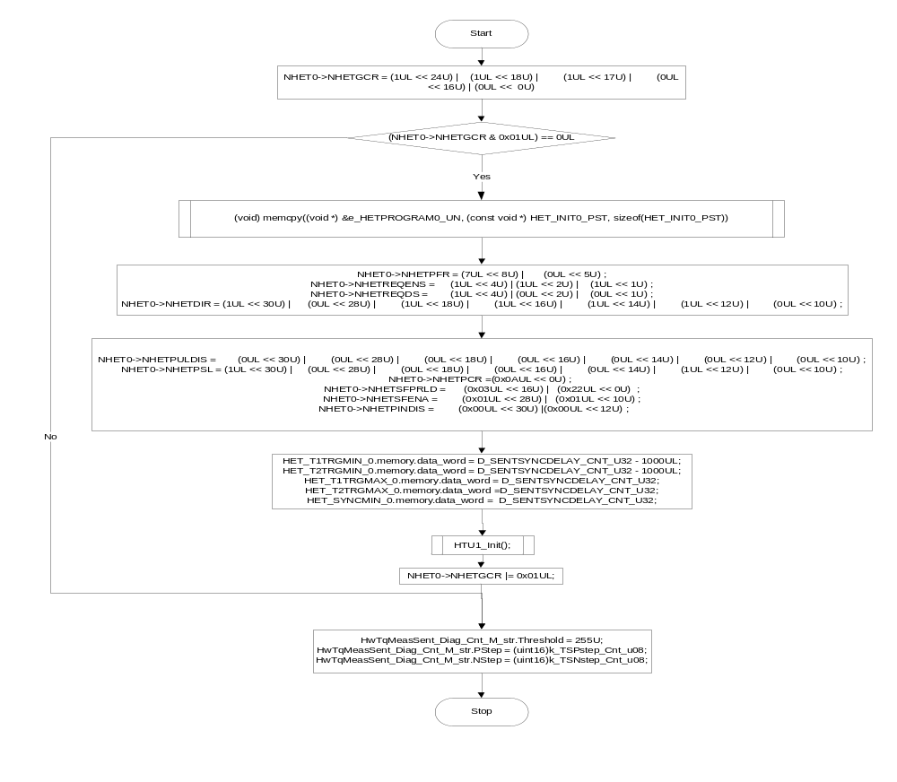

GLObAL Function #2

Function Name | Nhet1_Per3 | Type | Min | Max
Arguments Passed | None | N/A | N/A | N/A
Return Value | N/A

DESIGN Rationale
Non-RTE function

Description
PWM Duty Cycle& Period calculation

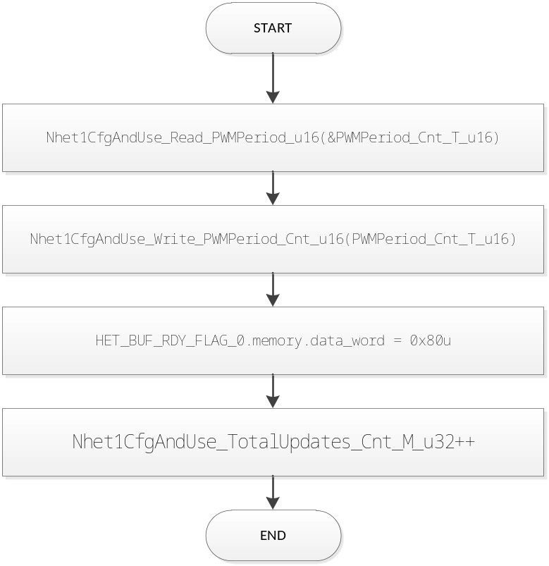

Known Limitations With Design
- The FDD contains the input signal SVC_Clear_Lgc which is not implemented as it was intended for EA4.0 design and this is the EA3.0 implementation where it was decided to not use the SVC_Clear_Lgc signal.
- ISO fault debounce logic is not implemented for EA3.0; instead of that regular pStep and nStep logic is implemented for NTC.
- This modules requires “std_nhet.h” file which resides in PhaseFdbkMeas/ES-36A component. So this component share the same “std_nhet.h” file from PhaseFdbkMeas/ES-36A.
- Variable Nhet1CfgAndUse_Htu1RstFail_Cnt_G_lgc has been renamed to Nhet_Htu1RstFail_Cnt_G_lgc in “Nhet.h” file to be used by the uDiag component. This is to avoid modification in uDiag component.
- Physical Inputs are terminated in the model which is intentional
- The constant definition in the m file has wrong naming convention which is corrected in source code and the .m fle needs to be updated
- Display variables mentioned in the .m file are not used in the source code as we already have variables serving the same purpose

UNIT TEST CONSIDERATION

None

Appendix
None

